H1: Screen turned on more before high stress

1. Hypotheses
H₀: The mean number of times the screen is turned on in the hour before a report is the same for a person's high-stress and low-stress reports (mean difference μd = 0).
H₁: The mean difference is not zero (μd ≠ 0).
Significance level α = 0.05, two-sided. Stress = tense arousal (0 = very calm, 100 = very restless).

2. Data
Data used: screen.csv (SCREEN_ON events counted in the clock hour before each report) + daily_survey.csv.
Each participant is compared with themselves; only participants with at least 3 reports in each situation are included.
A report is ‘High stress’ if it is above that person’s own median stress and ‘Low stress’ if below. Phone data come from the full clock hour before the report.

3. Test: Paired t-test
The same participants are measured in both situations, so the two sets of values are paired. The paired t-test works on each person's difference, which removes the large differences between people. It assumes the differences are roughly normal; with more than 30 participants the mean difference is close to normal anyway (central limit theorem).

4. Calculation step by step
Step 1 – For each participant, average the measure separately in 'Low stress' and 'High stress'.
 | Low stress | High stress
Mean over participants | 1.97 | 2.19

Step 2 – Difference for each person: d = (High stress) − (Low stress).
n = 93 mean difference d̄ = 0.224 standard deviation s_d = 0.808
Step 3 – Standard error of the mean difference:
SE = s_d / √n = 0.808 / √93 = 0.0838
Step 4 – Test statistic:
t = d̄ / SE = 0.224 / 0.0838 = 2.68 df = n − 1 = 92
Step 5 – Compare with the critical value and find the p-value (two-sided, α = 0.05):
critical value = ±1.986 |t| = 2.68 p = 0.0088
95% CI for the mean difference = d̄ ± 1.986 × SE = [0.06, 0.39] screen-on events per hour

5. Result
Test | Statistic | p-value | Effect
Paired t-test | t(92) = 2.68 | 0.0088 | Mean difference +0.22 screen-on events per hour, 95% CI [0.06, 0.39]

6. Graph
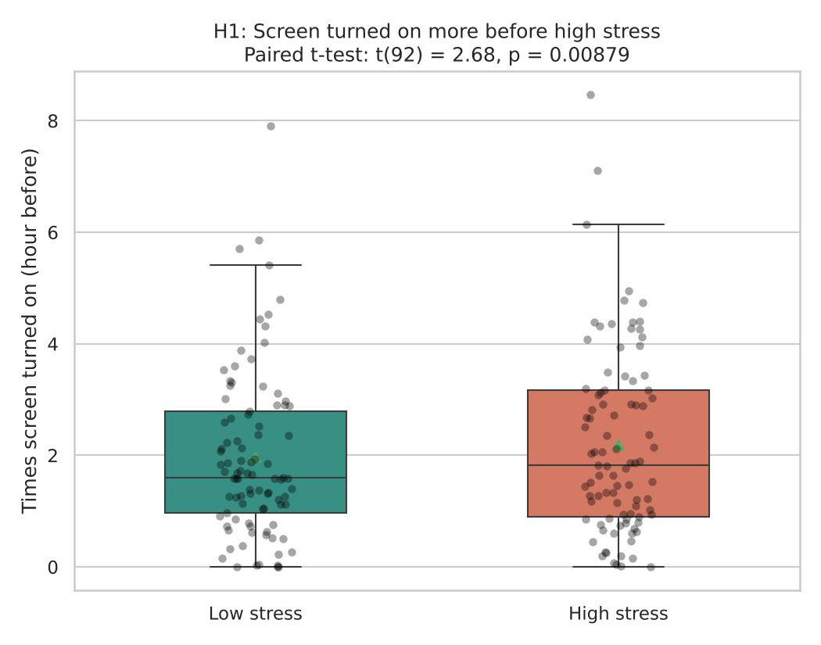
Each dot is one participant’s average in that situation; the box shows the middle 50% and the triangle marks the mean. If H₀ were true the two boxes would sit at about the same height.

7. Decision
p = 0.0088 < 0.05, so H₀ is rejected.

8. Conclusion
In the hour before a high-stress report, participants turned their screen on slightly more often (+0.22 times per hour). The effect is small. This is an association in the data, not proof of cause.

