H3: Less time sitting still before high stress

1. Hypotheses
H₀: The mean % of time spent still in the hour before a report is the same for high-stress and low-stress reports (μd = 0).
H₁: The mean difference is not zero (μd ≠ 0).
Significance level α = 0.05, two-sided. Stress = tense arousal (0 = very calm, 100 = very restless).

2. Data
Data used: activity_hourly.csv (% of activity records STILL in the hour before each report) + daily_survey.csv.
Each participant is compared with themselves; only participants with at least 3 reports in each situation are included.
A report is ‘High stress’ if it is above that person’s own median stress and ‘Low stress’ if below. Phone data come from the full clock hour before the report.

3. Test: Paired t-test
The same participants are measured in both situations, so the two sets of values are paired. The paired t-test works on each person's difference, which removes the large differences between people. It assumes the differences are roughly normal; with more than 30 participants the mean difference is close to normal anyway (central limit theorem).

4. Calculation step by step
Step 1 – For each participant, average the measure separately in 'Low stress' and 'High stress'.
 | Low stress | High stress
Mean over participants | 85.38 | 82.72

Step 2 – Difference for each person: d = (High stress) − (Low stress).
n = 86 mean difference d̄ = -2.654 standard deviation s_d = 9.543
Step 3 – Standard error of the mean difference:
SE = s_d / √n = 9.543 / √86 = 1.0290
Step 4 – Test statistic:
t = d̄ / SE = -2.654 / 1.0290 = -2.58 df = n − 1 = 85
Step 5 – Compare with the critical value and find the p-value (two-sided, α = 0.05):
critical value = ±1.988 |t| = 2.58 p = 0.0116
95% CI for the mean difference = d̄ ± 1.988 × SE = [-4.70, -0.61] percentage points

5. Result
Test | Statistic | p-value | Effect
Paired t-test | t(85) = -2.58 | 0.0116 | Mean difference -2.65 percentage points, 95% CI [-4.70, -0.61]

6. Graph
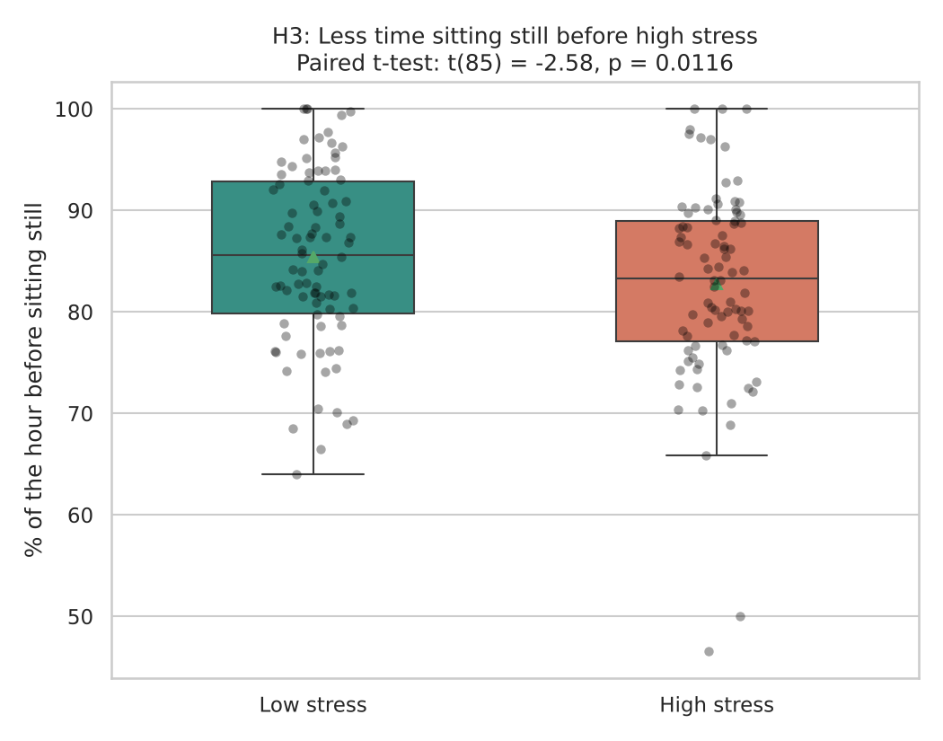
Each dot is one participant’s average in that situation; the box shows the middle 50% and the triangle marks the mean. If H₀ were true the two boxes would sit at about the same height.

7. Decision
p = 0.0116 < 0.05, so H₀ is rejected.

8. Conclusion
In the hour before a high-stress report, participants spent about 2.7 percentage points less time sitting still, i.e. they were more on the move. This is an association in the data, not proof of cause.

