H4: Unpleasant events raise stress

1. Hypotheses
H₀: A person's mean stress after an unpleasant event equals their mean stress when nothing happened (μd = 0).
H₁: The mean difference is not zero (μd ≠ 0).
Significance level α = 0.05, two-sided. Stress = tense arousal (0 = very calm, 100 = very restless).

2. Data
Data used: daily_survey.csv (emotional_event < 0 = unpleasant event, 0 = no event).
Each participant is compared with themselves; only participants with at least 3 reports in each situation are included.

3. Test: Paired t-test
The same participants are measured in both situations, so the two sets of values are paired. The paired t-test works on each person's difference, which removes the large differences between people. It assumes the differences are roughly normal; with more than 30 participants the mean difference is close to normal anyway (central limit theorem).

4. Calculation step by step
Step 1 – For each participant, average the measure separately in 'No event' and 'Unpleasant event'.
 | No event | Unpleasant event
Mean over participants | 38.01 | 55.12

Step 2 – Difference for each person: d = (Unpleasant event) − (No event).
n = 75 mean difference d̄ = 17.112 standard deviation s_d = 13.615
Step 3 – Standard error of the mean difference:
SE = s_d / √n = 13.615 / √75 = 1.5721
Step 4 – Test statistic:
t = d̄ / SE = 17.112 / 1.5721 = 10.88 df = n − 1 = 74
Step 5 – Compare with the critical value and find the p-value (two-sided, α = 0.05):
critical value = ±1.993 |t| = 10.88 p < 0.001
95% CI for the mean difference = d̄ ± 1.993 × SE = [13.98, 20.25] stress points

5. Result
Test | Statistic | p-value | Effect
Paired t-test | t(74) = 10.88 | < 0.001 | Mean difference +17.11 stress points, 95% CI [13.98, 20.25]

6. Graph
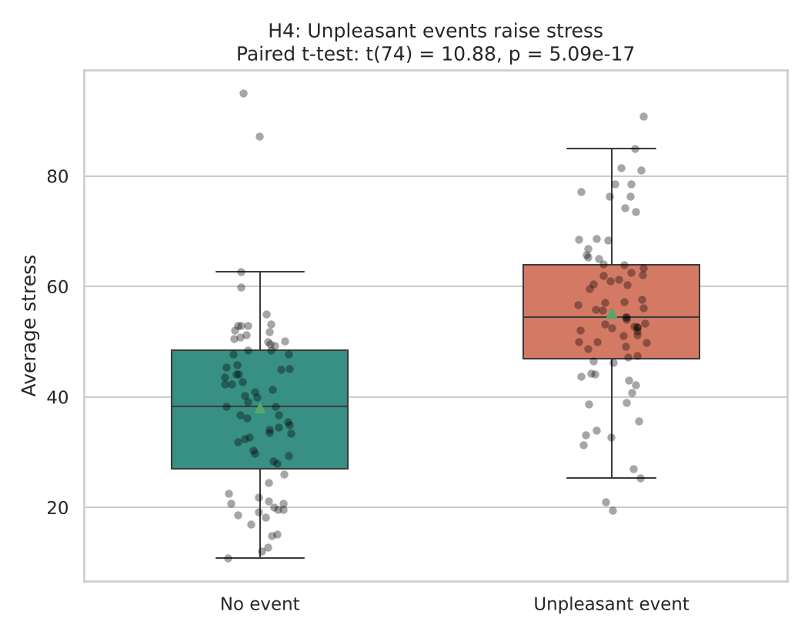
Each dot is one participant’s average in that situation; the box shows the middle 50% and the triangle marks the mean. If H₀ were true the two boxes would sit at about the same height.

7. Decision
p < 0.001 < 0.05, so H₀ is rejected.

8. Conclusion
After an unpleasant event a person’s stress is on average 17.1 points higher than when nothing happened. This is the largest effect in the project. This is an association in the data, not proof of cause.

