H5: Weekdays are more stressful than weekends

1. Hypotheses
H₀: A person's mean stress is the same on weekdays and at weekends (μd = 0).
H₁: The mean difference is not zero (μd ≠ 0).
Significance level α = 0.05, two-sided. Stress = tense arousal (0 = very calm, 100 = very restless).

2. Data
Data used: daily_survey.csv (Monday–Friday vs Saturday–Sunday).
Each participant is compared with themselves; only participants with at least 3 reports in each situation are included.

3. Test: z-test for the mean difference
The same participants are measured on weekdays and at weekends (paired), and the sample is large (n = 101 > 30). With a large sample the sample standard deviation is a good estimate of the population one, so the mean difference can be tested with the standard normal (z) distribution.

4. Calculation step by step
Step 1 – For each participant, average the measure separately in 'Weekend' and 'Weekday'.
 | Weekend | Weekday
Mean over participants | 33.32 | 35.82

Step 2 – Difference for each person: d = (Weekday) − (Weekend).
n = 101 mean difference d̄ = 2.508 standard deviation s_d = 5.397
Step 3 – Standard error of the mean difference:
SE = s_d / √n = 5.397 / √101 = 0.5371
Step 4 – Test statistic:
z = d̄ / SE = 2.508 / 0.5371 = 4.67
Step 5 – Compare with the critical value and find the p-value (two-sided, α = 0.05):
critical value = ±1.960 |z| = 4.67 p < 0.001
95% CI for the mean difference = d̄ ± 1.960 × SE = [1.46, 3.56] stress points

5. Result
Test | Statistic | p-value | Effect
z-test for the mean difference | z = 4.67 | < 0.001 | Mean difference +2.51 stress points, 95% CI [1.46, 3.56]

6. Graph
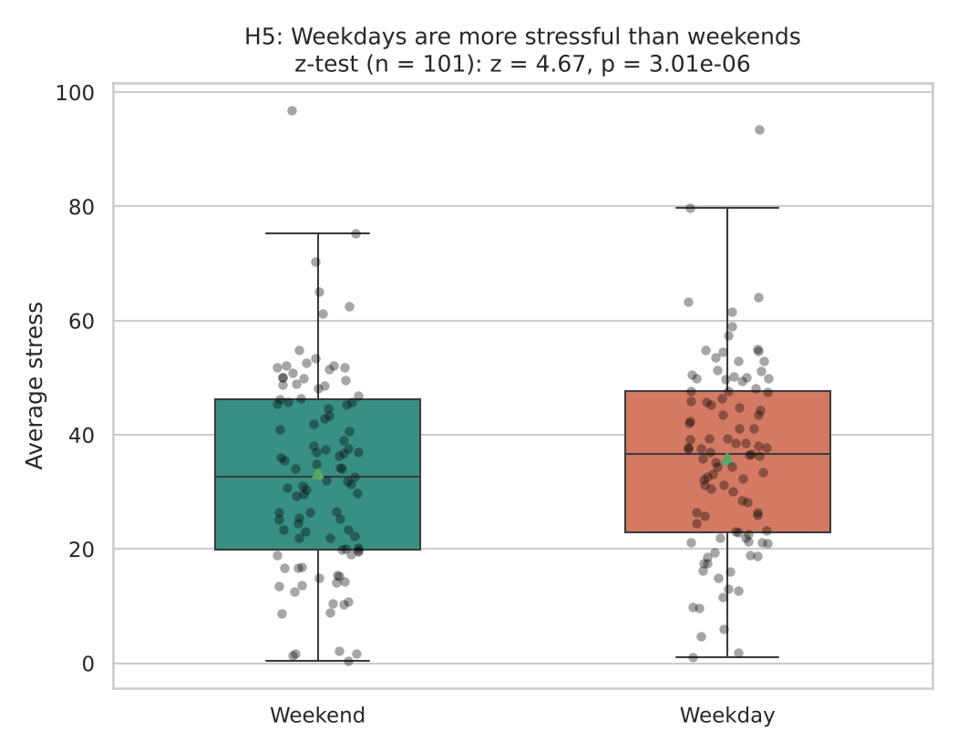
Each dot is one participant’s average on weekend days or weekdays; the triangle marks the mean.

7. Decision
p < 0.001 < 0.05, so H₀ is rejected.

8. Conclusion
Participants report on average 2.5 points more stress on weekdays than at weekends. This is an association in the data, not proof of cause.

