H6: More stress when tired

1. Hypotheses
H₀: A person's mean stress is the same in their tired and awake moments (μd = 0).
H₁: The mean difference is not zero (μd ≠ 0).
Significance level α = 0.05, two-sided. Stress = tense arousal (0 = very calm, 100 = very restless).

2. Data
Data used: daily_survey.csv (energetic arousal below / above the person's own median).
Each participant is compared with themselves; only participants with at least 3 reports in each situation are included.

3. Test: Paired t-test
The same participants are measured in both situations, so the two sets of values are paired. The paired t-test works on each person's difference, which removes the large differences between people. It assumes the differences are roughly normal; with more than 30 participants the mean difference is close to normal anyway (central limit theorem).

4. Calculation step by step
Step 1 – For each participant, average the measure separately in 'Awake' and 'Tired'.
 | Awake | Tired
Mean over participants | 34.05 | 38.03

Step 2 – Difference for each person: d = (Tired) − (Awake).
n = 93 mean difference d̄ = 3.974 standard deviation s_d = 11.214
Step 3 – Standard error of the mean difference:
SE = s_d / √n = 11.214 / √93 = 1.1629
Step 4 – Test statistic:
t = d̄ / SE = 3.974 / 1.1629 = 3.42 df = n − 1 = 92
Step 5 – Compare with the critical value and find the p-value (two-sided, α = 0.05):
critical value = ±1.986 |t| = 3.42 p < 0.001
95% CI for the mean difference = d̄ ± 1.986 × SE = [1.66, 6.28] stress points

5. Result
Test | Statistic | p-value | Effect
Paired t-test | t(92) = 3.42 | < 0.001 | Mean difference +3.97 stress points, 95% CI [1.66, 6.28]

6. Graph
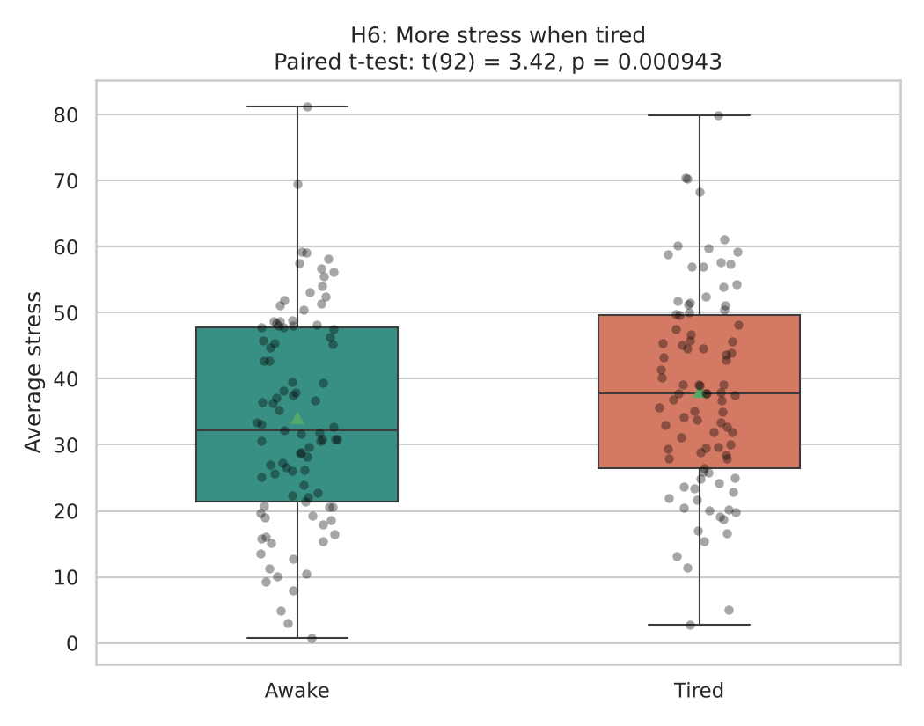
Each dot is one participant’s average in that situation; the box shows the middle 50% and the triangle marks the mean. If H₀ were true the two boxes would sit at about the same height.

7. Decision
p < 0.001 < 0.05, so H₀ is rejected.

8. Conclusion
Participants report on average 4.0 points more stress in moments when they feel more tired than usual. This is an association in the data, not proof of cause.

