H7: More stress when in a bad mood

1. Hypotheses
H₀: A person's mean stress is the same in their bad-mood and good-mood moments (μd = 0).
H₁: The mean difference is not zero (μd ≠ 0).
Significance level α = 0.05, two-sided. Stress = tense arousal (0 = very calm, 100 = very restless).

2. Data
Data used: daily_survey.csv (valence below / above the person's own median).
Each participant is compared with themselves; only participants with at least 3 reports in each situation are included.

3. Test: Paired t-test
The same participants are measured in both situations, so the two sets of values are paired. The paired t-test works on each person's difference, which removes the large differences between people. It assumes the differences are roughly normal; with more than 30 participants the mean difference is close to normal anyway (central limit theorem).

4. Calculation step by step
Step 1 – For each participant, average the measure separately in 'Good mood' and 'Bad mood'.
 | Good mood | Bad mood
Mean over participants | 32.41 | 41.18

Step 2 – Difference for each person: d = (Bad mood) − (Good mood).
n = 90 mean difference d̄ = 8.768 standard deviation s_d = 10.504
Step 3 – Standard error of the mean difference:
SE = s_d / √n = 10.504 / √90 = 1.1072
Step 4 – Test statistic:
t = d̄ / SE = 8.768 / 1.1072 = 7.92 df = n − 1 = 89
Step 5 – Compare with the critical value and find the p-value (two-sided, α = 0.05):
critical value = ±1.987 |t| = 7.92 p < 0.001
95% CI for the mean difference = d̄ ± 1.987 × SE = [6.57, 10.97] stress points

5. Result
Test | Statistic | p-value | Effect
Paired t-test | t(89) = 7.92 | < 0.001 | Mean difference +8.77 stress points, 95% CI [6.57, 10.97]

6. Graph
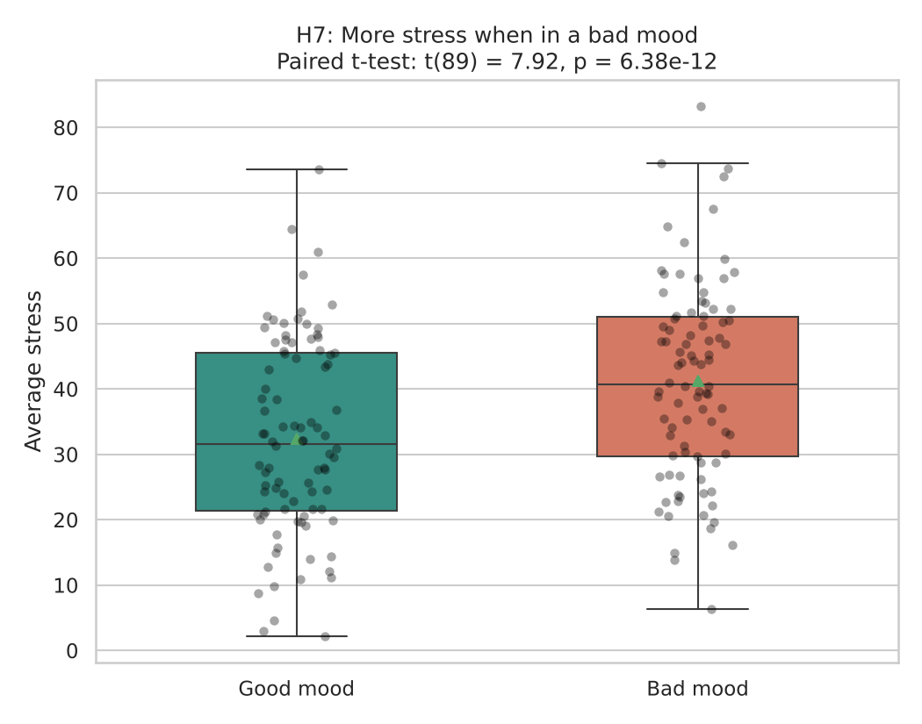
Each dot is one participant’s average in that situation; the box shows the middle 50% and the triangle marks the mean. If H₀ were true the two boxes would sit at about the same height.

7. Decision
p < 0.001 < 0.05, so H₀ is rejected.

8. Conclusion
Participants report on average 8.8 points more stress in moments when their mood is worse than usual. This is an association in the data, not proof of cause.

