H8: People with anxiety are more often highly stressed

1. Hypotheses
H₀: The proportion of people with above-median average stress is the same with and without anxiety symptoms (p₁ = p₂).
H₁: The proportions differ (p₁ ≠ p₂).
Significance level α = 0.05, two-sided. Stress = tense arousal (0 = very calm, 100 = very restless).

2. Data
Data used: initial_survey.csv (GAD-7 total, cut-off 10) + daily_survey.csv (average stress per person).

3. Test: Two-proportion z-test
The outcome is a yes/no (above-median stress or not) and we compare the proportion of ‘yes’ in two independent groups, so a two-proportion z-test is used. Its condition, at least 5 expected yes and no answers in each group, is met.

4. Calculation step by step
Step 1 – Label each participant ‘high stress’ if their average stress is above the median of all participants (35.7). Count per group:
Group | n | High-stress people | Proportion
Anxiety (GAD-7 ≥ 10) | 29 | 23 | p₁ = 0.793
No anxiety (GAD-7 < 10) | 74 | 28 | p₂ = 0.378

Step 2 – Pooled proportion (assuming H₀ is true):
p̂ = (x₁ + x₂) / (n₁ + n₂) = (23 + 28) / (29 + 74) = 0.495
Step 3 – Standard error:
SE = √[p̂(1 − p̂)(1/n₁ + 1/n₂)] = √[0.495 × 0.505 × (1/29 + 1/74)] = 0.1095
Step 4 – Test statistic and p-value:
z = (p₁ − p₂) / SE = (0.793 − 0.378) / 0.1095 = 3.79
critical value = ±1.96 p < 0.001

5. Result
Test | Statistic | p-value | Effect
Two-proportion z-test | z = 3.79 | < 0.001 | Difference in proportions = 0.41 (79% vs 38%)

6. Graph
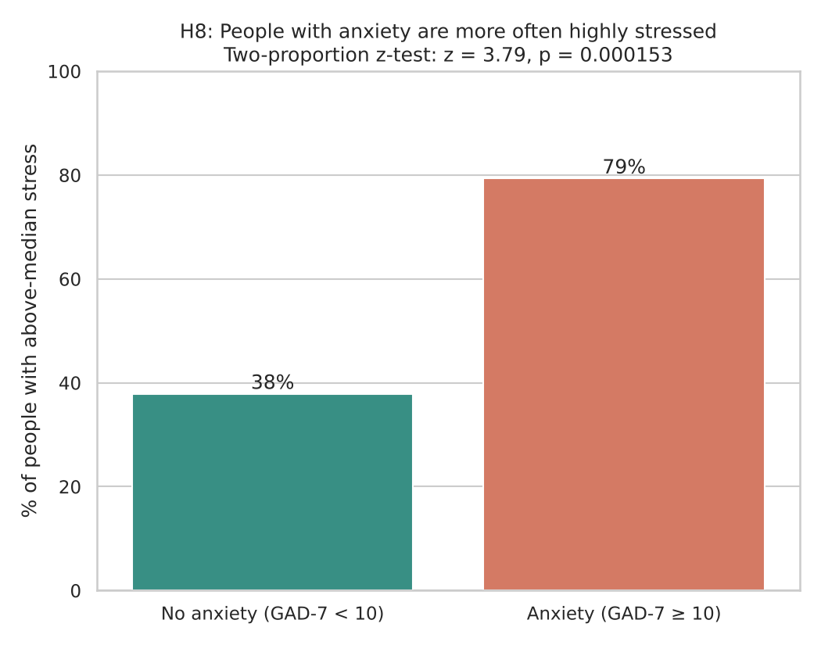
The bars show the % of people in each group whose average stress is above the median of all participants.

7. Decision
p < 0.001 < 0.05, so H₀ is rejected.

8. Conclusion
79% of people with anxiety symptoms have above-median stress, compared with 38% of people without. This is an association in the data, not proof of cause.

