H9: Depression symptoms are linked to stress level

1. Hypotheses
H₀: Depression group and stress level (low / medium / high third) are independent.
H₁: Depression group and stress level are associated.
Significance level α = 0.05, two-sided. Stress = tense arousal (0 = very calm, 100 = very restless).

2. Data
Data used: initial_survey.csv (PHQ-9 total, cut-off 10) + daily_survey.csv (average stress per person, split into thirds).

3. Test: Chi-square test of independence
Both variables are categorical (2 depression groups × 3 stress levels), so the chi-square test of independence is used. All expected counts are above 5, as the test requires.

4. Calculation step by step
Step 1 – Split participants into thirds by average stress (cut-offs 28.6 and 43.1) and count them by depression group (observed counts O):
 | Low stress | Medium stress | High stress | Total
No depression (PHQ-9 < 10) | 29 | 23 | 15 | 67
Depression (PHQ-9 ≥ 10) | 6 | 11 | 19 | 36
Total | 35 | 34 | 34 | 103

Step 2 – Expected counts if the variables were independent: E = row total × column total / n
 | Low stress | Medium stress | High stress
No depression (PHQ-9 < 10) | 22.77 | 22.12 | 22.12
Depression (PHQ-9 ≥ 10) | 12.23 | 11.88 | 11.88

Step 3 – Add up (O − E)² / E over all six cells:
χ² = 1.71 + 0.04 + 2.29 + 3.18 + 0.07 + 4.26 = 11.53
Step 4 – Degrees of freedom and decision:
df = (rows − 1)(columns − 1) = (2 − 1)(3 − 1) = 2
critical value χ²(0.05, 2) = 5.991 χ² = 11.53 p = 0.0031
Step 5 – Strength of the association (Cramér’s V):
V = √[χ² / (n × (min(rows, columns) − 1))] = √[11.53 / (103 × 1)] = 0.33

5. Result
Test | Statistic | p-value | Effect
Chi-square test of independence | χ²(2) = 11.53 | 0.0031 | Cramér's V = 0.33 (moderate)

6. Graph
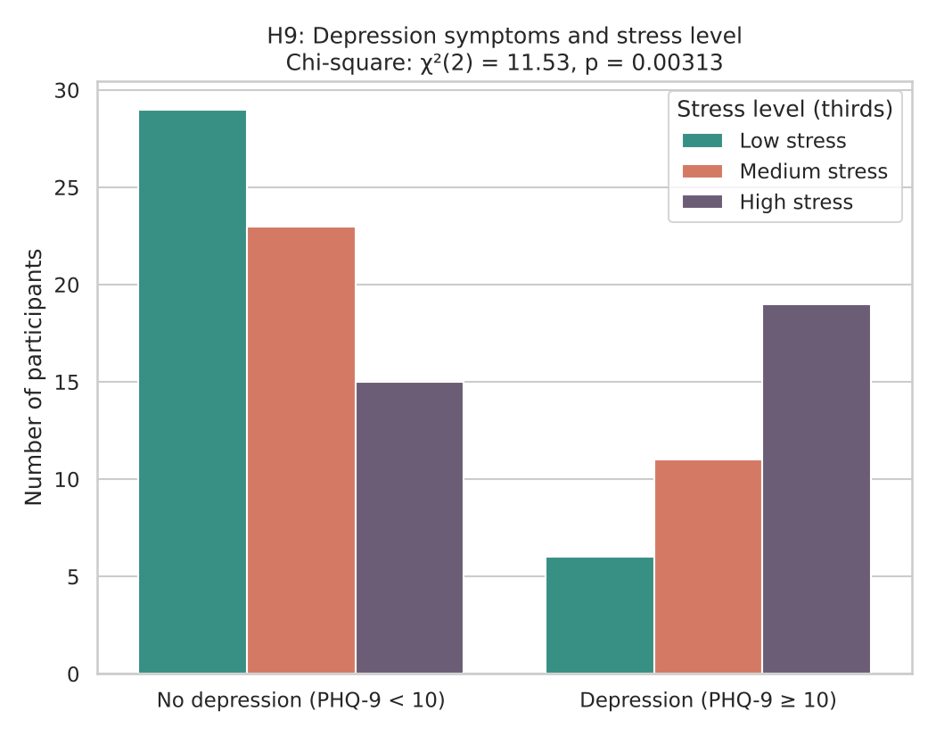
The bars count people in each stress third. Under H₀ both depression groups would have the same mix of low, medium and high stress.

7. Decision
p = 0.0031 < 0.05, so H₀ is rejected.

8. Conclusion
Stress level is not independent of depression symptoms: 19 of the 36 people with depression symptoms fall in the highest stress third, against 15 of 67 without. This is an association in the data, not proof of cause.

