H10: People with low resilience are more stressed

1. Hypotheses
H₀: Mean average stress is the same for people with low resilience and normal / high resilience (μ₁ = μ₂).
H₁: The means differ (μ₁ ≠ μ₂).
Significance level α = 0.05, two-sided. Stress = tense arousal (0 = very calm, 100 = very restless).

2. Data
Data used: initial_survey.csv (Brief Resilience Scale mean, cut-off 3) + daily_survey.csv.

3. Test: Independent-samples t-test (Welch)
Two independent groups of people with a numeric outcome, so an independent-samples t-test is used. The groups have very different sizes (27 vs 76) and spreads, so Welch’s version, which does not assume equal variances, is the safer choice.

4. Calculation step by step
Step 1 – Summary of each group (average stress per participant):
Group | n | Mean | Standard deviation
Low resilience (< 3) | 27 | 43.49 | 18.94
Normal / high resilience | 76 | 32.66 | 14.95

Step 2 – Standard error of the difference (Welch):
SE = √(s₁²/n₁ + s₂²/n₂) = √(18.94²/27 + 14.95²/76) = 4.028
Step 3 – Test statistic:
t = (x̄₁ − x̄₂) / SE = (43.49 − 32.66) / 4.028 = 2.69
Step 4 – Welch degrees of freedom:
df = (s₁²/n₁ + s₂²/n₂)² / [ (s₁²/n₁)²/(n₁−1) + (s₂²/n₂)²/(n₂−1) ] = 38.1
Step 5 – Decision:
critical value = ±2.024 t = 2.69 p = 0.0105
95% CI for the difference = 10.83 ± 2.024 × 4.028 = [2.68, 18.99]

5. Result
Test | Statistic | p-value | Effect
Independent-samples t-test (Welch) | t(38.1) = 2.69 | 0.0105 | Mean difference +10.83 stress points, 95% CI [2.68, 18.99]

6. Graph
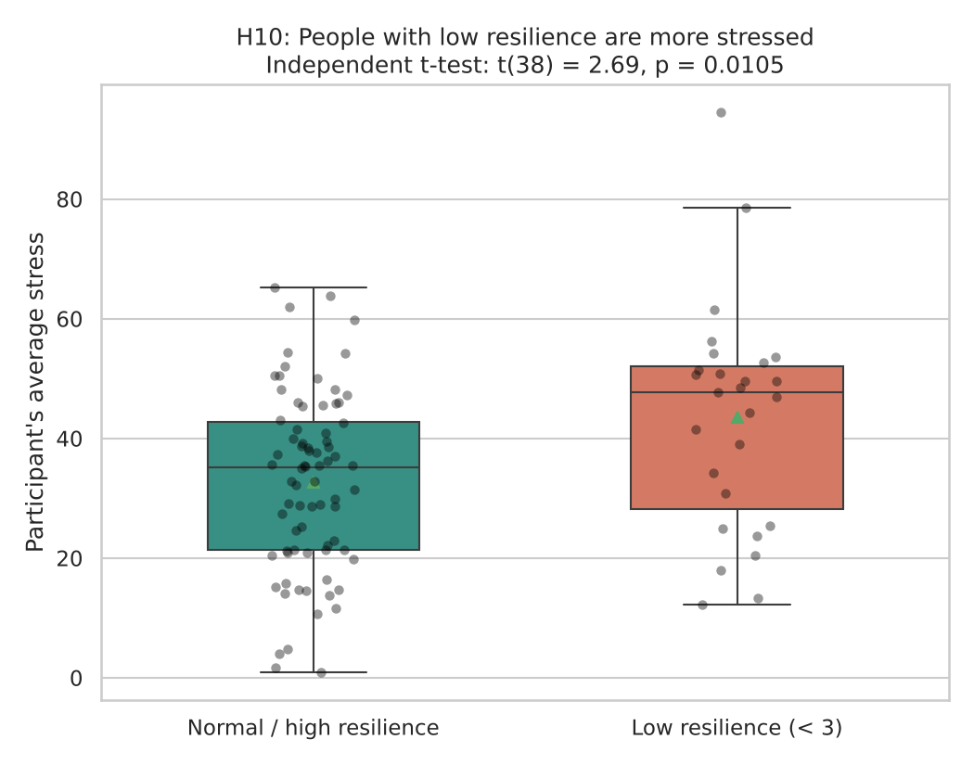
Each dot is one participant; the triangle marks the group mean.

7. Decision
p = 0.0105 < 0.05, so H₀ is rejected.

8. Conclusion
People with low resilience report on average 10.8 points more daily stress than people with normal or high resilience. This is an association in the data, not proof of cause.

