H11: Stress differs by satisfaction with mental health

1. Hypotheses
H₀: Mean average stress is equal in the three satisfaction groups (μ₁ = μ₂ = μ₃).
H₁: At least one group mean is different.
Significance level α = 0.05, two-sided. Stress = tense arousal (0 = very calm, 100 = very restless).

2. Data
Data used: initial_survey.csv (MENT_LS: 1–2 dissatisfied, 3 satisfied, 4 very satisfied) + daily_survey.csv.

3. Test: One-way ANOVA
Average stress (numeric) is compared across three independent groups, so one-way ANOVA is used instead of several t-tests, which would inflate the chance of a false positive.

4. Calculation step by step
Step 1 – Summary of each group (average stress per participant):
Group | n | Mean | Standard deviation
Very satisfied | 25 | 31.89 | 14.52
Satisfied | 50 | 33.31 | 16.02
Dissatisfied | 28 | 42.62 | 18.05

Grand mean of all 103 participants = 35.50
Step 2 – Between-groups sum of squares (how far each group mean is from the grand mean):
SSB = Σ nⱼ (x̄ⱼ − x̄)² = 25×(31.89 − 35.50)² + 50×(33.31 − 35.50)² + 28×(42.62 − 35.50)² = 1985.4
Step 3 – Within-groups sum of squares (spread inside each group):
SSW = Σ Σ (x − x̄ⱼ)² = 26429.4
Step 4 – ANOVA table:
Source | SS | df | MS = SS/df | F
Between groups | 1985.4 | 2 | 992.7 | 3.76
Within groups | 26429.4 | 100 | 264.3
Total | 28414.8 | 102

Step 5 – Decision:
F = MSB / MSW = 992.7 / 264.3 = 3.76
critical value F(0.05; 2, 100) = 3.087 p = 0.0267
Effect size η² = SSB / SST = 1985.4 / 28414.8 = 0.07

5. Result
Test | Statistic | p-value | Effect
One-way ANOVA | F(2, 100) = 3.76 | 0.0267 | η² = 0.07 (medium)

6. Graph
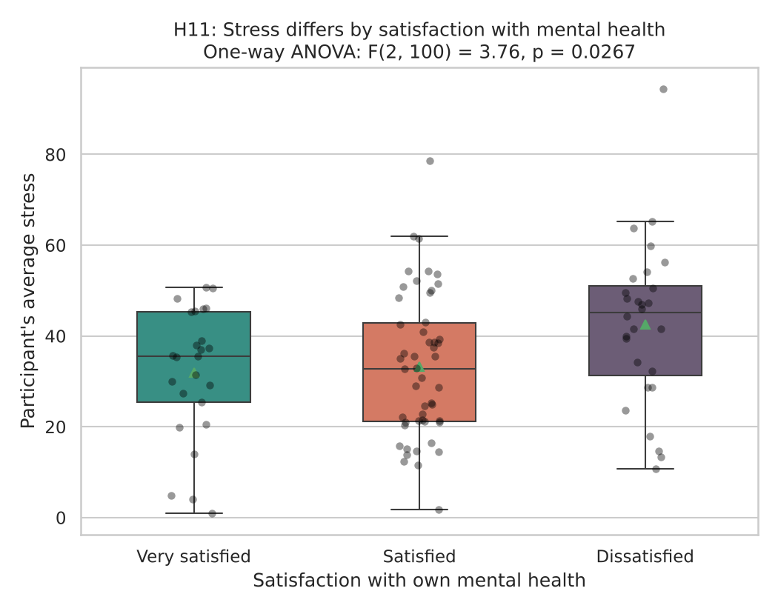
Each dot is one participant; the triangle marks the group mean. Under H₀ all three means would be similar.

7. Decision
p = 0.0267 < 0.05, so H₀ is rejected.

8. Conclusion
People dissatisfied with their mental health have higher mean stress (42.6) than satisfied (33.3) and very satisfied people (31.9). This is an association in the data, not proof of cause.

