H12: Stress rises with general negative feelings

1. Hypotheses
H₀: Mean average stress is equal in the low, medium and high negative-feelings groups (μ₁ = μ₂ = μ₃).
H₁: At least one group mean is different.
Significance level α = 0.05, two-sided. Stress = tense arousal (0 = very calm, 100 = very restless).

2. Data
Data used: initial_survey.csv (PANAS negative items: upset, hostile, ashamed, nervous, afraid; 5–25) + daily_survey.csv.

3. Test: One-way ANOVA
Average stress (numeric) is compared across three independent groups, so one-way ANOVA is used instead of several t-tests, which would inflate the chance of a false positive.

4. Calculation step by step
Step 1 – Summary of each group (average stress per participant):
Group | n | Mean | Standard deviation
Low (5-7) | 44 | 32.24 | 18.08
Medium (8-11) | 34 | 33.55 | 12.56
High (12-25) | 25 | 43.88 | 16.84

Grand mean of all 103 participants = 35.50
Step 2 – Between-groups sum of squares (how far each group mean is from the grand mean):
SSB = Σ nⱼ (x̄ⱼ − x̄)² = 44×(32.24 − 35.50)² + 34×(33.55 − 35.50)² + 25×(43.88 − 35.50)² = 2351.7
Step 3 – Within-groups sum of squares (spread inside each group):
SSW = Σ Σ (x − x̄ⱼ)² = 26063.1
Step 4 – ANOVA table:
Source | SS | df | MS = SS/df | F
Between groups | 2351.7 | 2 | 1175.9 | 4.51
Within groups | 26063.1 | 100 | 260.6
Total | 28414.8 | 102

Step 5 – Decision:
F = MSB / MSW = 1175.9 / 260.6 = 4.51
critical value F(0.05; 2, 100) = 3.087 p = 0.0133
Effect size η² = SSB / SST = 2351.7 / 28414.8 = 0.08

5. Result
Test | Statistic | p-value | Effect
One-way ANOVA | F(2, 100) = 4.51 | 0.0133 | η² = 0.08 (medium)

6. Graph
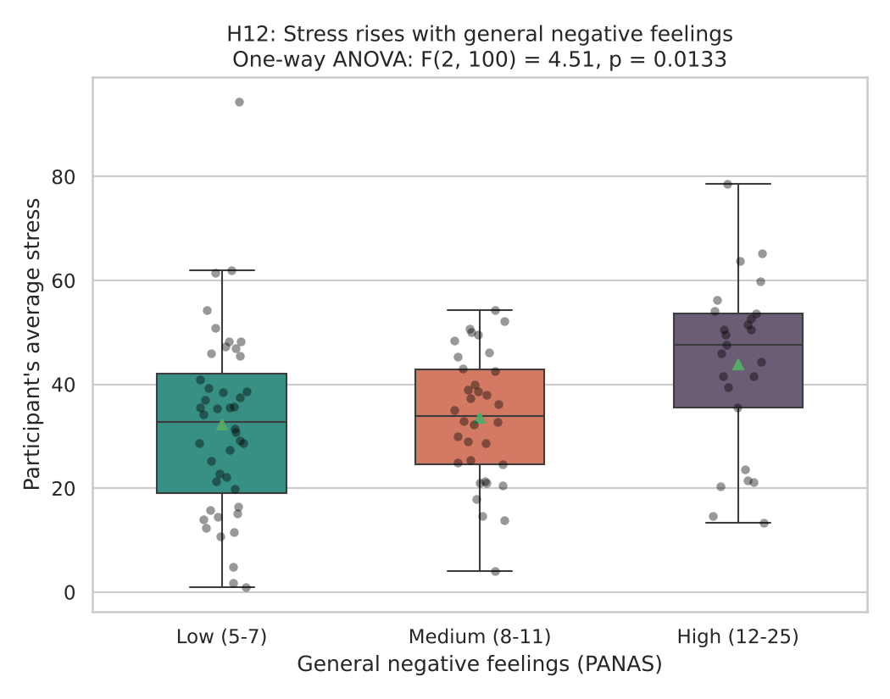
Each dot is one participant; the triangle marks the group mean. Under H₀ all three means would be similar.

7. Decision
p = 0.0133 < 0.05, so H₀ is rejected.

8. Conclusion
Mean stress is highest in people with high general negative feelings (43.9) compared with medium (33.6) and low (32.2). This is an association in the data, not proof of cause.

