THE VENUE STREAMING
PLAYBOOK
How Smart Venues Are Turning Live Events
Into Global Experiences
__________________________________________________

✓ Reach audiences beyond your four walls
✓ Create new revenue streams from every event
✓ Build a global brand without a global budget

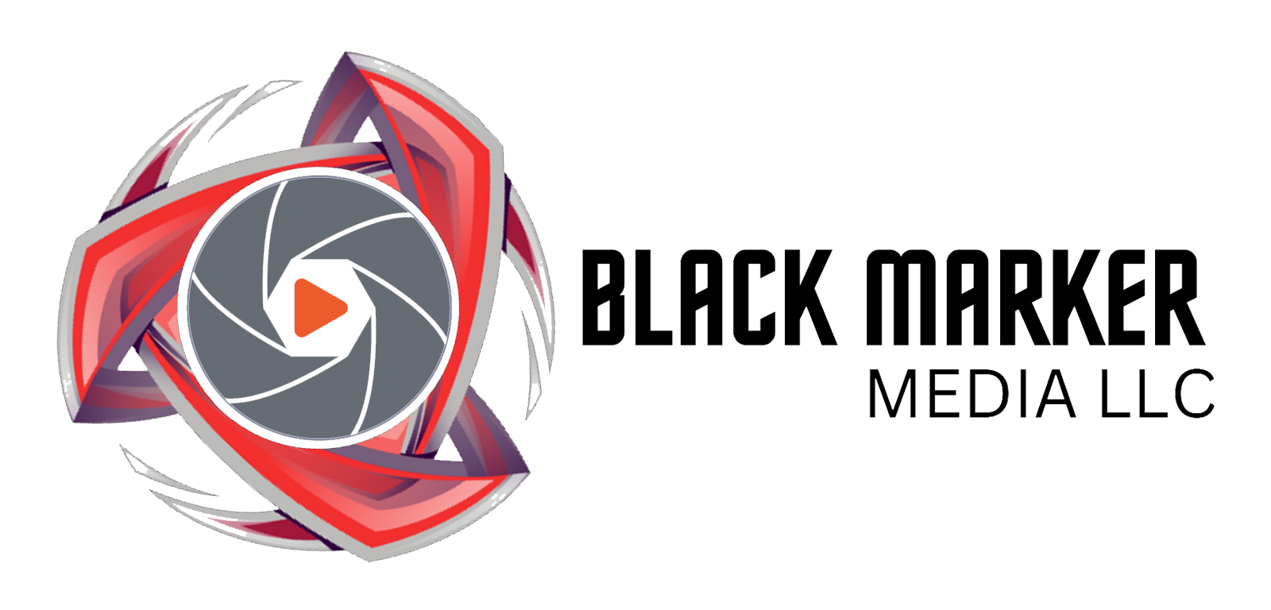
A free guide from Black Marker Media, LLC
www.blackmarkermedia.com | playbook@blackmarkermedia.com | 727-632-2700

WHAT'S INSIDE
01 The Live Streaming Opportunity
Why venues that don't stream are leaving money on the table
02 5 Revenue Streams You're Missing
Monetization models that work right now
03 What It Actually Takes
Equipment, internet, and crew — simplified
04 The 3-Tier Approach
Start small, prove ROI, then scale
05 Platform Strategy
Where to stream and why it matters
06 Audio: The Make-or-Break Factor
Why 90% of stream quality is sound
07 Legal Essentials
Music rights, licensing, and protecting your venue
08 Your Next Step
How we make this effortless for you

01 The Live Streaming Opportunity
The live events industry has fundamentally changed. Audiences now expect a digital option — and the venues delivering it are winning.
The Numbers Tell the Story
Metric | Data Point
Global live streaming market | $100+ billion by 2027 (Grand View Research)
Viewers who prefer hybrid events | 67% want the option to attend virtually (Eventbrite)
Revenue lift from adding virtual tickets | 15-35% average increase per event
Fan willingness to pay for streams | 72% of live music fans have paid for a stream (MIDiA Research)
Average virtual ticket price | $10-25 for concerts, $5-15 for other events

Every show you don't stream is an audience you're not reaching and revenue you're not earning.
Who's Already Doing This?
Forward-thinking venues across every category are streaming today:
- Music venues — selling virtual tickets alongside physical ones, reaching fans in other cities and countries
- Theaters — offering accessible viewing for patrons who can't attend in person
- Houses of worship — connecting with congregants who are homebound, traveling, or remote
- Conference centers — hybrid events are now the default expectation for corporate clients
- Comedy clubs — building national followings from local stages

02 5 Revenue Streams You're Missing
Streaming isn't just about exposure — it's a profit center. Here are five proven models:

1. Virtual Ticket Sales (Pay-Per-View)  Sell access to your stream just like a physical ticket. Virtual tickets typically price at 30-50% of in-person tickets. A 500-capacity venue selling 200 virtual tickets at $15 each adds $3,000 per event with zero additional venue costs. | POTENTIAL  $3,000-15,000/event

2. Subscriptions & Memberships  Charge $10-25/month for access to all your streamed events. With 200 subscribers, that's $2,000-5,000/month in predictable recurring revenue — even during slow booking periods. | POTENTIAL  $2,000-5,000/month

3. Tips & Donations  Viewers send voluntary payments during streams. Music streams commonly generate $200-1,000+ per event in tips. Setup takes 10 minutes with tools like Streamlabs or Ko-fi. | POTENTIAL  $200-1,000/event

4. Sponsorships  Local businesses pay to have their brand on your stream — logo placement, branded segments, pre-roll ads. A single local sponsor can cover your entire streaming operation cost. | POTENTIAL  $500-5,000/month

5. VOD & Content Licensing  Your archived streams become a content library. License performances to artists, sell VOD replays, or generate YouTube ad revenue. Content works for you long after the show ends. | POTENTIAL  Ongoing passive income

Combined, these revenue streams can add $50,000-200,000+ annually
to your venue's bottom line.

03 What It Actually Takes
Venue streaming has gotten dramatically simpler and more affordable. Here's an honest breakdown of what's involved:
Equipment Essentials
Component | What It Does | Starting Cost
PTZ Cameras (2-3) | Remote-controlled cameras mounted in your venue — no operators needed | $1,600-6,000
Video Switcher | Cuts between camera angles in real time | $450-1,300
Audio Interface | Captures clean audio from your mixing board | $100-250
Streaming PC or Encoder | Compresses and sends video to the internet | $600-1,500
Cabling & Mounts | HDMI/SDI cables, ceiling mounts, adapters | $200-500

Internet Requirements
You need reliable upload speed — not download. Most venues need far less than they think:
Stream Quality | Upload Speed Needed | Typical Cost
720p (Good) | 5-10 Mbps upload | Often included in existing business internet
1080p (Professional) | 10-20 Mbps upload | $50-100/month for business fiber
4K (Premium) | 25-50 Mbps upload | $100-200/month for dedicated fiber

Crew Requirements
Modern PTZ camera systems dramatically reduce crew needs:
Setup | Crew Size | Skill Level
2 PTZ cameras + auto-switching | 0 (fully automated) | Initial setup only
2-3 PTZ cameras + live switching | 1 person | Moderate (trainable in 1-2 sessions)
4-6 cameras + graphics | 2-3 people | Experienced AV / trained staff
Full broadcast production | 3-5 people | Professional crew

Total starting investment: $3,000-8,000
That's often recouped within 2-4 streamed events through virtual ticket sales alone.

04 The 3-Tier Approach: Start Small, Scale Smart
You don't need to build a broadcast studio on day one. The smartest venues follow a phased approach that proves ROI at each stage before investing more.
TIER 1: PROVE IT ($2,500-5,000)
- 2 PTZ cameras (wide shot + close-up)
- Blackmagic ATEM Mini Pro ($450)
- Audio feed from your existing FOH board
- Stream to YouTube + Facebook (free platforms)
- 1 person operates everything
Goal: Validate audience demand. Measure viewership and engagement for 4-6 events. This tier pays for itself if even 50 people buy a $10 virtual ticket.
TIER 2: MONETIZE ($8,000-15,000)
- 3-4 PTZ cameras with preset positions
- Dedicated streaming PC with vMix or OBS
- Professional audio interface + room microphones
- Ticketed streaming on Mandolin, Eventive, or Vimeo OTT
- Branded graphics, lower thirds, and overlays
- 1-2 person crew
Goal: Generate consistent revenue. Add virtual ticketing, sponsorship packages, and build a subscriber base. Target: $2,000-5,000/month in streaming revenue.
TIER 3: PROFESSIONALIZE ($20,000-50,000+)
- 5-6 cameras (PTZ + operated) with full coverage
- Broadcast-quality switcher with dedicated control panel
- Redundant internet with automatic failover
- ISO recording of all camera angles
- Dedicated stream audio mix with ambient mics
- Instant replay capability
- 2-4 person professional crew
Goal: Premium product commanding premium pricing. Virtual tickets at $20-50, corporate hybrid events at premium rates, national sponsorship deals.

05 Platform Strategy: Where to Stream
Different platforms serve different goals. Here's where to focus based on what you want to achieve:
Your Goal | Best Platform | Why
Maximum free reach | YouTube Live + Facebook Live | Largest audiences, free, permanent VOD archive
Sell virtual tickets | Mandolin / Eventive / Vimeo OTT | Built-in ticketing, access control, payment processing
Build a loyal community | Twitch or YouTube | Subscription models, chat culture, repeat viewership
Corporate / branded events | Vimeo Livestream | Ad-free, white-label, password protection
Cover all bases | Restream (multi-platform) | Stream to 30+ platforms from one feed simultaneously

Our recommendation: Start with YouTube + Facebook (free, maximum reach), then add a ticketed platform once you've validated demand.

06 Audio: The Make-or-Break Factor
Here's a truth most people learn the hard way: viewers will tolerate mediocre video for hours, but they'll leave within 30 seconds of bad audio.
The Right Way to Capture Audio
Method | Quality | Complexity | Best For
Camera microphone | Poor | Zero | Never use this for a real stream
Direct feed from FOH board | Good | Low | Quick and easy starting point
Dedicated stream mix (aux send) | Excellent | Moderate | Best balance of quality vs. effort
Full audio split + stream mixer | Broadcast | High | Large productions, ultimate control

The Secret Ingredient: Room Microphones
A direct board feed sounds like a studio recording — clean but lifeless. Adding 1-2 room microphones captures crowd energy, applause, and ambient atmosphere that makes viewers feel like they're actually there. This one addition transforms stream quality more than any camera upgrade.
We handle all of this for you — from the audio interface to the final mix that makes your stream sound broadcast-ready.

07 Legal Essentials You Need to Know
Music licensing for streaming is different from your standard venue performance license. Here's what you need to stay protected:
Quick Reference
Scenario | Risk Level | What You Need
Band plays original music | Low | Written permission from artist (in booking contract)
Band plays cover songs | Moderate | PRO streaming licenses (ASCAP, BMI, SESAC, GMR)
Recorded music during intermission | High | Royalty-free music library (Epidemic Sound, Artlist)
DJ set / all recorded music | Very High | Direct master licenses (complex) — avoid streaming unless cleared
Worship services | Low | CCLI Streaming License (~$100-500/year)

Essential Protections
- Streaming clause in every booking contract — get written permission from artists to stream their performance
- PRO licenses for streaming — your existing venue performance license likely doesn't cover online streaming
- Venue signage — "This event is being live streamed" posted at entrances
- Royalty-free music — for all non-live segments (pre-show, intermission, post-show)

We help our clients navigate all of this — from contract language to PRO registration to platform compliance.

08 Your Next Step

You've seen the opportunity. You know the numbers.
Now imagine this for your venue:
✓ Every event you host reaches 2x-10x more people
✓ A new revenue stream that grows with every show
✓ Artists choosing your venue because you offer streaming
✓ Corporate clients booking you because hybrid events are built in
✓ A growing content library that markets your venue 24/7

LET'S TALK ABOUT YOUR VENUE
We'll assess your space, recommend the right setup for your budget,
and show you exactly what your streaming revenue could look like.
FREE VENUE STREAMING ASSESSMENT
www.blackmarkemedia.com
playbook@blackmarkermedia.com
727-632-2700

What Happens When You Reach Out
- 1. Free consultation call — we learn about your venue, events, and goals (30 min)
- 2. Custom streaming plan — tailored equipment, platform, and monetization recommendations
- 3. Revenue projection — realistic numbers based on your event schedule and audience
- 4. Pilot event — we handle everything for your first stream so you can see it in action

No pressure. No obligation. Just a conversation about what's possible.

