**Scenic Drive Hiking Trails**

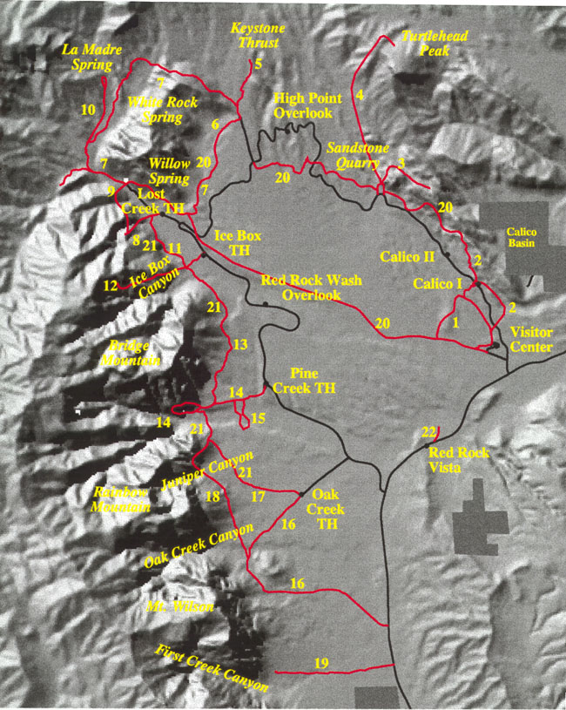

|  |  |  |  |
| --- | --- | --- | --- |
| **Trail #** | **Trail Name** | **Trail #** | **Trail Name** |
| 1 | Moenkopi Loop | 12 | Ice Box Canyon |
| 2 | Calico Hills | 13 | Dale |
| 3 | Calico Tanks | 14 | Pine Creek |
| 4 | Turtlehead Peak | 15 | Fire Ecology |
| 5 | Keystone Thrust | 16 | Oak Creek |
| 6 | White Rock - Willow Springs | 17 | Arnight |
| 7 | White Rock Loop | 18 | Knoll |
| 8 | Children's Discovery - Lost Creek | 19 | First Creek Canyon |
| 9 | Willow Spring Loop | 20 | Grand Circle Loop |
| 10 | LaMadre | 21 | Base of the Escarpment (composed of 11, 13 and 17) |