SRH Java Training Collaboration Account

## Installation of Developer Collaboration Module:

1. Open the NetBeans IDE Software.
   1. A desktop icon should be available to start the program.
   2. Access to starting the NetBeans 6.0 IDE application is also available through the Windows XP “Start Menu”.
2. Once the NetBeans 6.0 application loads…
   1. In the menu bar select:
      1. **Tools**
      2. **Plugins**
3. This will open the Plugins GUI
   1. Click on the **Installed** tab (**highlighted/ARROW red in image below**) and determine if the “Developer Collaboration Plugin” is already installed.
   2. If installed, it will appear in this list of plugins. ( **orange highlight/ARROW in image below**).
      1. If already installed skip to section titled “To create a Collaboration account:”.
      2. Otherwise continue to step 4 in order to install the developer collaboration module.

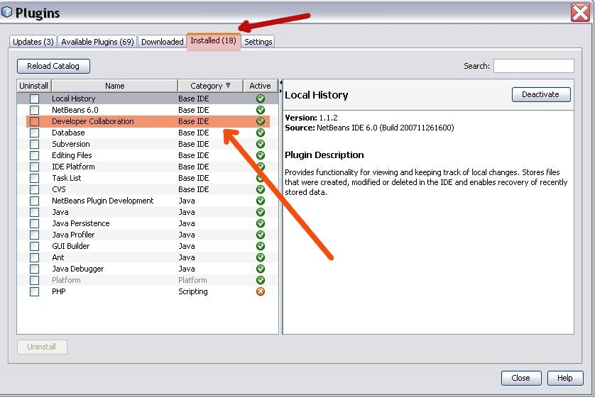

1. Installing the Developer Collaboration Module…
   1. Click on **Available Plugins** tab (**highlighted red in image below**)
      1. Scan through list to find “Developer Collaboration”
         1. Select It. (**highlighted orange in image below**)
         2. 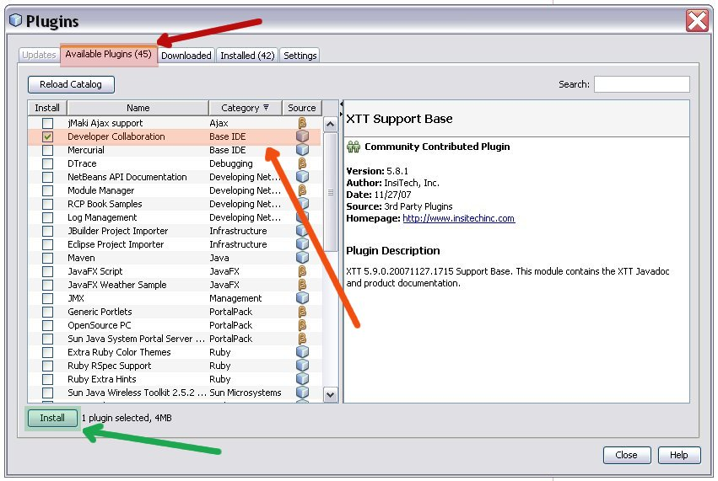Click on Install. (**highlighted green in image below**)
2. Verify Developer Collaboration plugin installation and **Click Next**.
3. Accept the license agreement and **Click Install**.
4. Wait for the update operation to complete (It will take a few minutes for the package to download & install). **Click Finish**.
5. Installation of the Developer Collaboration Module is now complete.
   1. You should have a new menu item in NetBeans called **Collaboration**.
6. You can now create a Collaboration account for the SRH Java Training.

## To create a Collaboration account:

1. From the main menu select:
   1. **Collaboration** (**highlighted red with red arrow in image**)
   2. **Login…**

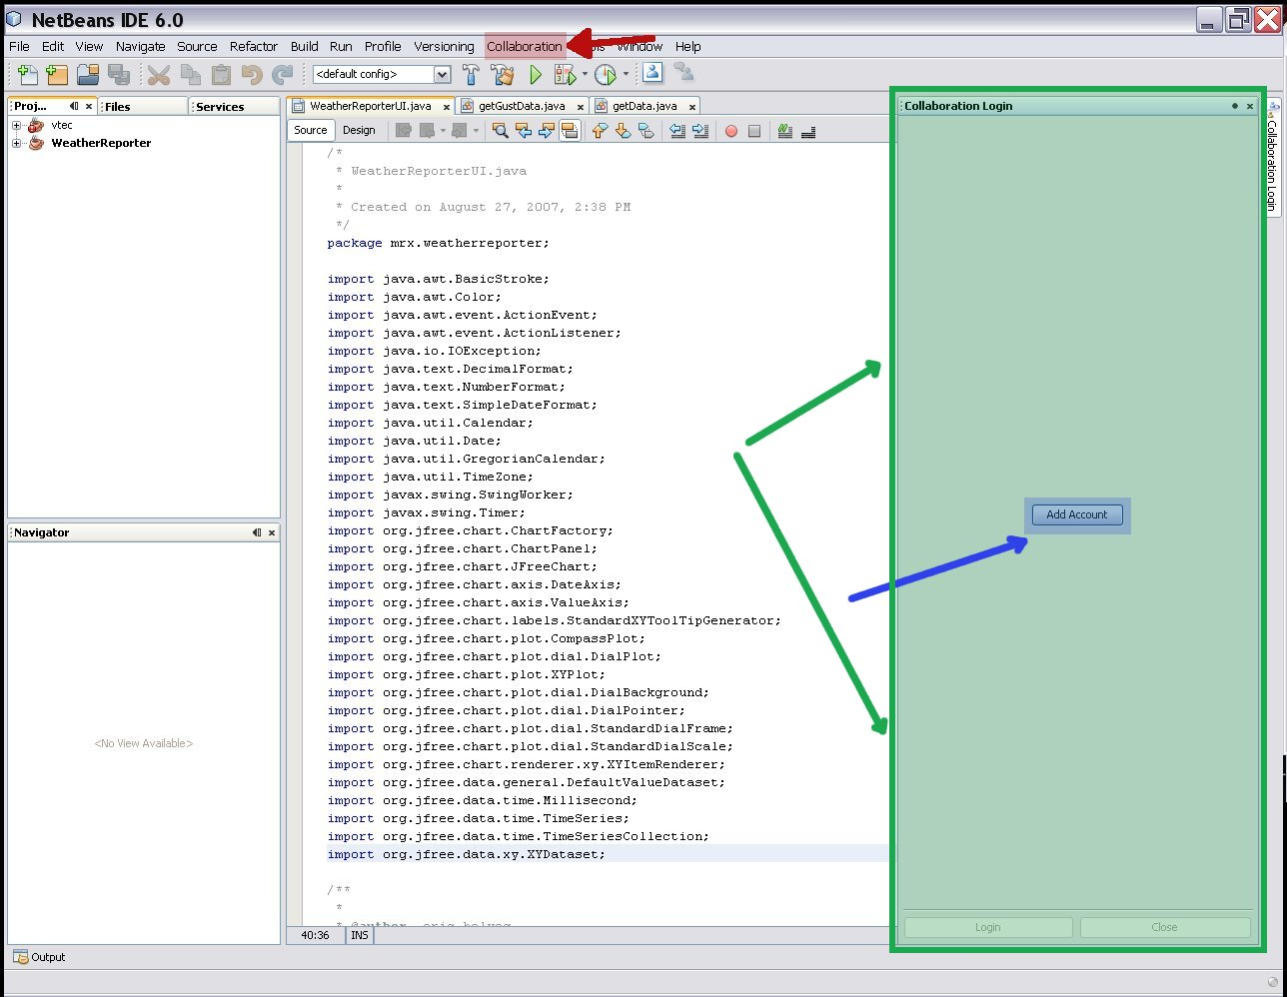

1. This will open the Collaboration Login Panel (**GREEN Highlight/ARROW in image**)
2. In the *Collaboration Login Panel*
   1. Click the **Add Accounts** link (**BLUE Highlight/ARROW**)
3. This launches the *Add Collaboration Account Wizard*, which you will use to add an account to the collaboration server.
4. There are five steps to setting up a new collaboration account in the wizard.
   1. **Step 1: Account Creation**
   2. Select Second Button: *I want to register for a new collaboration account on a different collaboration server.* (**red highlight**)
   3. 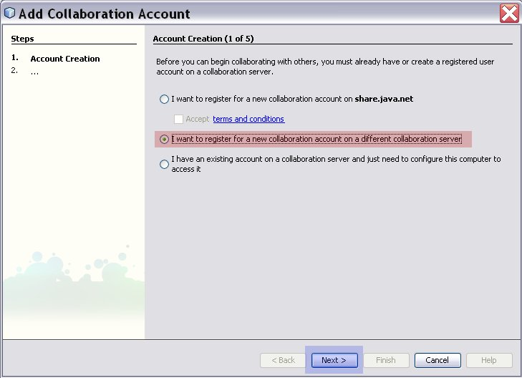**Click Next** (**blue highlight**)
5. **Step 2: Account Name**
   1. Type in the display name that will identify you online. (**red highlight**)
   2. Cannot be modified once registered. Would have to delete the account and re-create.
   3. 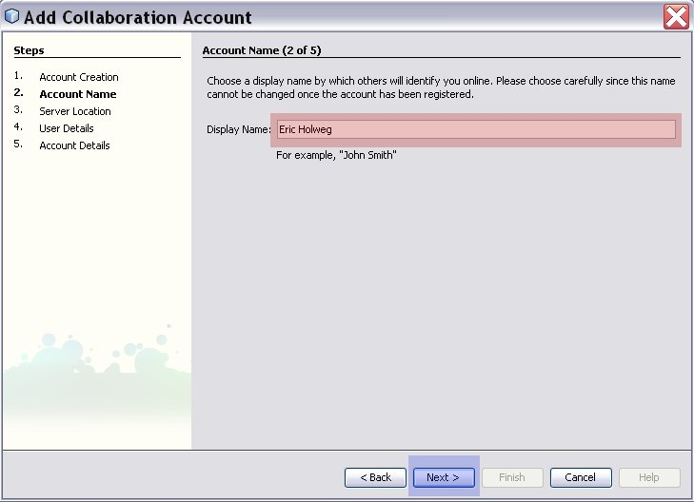**Click Next** (**blue highlight**)
6. **Step 3: Server Location**
   1. Type in the server hostname (**red highlight**):

**lucretia.srh.noaa.gov**

* 1. Ensure that button *“A proxy is not required to connect to the collaboration server (direct connection)”* is toggled on. (**orange highlight**)
  2. 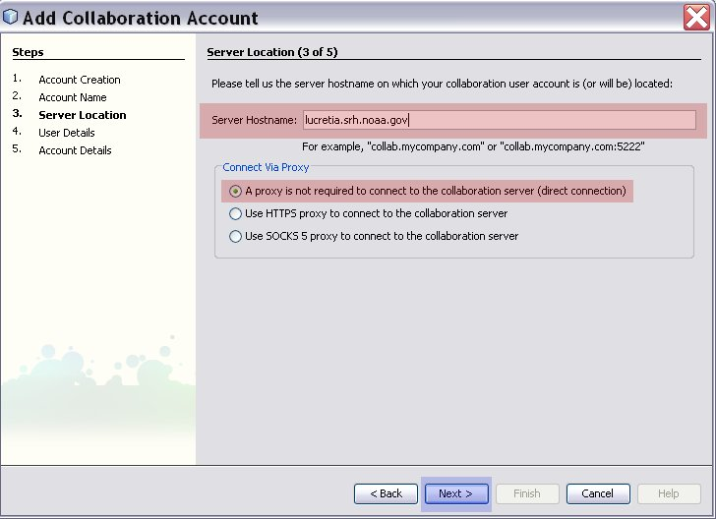**Click Next** (**blue highlight**)

1. **Step 4: User Details**
   1. Enter the details for the account. First name, last name, and email address. (**red highlight**)
   2. 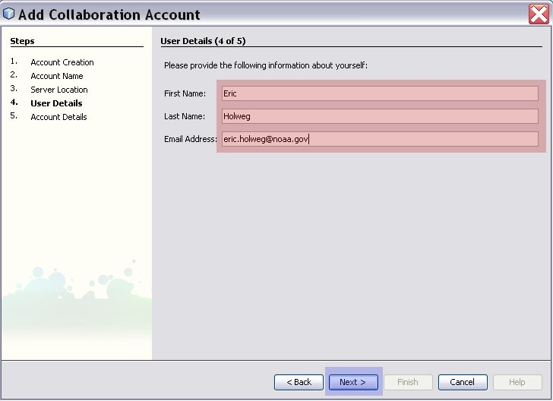**Click Next** (**blue highlight**)
2. **Step 5: Account Details**
   1. Enter the account user name and set the account password (**red highlight**)
   2. 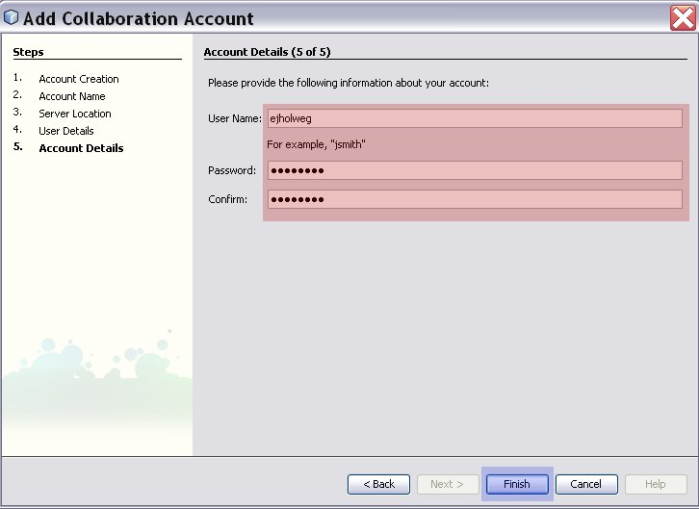Click Finish (**blue highlight**)
3. Please wait while the collaboration account details are now sent to the server and the account is established.
   1. A Pop-Up will display indicating that the collaboration account is created and ready for use.

## Login with existing Collaboration account:

With an already existing account on lucretia, simply login via the collaboration menu.

1. From the main menu select:
   1. **Collaboration (RED HIGHTLIGHT)**
   2. **Login…**
2. From the Collaboration Login Screen
   1. Ensure that your account is selected **(BLUE HIGHLIGHT)**
   2. Enter account password **(GREEN HIGHLIGHT)**
   3. 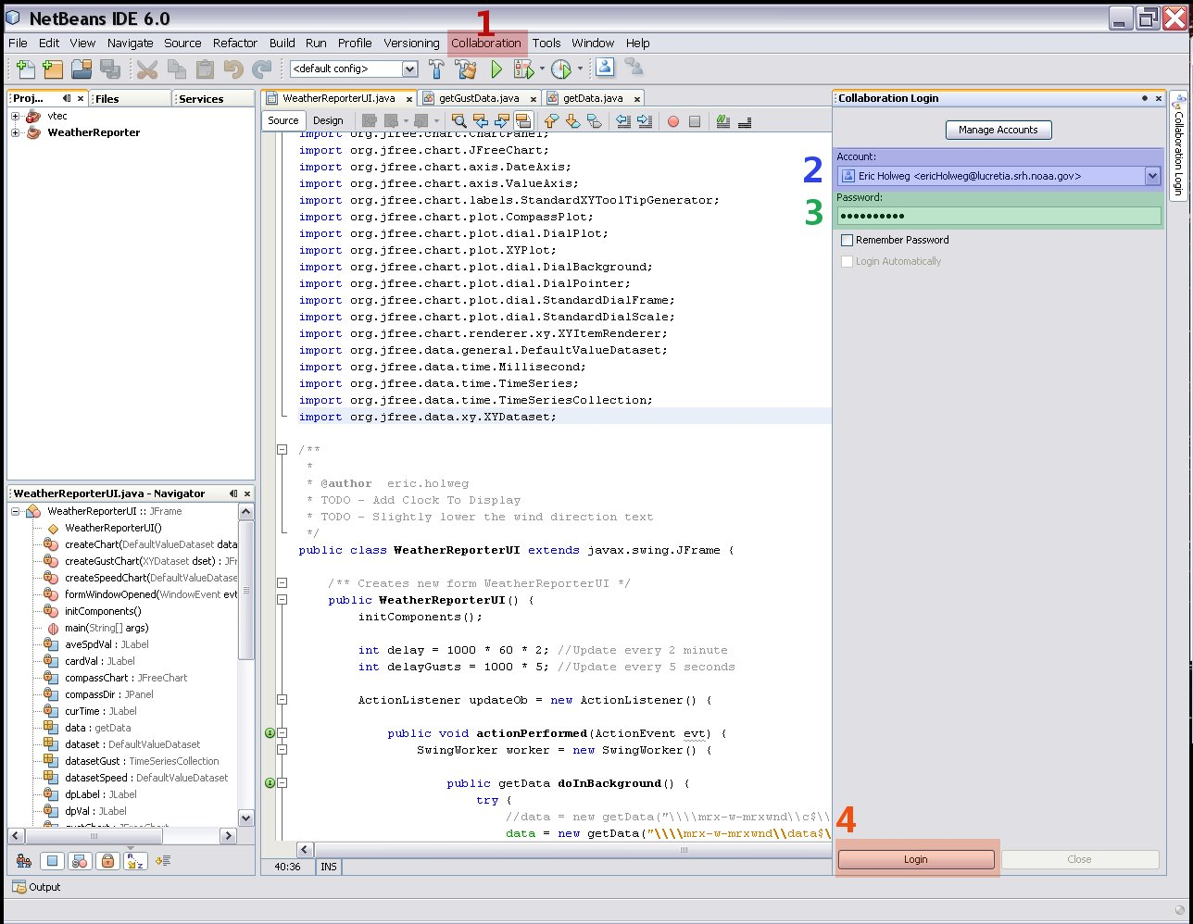Click Login **(ORANGE HIGHTLIGHT)**

## To manage and delete Collaboration accounts:

1. On the Collaboration Login panel click the Manage Accounts link found at the top of the window.
2. This opens the Account Management window.
3. Account options are displayed for each user whose accounts you manage.
4. Use this screen to change/delete account information.
   1. Changes take effect the next time the user logs in.