MRX Archiver

NWSFO Morristown TN has put together a series of crons, scripts, and small GUI’s that allow the office to store AWIPS operational data over a much larger time period than is allowed with the current baseline AWIPS AX Archiver. Prior to OB7.2, MRX was able to store nearly 25-30 days worth of AWIPS data which was readily available for recall in an operational AWIPS D2D or able to be compressed and burned to dvd/cd as is possible with the baseline AWIPS archiver.

This collection of executables used to accomplish the extended archiving was pieced together from numerous other locally and nationally developed AWIPS archiver packages and programs. Credit to those developers is given. These include CRON files and scripts from NWSFO Houston (HGX), a modified version of the baseline AWIPS archiver compression utility originally written by Paul Kirkwood of SRH, as well as use of the National baseline DVD/CD Burner utility to allow transfer of data from HDD to DVD/CD for storage or transfer to the WES.

MRX purchased twin 400 Gbyte IDE hard disk drives (HDD) installed into an existing Non-Associated AWIPS Machine (NASR). Mounting this drive space to certain machines within the AWIPS network, MRX is now able to store and view on the fly approximately 16- 24 days worth of AWIPS Archive Data while operating under OB72. The cumulative 800 Gbyte HDD used to store this AWIPS data remains at nearly 95-98% capacity with the oldest data being overwritten when space is needed to archive newer data.

**INSTALLATION PROCESS**

1. **Non Associated AWIPS machine (NASR)** 
   1. Create Data Storage Location on NASR
      1. MRX has twin 400 GB hard disk drives on NASR
      2. These HDD are mounted together on that machine as **/Archiver**
      3. Set ownership and permissions to **fxa:fxalpha** and **rwxrwxr-x** respectively for the directory **/Archiver** on the NASR box.
         1. As user root from the root directory ( **/** ) on the NASR perform the following commands:

**chown fxa:fxalpha /Archiver**

**chmod 775 /Archiver**

1. **UNPACKING FILES**
   1. Perform all commands as user fxa on dx1.
   2. Copy the zipped tar file **MRX_30Day_Archive.tar.gz** to **/data/local/**

**cp MRX_30Day_Archive.tar.gz /data/local/**

**cd /data/local/**

* 1. Unzip and untar the file **MRX_30Day_Archive.tar.gz** to expose a new directory called **MRX_30DayInstall** which contains two tar/zipped files and the install instructions in pdf, txt, and doc formats. One of these tar/zip files, **AX_Files_MRX_30.tar.gz**, contains the cron scripts and cron entries to be utilized on the AX. The other tar/zip file, **MRX_30.tar.gz**, contains the executables and scripts to be used in the mounted directory of **/data/local/**.

**tar –zxvf MRX_30Day_Archive.tar.gz**

* 1. Verify that installation directory was created correctly. Change directory into the install directory and list contents to verify correct files.

**cd /data/local/MRX_30DayInstall**

**ls**

1. **AWIPS AX Server**
   1. Add a mount point of **/data/archiver/data/** on the AX which mounts to **/Archiver** on the NASR machine where the extended archive data is stored.
      1. Edit the file **/etc/fstab** on the AX in order to add a line to mount the archive data directory on the NASR machine to the AX machine. This mount point is used to move data from the baseline AX archive storage to the NASR storage location. For MRX, the line entry added to the fstab was:

nasr1-mrx:/Archiver /data/archiver/data nfs rsize=8192,wsize=8192

* 1. Insure that system is remounted before proceeding in order to gain access to **/data/archiver/data/** locally and **/Archiver** on the NASR machine.
  2. *It is important to note that whenever the NASR machine is scheduled to be down for an extended period of time, this fstab entry on the AX should be commented out in order to avoid issues with the AX attempting to copy data to a non-existent mount point.*
  3. Once this mount point has been established. As user fxa perform the following steps on the AX processor in order to complete the setup:
     1. Change directory into /**data/archiver/data/**

***cd /data/archiver/data/***

* + 1. Copy the file **AX_Files_MRX_30.tar.gz** into **/data/archiver/data/**

***cp /data/local/MRX_30DayInstall/AX_Files_ MRX_30.tar.gz /data/archiver/data/***

* + 1. Unzip and untar AX_Files_MRX_30.tar.gz

**tar –zxvf AX_Files_MRX_30.tar.gz**

* + 1. The tar ball will explode into the directory structure specified below.

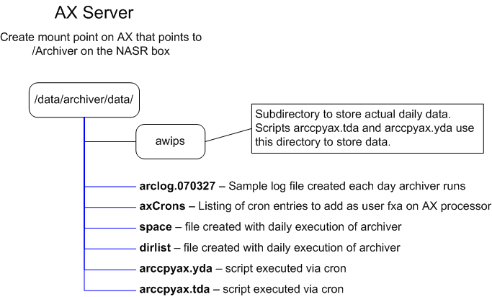

* + 1. Install CRON set as user fxa on AX
       1. CRON entries are included in file **axCrons** in the **/data/archiver/data/** directory. Either copy and paste the CRON set from the file **axCrons** in the directory **/data/archiver/data/** or type these cron entries into user fxa’s crontab and save the crontab for fxa.

**crontab –e**

1. **AWIPS DIRECTORY /data/local/** 
   1. Perform all steps below as user fxa from DX1
   2. Change directory into /**data/local/**

***cd /data/local/***

* 1. Copy the file MRX_30.tar.gz into **/data/local/**

***cp /data/local/MRX_30DayInstall/ MRX_30.tar.gz /data/local/***

* 1. Unzip and untar MRX_30.tar.gz
     1. Ensure that there is not already a directory called **/data/local/ITO/**on your AWIPS system. If so, unzip/untar of this tarball will attempt to overwrite that directory. In event that the ITO directory already exists on your system, untar/zip the file to **/tmp** and recursively copy the subdirectory **./archiveGrab/** to the **/data/local/ITO/** directory on dx1.

**tar –zxvf MRX_30.tar.gz**

* + 1. The tar ball will explode into the directory structure specified below.

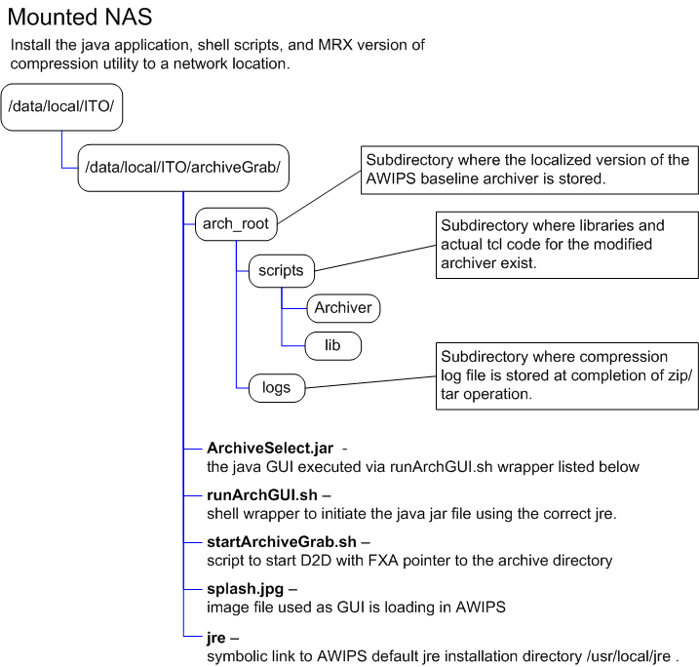

* 1. Create an entry in **/awips/fxa/data/appLauncher/local.conf** that will point to the executable needed for the MRX 30 day archiver.
     1. Edit existing **local.conf** to include:

START_RECORD

Name=MRX 30 Day Archiver

Exec=/data/local/ITO/archiveGrab/runArchGUI.sh

END_RECORD

* + 1. Ensure that this **local.conf** file is propagated to all applicable machines in the AWIPS network.

1. **AWIPS LX MACHINES:**
   1. Perform the following actions on each AWIPS LX processor that you would like to be capable of viewing the 30 day archive data on.
      1. MRX has completed this step on each baseline LX in the office. Therefore all operational LX machines have the capability to view the archived data off of the NASR box. Additionally, each of these machines can be used to run compression and dvd/cd burning of the 30 day archive data.
   2. Add a mount point of **/data/archiver/data/** on the LX which mounts to **/Archiver** on the NASR machine where the 30 days worth of data are stored.
      1. Edit the file **/etc/fstab** to add a line in order to mount the Archive data to the local LX machine. For MRX, the line entry added to the fstab was:

nasr1-mrx:/Archiver /data/archiver/data nfs rsize=8192,wsize=8192

* + 1. Insure that the system is remounted before proceeding in order to gain access to **/data/archiver/data/** locally and **/Archiver** on the NASR machine.

1. **MRX 30 Day Archiver should now be ready for use.**
   1. In order to utilize the MRX 30 Day Archiver from a configured LX machine:
   2. Bring up the AWIPS Start-Up Menu.
      1. Starting on the LX desktop:
         1. LEFT CLICK on blank area of desktop
         2. LEFT CLICK on "AWIPS start-up menu"  (second selection in the pop-up list )
         3. From the AWIPS start-up menu:
            1. LEFT CLICK on "MRX 30 Day Archiver"
            2. This will open the AWIPS Archive Select GUI
   3. Further instructions on selecting the archive date to view along with instructions to start a D2D for that data are listed under the **Directions Tab** in the GUI.
2. **REMOVING INSTALL DIRECTORY AND TAR/ZIP FILES**
   1. After successfully testing the MRX Archiver, remove the installation directory found in **/data/local/** of the AWIPS network.
      1. As user fxa change directory to /data/local and remove the install directory.

**cd /data/local**

**rm –rf ./*MRX_30DayInstall***

* 1. While still in **/data/local/ ,** remove the application tar/zip file on **/data/local/**

***rm –rf ./MRX_30.tar.gz***

* 1. Remove the tar/zip file **AX_Files_MRX_30.tar.gz** from the mounted directory of **/data/archiver/data .** 
     1. As user fxa from a machine with mounted access to **/data/archiver/data** change directory to **/data/archiver/data** and remove the tar/zip AX files.
        1. This could be the AX, or any of the LX workstations set up to mount this directory.

**cd /data/archiver/data**

**rm –rf AX_Files_MRX_30.tar.gz**

1. **CONTACT INFORMATION**
   1. Please contact Eric Holweg, MRX ITO at:

**email address:** [eric.holweg@noaa.gov](mailto:eric.holweg@noaa.gov)

**phone:** 423.586.3771

with any further questions, comments, concerns, or feedback on this application.