Datasheet


New York ∙ USA ∙ blackoakeng.com ∙ (347) 467-0912

BlueJay nRF54L15 MultiBoard
with internationally certified BLE 6.0
Part number BE-BLUJ
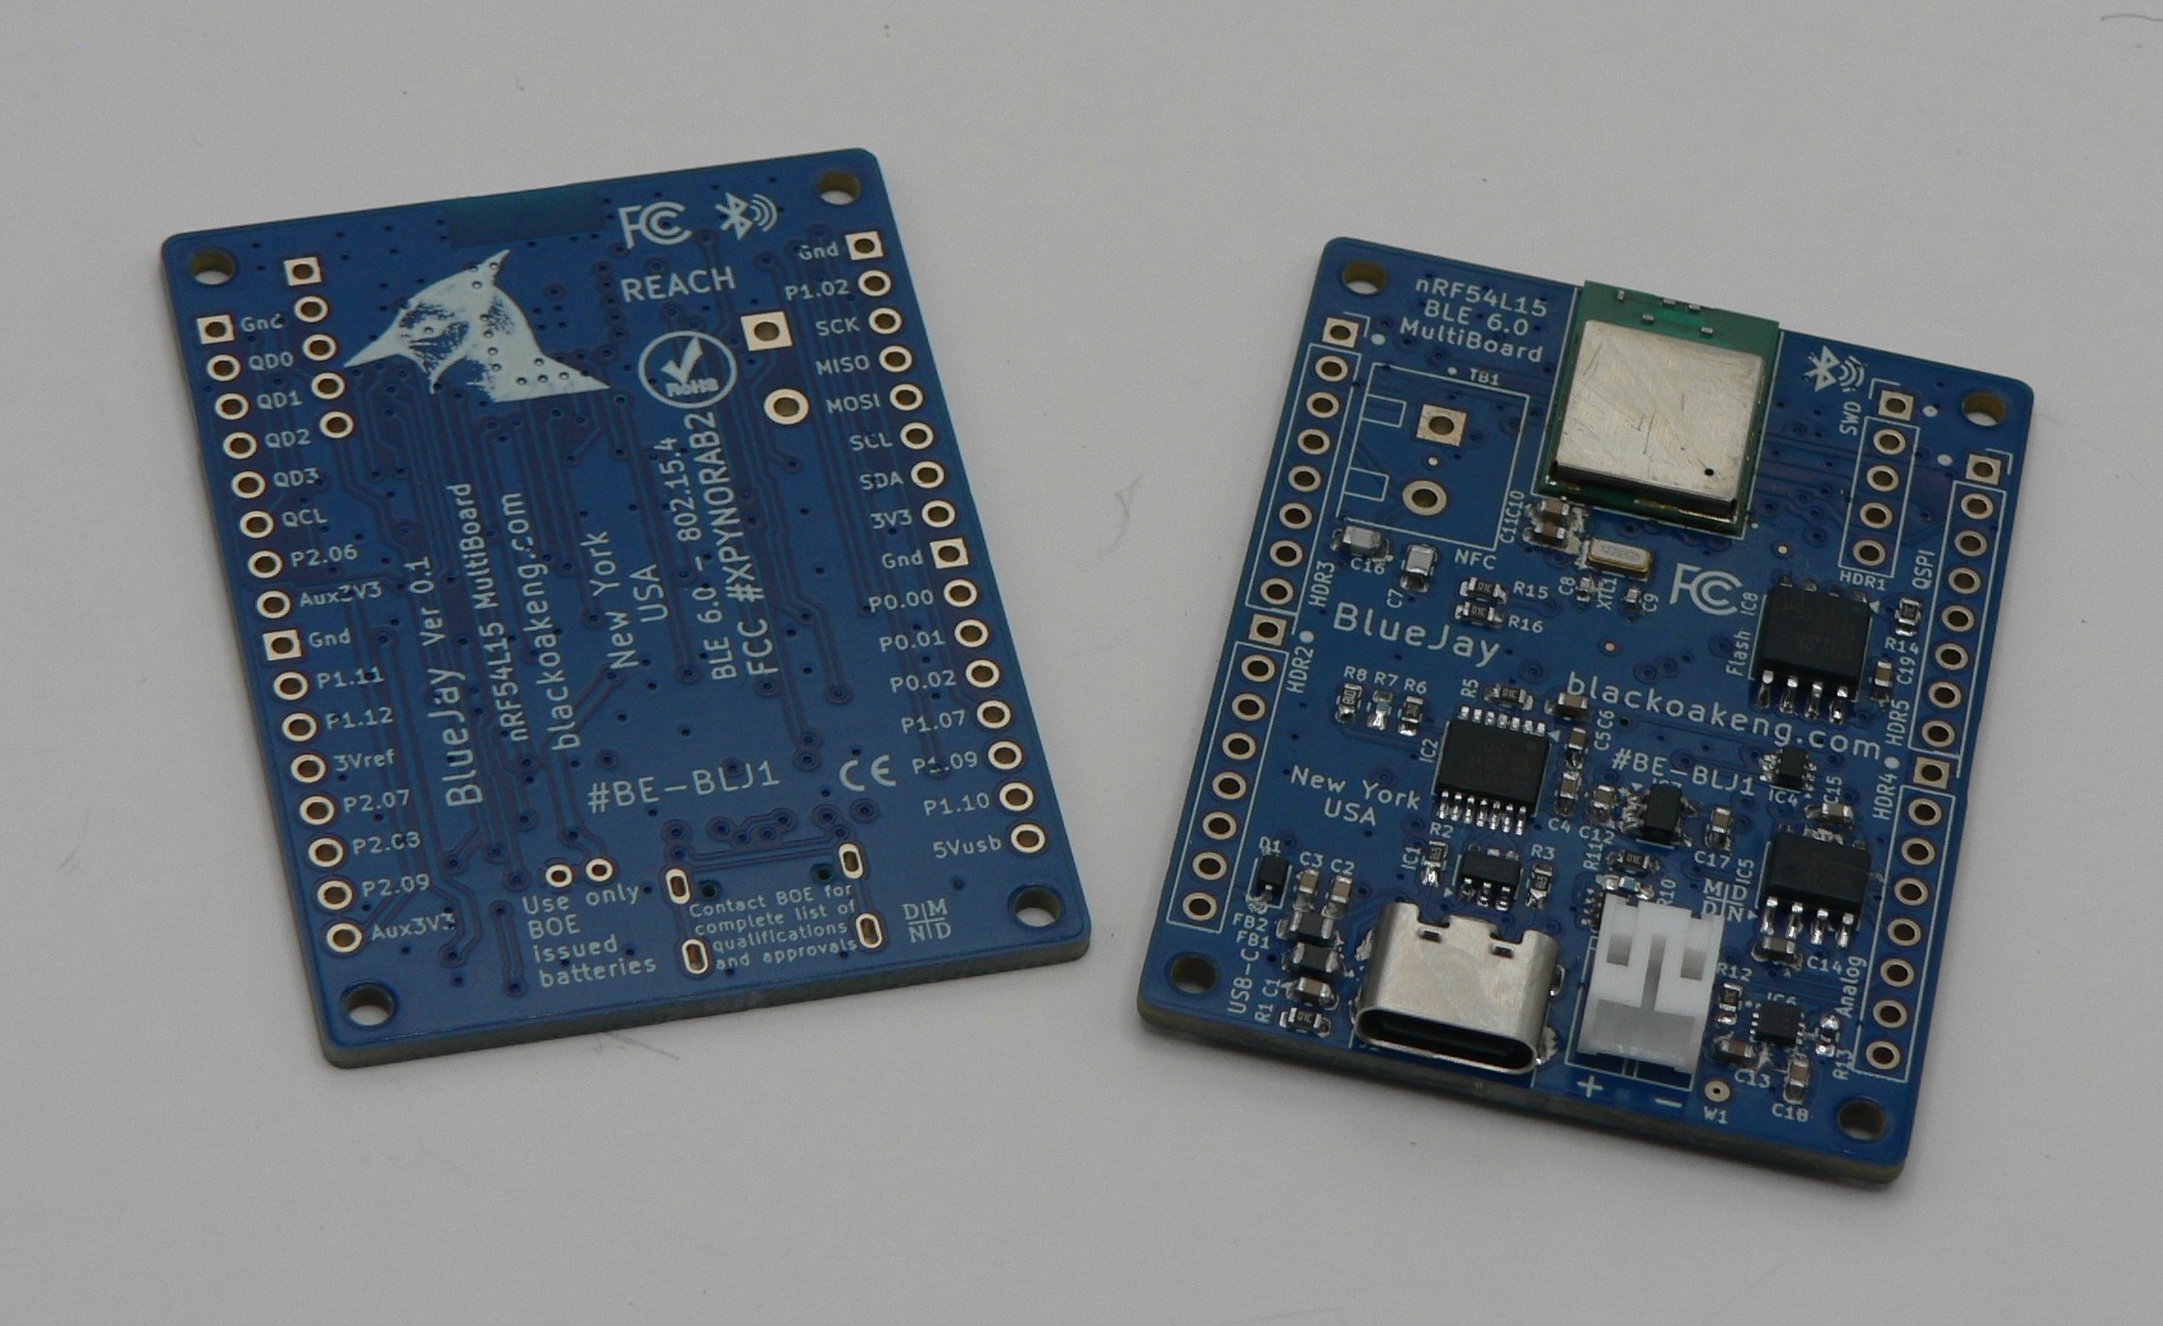
Version 1.2
Description. The Black Oak Engineering (BOE) BlueJay nRF54L15 MultiBoard (#BE-BLUJ) goes beyond a typical eval or demo board. It is an internationally certified BLE 6.0 Single Board Computer (SBC) designed to take on many jobs. It also makes a good development tool. It is compact, but still large enough to be useful. It is based on the popular and widely available extreme-low-power Nordic Semiconductor nRF54L15 SoC, which in turn is based upon the 128 MHz dual ARM Cortex M33 / RISC V 32-bit processors. BlueJay has a wide operating temperature range of -40 to +85 °C (-40 to +185 °F). It lends itself well to the development of systems for data acquisition, user interface, AI/ML/Edge, IOT, automation, and OEM integration.
BlueJay is RF certified to operate in all major world jurisdictions, including US FCC Part 15.
BlueJay may be operated from a standard rechargeable battery, available as an option, or from a 5V source, including USB. The design is modular. There are complete breakouts on 100 mil centers. The user may attach a variety of headers / sockets. There are several power options and general purpose IO. There are four M2 mounting holes. The design is completely open, so you may easily design your own attaching board. Standard boards exist for analog data acquisition and various sensors.
A Board Support Package (BSP) and a complete set of various tested drivers are available at our GitHub. BOE releases source code and other collateral under an attached MIT license.
BlueJay has these built-in components:
- Built-in Vivaldi antenna. Operation at 2.4 GHz. Transmit power 7 dBm. Receive sensitivity -102 dBm.
- Range typical, 100+ m, open.
- High efficiency synchronous 3.3 V / 600 mA voltage regulator.
- May be powered from battery or USB.
- SWD interface.
- Stable primary oscillator.
- 32768 Hz secondary oscillator for RTC.
- Multiple fast QSPI, SPI, & IIC.
- 8Mx8 Flash memory on QSPI.
- NFC antenna breakout with standard FFC.
- All IO exposed on 100 mil headers.
- Multiple power options exposed.
- USB 2.0 Device.
- EMI protections.
- Diagnostic LED.
- Peripherals are power switched to save power.
- USB only draws power while connected.
- Battery self-check.
- Made in the USA.

BlueJay may be operated from a standard lithium polymer battery, which BlueJay charges from its power source (USB-C or a header connection).
nRF54L15 SoC specifications (partial)
- Dual ARM Cortex-M33 + RISC V.
- Includes Floating Point Unit, DSP, and CryptoCell-312.
- Integral antenna.
- 1.5 MB Flash, 256 KB SRAM,
- Clock 128 MHz (both).
- Supports BLE 6.0, Channel Sounding, LE Audio, 802.15.4-2020 (Thread, Matter, Zigbee).
- ARM TrustZone.
- Easily programmable in Nordic Zephyr ecosystems.
- 4 kB caches.
- 12 bit ADC.
- Low power modes.

BlueJay PCBA specifications
- 51 × 34 mm (2.0 × 1.3 inches).
- 4× 2-56 (or M2) mounting holes.
- Mass = 8.5 g (0.3 oz).

BOE is continuously improving. We also strive to keep one step ahead of procurement shortfalls. We will deliver to you the latest hardware version possible. In some cases specifications will change.
Environmental
- Temperature. -40 to +85 °C (-40 to +185 °F), excluding battery option.
- Humidity / water exposure. The PCBA does not include a protective enclosure. Nor is it conformally coated. Condensing humidity and water exposure must be completely avoided.

Approvals & Compliance
- RoHS.
- REACH.
- California Prop 65.
Value Added Design. Want to use the BlueJay in a new project or OEM application, but need a little assistance? Not a problem. BOE contracts regularly with end users for value added design.

Warranty Policy. Any instrument ordered from BOE may be returned for full refund, less shipping costs, within 30 days of delivery, provided that the instrument has not, in the opinion of BOE been damaged or misused. An RMA number is required in all cases. See our Standard Terms & Conditions – Instruments for more details.

BOE reserves the right to make changes to these specifications as it deems necessary. All technical information contained herein is as accurate as possible; however BOE shall not be held responsible for any errors or for product use, nor for any infringements upon the rights of others which may result from its use. BOE products are not to be used in life support or safety critical applications.
All BOE products are designed and manufactured in the USA.

