POC Success Story

Project Title
Microsoft Copilot – AI Workspace Assistant (Powered by Ollama)

The Problem
Modern workplaces rely heavily on documents such as reports, proposals, meeting notes, and business emails. Employees often spend significant time reading lengthy documents, drafting emails, extracting important action items, and searching for specific information. These repetitive tasks reduce productivity and delay decision-making.
Many AI productivity tools are cloud-based and require paid subscriptions or internet connectivity, making them unsuitable for organizations that need local, private, or cost-effective AI solutions.

Our Solution
We developed Microsoft Copilot – AI Workspace Assistant, a Proof of Concept (PoC) that demonstrates how a local Large Language Model (LLM) can improve workplace productivity.
The application allows users to upload documents (PDF, DOCX, and TXT), ask questions about the uploaded content, generate summaries, rewrite text professionally, draft business emails, extract action items, and translate text into different languages.
The application is powered entirely by Ollama, enabling AI processing on the user's local machine without relying on external cloud APIs.
The solution provides an intuitive chat interface inspired by Microsoft Copilot, making AI assistance easily accessible for everyday office tasks.

Solution Architecture
User
│
Microsoft Copilot Web UI
│
HTML • CSS • JavaScript
│
Flask Backend
┌──────────┴──────────┐
│ │ │
Document Processing Ollama API

(PDF / DOCX / TXT) (Llama / Qwen Model)
│ │ │
└──────────┬──────────┘
AI Generated Response
│
Display to User

- User uploads a document.
- Backend extracts text from the document.
- The extracted content is stored temporarily in memory.
- User asks a question or selects a quick action.
- Flask sends the prompt and document context to Ollama.
- The LLM generates an intelligent response.
- The response is displayed in the chat interface.

Deliverables
The project includes the following deliverables:
- Complete Source Code
- Project Documentation
- Microsoft Copilot-inspired Web Application
- AI-powered Chat Interface
- Document Upload Feature
- Document Summarization
- AI Question Answering
- Email Generation
- Text Rewriting
- Action Item Extraction
- Translation Feature
- Demo Video
- POC Success Story

Tech Stack
Frontend
- HTML5
- CSS3
- JavaScript
Backend
- Python
- Flask
- Flask-CORS
AI
- Ollama
- Qwen 2.5 / Llama 3.1
Libraries
- Requests
- PyPDF
- python-docx
Development Tools
- VS Code
- Git
- GitHub

Business Impact
This solution demonstrates how AI assistants can improve workplace productivity while maintaining privacy through local AI execution.
Potential business benefits include:
- Reduces document reading time through automatic summarization.
- Helps employees quickly understand lengthy reports.
- Automates email drafting for professional communication.
- Identifies action items from meeting notes and reports.
- Improves employee productivity by reducing repetitive tasks.
- Enables AI-powered document search and question answering.
- Supports organizations requiring offline or privacy-focused AI solutions.
- Eliminates dependency on paid cloud AI services by using locally hosted LLMs through Ollama.
- Can be extended into enterprise knowledge management systems and internal AI assistants.
Industries that can benefit include:
- IT Services
- Education
- Healthcare
- Banking
- Legal Services
- Government Organizations
- Corporate Offices
- Consulting Firms

Project Snapshots (Minimum 5 Pictures)
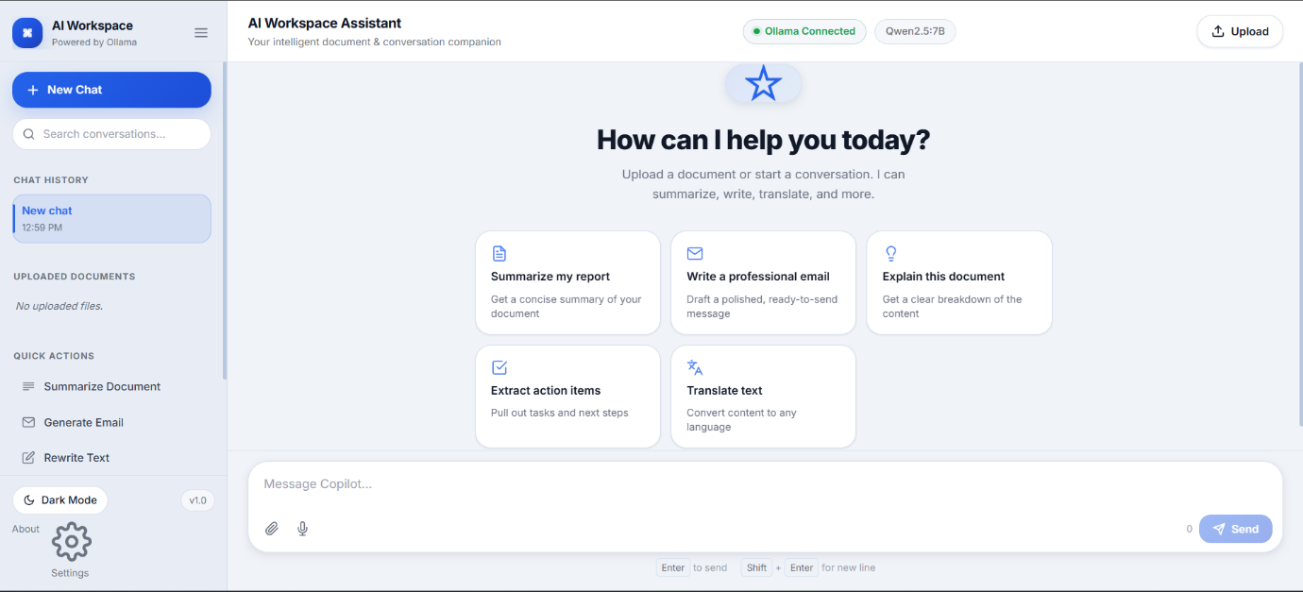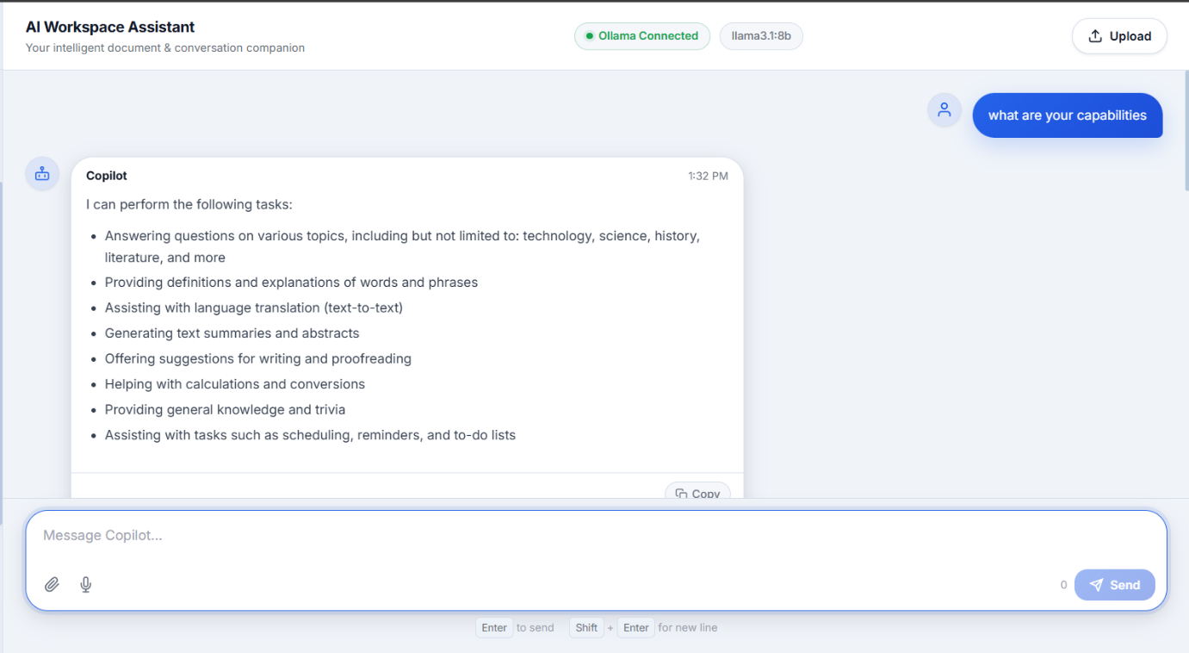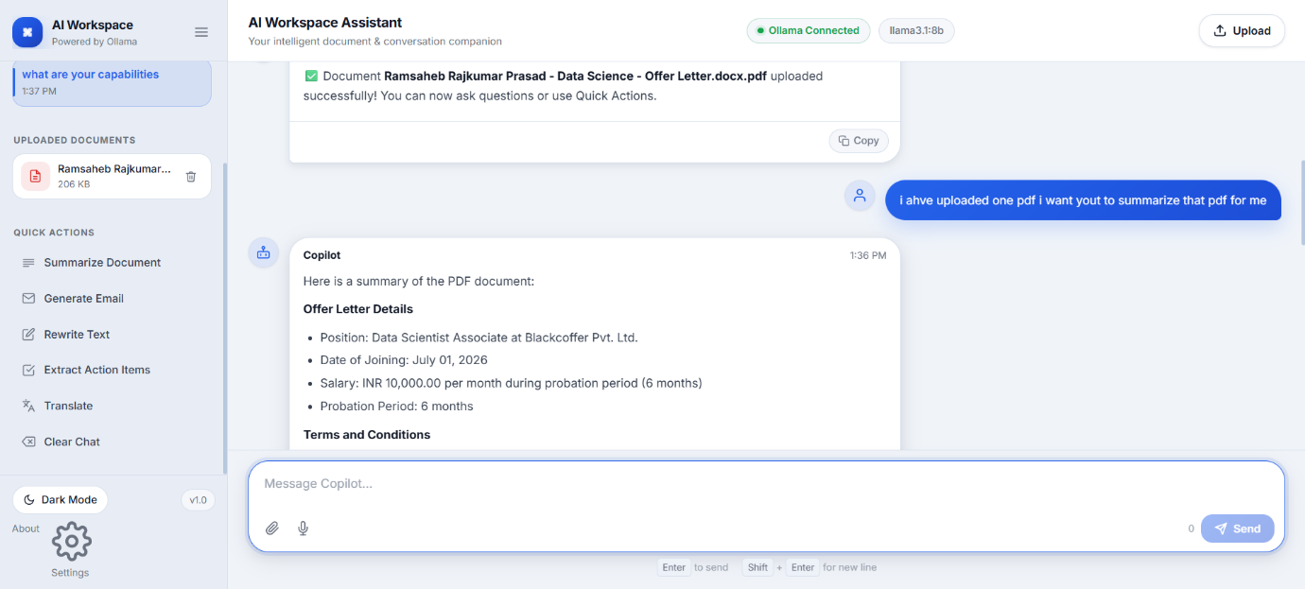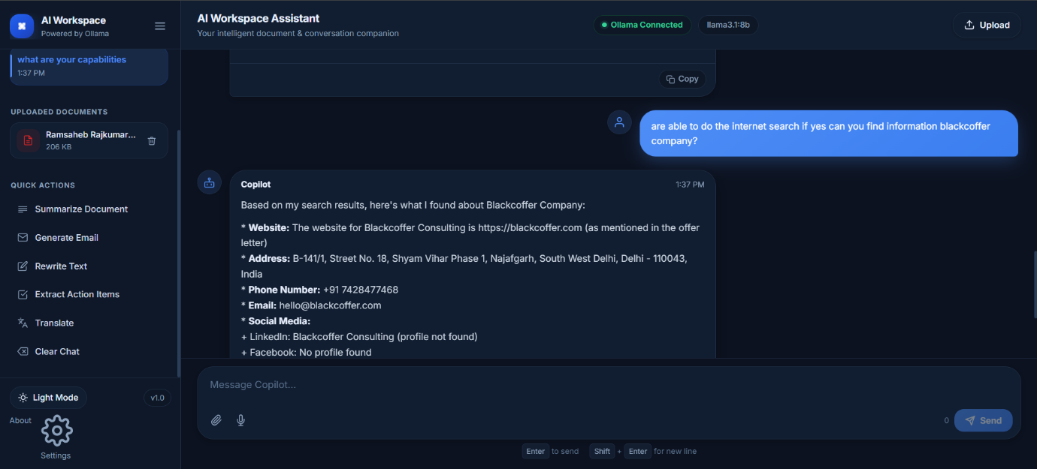

Project URL
https://github.com/blackoffer-ramsaheb/microsoft-copilot

Project Video
https://drive.google.com/file/d/1fZZVfi6a_Trybgzkh4L7GPfqEvIqpD6Z/view?usp=sharing

