Formula 1 Points and Finishing Position — What We Learn From Different Predictive Methodologies and Model Validation Techniques

Progress and Learnings So Far:
Accounting for the statistical shortcomings of the dataset requires careful consideration of distribution behavior, feature engineering (or lack thereof), and beyond. I’ve cleaned the data, implemented pre-race feature engineering, and assessed relationships between variables.
So far, I’ve learned a lot about the structure and behavior of Formula 1 Racing. But the question still remains — how reliable are these insights? In what ways can I validate outcomes and achieve optimal model stability given constraints of this project? In other words, how can I be most confident in my predictions and insights, while paving the way to continued learnings and model performance? Here are the facts so far:
- Race performance is governed largely by “tail events”, or high impact events such as safety cars, unexpected DNF, weather, etc., implying strong volatility.
- Predictive signal is concentrated amongst a handful of underlying driver and constructor strength dimensions. Engineered features don’t necessarily offer anything new and exciting about the competitive reality beyond what we already know from the raw data. Overfitting becomes a risk in the presence of feature redundancy.
- Independent features need to be collapsed into a cleaner representation to avoid instability in model results, attributable to arbitration between redundant inputs.
- PCA supports the notion that driver/constructor performance can be explained largely by latent factors like driver skill, constructor performance, and race setup. Interactions between these variables are likely non-linear, non-binary, and therefore performance is better represented by tree based models rather than strictly linear ones.
- Wet races don’t behave in a way that is structurally different from dry races. Instead of adding new signal or explainability, they simply enhance uncertainty, or variability, of race outcomes.
- Bias is introduced if we do not encode circuit anomalies and differences between point scoring regimes. Tracks should not be treated as entirely unique, and reducing dimensionality of circuit characteristics can capture a majority of the variance. Points across eras should be regularized in order to be a meaningful datapoint.

Refining the Question
With these learnings, I am in a better position to elaborate on the following two questions:
How stable are modeling results once I account for resampling, time series validation, and feature sensitivity?
and
Does the cleaned, transformed, and reduced feature set actually contribute to improved model reliability versus the original, raw dataset?

Designing the Final Modeling Dataset
PCA gave me an unsupervised way to distill the principal components of the data, ultimately reducing dimensionality and noise. By putting principal components to work and using them as model inputs, it unlocks potentially enhanced predictive insights. Comparing these results across modeling datasets unlocks a whole new level of insight.
By investigating finish_position and target_points as the dependent variables, we get a glimpse into both continuous and binary outcomes, and how they change with enhanced methodologies and refined vs. original features. Different target variables, despite using the same validation framework, are susceptible to different statistical challenges from the underlying data structure.
Using Ridge Regression, PCR, and XGBoost, I can more accurately compare original variables with shrinkage, to latent components from predictors, to non-linear/more flexible model solutions. With resampling, PCA, cross validation, and modeling for multiple targets, it becomes clear that the original data isn’t as much “information overload” as earlier analysis suggested. In order to refine the dataset so that it truly represents the population of race characteristics and outcomes, there is more work to do in scrubbing, manipulating, and enhancing the data.

Building the Scalable Pipeline

Resampling Methods and Cross Validation
In addition to the resampling methods, I also evaluated classical statistical model assessment criteria such as AIC, BIC, adjusted R² and Mallows’ Cp. In measuring these theoretical indicators against empirical validation, I found that the original feature set is deemed superior by both methods, but for different reasons.
Penalizing the number of predictors did not make meaningful improvements to model quality according to theoretical criteria. Similarly, empirical validation methods reveal that refining the dataset reduces multicollinearity, but removes relevant signal from the model. While we sacrifice interpretability by relying on the original dataset, this also paves the way for future analysis of additional data points, interaction effects, and beyond.

Rolling Origin Validation
Rolling origin validation provides a way to assess the data in a time-aware fashion. This is key for illustrating different eras of racing, as well as point scoring regime shifts throughout history.
Rolling origin validation revealed that interpretability improved after refining the dataset. Reducing multicollinearity with PCA boils down to the most meaningful features. Even though this simplifies the model and eliminates perceived redundancy, we lost meaningful signal by using refined features in our dataset rather than the original modeling set. This proves that redundancy is not just noise, it is meaningful predictive signal not currently captured in our dataset. In reality, there are untapped ways to capture this expression of competitive strength.
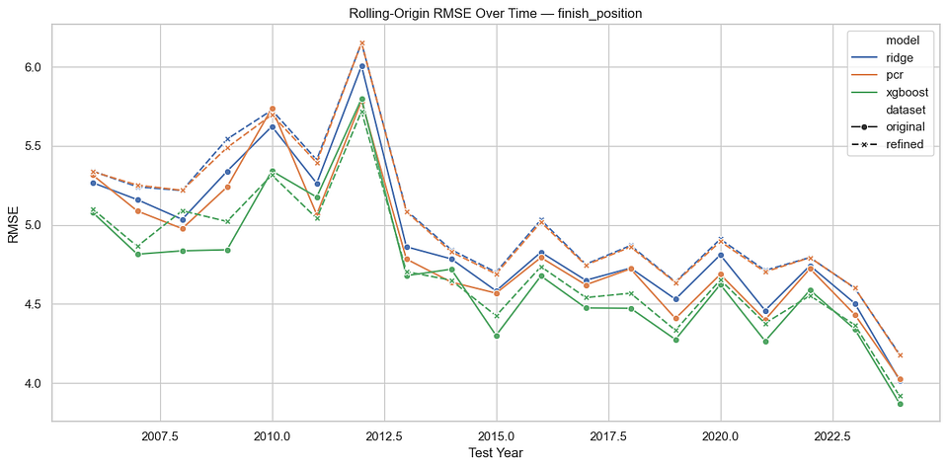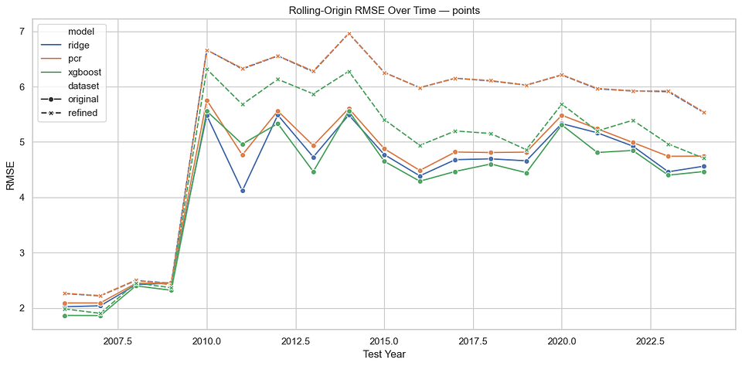

Train/Test Split
While rolling validation gives us an idea of model stability across different windows, it is also worthwhile to assess how model performance changes with respect to varied train/test splits. The points plot errors are far more unstable than the finish position errors as we can see from the sharper spikes, which discount reliability of conclusions drawn from a single train/test split.
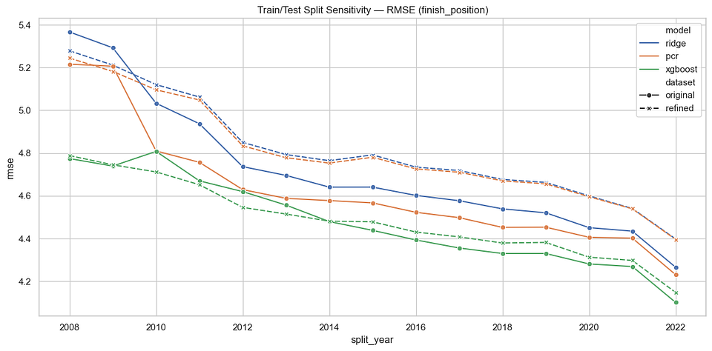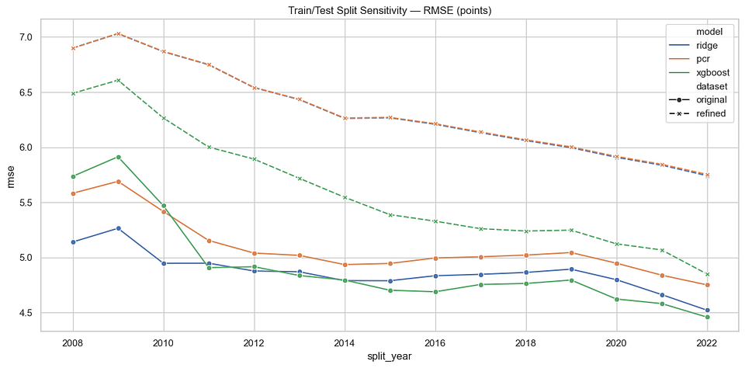
If shuffling the features of the original dataset degrades model performance, permutation importance
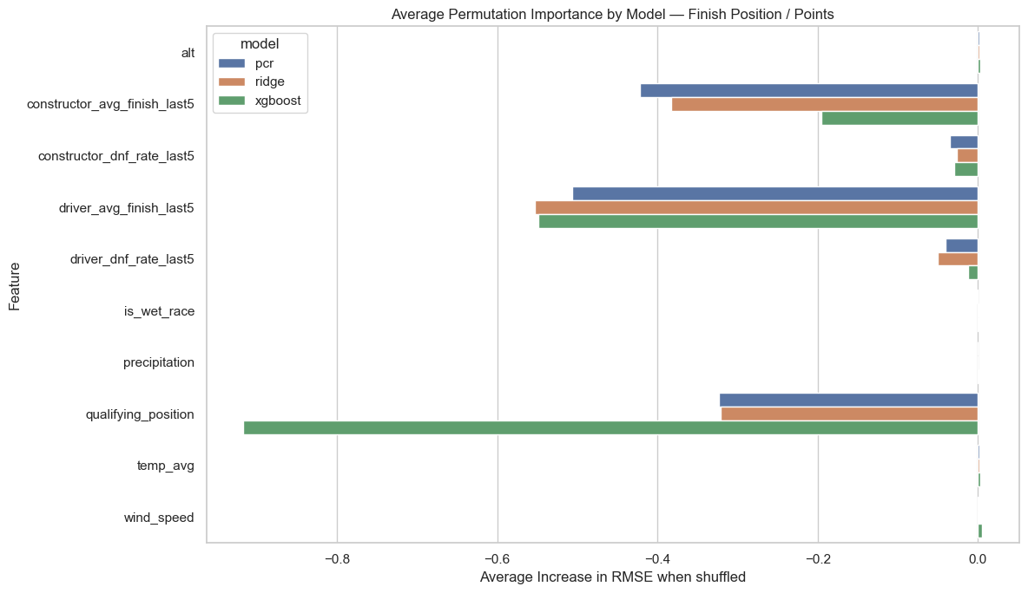
Classical statistical criteria and cross validation outcomes are in agreement with one another — the original dataset opens the door to stronger model conclusions than the refined set. The breadth of different assumptions between classical and CV serve to reinforce how confident we can be in the conclusions drawn from these models.

Robustness and Interpretability
Interpreting the model depends on values of RMSE, MAE, Median Absolute Error, R², bias (average residual), explained variance, and lastly, Spearman rank correlation.
Robustness helps us to hold more conviction in our decision making framework for which model to use. Comparing these metrics across models elaborates on different outcome definitions, and how they contribute to the accuracy of model conclusions. To quantify and explain why some models perform better than others, I expanded on the original question of which model performs best. Drilling this overarching question down to:
How do different targets behave under the same validation framework?
What happens when I model with hand-selected features vs principal components?
What is the difference between unsupervised structure discovery and supervised prediction?
Rolling Origin Validation ensured that model performance is stable over time, and outcomes are more reliably assessed by looking at the feature set and choice of dependent variable.
Finish position performed much more consistently in the models and validation, with XGBoost being the most performant on the original dataset rather than the refined features one. The all-powerful bias-variance tradeoff is in full gear as it explains how a feature dense set may have multicollinearity issues, but not all features should be treated as redundant and noisy.
Points were a bit of a different story — rolling validation revealed significantly higher bias and variance amongst this target. This implies a shortcoming in this model’s ability to predict magnitudes of outcomes. While ranking points is more reliable, precisely estimating points falls short due to nonlinearity and potentially era-dependent entropy among points values across drivers and teams.
Ultimately, this is consistent with the precedent in statistical modeling that cleaner model doesn’t always lead to stronger predictability.
This means that our dataset essentially has “blind spots”, meaning that it isn’t fully representative of the systems weaving the tapestry of a team/driver’s race performance.
From this, new questions arise — without increasing noise or losing predictive accuracy, what other ways can we enhance our dataset to better capture the environment and circumstances under which these outcomes take place?

Comparing Performance Between Refined and Original Datasets
Pruning out seemingly redundant features based on PCA, correlation analysis, and Variance Inflation Factors (VIF) didn’t provide the model improvement I had hoped for. What it revealed instead, is that redundancy is simply an illusion of noise, and that real structure exists in the systems of F1. Without accounting for this structure, we lose confidence in our predictions, and need to identify additional parts of the equation.
Across both targets, XGBoost is the clear winner, solidifying the importance of nonlinear relationships within the data. PCR ultimately does not perform well regardless of whether we want to predict points or finish position, and independently of dimensionality within the data. Ridge regression is slightly more performant when predicting points, but is roughly the same as PCR for finish position predictions. This indicates that PCA reveals useful latent structure, but this alone isnt enough for optimal prediction. For more accuracy and reliability in our predictions, we need to either change or enhance the dataset.
Z~

