**CPE341 Computer Networks (2/2014)**

**Project I Report**

**File Transfer Protocol**

**Group Member:**

1. Thanasit Yiamwinya ID: 55070503417
2. Phanomphorn Kanyawongha ID: 55070503430
3. Wipada Waisaya ID: 55070503444
4. Wasin Sirisuppinyo ID: 55070503470
5. **Flowchart**
   1. Starting server

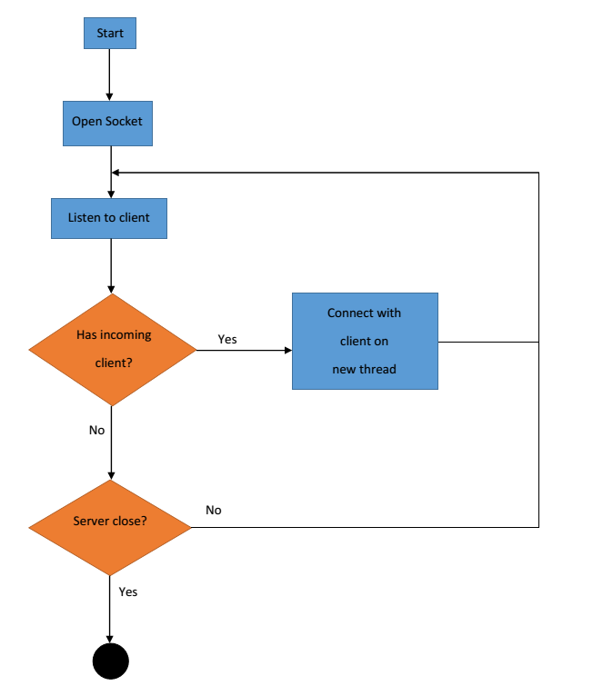

* 1. Server command execution

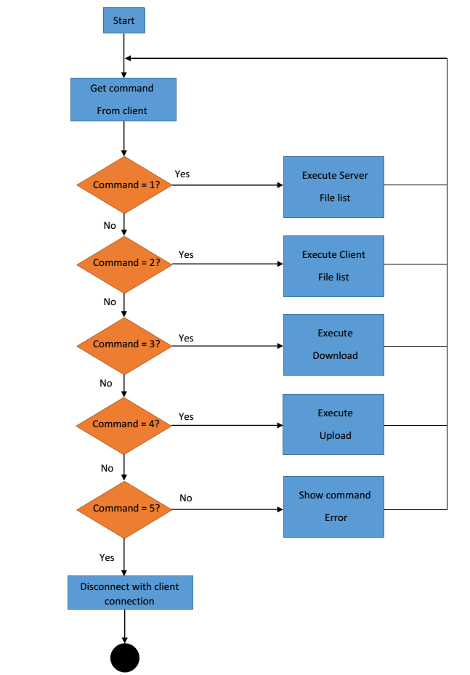

* 1. Client command execution

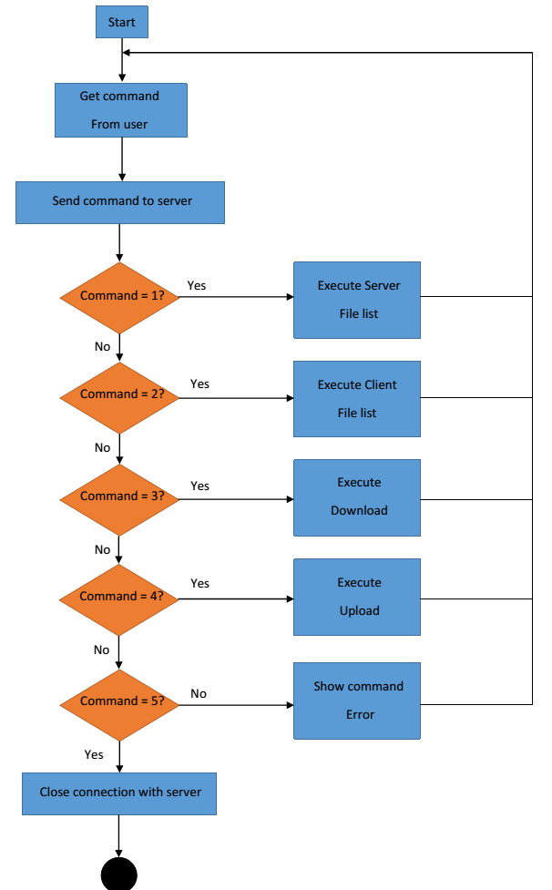

* 1. Server file list execution

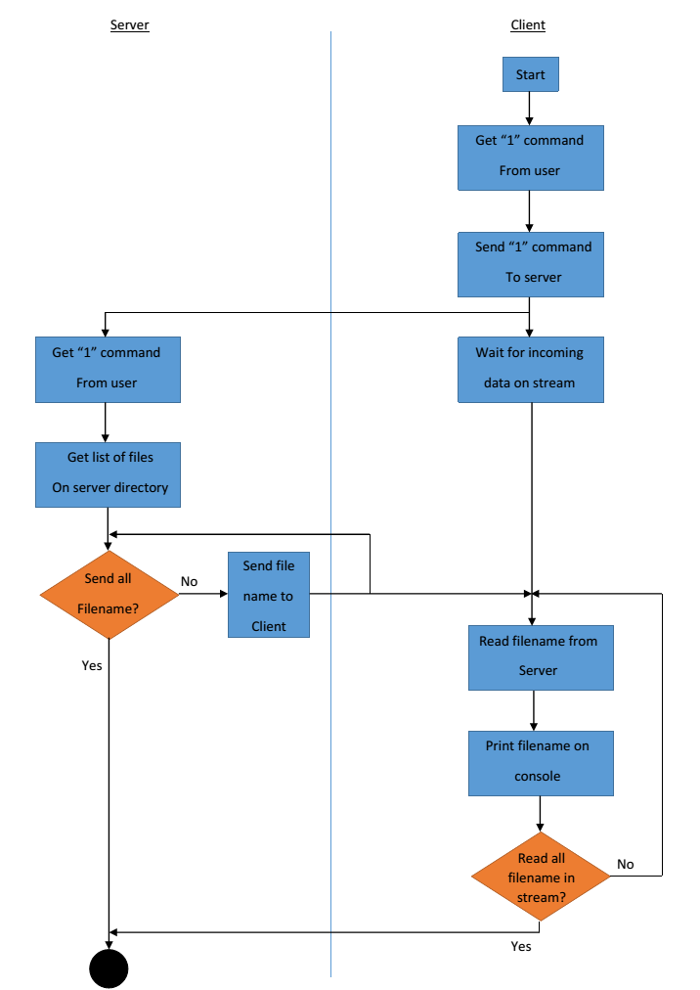

* 1. Client file list execution

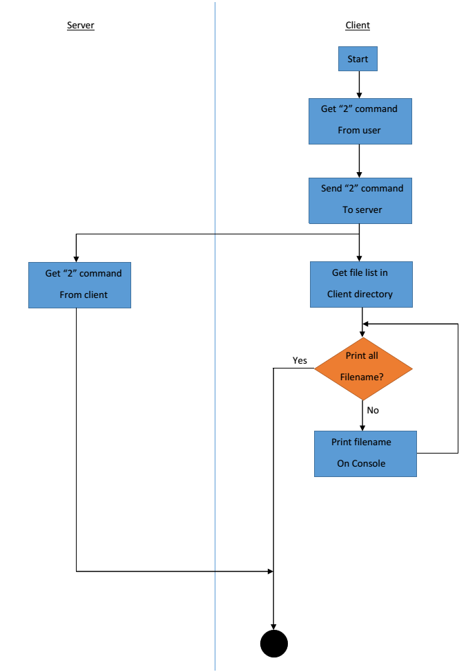

* 1. Download Execution

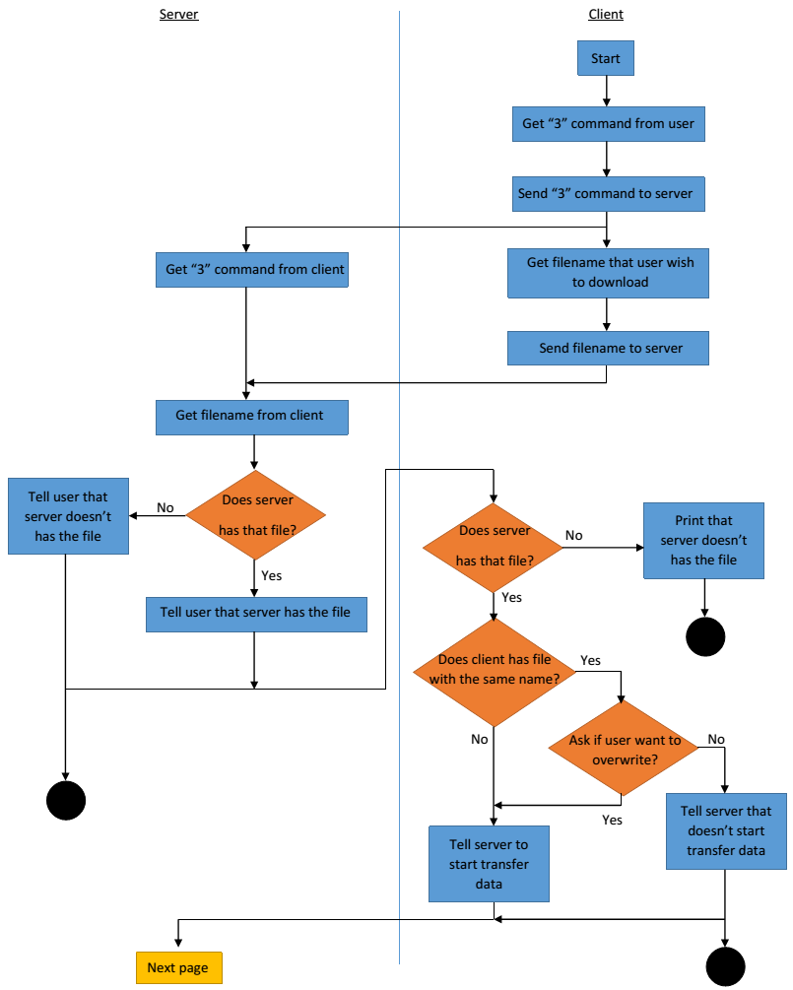

Download execution (cont.)

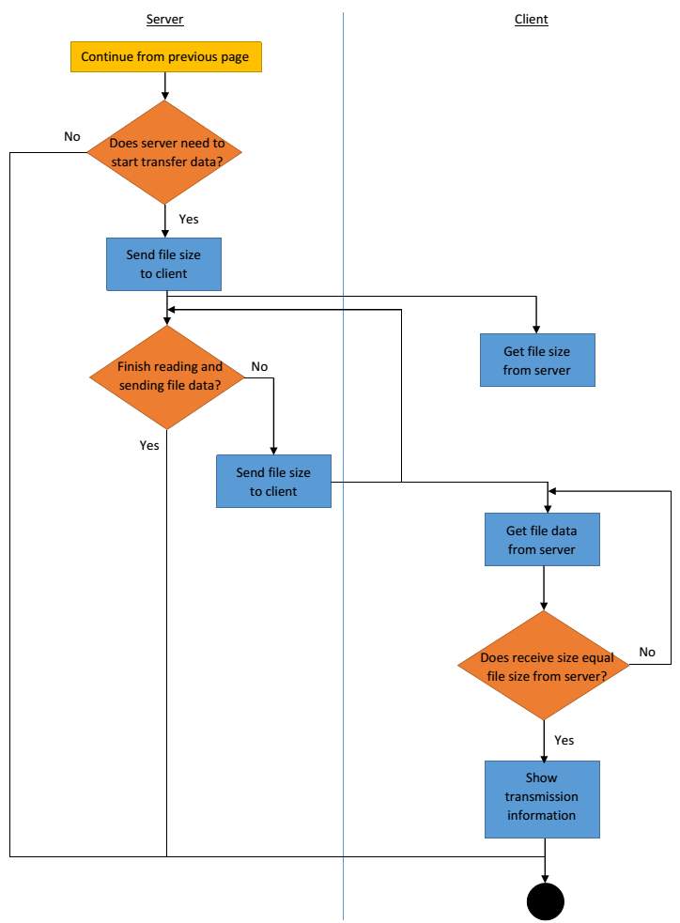

* 1. Upload Execution

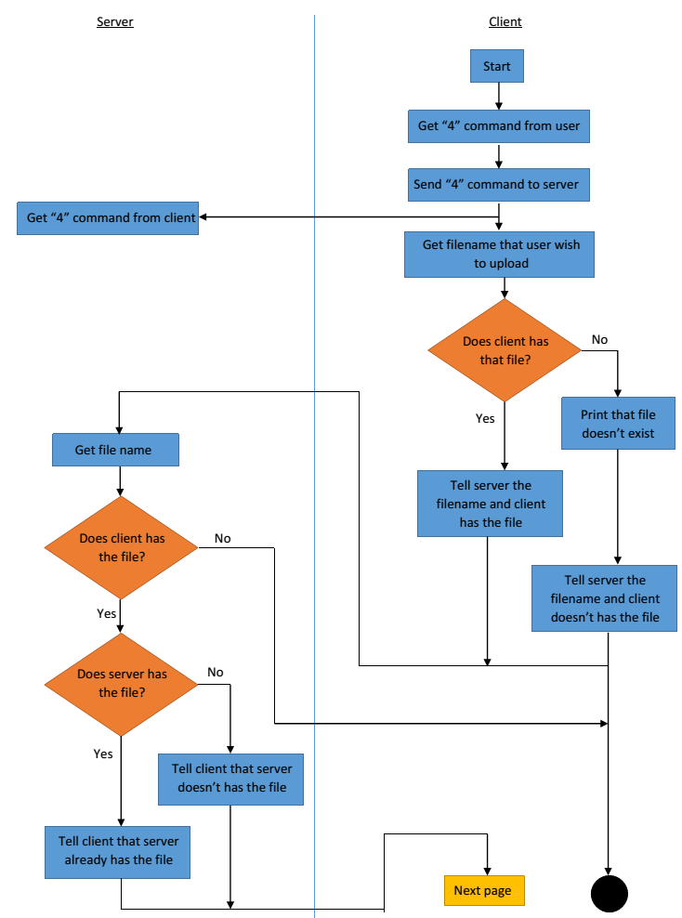

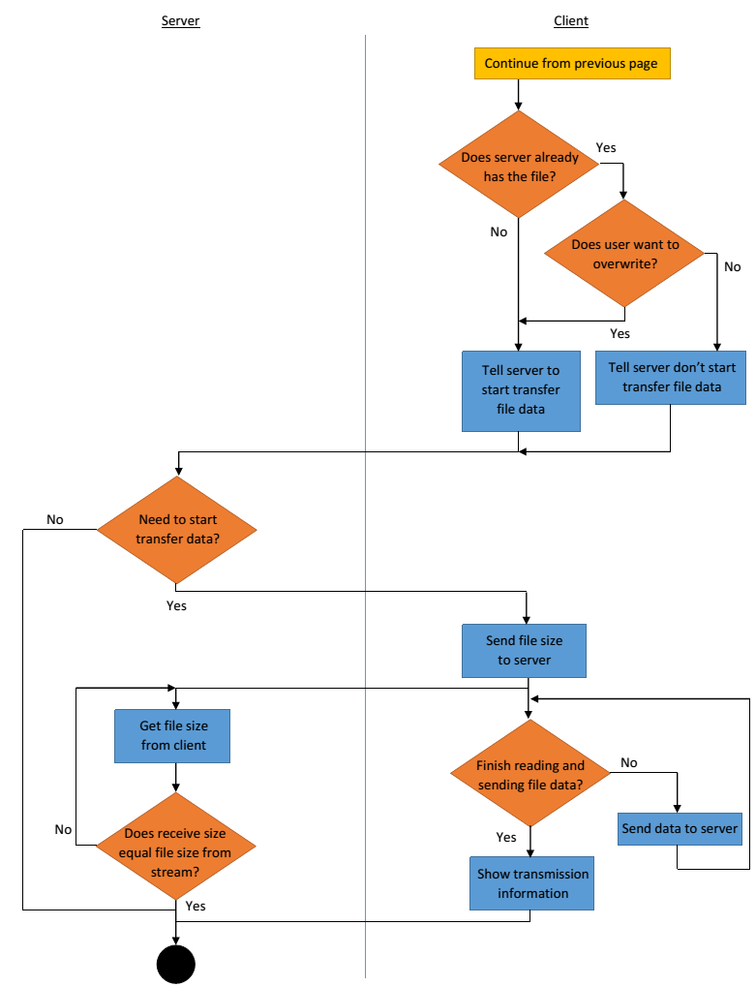Upload execution (cont.)

* 1. Close Connection execution

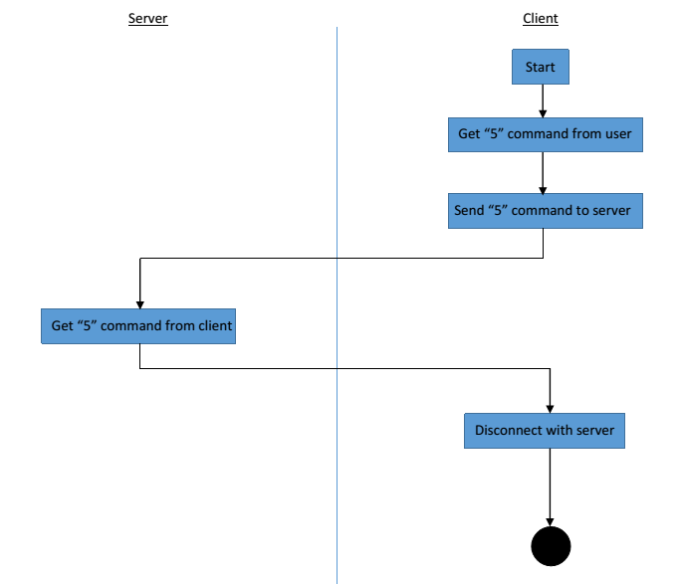

1. **Protocol Design**
   1. Server to Client

2.1.1) File list (array1) – Tell the client file list in the remote server directory.

2.1.2) fileExist – Tell the client that the file which client is call for the upload is existed in the server

2.1.3) File (FileIF) – Tell the client about the file information

2.2) Client to Server

2.2.1) Command - The client program send user command to server

2.2.2) dlFilename – Client send name of file to request for download   
from server

2.2.3 start – Client tell server to start executing download from server

2.2.4 ulFilename – Client tell server upload file name

2.2.5 fileSize – Client tell server upload file size