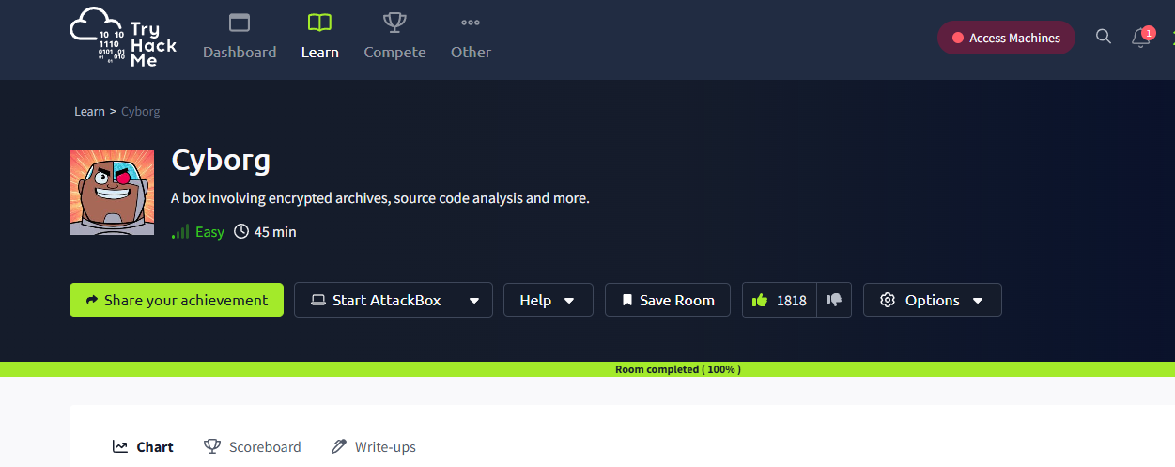

https://medium.com/@JAlblas/tryhackme-cyborg-walkthrough-329c508b5d91