

A Project Report On

**Online Book Store Project**

**By**

**Batch:** 2022 – 6518

**Center: Chennai**

Under the Guidance of,

**Chittaranjan Ghosh.**

**Technical Trainer**

**EduBridge**

(School of coding)

## Introduction:

Online Book Store manages Books information in the college with regard to placement. It improves existing system. It has the facility of maintaining the details of the Books, thereby reducing the manual work. It will save time and energy which are spending in making reports and collecting data. Online Book Store can be accessed throughout the Admin with proper login provided.

. **Modules:-**

* Admin Module
* Customer Module
* Database Module

I have developed this Application in **Java, MySQL.** It’s a web-based projects

The main objective of the Online Book Store is to reduce manual work and time. It is difficult and time-consuming to collect all the details from each

customer. To avoid this problem, we have planned to develop a web-based Online Book Store . In Admin module, admin can add the Category and Products in the specific category. He can also view the total number of users at present in the website. And category and product details also. Admin can only see the admin page and cart if he wants to order something.

* It manages the details of student records, placement training, different placements happening in and out of the college.
* Saves the time of placement officer and faculties.
* This system makes student information more secure.

Admin Module: Admin can able to handle recruiter portal and Books portal. It provides access to the Recruiter for uploading new jobs as well as to track the process of job application with a username and password.

Customer Module: Recruiter can access this website by signing up. Order the new books from his portal as well as he/she can update Order Table for student

Database Module: Its is used to Make Connectivity of database control

Get data from Db to jdbc and set value to store in the database .

**Software Requirements:**

**Front end:** Java

**Back end**: MySQL workbench 8.0 CE.

# Data Dictionary:

**Admin Table creation**

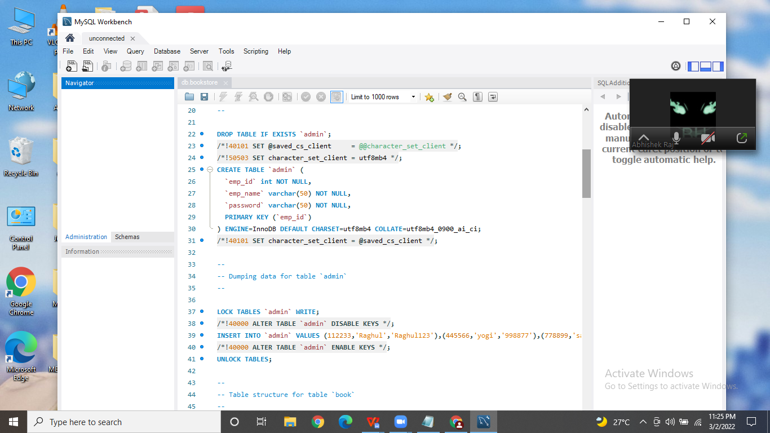

**Customer Table Create:**

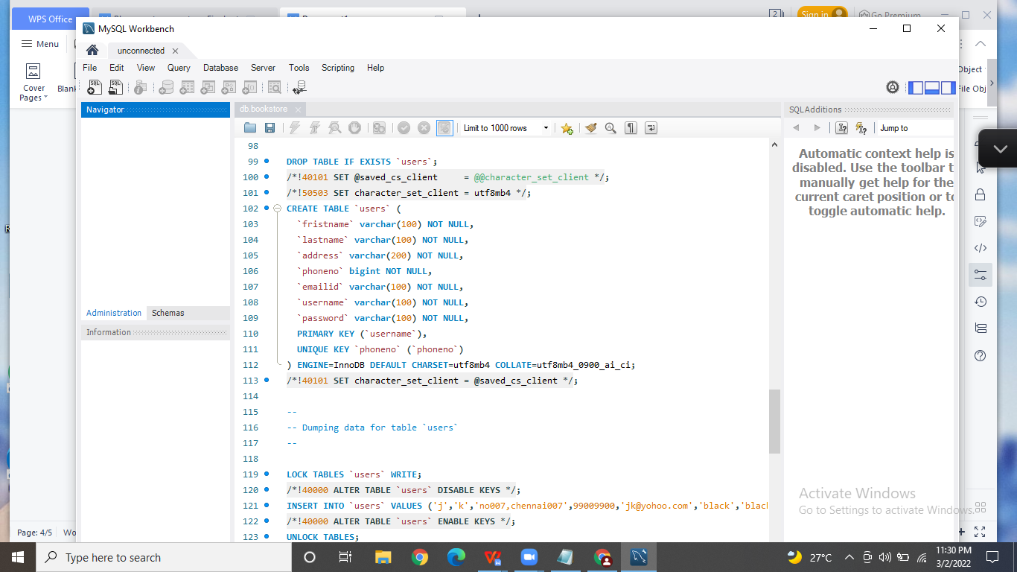

**Order Table Create:**

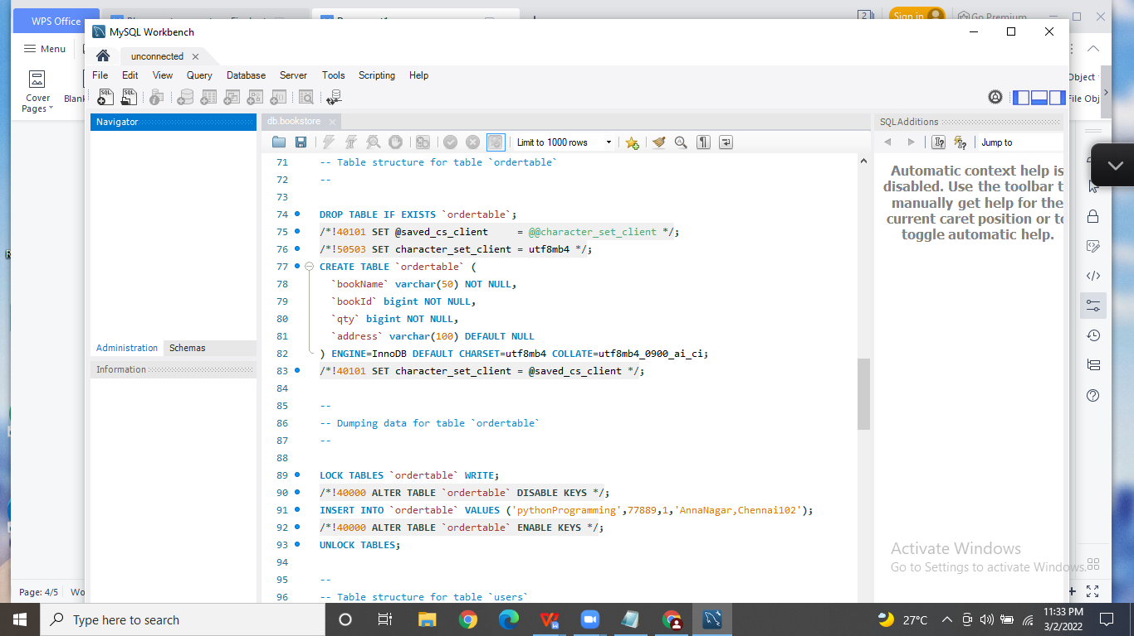

**Book Table create(Admin to ADD/DELETE):**

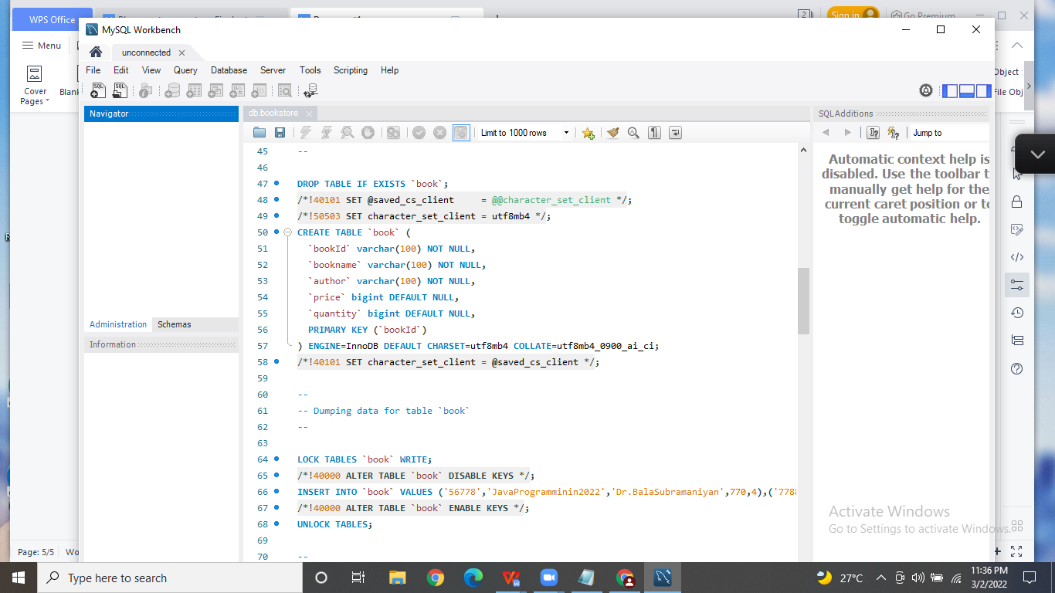

**ViewCart /Order Table Create(Customer):**

**Order table-**

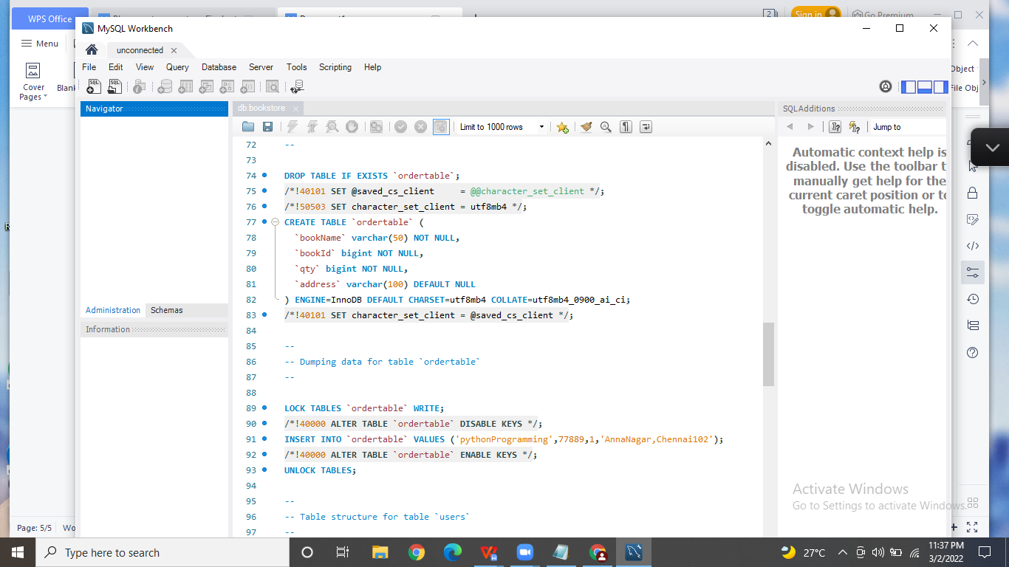

**View cart table-**

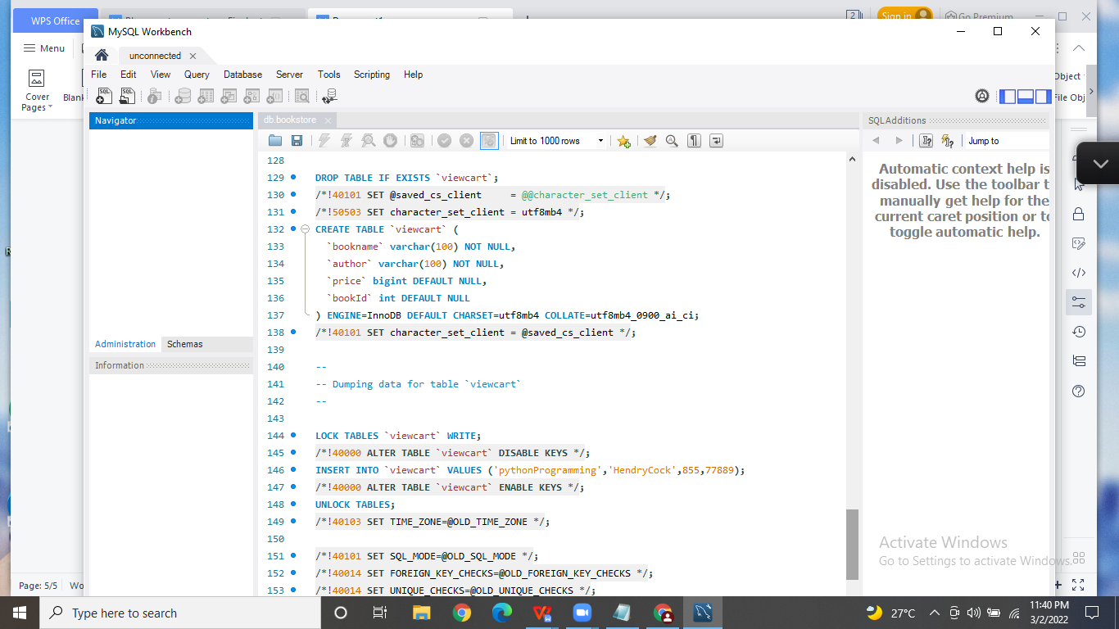

**Console Outputs:**

1. **Login Page:**

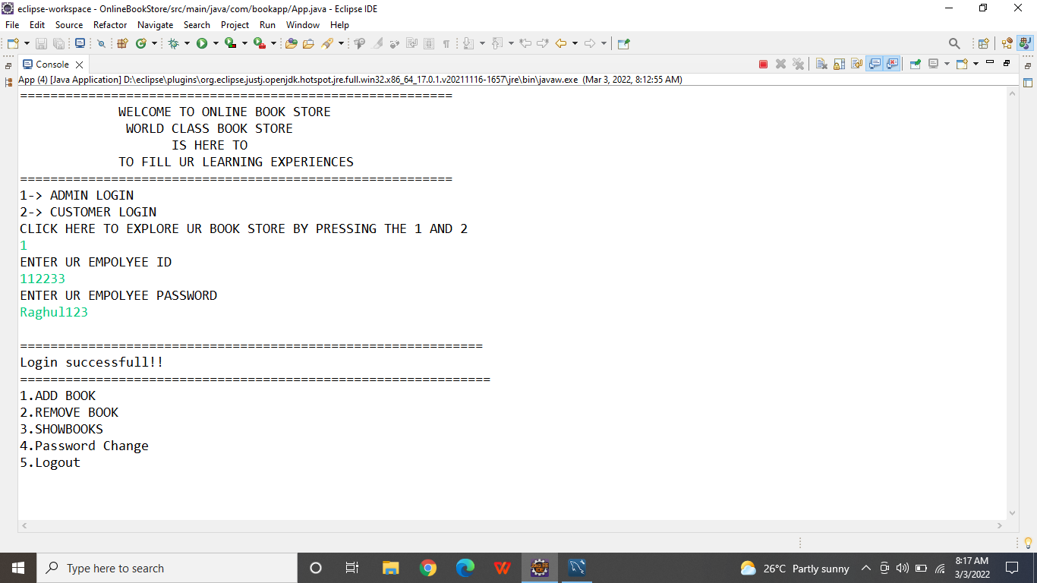

1. **Add Book Page:**

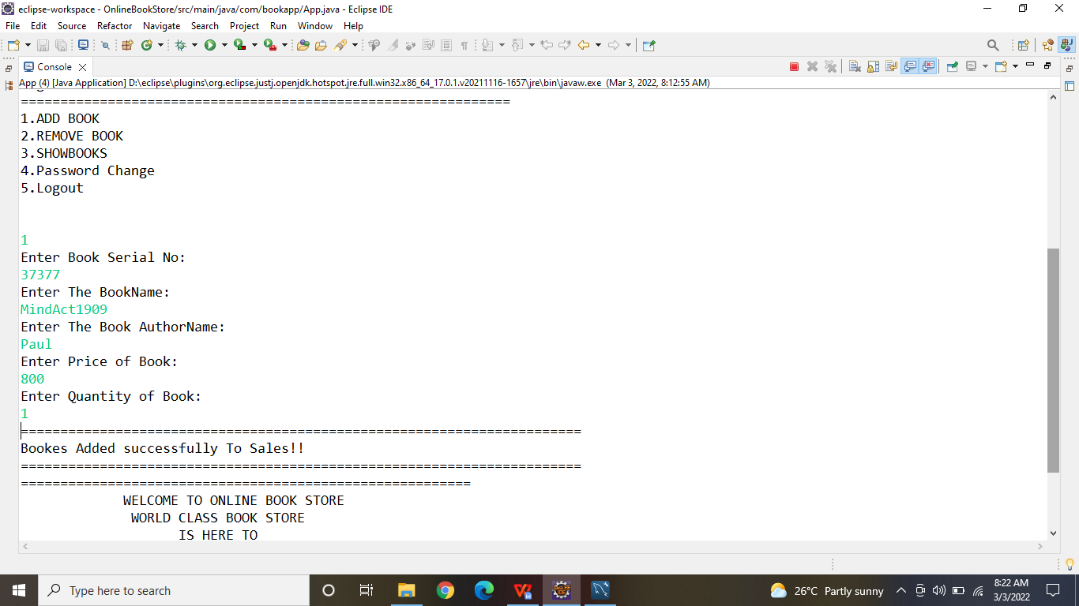

1. **Delete Book page:**

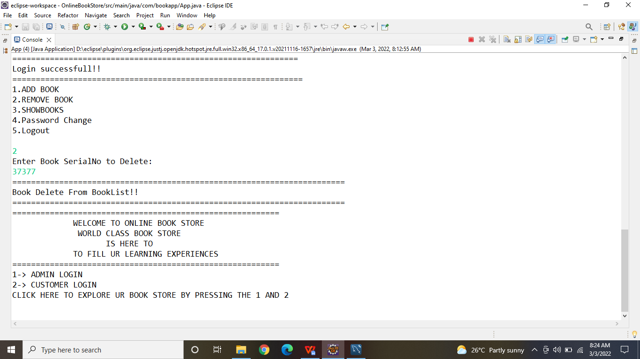

1. **Logout :**

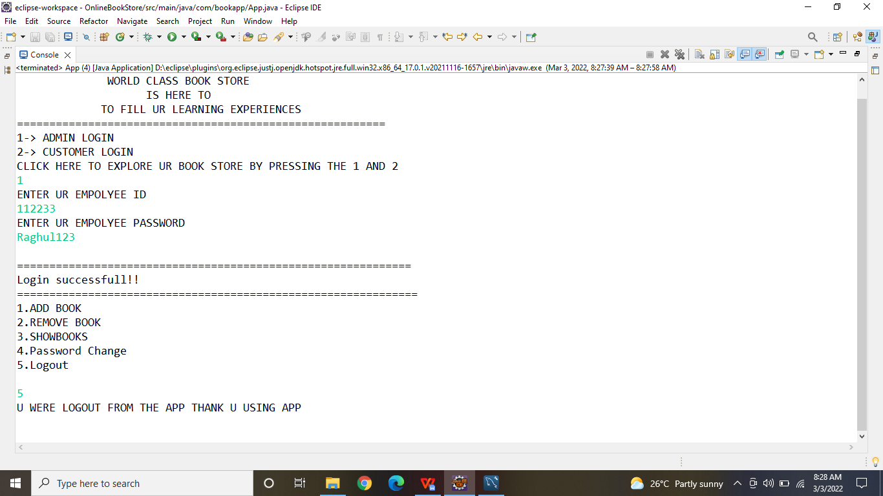

**Customer Page:**

1. **Regitration page :**

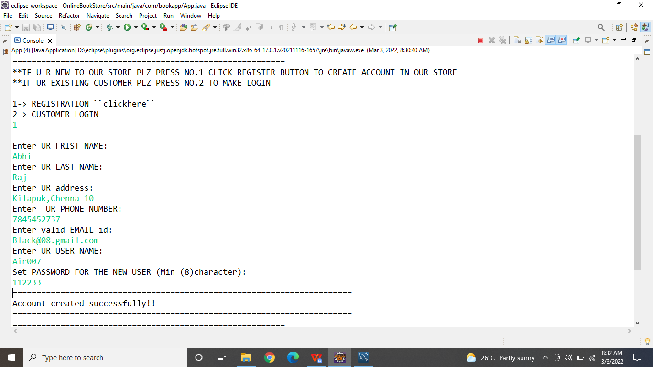

**2.Login Page:**

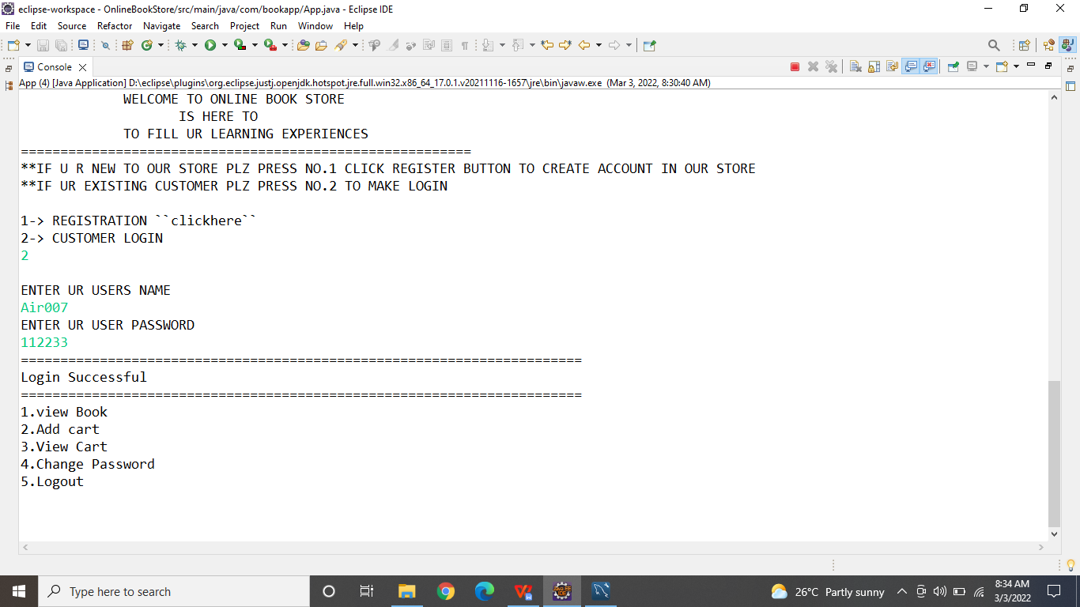

**3.BookList page:**

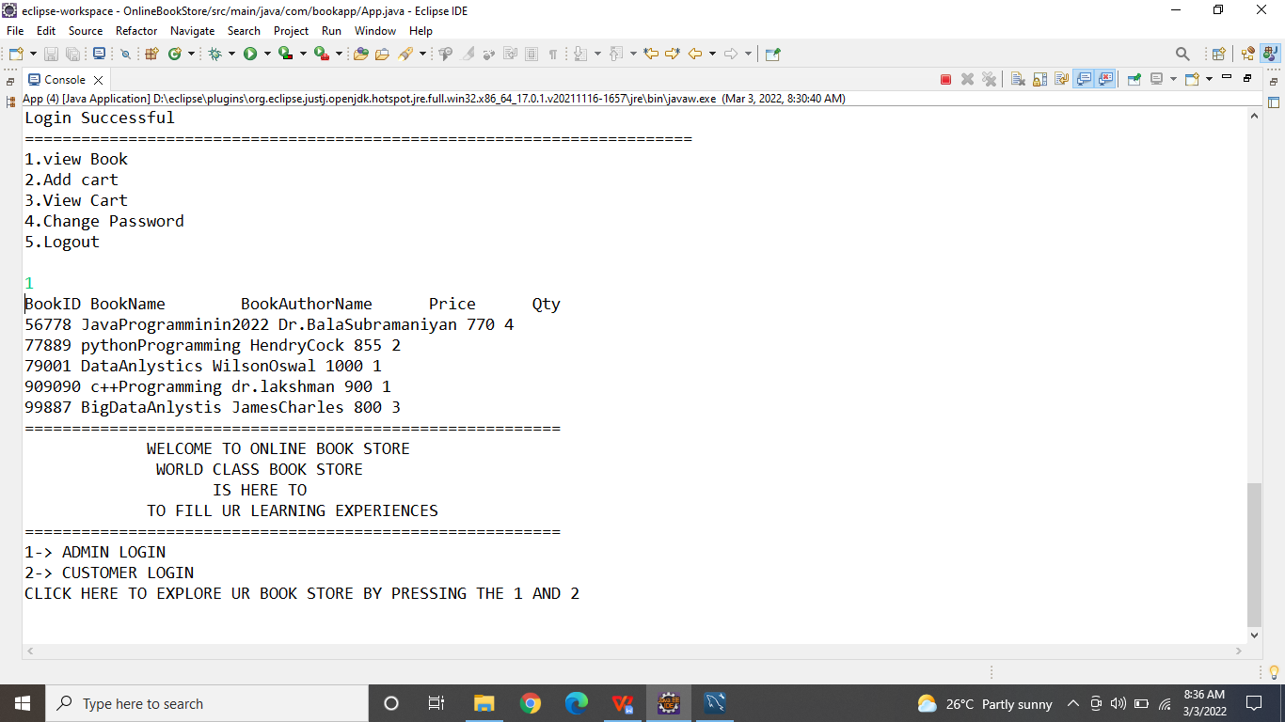

**4.Add TO Cart page:**

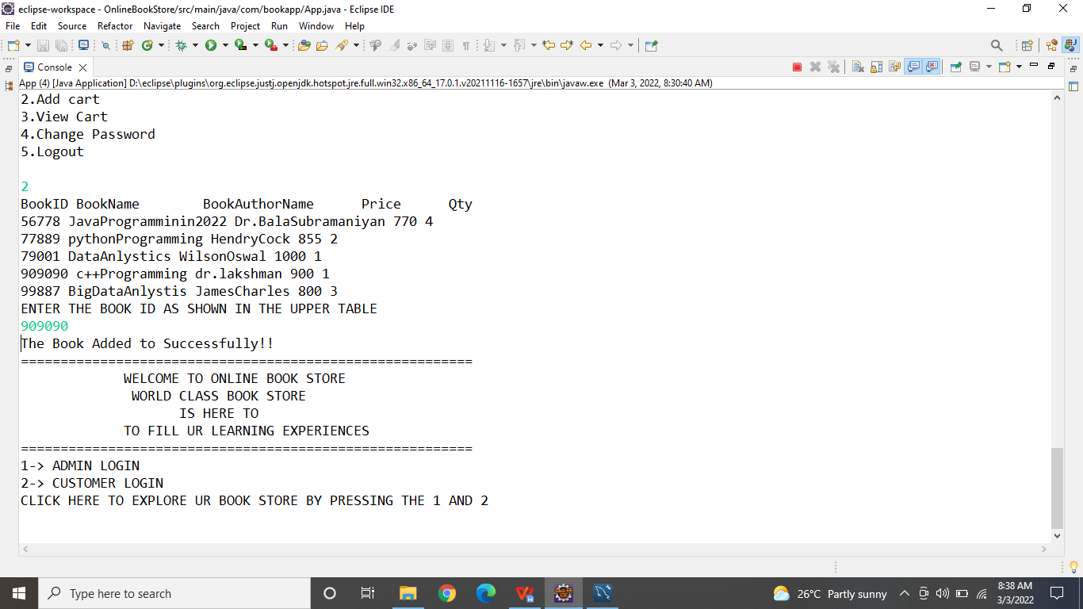

1. **View Cart:**

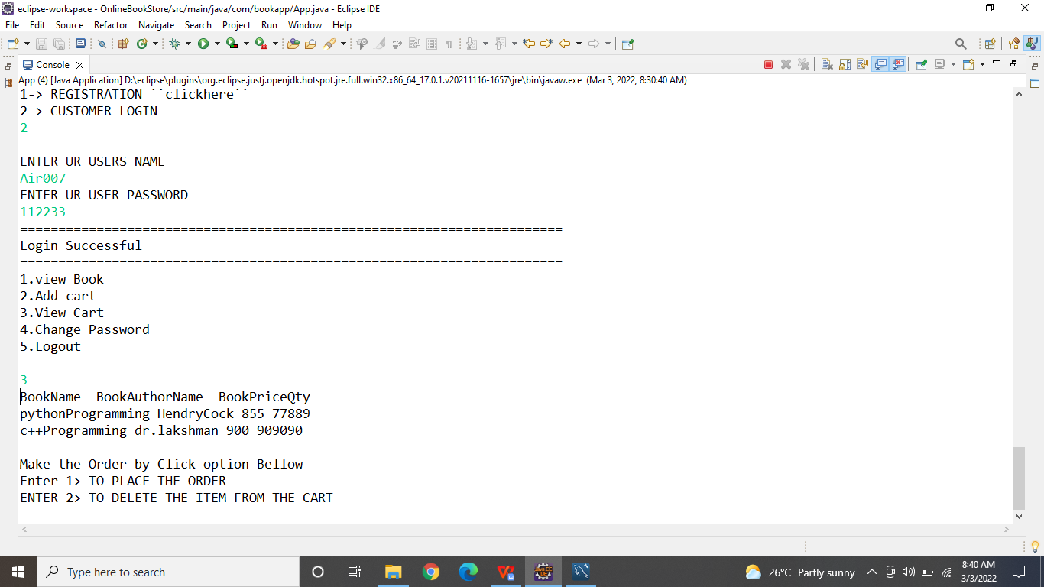

1. **Delete From Cart:**

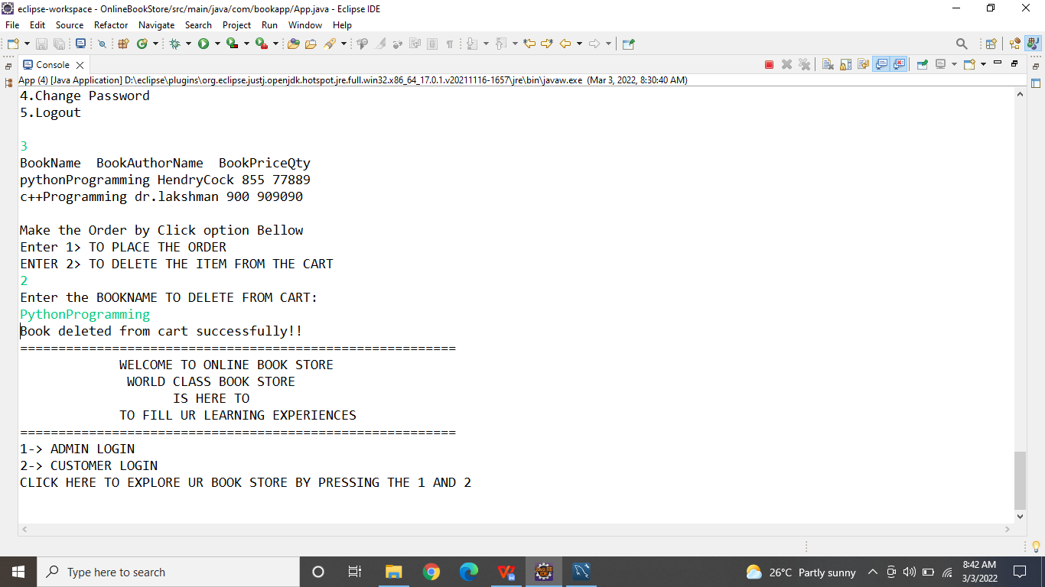

1. **Place Order:**

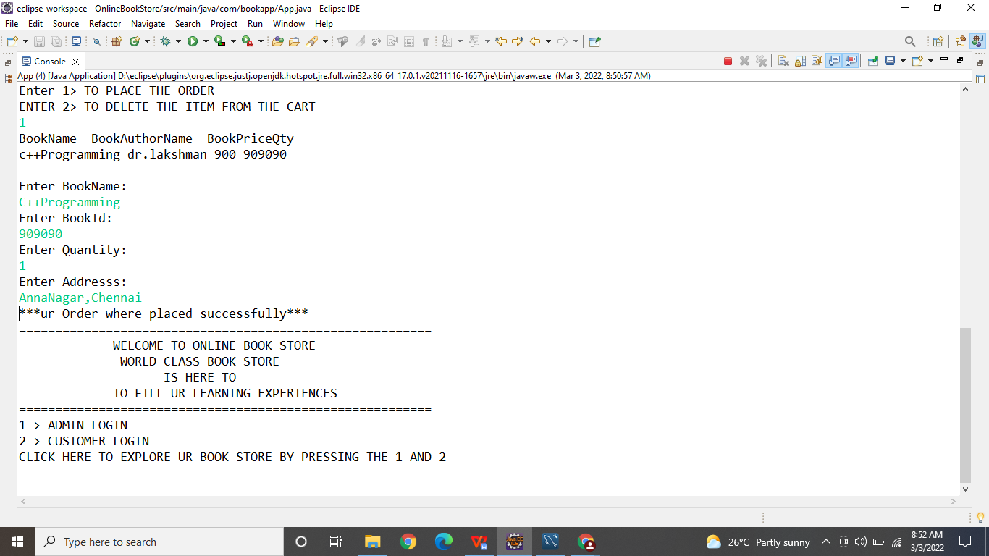

1. **Logout Customer:**

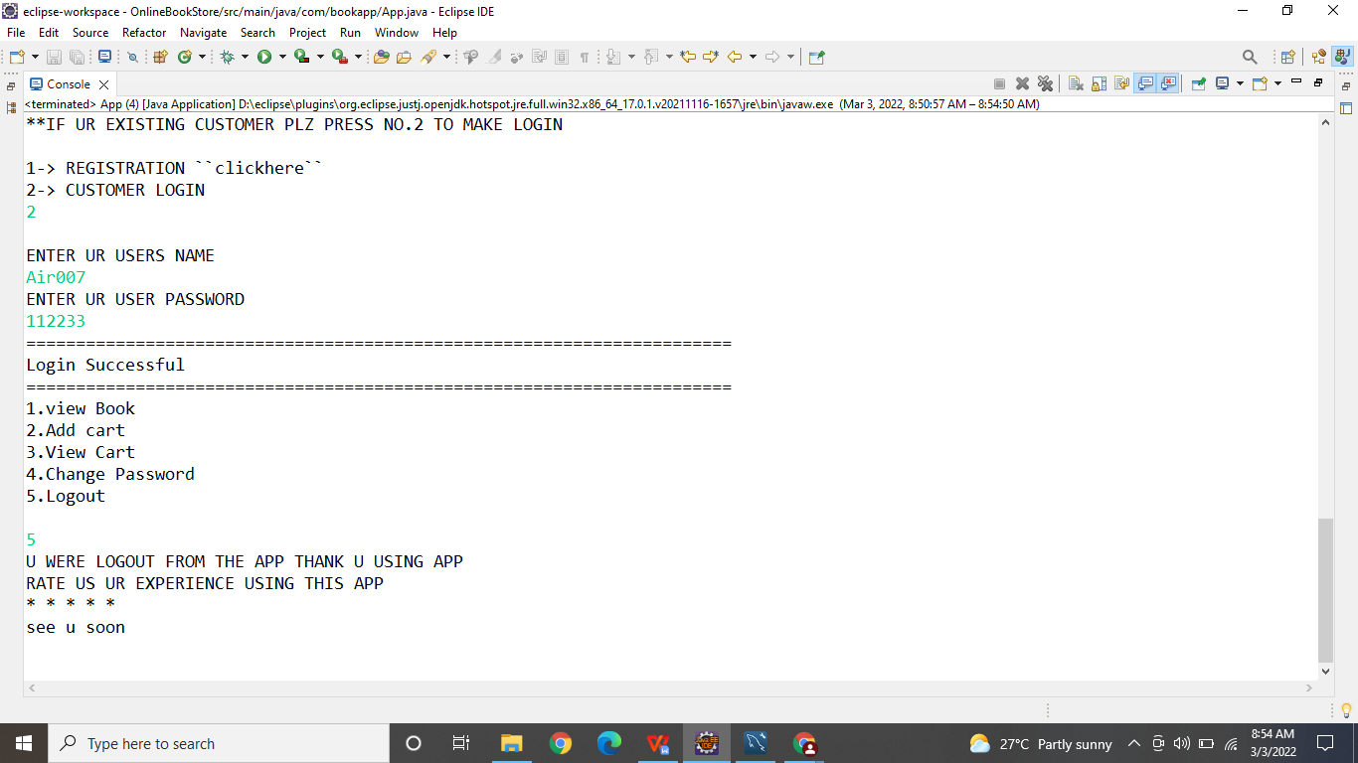

**Conclusion:**

The Book Store Summary as Details above the presentation of fullfilled our app

To save the time and realibity of usage by customer who have love to read book. They

Can use the app to order in simple to purchase book

**Thank you…..**