

A Project Report On

**Grocery Ecommerce Application**

**Project**

**By**

**JAYAKUMAR.R**

**Batch:** 2022 – 6518

**Center: Chennai**

Under the Guidance of,

**Chittaranjan Ghosh.**

**Technical Trainer**

**EduBridge**

(School of coding)

**Introduction:**

OurprojectexplainsabouttheE-commerceShoppingWebsitenameMyCart.This

project mainly explains the various actions related to shop online. You can

search various products and shuffle according to category. Our Project Include

.

**Modules:-**

* Admin Module
* Customer Module
* Category Module
* Delivery Module
* Transaction Module
* Order Module

|  |
| --- |
|  |

I have developed this Application in **Java, JSP, Servlets, Hibernate**

**and MySQL.** It’s a web-based projects so I have used **HTML, CSS,**

**JavaScript and Bootstrap also**.

The main feature of the project is to make shopping easier. You can

access this website from anywhere and everywhere.

In **Admin module**, admin can add the Category and Products in the

specific category. He can also view the total number of users at

present in the website. And category and product details also. Admin

can only see the admin page and cart if he wants to order something.

In **Customer module**, Customer can register and Login into application

And view product by there category. And the can see the user interface and

Public interface in application.

In **Category module**, user can access the website and see the pro and

products to cart and buy and shuffle by category. New user can

register and login after that to shop. In Cart, admin and user both can

access, they can add the products and buy if they want.

In **Delivery module**, Delivery mode will help store delivery details and

Address and other id for this table when customer will place the order.

In **Transaction module**, transaction can have the details about transaction of the

Project can this access can be managed by admin when the submit the report.

In **Order module**,Order table will contains all the order when customer login and

Place the order .Order will show the order data and its help to connect delivery and

Trancation and Order Product to service the customer.

**Software Requirements:**

**Front end:** Java/J2EE technologies (Servlet, JSP), HTML, CSS, JavaScript,

Bootstrap, Hibernate.

**Back end**: MySQL workbench 8.0.23CE.

**Middleware/Server:**

Apache Tomcat v8.5. IDE: Spring Test Suits

Developers

**Browser:** Best result on Google Chrome

**Operating System:** Window 10.

# Data Dictionary:

**Table creation:**

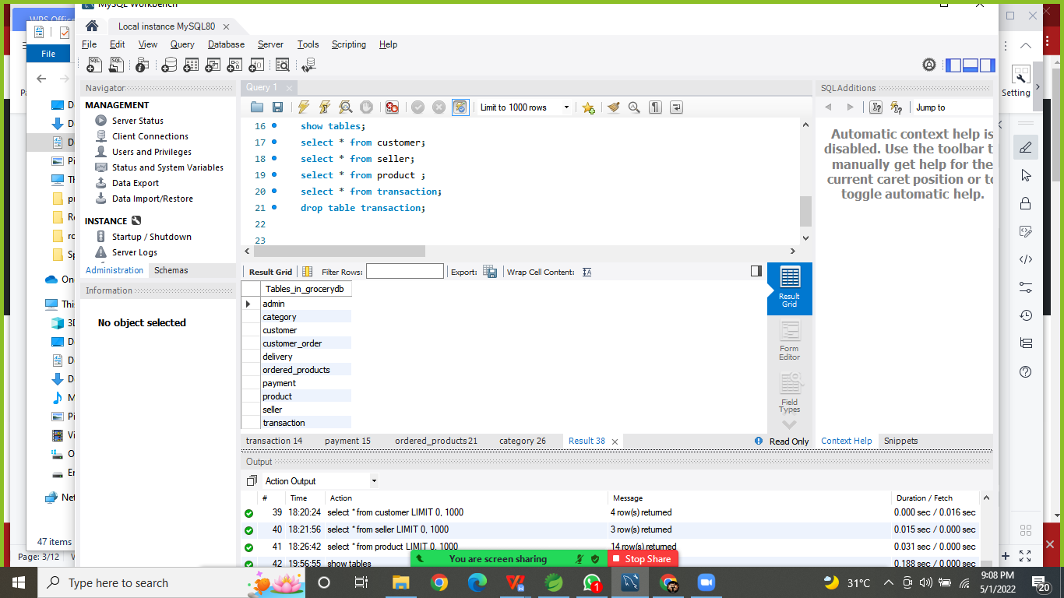

**Home Screen (1):**

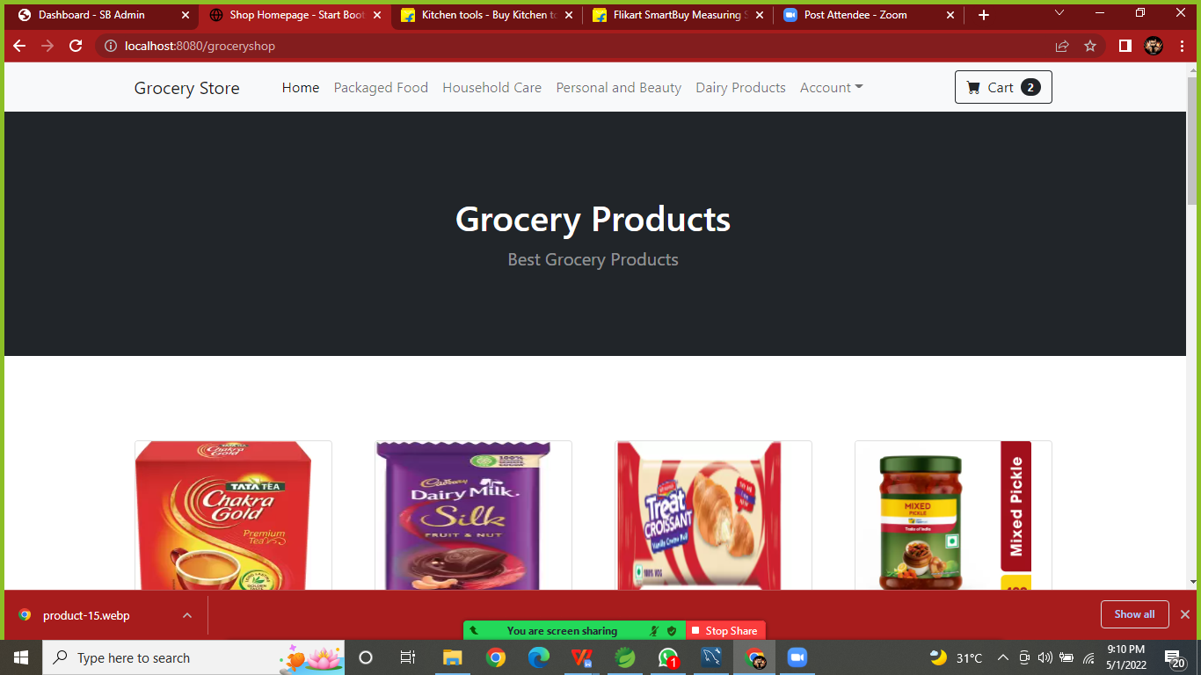

**Home Page (2):**

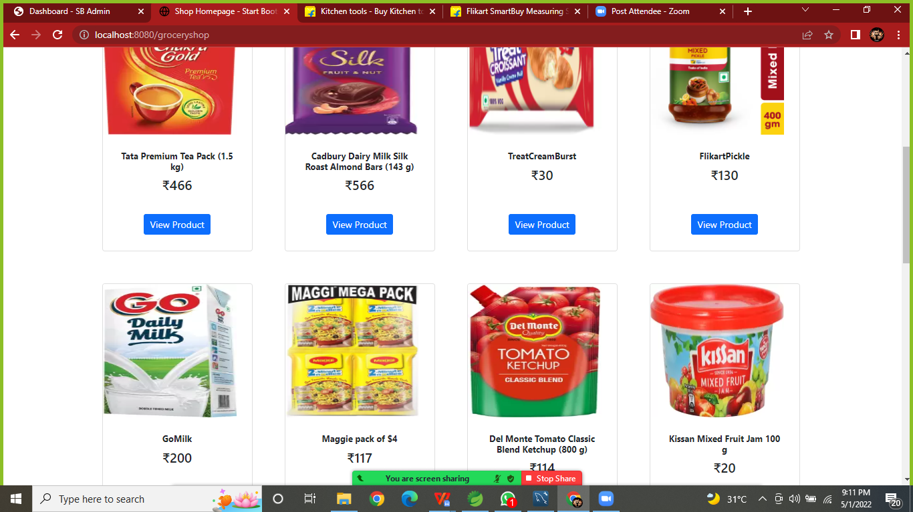

**View Single product:**

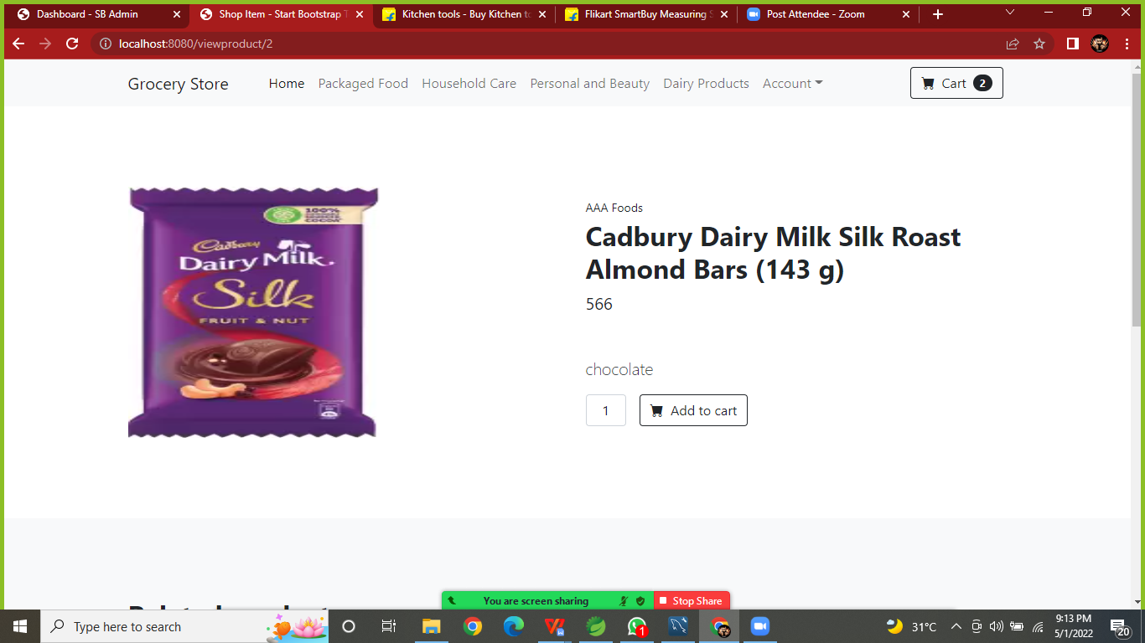

**Category Page(package Food(1)):**

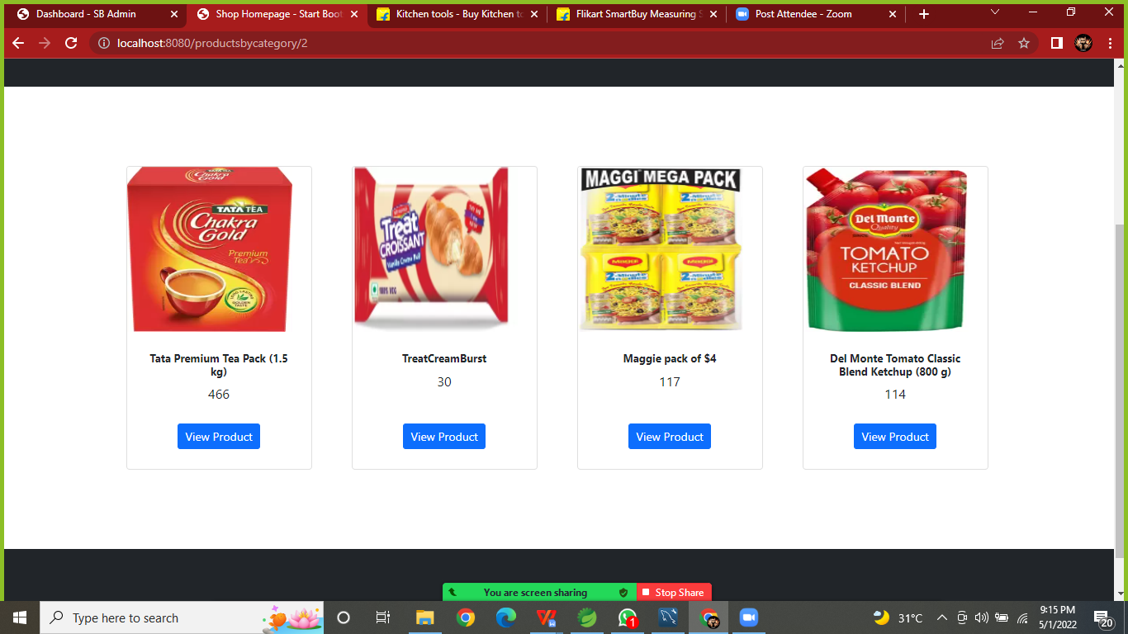

**Category Page (HouseHold Care(2)):**

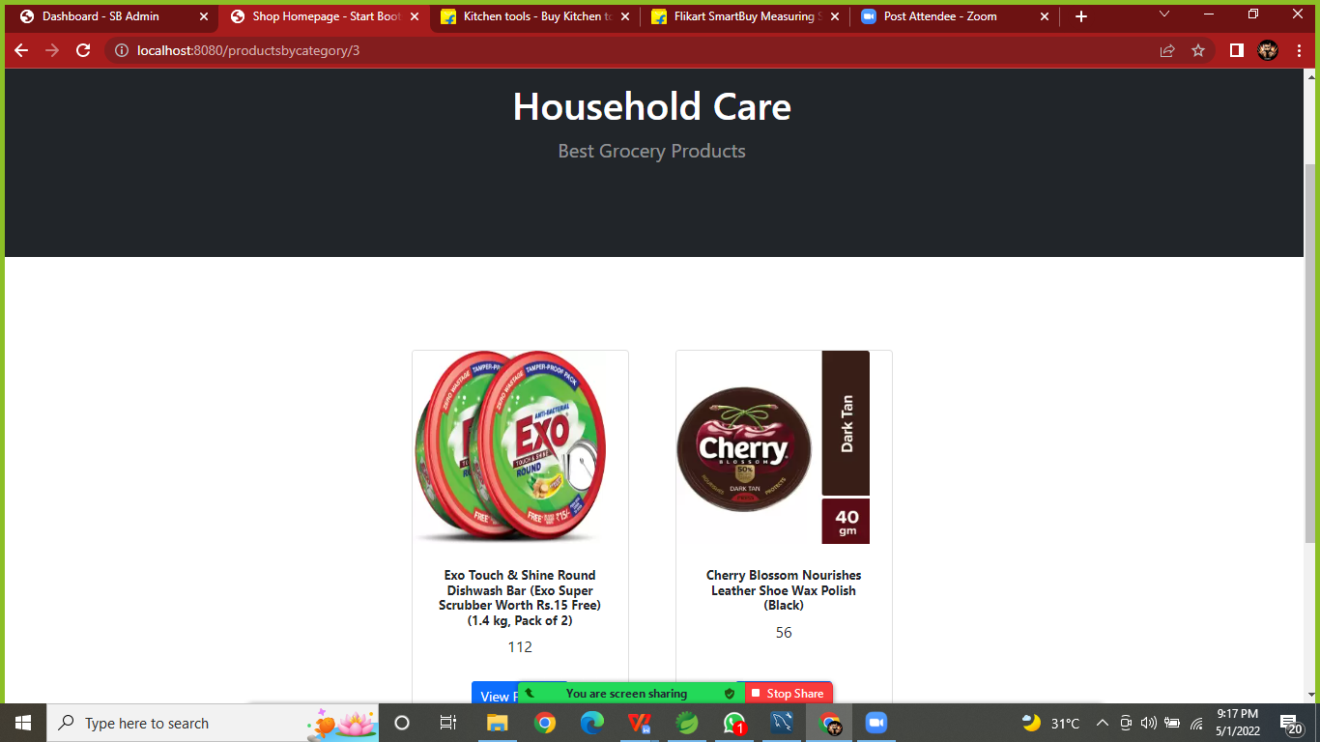

**Category page(Personal & Beauty):**

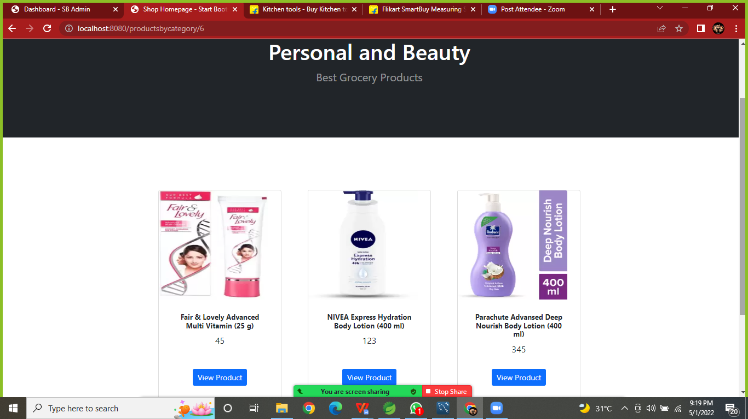

**Category page (Daily Product):**

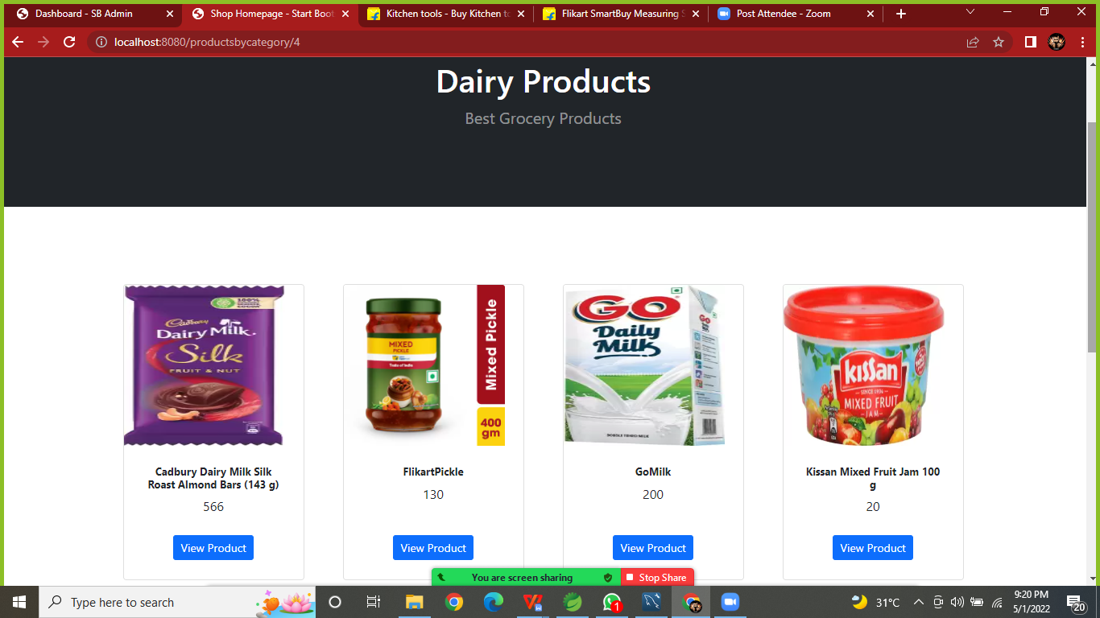

**Cart Page:**

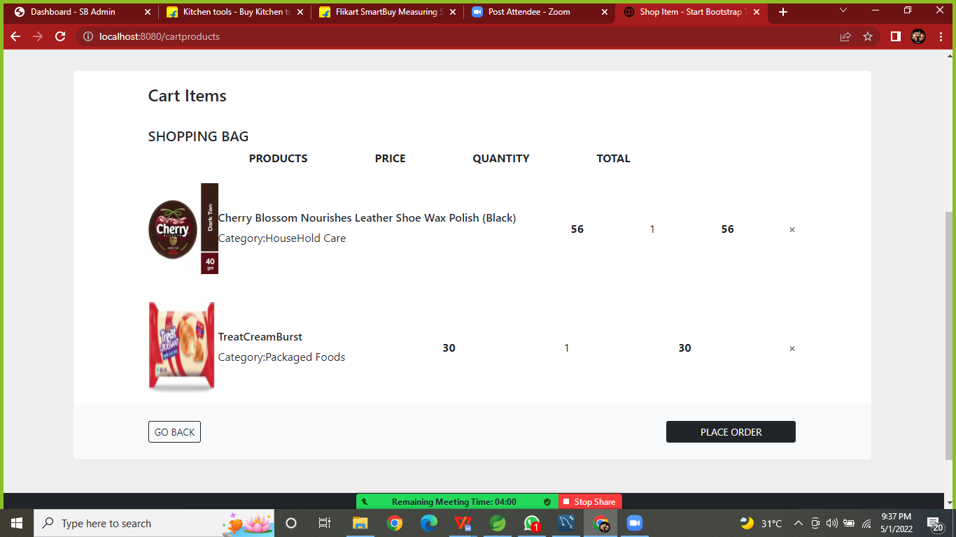

Empty Cart:

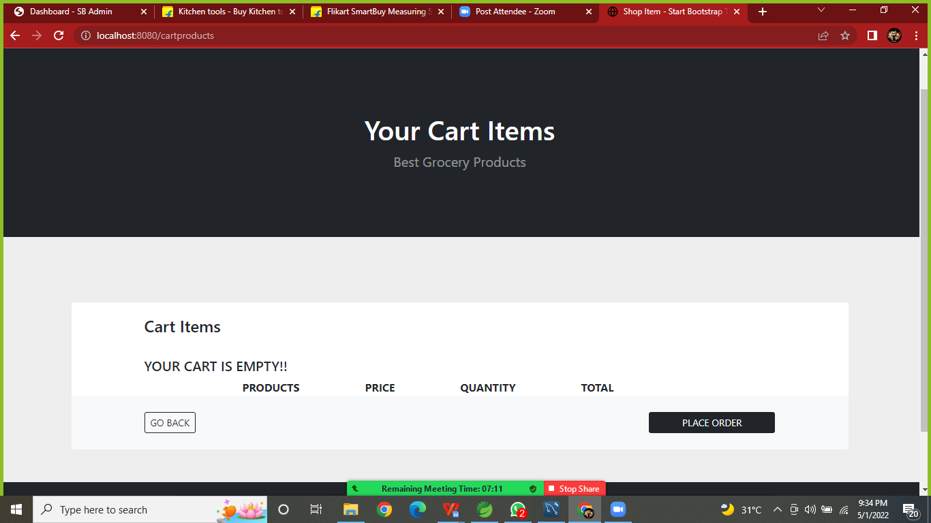

Register Form:

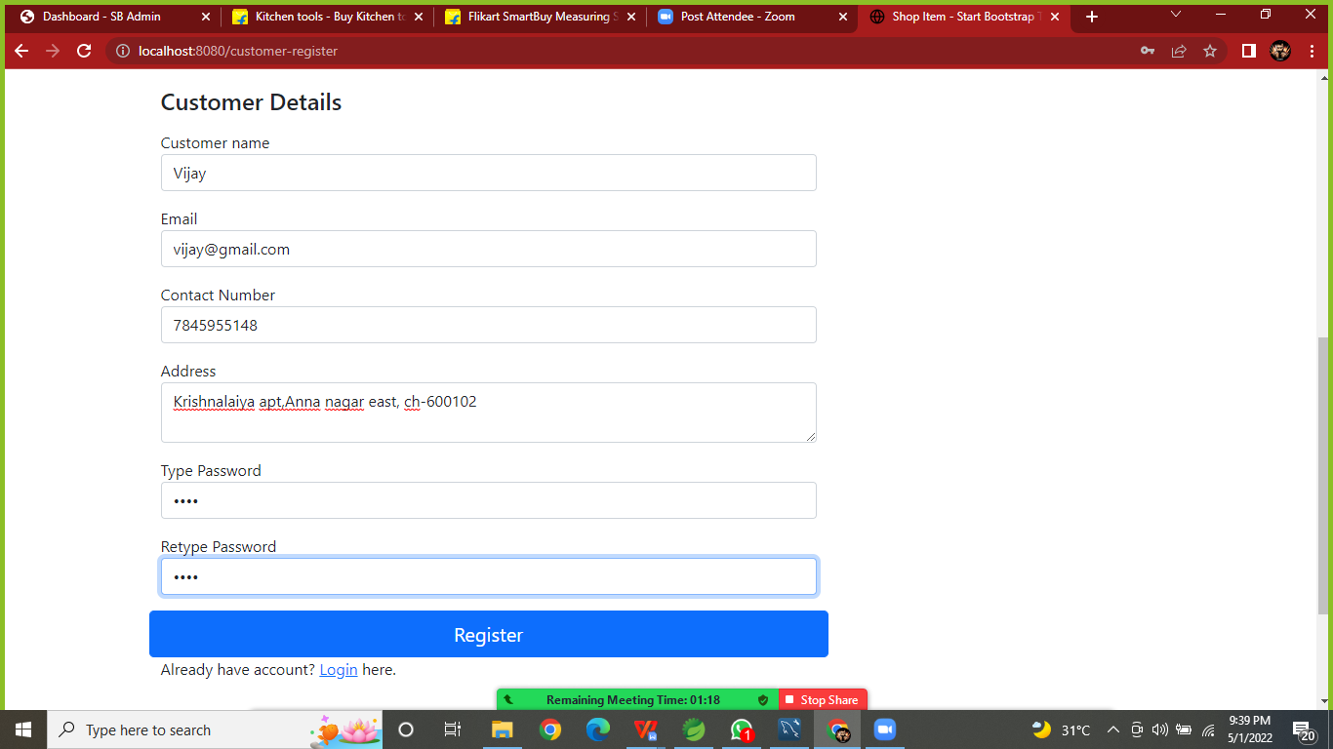

**Registration Successful Alert:**

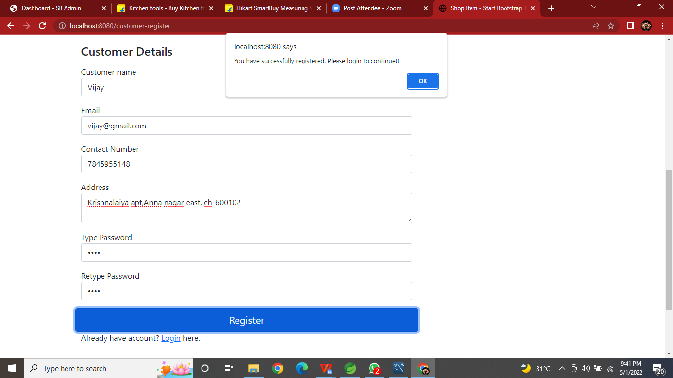

**Login Successful Page:**

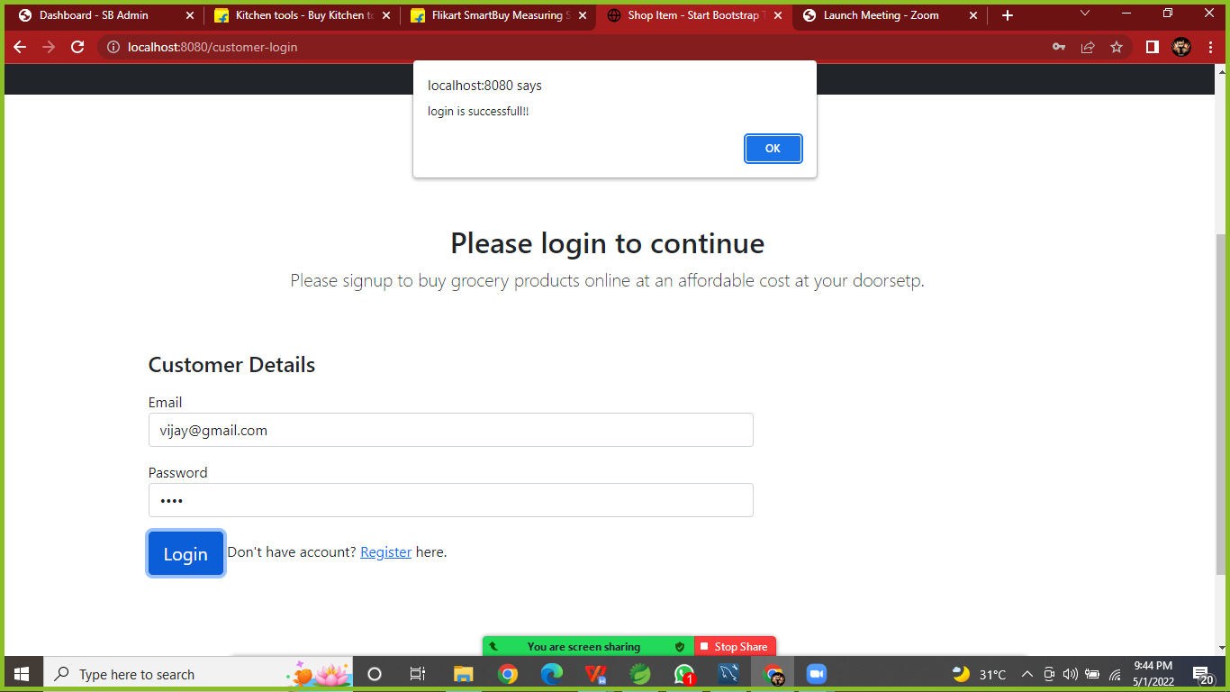

**CheckOut Form (1):**

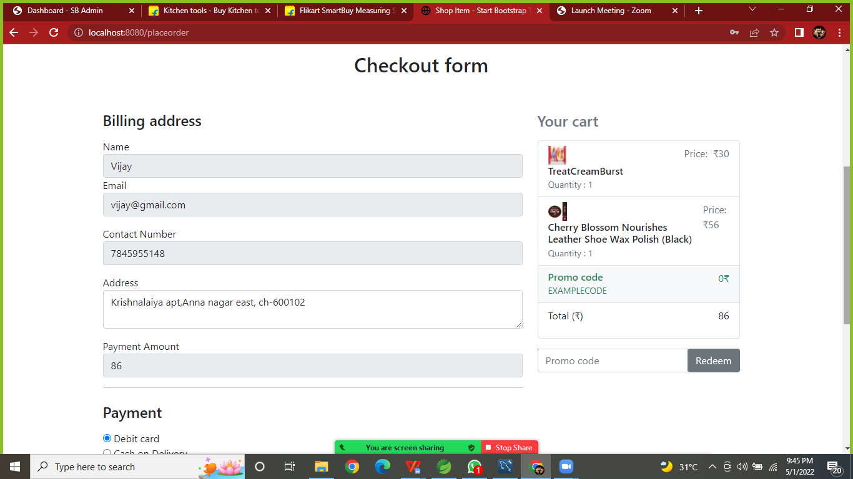

**Checkout Form (2):**

**Debit Card Required form:**

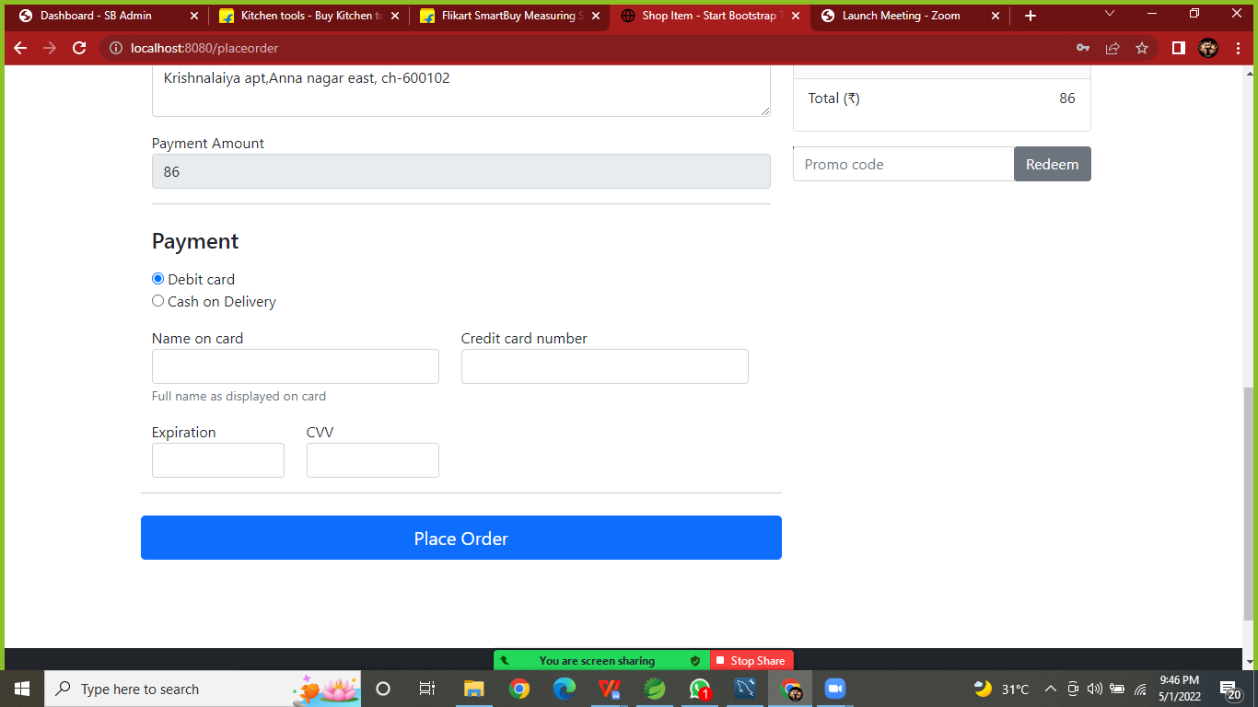

**Cash on delivery request:**

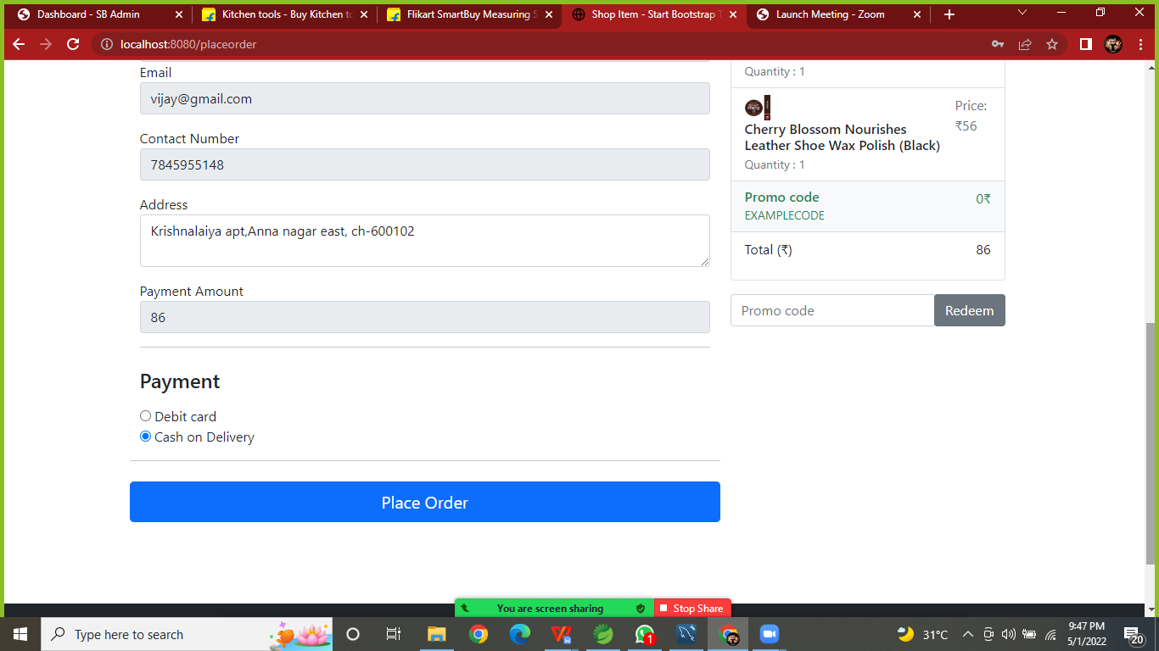

**Order Confirmed Page:**

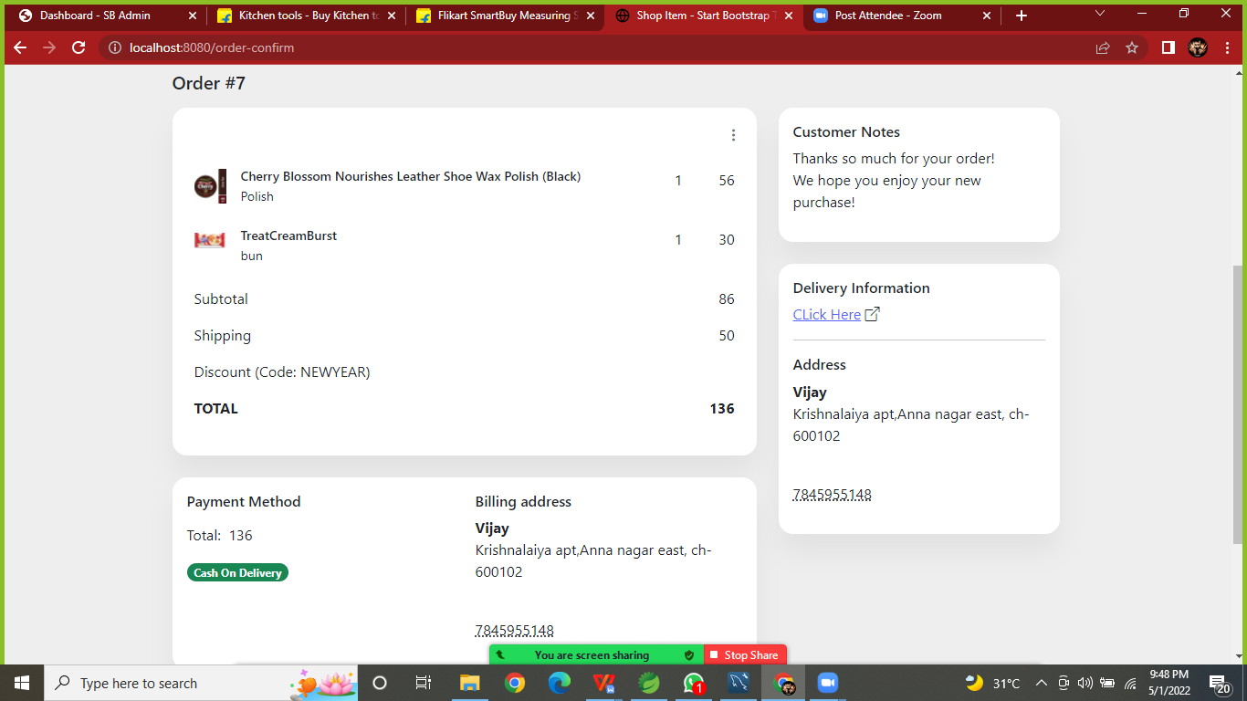

**ADMIN MODULE**

**Admin Login Page:**

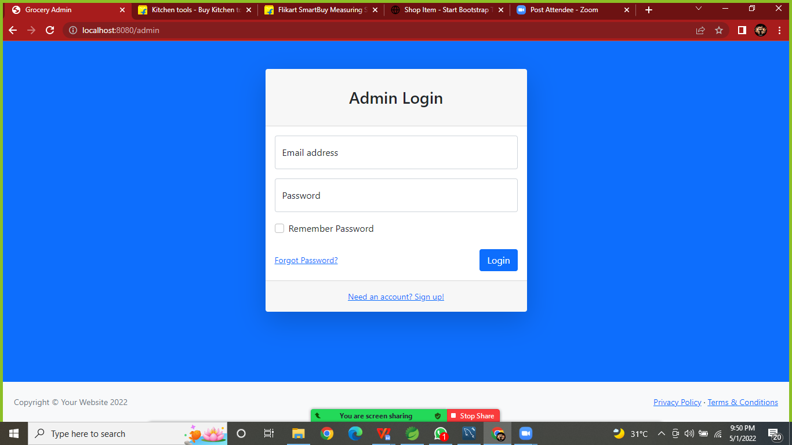

**Admin Home Page:**

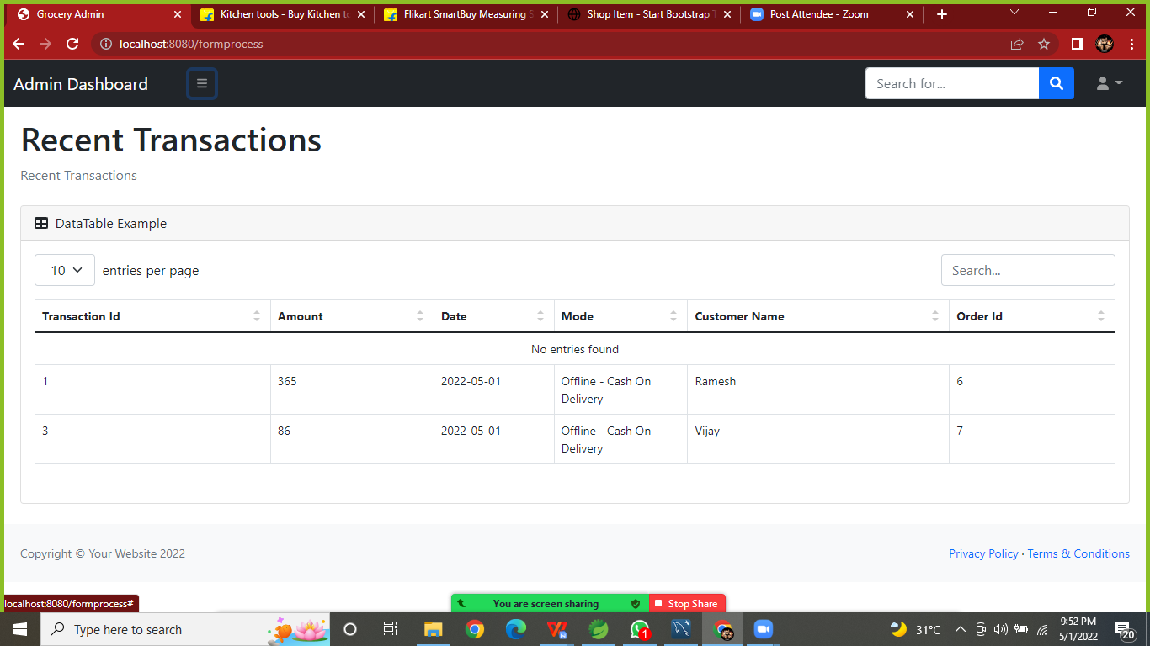

**Managed Product by Admin:**

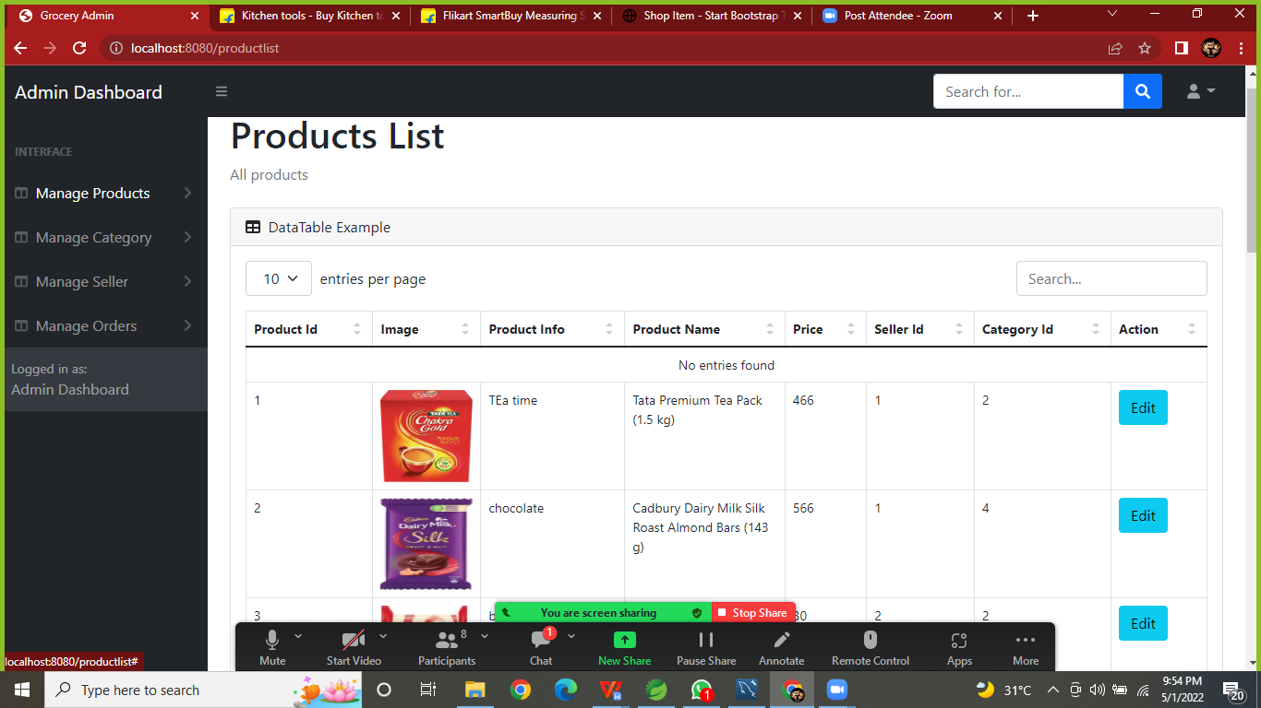

**Add Product:**

**In Add Product page required product information in that.**

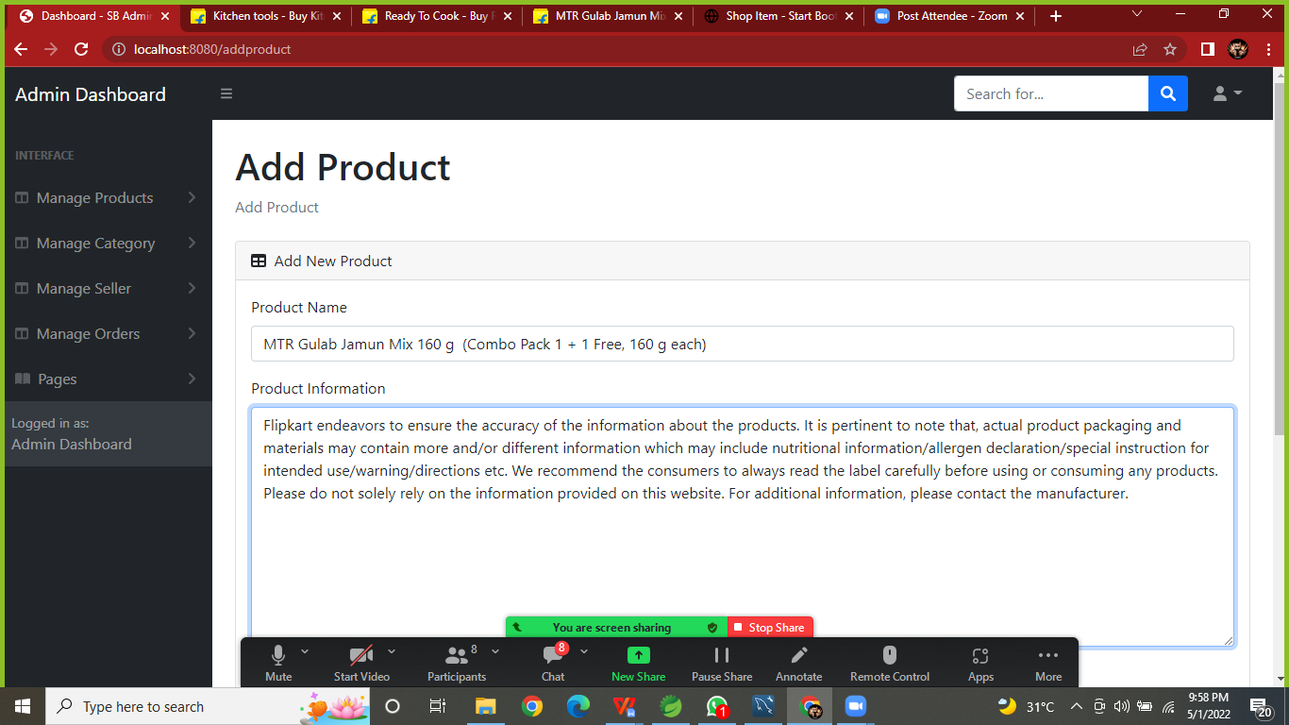

**Add Product(2):**

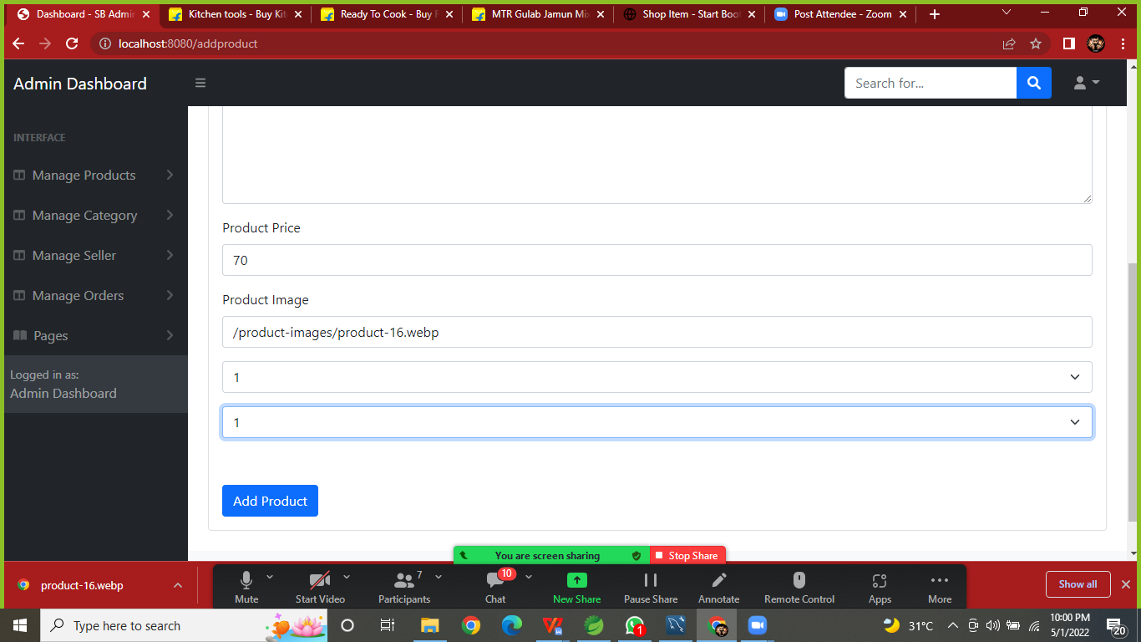

**Product Added /Updated page:**

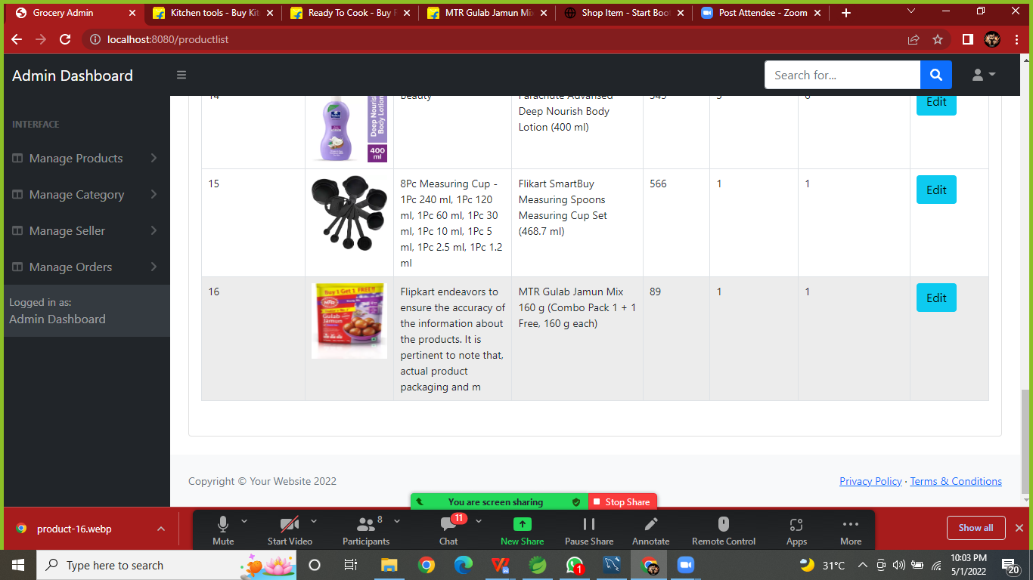

**Manged Category List:**

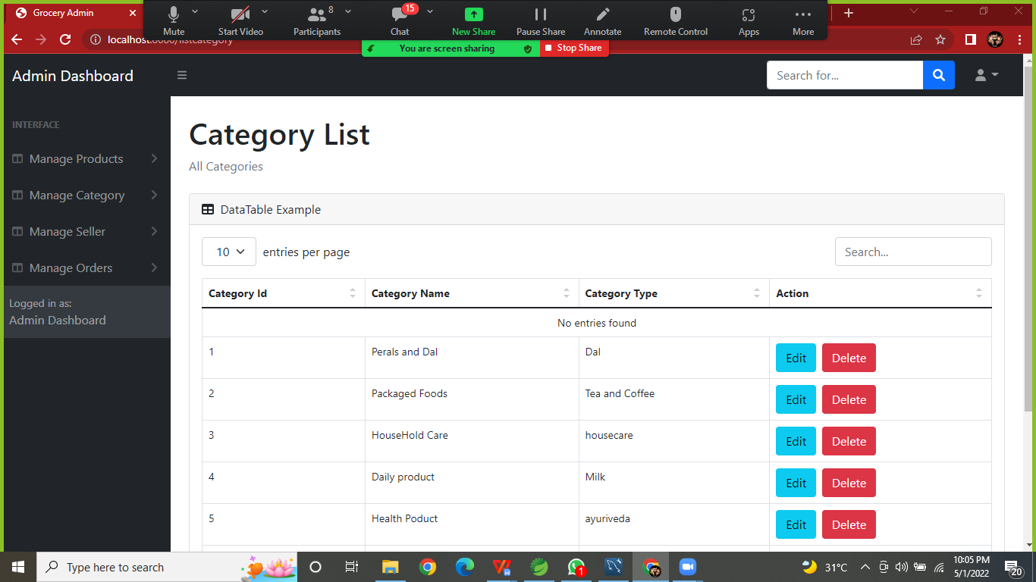

**Manged Category Add/Update:**

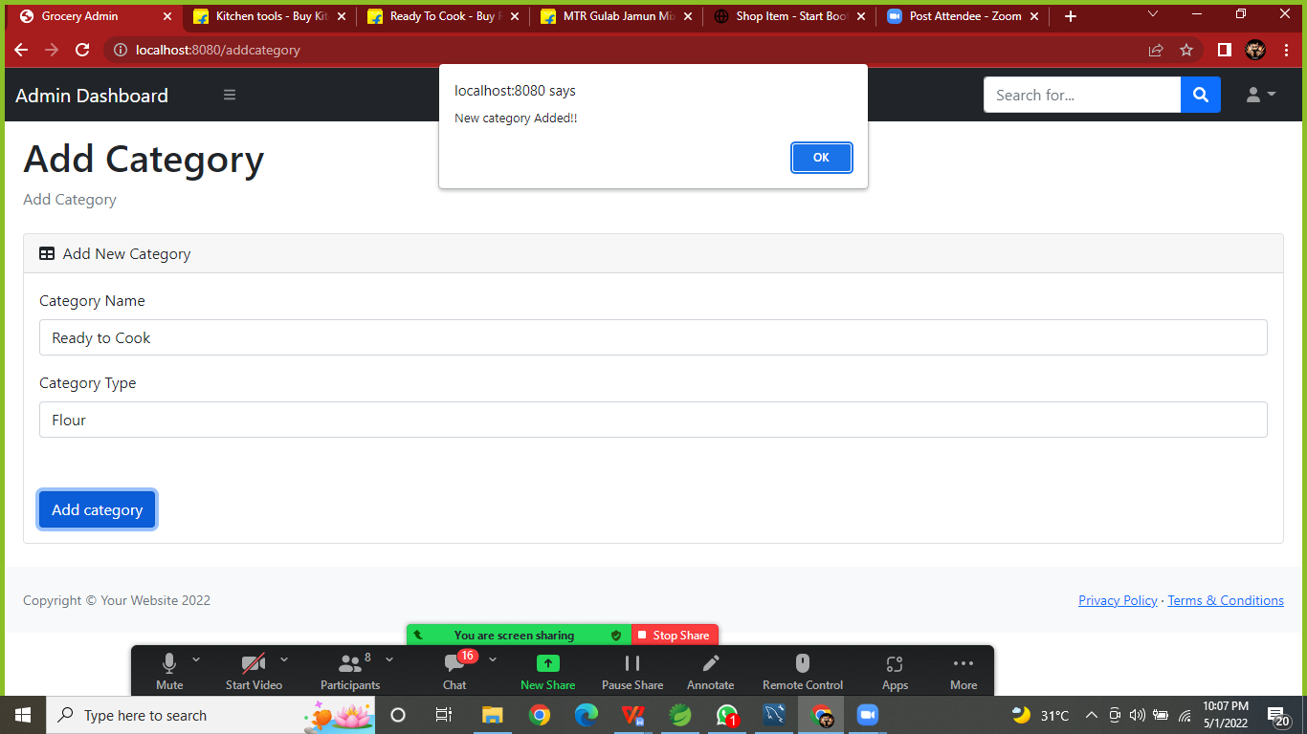

**2.Managed Category:**

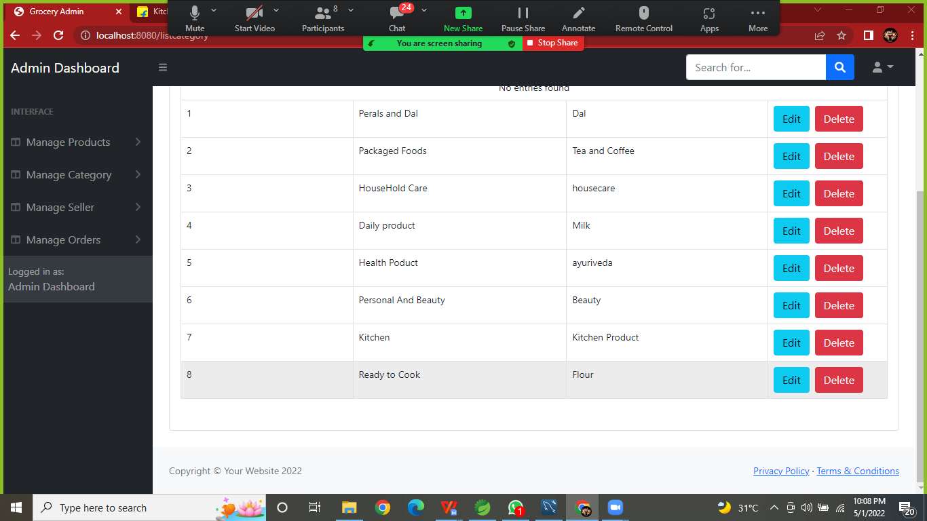

**Admin can Update Delivery Status:**

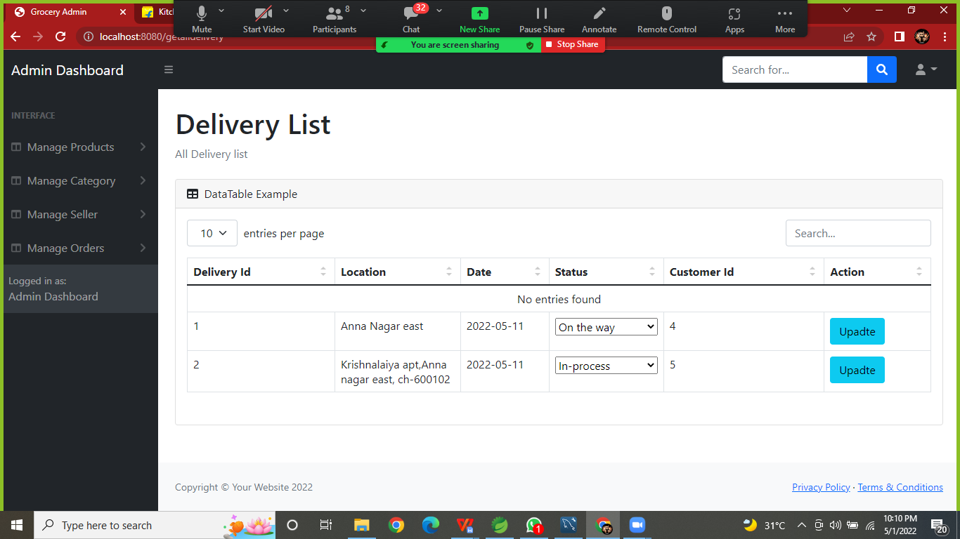

1. **Delivery Status Page in userInterface:**

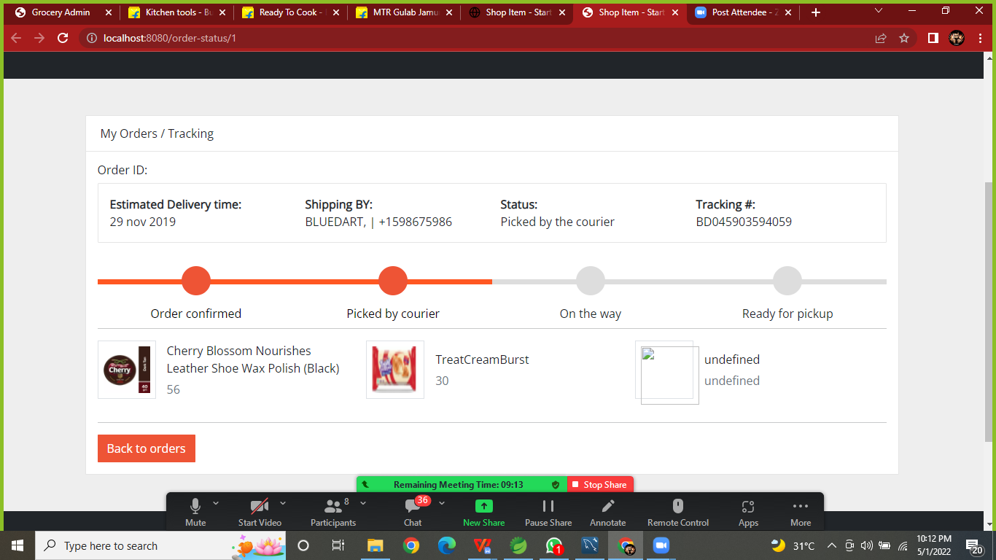

**Conclusion:**

This is our project is running process is displaced on presented in above.we believe this application will be help to managed the grocery order in anywhere..

**Thank You**