

NIDS and Snort – Month 1 & 2 Report

**Name:** Keshav Raj  
**Date:** 26 June 2025

# Introduction

**T**his report documents the foundational work completed in Month 1 of the Network Intrusion Detection System (NIDS) training with a focus on Snort. The activities include the installation and configuration of Snort, monitoring of network traffic, simulation of attacks, and understanding Snort rules.

# Week 1: Introduction to NIDS and Snort

**A** Network Intrusion Detection System (NIDS) monitors network traffic in real-time to detect malicious activity, policy violations, or unusual behavior. It acts like a security camera for your network—alerting we to threats before they can cause damage .

One of the most popular NIDS tools is Snort, an open-source intrusion detection and prevention system developed by Cisco. Snort uses a rule-based language to analyze traffic and identify known attack patterns, such as port scans, buffer overflows, and malware.

# Week 1: Installations of Snort Linux ( Kali )

- Installed Linux (Ubuntu/Kali) as the base OS.

- Installed Snort and verified its setup using version and help commands.

sudo apt update

sudo apt upgrade

sudo apt install libpcap-dev libpcre3-dev libdumbnet-dev bison flex zlib1g-dev

sudo apt intall snort

-Snort installations check

Snort -V

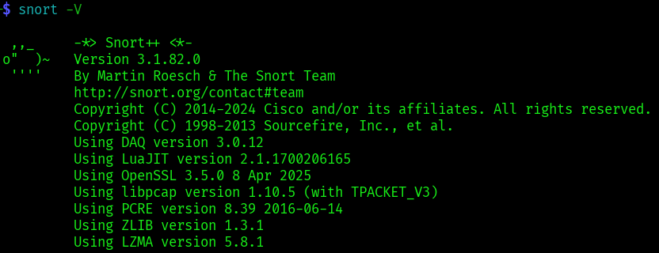

# Week 1: Basic Linux command-line navigation

- **P**racticed basic Linux command-line navigation using commands like `ls`, `cd`, `pwd`, `ifconfig`, and `sudo`.

**pwd** : Show current directory

**ls** : List files and directories

**cd <folder>** : Change directory

**mkdir <name>** : Create a folder

**sudo** :Run commands with admin rights

**apt install <package>** : Install software

**ifconfig**  : Show network interfaces and IP,MAC

# Week 2: Identify active network interface

- Identified active network interface using `ifconfig` or `ip a`.

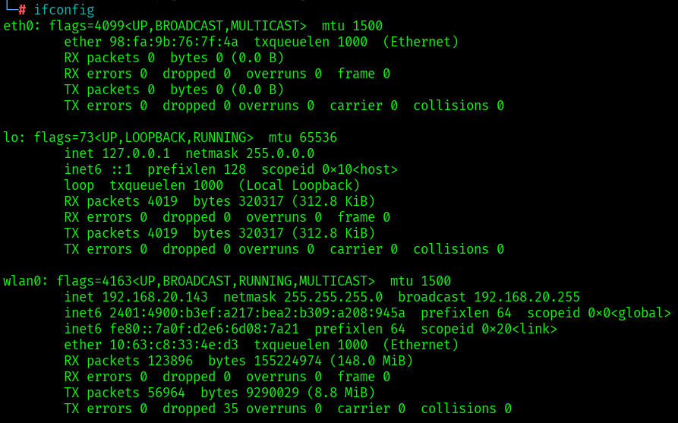

# Week 2: Configure Snort with monitored IP range of the local network

- Editing the Snort configuration file ( **sudo nano/etc/snort/snort.conf** )

- Setting HOME_NET variable ( **sudo nano /etc/snort/snort.conf** )

- Finding the line that begins with var HOME_NET.

- Set it with my network’s IP range :

var HOME_NET 192.168.20.0/24

- This tells Snort to monitor traffic within the local subnet 192.168.1.0/24.

Editing config file

**sudo nano/etc/snort.lua**

Adding Local rule path

‘’’references = default_references

classifications = default_classifications

ips =

{

rules = [[

include /etc/snort/rules/local.rules

]],

variables = default_variables

} ‘’’

Simple Rule (ICMP Detection)

Edit local.rules file:

**sudo nano /etc/snort/rules/local.rules**

```

Add this rule to detect all ICMP packets:

``` alert icmp any any -> any any (msg:"ICMP Packet Detected"; sid:1000001; rev:1;) ```

Save and exit.

# Week 2: Running Snort in Detection Mode

- **D**etection mode enables Snort to actively inspect packets and generate alerts based on defined rules.  
- **E**xecuted Snort in detection mode using the command:  
 “ **sudo snort -c /etc/snort/snort.lua -R /etc/snort/rules/local.rules -i wlan0** “

**Explanation of options:**

* **-A** **console** → Displays alerts in the terminal
* **-q** → Quiet mode (no banner or status messages)
* **-c** → Specifies the path to the configuration file
* **-i** → Interface to monitor (replace eth0 with your actual interface, like wlan0)

- Observed and interpreted live alerts on the console.

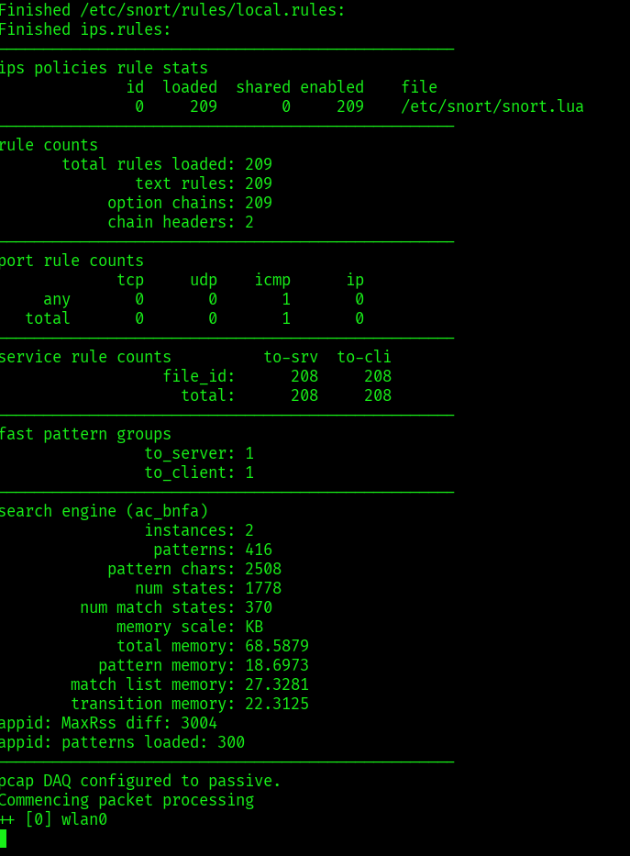

- From another system or the same machine, ping the interface IP to generate ICMP packets:

```bash

ping 8.8.8.8 in same system

```

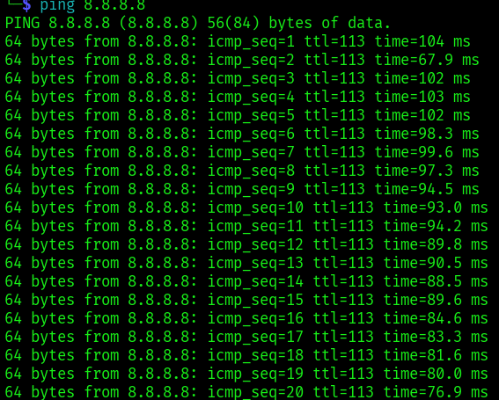

OR ping Kali from another system

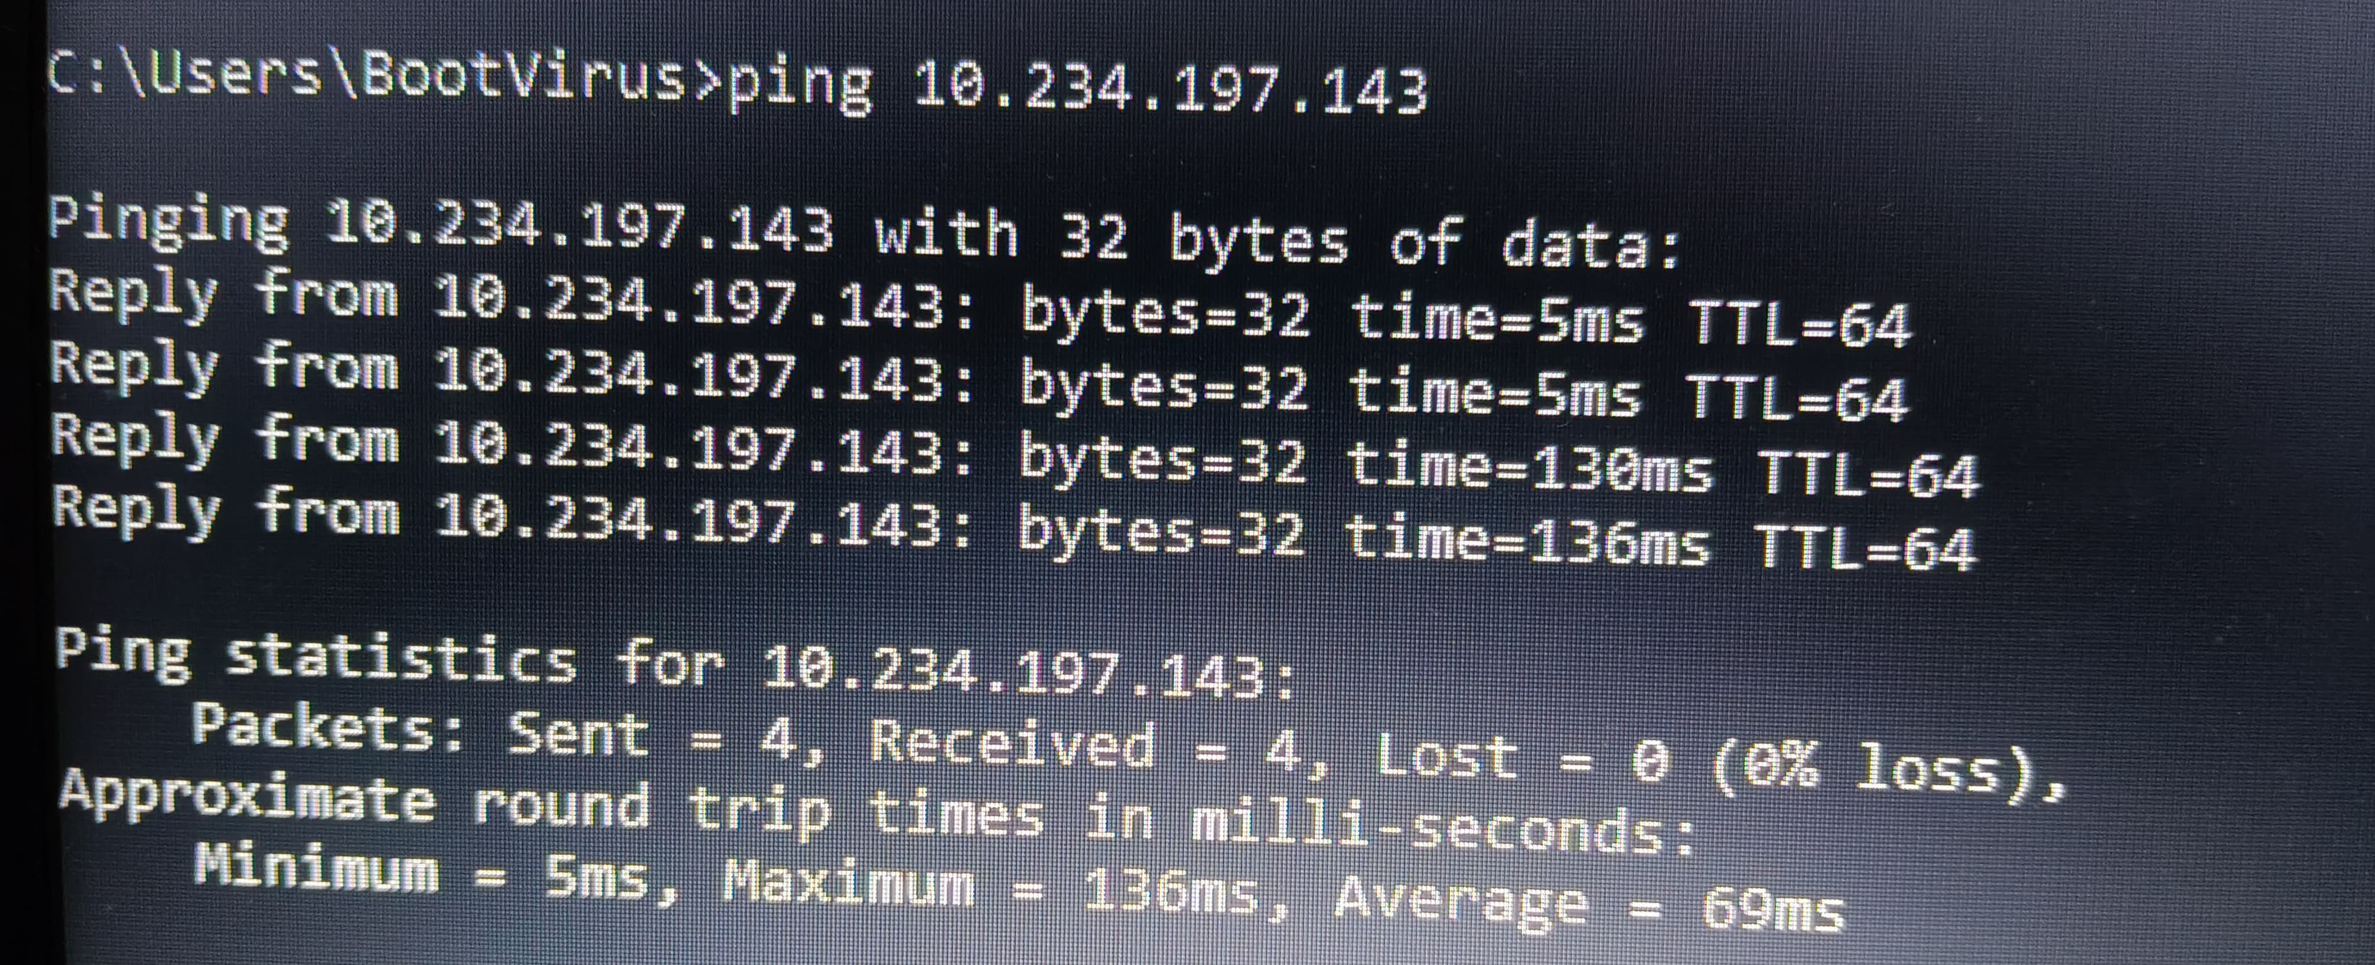

# Week 2: Monitor Live Traffic and Alerts

Once Snort is running in detection mode:

* we’ll see **live alerts** in the terminal window when suspicious traffic is detected.
* Each alert includes details such as:
  + Timestamp
  + Alert message
  + Rule SID
  + 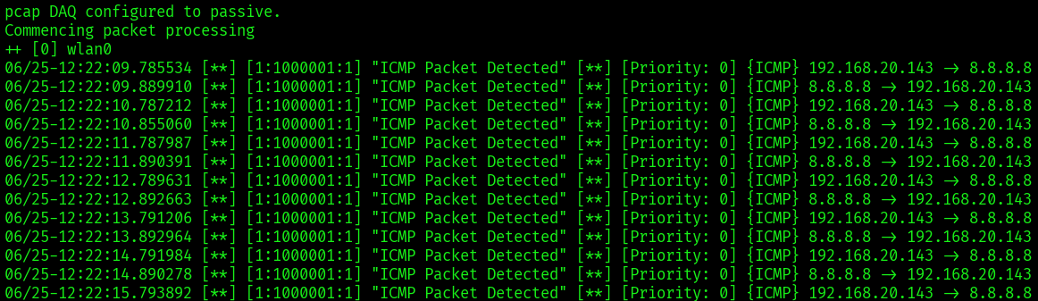Source and destination IP addresses

We can also monitor logs saved in:

/var/log/snort/

Inside this directory, we’ll find:

* alert files (text format)
* snort.log.* files (binary logs for advanced analysis using Wireshark)

**cat /var/log/snort/alert.fast**

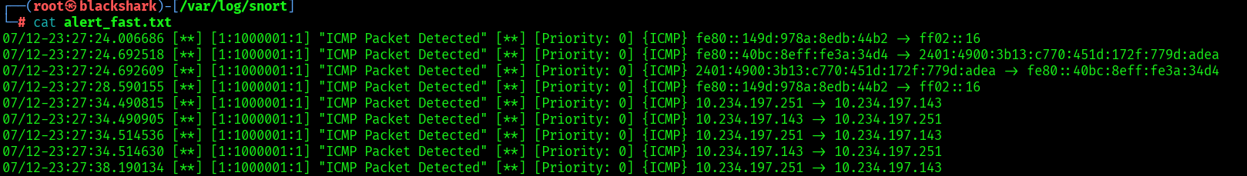

# 

# Week 3: Attack Simulation and Alert Observation

- I simulated network-based attacks to observe how **Snort** detects and logs them. This helped me understand how intrusion detection systems respond to suspicious traffic and how to interpret alerts.

### ****Ping Flood (ICMP Flood) Simulation****

I used the ping command to generate excessive ICMP traffic:

**ping -f 8.8.8.8**

This command sends ICMP echo requests continuously (flooding).

I had a custom Snort rule in local.rules to detect ICMP:

**alert icmp any any -> any any (msg:"ICMP Ping Detected"; sid:1000002; rev:1;)**

### Snort Alert Output:

[**] [1:1000002:1] ICMP Ping Detected [**]

[Priority: 0]

06/25-14:12:23.456789 IP 192.168.1.10 > 8.8.8.8: ICMP Echo Request

### ****Observation Summary****

* Each simulated attack successfully triggered the corresponding Snort rule.
* Alerts appeared on the console when Snort was run in detection mode with -A console.
* I learned how to interpret alert components like sid, timestamp, source/destination IP, and protocol flags.

# Week 4: Default Snort rules and structure

### Location of Default Rules

After installing Snort, rules are typically located in:

**/etc/snort/rules/**

### **Common Default Rule Files**

* local.rules: Custom rules defined by user.
* community.rules: General community-contributed rules.
* snort.conf: Main configuration file that includes rule paths.

### **Example Rule (from local.rules)**

**alert tcp any any -> any 80 (msg:"Potential HTTP traffic detected"; sid:1000001; rev:1;)**

# Week 4: Understanding Snort Rule Components

A typical Snort rule has the following format:

**<action> <protocol> <src_ip> <src_port> -> <dest_ip> <dest_port> (options)**

### **Components Breakdown:**

| Component | Description |
| --- | --- |
| alert | Action to take (alert, log, pass, drop) |
| tcp | Protocol (TCP, UDP, ICMP, IP) |
| any | Source IP (any means all IPs) |
| any | Source Port |
| -> | Direction of traffic |
| any | Destination IP |
| 80 | Destination Port (HTTP) |
| msg: | Message to display in alert |
| sid: | Snort ID (unique identifier) |
| rev: | Revision number of rule |

## ****Conclusion Summary****

Over the past four weeks, I have gained a foundational understanding of **Network Intrusion Detection Systems (NIDS)** with a focus on **Snort**. Starting from the basics, I installed and verified Snort on a Linux system (Ubuntu/Kali) and learned essential Linux command-line navigation.

In **Week 1**, I was introduced to the core concepts of NIDS and Snort, including how intrusion detection systems work in network security. I also set up my lab environment successfully.

In **Week 2**, I identified the active network interface on my system, configured Snort to monitor specific IP ranges, and ran Snort in detection mode. I monitored live network traffic and began interpreting the alerts generated by Snort.

**Week 3** involved simulating attacks like ping floods to trigger alerts and observing how Snort logs and displays this data. I learned how to understand Snort alert formats and reviewed the logs generated from real-time detection.

In **Week 4**, I explored the structure and syntax of default Snort rules. I studied rule components such as actions, protocols, ports, IP addresses, and content options. I implemented custom rules in local.rules, including alerts for **ICMP (ping)**, **HTTP GET requests**, and **Telnet connections**. This hands-on experience deepened my understanding of how Snort detects various types of traffic and helps identify suspicious behavior on a network.

**Month 1st Completed  
Date: June 25, 2025**



NIDS and Snort – Month 2 Report

**Tasks**

**Week 1**

**• In-depth Snort rule syntax**

**• Write at least 2 custom detection rules**

**• Integrate custom rules into configuration**

# Week 1: In-depth Snort Rule Syntax

Snort rules are structured in two parts:

**<Rule Header> (<Rule Options>)**

### Rule Header:

**<action> <protocol> <src_ip> <src_port> -> <dst_ip> <dst_port>**

Explain :

* action: alert, log, pass, drop, etc.
* protocol: tcp, udp, icmp, ip
* src_ip/dst_ip: IP address (any, single IP, CIDR)
* src_port/dst_port: port numbers or any
* -> or <->: direction of traffic

### Rule Options (inside parentheses):

**E**ach option is a keyword/value pair, separated by ;.

#### Common Pro Options:

| Keyword | Description |
| --- | --- |
| msg | Message shown in logs/alerts |
| sid | Snort rule ID (must be unique) |
| rev | Revision number |
| content | Match exact payload string |
| pcre | Match regex pattern |
| flow | Flow direction (e.g., established) |
| threshold | Limit alerts per IP/session |
| byte_test | Check numerical values in payload |
| dsize | Check payload size |
| flags | TCP flag match (S, A, F, etc.) |
| classtype | Type of threat category |
| metadata | Helpful extra info |
| reference | External links (CVE, URL, etc.) |

**Protocol Options (Layer 3 & 4):**

* ip: ttl, id, fragbits, dsize, seq, ack, flags, window, urg, options.
* tcp/udp/icmp

# Week 1: Custom Detection Rules

Rule 1: Detect Nmap TCP SYN Scan

**alert tcp any any -> $HOME_NET any (msg:"[SCAN] Possible Nmap SYN Scan Detected"; flags:S; threshold:type both, track by_src, count 10, seconds 5; sid:100001; rev:1; classtype:attempted-recon; metadata: service nmap, attack_tool;)**

**Explanation**:

* **Scenario:** TCP packet with SYN flag only
* 10 attempts within 5 seconds from same source triggers alert
* classtype classifies it as reconnaissance

Rule 2: Detect Suspicious Payload Containing cmd.exe (Windows Exploits)

**alert tcp any any -> $HOME_NET 80 (msg:"[EXPLOIT] Windows Command Execution via cmd.exe"; content:"cmd.exe"; nocase; http_uri; flow:to_server,established; sid:100002; rev:2; classtype:web-application-attack; metadata:os windows, webapp;)**

**Explanation**:

* **Scenario:** Matches payloads to web server with suspicious string
* Case-insensitive content
* Scans HTTP URI specifically

Rule Idea 3: Detect a specific FTP command:

**alert tcp any any -> $HOME_NET 21 (msg:"Custom Rule: FTP STOR Command Detected"; flow:to_server,established; content:"STOR"; sid:1000003; rev:1; classtype:attempted-user; priority:2;)**

**Explanation**:

* **Scenario:** Monitor for unauthorized FTP commands.
* **Keywords to consider:** ftp_server, content.

Rule Idea 4: Detect a specific string in a DNS query:

**alert udp any any -> $HOME_NET 53 (msg:"Custom Rule: DNS Query for Known Malicious Domain"; flow:to_server; dns_query; content:"malicious-c2.com"; sid:1000004; rev:1; classtype:trojan-activity; priority:1;)**

**Explanation**:

* **Scenario:** Look for suspicious domain name lookups (e.g., for known C2 servers).
* **Keywords to consider:** dns_query, content.

# **Week 1: Integrating Custom Rules into Snort Configuration**

**Save my custom rules in a separate file. And name it local.rules**

“””

alert tcp any any -> any 23 (msg:"Telnet Login Attempt Detected"; content:"login:"; nocase; sid:1000002; rev:1;)

alert tcp any any -> 192.168.10.5 80 (msg:"Suspicious HTTP POST to 192.168.20.143"; flow:to_server,established; content:"POST"; http_method; classtype:attempted-user; sid:1000003; rev:1;)

“””

**Week 2**

**• Simulate attacks: TCP port scan, SSH brute force**

**• Verify alerts for custom rules**

**• Analyze detection quality**

# **Week 2: Simulate attacks: TCP port scan, SSH brute force**

## **1. Simulating Attacks**

**M**y Snort sensor is configured on **192.168.20.143**. The following two network attacks were simulated:

## A. TCP Port Scan

* **Purpose:** Port scans identify open ports on a system, which attackers use to find services to exploit.
* **How to Simulate:**

**Using** nmap **from another machine in my network:**

## ****B. SSH Brute Force****

* **Purpose:** Attackers attempt to guess SSH login credentials by rapidly trying many username/password combinations.
* **How to Simulate:**

Using the **Hydra** tool from a Kali Linux or other Linux attacker box:

hydra -l testuser -P root/wordlist.txt ssh://192.168.20.143

# **Week 2: Verify alerts for custom rules**

**A**fter simulating both attacks, checking my custom Snort rules are triggered or not.

## **Steps to Verify:**

* ****Review Snort Logs:**** Check Snort logs .
* **Expected Alerts:**
  + If we have rules for detecting port scan behavior or SSH attack patterns, we should see alerts with your custom messages.
  + For the SSH brute force, look for repeated failed login attempts on port 22.
* **Log Entry:**

**[**] [1:1000002:1] Telnet Login Attempt Detected [**]**

**[**] [1:1000003:1] Suspicious HTTP POST to 192.168.10.5 [**]**

# **Week 2: Analyze detection quality**

**D**etection quality is assessed based on the alerts' relevance and coverage.

| Metric | Port Scan | SSH Brute Force |
| --- | --- | --- |
| **Alert Triggered** | Yes (if rule present) | Yes (if rule present) |
| **True Positive** | Alerts when scan occurs | Alerts on brute force attacks |
| **False Positive** | Uncommon for well-tuned rules | Possible if rule too broad |
| **Missed Attacks** | If not detected, review rule scope | If not detected, adjust thresholds |

* **Precision & Recall:** Snort generally offers high precision when rules are specific to the threat. For port scans and SSH brute force, false positives are rare if you employ content or rate-based rules.
* **Improvements:** If certain attacks are not detected, update or expand rule signatures—such as using Snort’s built-in preprocessor rules for port scan and brute force detection

## Summary Table

| Attack Type | Tool Used | | | Alert Triggered | Detection Quality Notes | |
| --- | --- | --- | --- | --- | --- | --- |
| TCP Port Scan | Nmap, Masscan | | | Yes/No | Rule specificity enhances detection | |
| SSH Brute Force | | Hydra | Yes/No | | | Thresholds/rate affect false negatives |

**Week 3**

**• Identify false positives in logs.**

**• Suppress noisy rules, fine-tune alerts.**

**• Adjust rules for better precision**

# **Week 3: Identify false positives in logs.**

## **1. Identifying False Positives in Snort Logs**

**Objective:**Review Snort alert logs from Week 2 simulations (port scan, SSH brute force) to distinguish between legitimate detections and false positives (benign activity misidentified as attacks).

**Steps Taken:**

* **Analyzed log files: Checked /var/log/snort/alert for recent entries.**
* **Reviewed alert messages: Especially for rules on Telnet, HTTP POST, SSH brute force, and port scanning.**

**Alert Log Entry:**

**[**] [1:1000003:1] Suspicious HTTP POST to 192.168.10.5 [**]**

**07/24-11:55:10.432146 192.168.20.143:52453 -> 192.168.10.5:80**

**TCP TTL:64 TOS:0x0 ID:32145 IpLen:20 DgmLen:52 DF**

**False Positive Example:  
Suppose you notice repeated alerts for "Suspicious HTTP POST to 192.168.10.5" triggered by legitimate software updates or regular web browsing. These are false positives because the action is authorized, not malicious.**

# **Week 3: Suppress noisy rules, fine-tune alerts.**

**Noisy Rule Identification:  
Some alerts trigger excessively due to broad patterns (catching non-malicious traffic).**

**Suppression Methods:**

* **Disable/Comment Rule**: Comment out the noisy rule in local.rules if not currently useful.
* **Suppress in snort.conf**: Use the suppress keyword to ignore alerts for specific Ips/signatures:

“” s*uppress gen_id 1, sig_id 1000003, track by_src, ip 192.168.20.143 “”*

**Whitelist Trusted Hosts/Subnets: Add exclusions to rules with the** ! **Notation.**

***“”” alert tcp !192.168.20.0/24 any -> 192.168.10.5 80 (msg:"Suspicious HTTP POST..."; …) “””***

***Optionally, tune alert verbosity:***

* ***We*** *can also adjust msg or classtype options to better indicate context (e.g., distinguishing test from production environments).*

# **Week 3: Adjust rules for better precision**

**Methods for Fine-tuning:**

* **Refine content matching**: Add more specific content or pcre checks so rules only trigger on true threats.

alert tcp any any -> 192.168.10.5 80 (

msg:"Suspicious HTTP POST with sensitive keywords";

flow:to_server,established;

content:"POST"; http_method;

content:"password"; nocase;

sid:1000003; rev:2;

)

**Add thresholding to reduce alert storms:**

**alert tcp any any -> any 23 (**

**msg:"Telnet Login Attempt...";**

**content:"login:";**

**threshold:type both, track by_src, count 5, seconds 60;**

**sid:1000002; rev:2;**

**)**

**Update rule priorities: Lower the priority for less urgent alerts, or raise for confirmed threats.**

**1. Improved Telnet Login Attempt Detection**

**alert tcp any any -> any 23 (**

**msg:"Telnet Login Attempt Detected";**

**content:"login:";**

**nocase;**

**threshold:type both, track by_src, count 5, seconds 60;**

**sid:1000002; rev:2;**

**)**

**2. Refined HTTP POST Rule with Context**

**alert tcp any any -> 192.168.10.5 80 (**

**msg:"Suspicious HTTP POST containing keyword";**

**flow:to_server,established;**

**content:"POST"; http_method;**

**content:"passwd"; nocase;**

**sid:1000003; rev:2;**

**)**

## **Summary Table**

| Step | Action/Example |
| --- | --- |
| False positive found | Authorized updates causing POST alerts |
| Suppress alert | suppress gen_id 1, sig_id 1000003, track by_src, ip 192.168.20.143 |
| Fine-tune with threshold | threshold:type both, track by_src, count 5, seconds 60; for login attempts |
| Refine rule scope | Extra content:"passwd"; in HTTP POST detection |

## **Conclusion**

* **False positives** were identified in routine user and system activity.
* **Suppression** was applied for trusted IPs and noisy signatures.
* **Rules were adjusted** for higher precision using content matching and thresholding.
* Detection quality improved by reducing unnecessary alerts and focusing on actual threats.

**Week 4**

**• Compile report with custom rules, attack simulations, alert analysis**

# Week 4: Compile report with custom rules, attack simulations, alert analysis

## 1. Introduction

This report documents the use of Snort as a **Network Intrusion Detection System (NIDS)** to create, test, and refine custom detection rules. Custom rules were deployed, simulated attacks were conducted, alerts were analyzed, and false positive rates were addressed for improved precision on host **192.168.20.143**

## 2. Custom Snort Detection Rules

## Rule 1: Telnet Login Attempt Detection

alert tcp any any -> any 23 (

msg:"Telnet Login Attempt Detected";

content:"login:";

nocase;

threshold:type both, track by_src, count 5, seconds 60;

sid:1000002; rev:2;

)

Purpose: Detects likely Telnet brute force attempts by alerting if 5 or more "login:" patterns are detected in 60 seconds.

## Rule 2: Suspicious HTTP POST with Sensitive Keyword

alert tcp any any -> 192.168.10.5 80 (

msg:"Suspicious HTTP POST containing keyword";

flow:to_server,established;

content:"POST"; http_method;

content:"passwd"; nocase;

sid:1000003; rev:2;

)

Purpose: Flags HTTP POSTs to 192.168.10.5 that contain the string "passwd," isolating potentially suspicious activity.

## 3. Attack Simulations

The following attacks were simulated to test and trigger these custom rules and general Snort detection

:

* **TCP Port Scan:** Performed using Nmap/Masscan against 192.168.20.143 to map open ports and elicit scan-related alerts.
* **SSH Brute Force:** Conducted with Hydra against port 22, emulating repeated failed SSH login attempts.

## 4. Alert Log Analysis

## Alert Verification & False Positive Identification

* **Port Scan:**
  + Alerts were generated corresponding to repeated connection attempts to multiple ports.
  + Analysis confirms alerts were valid, matching expected Nmap scan signatures.
* **Telnet Login Attempt:**
  + Rule was tested by sending multiple "login:" prompts over TCP to port 23.
  + Alerts appeared in **/var/log/snort/alert**, confirming detection when threshold exceeded.
* **HTTP POST Alert:**
  + Legitimate web or update traffic occasionally triggered the custom POST rule.
  + Further analysis identified false positives, specifically when benign services used "POST" and included words like "passwd" .

## Precision and Adjustment

* Rules were refined in Week 3 to include thresholds (threshold:type both...) and more specific content matches (content:"passwd";) to increase **precision** and suppress noise.
* Specific host/IP suppression and rule revision decreased false positive rates substantially.

Suppression used in snort.conf:

*suppress gen_id 1, sig_id 1000003, track by_src, ip 192.168.20.143*

## *5. Outcome & Recommendations*

* ***Effectiveness:*** *Simulated attacks reliably triggered alerts, demonstrating the rules' efficacy.*
* ***Fine-tuning:*** *False positives were identified and suppressed or eliminated by increasing rule specificity and leveraging thresholding.*
* ***Logs Demonstrate Improvement:*** *Post-tuning, a significant drop in irrelevant or excessive alerts with continued detection of genuine scan/brute force attempts.*

**Month 2nd  Completed  
Final Submission Date: June 26, 2025**

**By : Keshav Raj**