# 系统模块

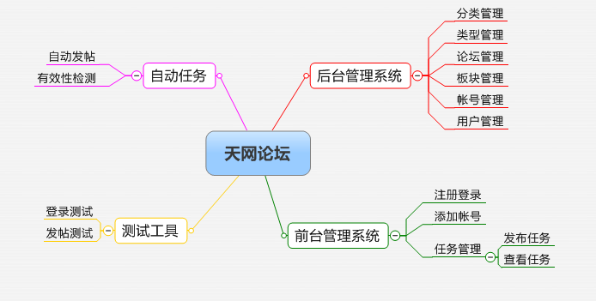

### 1.1后台管理模块

#### 1.1.1分类管理

暂时直接在数据库里操作

#### 1.1.2类型管理

暂时直接在数据库里操作

#### 1.1.3论坛管理

#### 1.1.4板块管理

#### 1.1.5帐号管理

#### 1.1.6用户管理

### 1.2前台管理模块

### 1.3自动任务

### 1.4测试工具

# 数据字典

论坛大全网站:

<http://www.bbs178.com/>

<http://top.daqi.com/>

论坛分类:

|  |  |  |  |
| --- | --- | --- | --- |
| **分类目录** | | | |
| http://www.bbs178.com/images/dot01.gif | [综合论坛](http://www.bbs178.com/list2.php?c=&t=1) | http://www.bbs178.com/images/dot01.gif | [旅游名胜](http://www.bbs178.com/list2.php?c=&t=3) |
| http://www.bbs178.com/images/dot01.gif | [房地产](http://www.bbs178.com/list2.php?c=&t=2) | http://www.bbs178.com/images/dot01.gif | [建筑装饰](http://www.bbs178.com/list2.php?c=&t=4) |
| http://www.bbs178.com/images/dot01.gif | [金融财经](http://www.bbs178.com/list2.php?c=&t=61) | http://www.bbs178.com/images/dot01.gif | [体育健身](http://www.bbs178.com/list2.php?c=&t=62) |
| http://www.bbs178.com/images/dot01.gif | [文化艺术](http://www.bbs178.com/list2.php?c=&t=72) | http://www.bbs178.com/images/dot01.gif | [文学小说](http://www.bbs178.com/list2.php?c=&t=76) |
| http://www.bbs178.com/images/dot01.gif | [教育考试](http://www.bbs178.com/list2.php?c=&t=77) | http://www.bbs178.com/images/dot01.gif | [校园学校](http://www.bbs178.com/list2.php?c=&t=78) |
| http://www.bbs178.com/images/dot01.gif | [设计创作](http://www.bbs178.com/list2.php?c=&t=83) | http://www.bbs178.com/images/dot01.gif | [电脑网络](http://www.bbs178.com/list2.php?c=&t=74) |
| http://www.bbs178.com/images/dot01.gif | [摄影贴图](http://www.bbs178.com/list2.php?c=&t=75) | http://www.bbs178.com/images/dot01.gif | [数码家电](http://www.bbs178.com/list2.php?c=&t=87) |
| http://www.bbs178.com/images/dot01.gif | [音乐影视](http://www.bbs178.com/list2.php?c=&t=81) | http://www.bbs178.com/images/dot01.gif | [游戏动漫](http://www.bbs178.com/list2.php?c=&t=80) |
| http://www.bbs178.com/images/dot01.gif | [少年儿童](http://www.bbs178.com/list2.php?c=&t=88) | http://www.bbs178.com/images/dot01.gif | [妇婴育儿](http://www.bbs178.com/list2.php?c=&t=89) |
| http://www.bbs178.com/images/dot01.gif | [美食消费](http://www.bbs178.com/list2.php?c=&t=85) | http://www.bbs178.com/images/dot01.gif | [休闲娱乐](http://www.bbs178.com/list2.php?c=&t=79) |
| http://www.bbs178.com/images/dot01.gif | [汽车摩托](http://www.bbs178.com/list2.php?c=&t=73) | http://www.bbs178.com/images/dot01.gif | [健康卫生](http://www.bbs178.com/list2.php?c=&t=82) |
| http://www.bbs178.com/images/dot01.gif | [情感交友](http://www.bbs178.com/list2.php?c=&t=84) | http://www.bbs178.com/images/dot01.gif | [农林牧渔](http://www.bbs178.com/list2.php?c=&t=86) |
| http://www.bbs178.com/images/dot01.gif | [时装时尚](http://www.bbs178.com/list2.php?c=&t=90) | http://www.bbs178.com/images/dot01.gif | [美容减肥](http://www.bbs178.com/list2.php?c=&t=91) |
| http://www.bbs178.com/images/dot01.gif | [法律律师](http://www.bbs178.com/list2.php?c=&t=92) | http://www.bbs178.com/images/dot01.gif | [军事时事](http://www.bbs178.com/list2.php?c=&t=93) |
| http://www.bbs178.com/images/dot01.gif | [人才职客](http://www.bbs178.com/list2.php?c=&t=94) | http://www.bbs178.com/images/dot01.gif | [科技技术](http://www.bbs178.com/list2.php?c=&t=95) |
| http://www.bbs178.com/images/dot01.gif | [财会税务](http://www.bbs178.com/list2.php?c=&t=96) | http://www.bbs178.com/images/dot01.gif | [宗教信仰](http://www.bbs178.com/list2.php?c=&t=97) |
| http://www.bbs178.com/images/dot01.gif | [营销管理](http://www.bbs178.com/list2.php?c=&t=98) | http://www.bbs178.com/images/dot01.gif | [新闻媒体](http://www.bbs178.com/list2.php?c=&t=99) |
| http://www.bbs178.com/images/dot01.gif | [公司企业](http://www.bbs178.com/list2.php?c=&t=100) | http://www.bbs178.com/images/dot01.gif | [交通运输](http://www.bbs178.com/list2.php?c=&t=101) |