# Module 2 - Assignment 2

## Black, Tyler

### Introduction to R Markdown

This document serves as an introduction to R Markdown. The R code in the following document will cover R data types, graphs, and common packages. The code produced here was introduced in an earlier assignment.

The code underneath this paragraph plots two vectors, sales on the x-axis and month on the y-axis using the package tidyverse and the function qplot.

library(ggplot2)  
library(tidyverse)

## ── Attaching core tidyverse packages ──────────────────────── tidyverse 2.0.0 ──  
## ✔ dplyr 1.1.4 ✔ readr 2.1.5  
## ✔ forcats 1.0.0 ✔ stringr 1.5.1  
## ✔ lubridate 1.9.3 ✔ tibble 3.2.1  
## ✔ purrr 1.0.2 ✔ tidyr 1.3.1  
## ── Conflicts ────────────────────────────────────────── tidyverse_conflicts() ──  
## ✖ dplyr::filter() masks stats::filter()  
## ✖ dplyr::lag() masks stats::lag()  
## ℹ Use the conflicted package (<http://conflicted.r-lib.org/>) to force all conflicts to become errors

sales <- c(50,150,200,100,300,250)  
month <- c(1,2,3,4,5,6)  
qplot(month,sales)

## Warning: `qplot()` was deprecated in ggplot2 3.4.0.  
## This warning is displayed once every 8 hours.  
## Call `lifecycle::last_lifecycle_warnings()` to see where this warning was  
## generated.

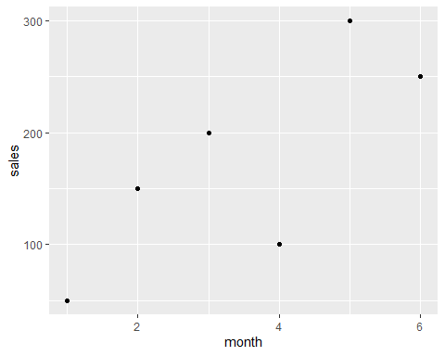

What month had the largest sales? What was the amount? -> Month 5 and 300

months <- c('Jan','Feb','Mar', 'Apr', 'May','Jun','Jul','Aug','Sep','Oct','Nov',  
 'Dec')  
month <- months  
sales <- c(150.25, 258.54, 268.55, 122.52, 987, 458.82, 667.23, 845.54, 586.78,   
 888.58, 756.12, 456.84)  
Yearly_Sales <- data.frame(month,sales)  
qplot(Yearly_Sales$sales, Yearly_Sales$month)

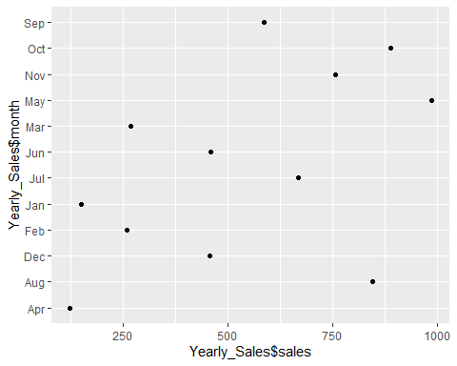

Which month had the most sales? May  
Which month had the least sales? April