# Module 3 - Assignment 3

## Black, Tyler

### More Practice with Plots

library(tidyverse)

## ── Attaching core tidyverse packages ──────────────────────── tidyverse 2.0.0 ──  
## ✔ dplyr 1.1.4 ✔ readr 2.1.5  
## ✔ forcats 1.0.0 ✔ stringr 1.5.1  
## ✔ ggplot2 3.5.1 ✔ tibble 3.2.1  
## ✔ lubridate 1.9.3 ✔ tidyr 1.3.1  
## ✔ purrr 1.0.2   
## ── Conflicts ────────────────────────────────────────── tidyverse_conflicts() ──  
## ✖ dplyr::filter() masks stats::filter()  
## ✖ dplyr::lag() masks stats::lag()  
## ℹ Use the conflicted package (<http://conflicted.r-lib.org/>) to force all conflicts to become errors

library(readr)  
GOOG <- read_csv("GOOG.csv", col_types = cols(Date = col_date(format = "%Y-%m-%d")))

#### Google Stock Price Plots

The following is an analysis of Google’s stock price from October of 2019 to October of 2020. This will include a scatter, line, bar, histogram and boxplot. All the plots represent the closing price on the dates listed on the x-axis.

ggplot(data=GOOG,aes(x=Date,y=Close)) +  
 geom_point()

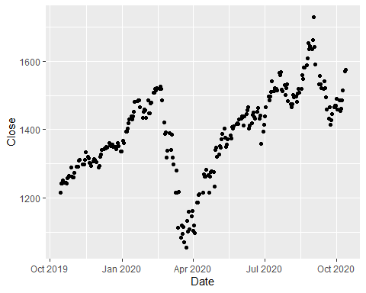

ggplot(data=GOOG,aes(x=Date,y=Close)) +  
 geom_line()

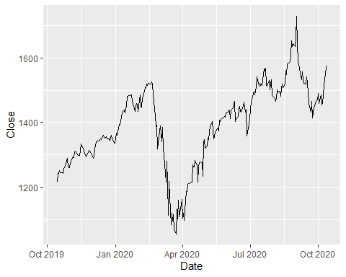

ggplot(data=GOOG,aes(x=Date, y= Close)) +  
 geom_col()

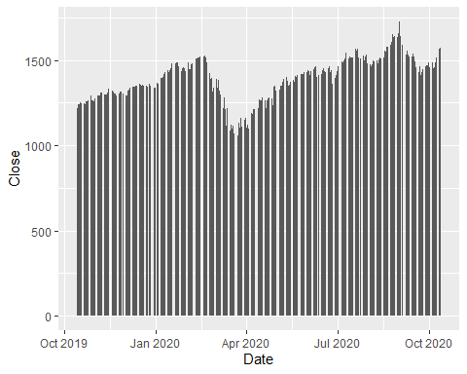

ggplot(data=GOOG,aes(x=Close)) +  
 geom_histogram(binwidth = 75)

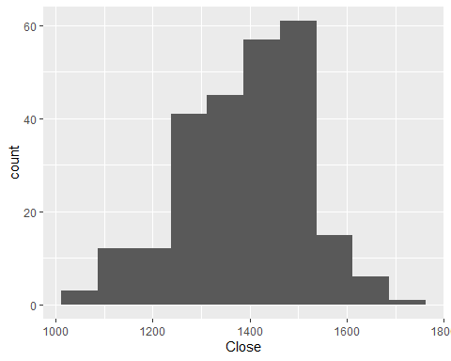

ggplot(data=GOOG,aes(x=Close)) +  
 geom_boxplot()

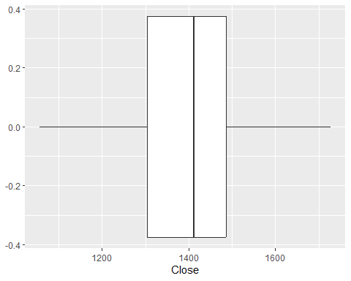

ggplot(data=GOOG,aes(x=Date,y=Close)) +  
 geom_line() +  
 geom_point()

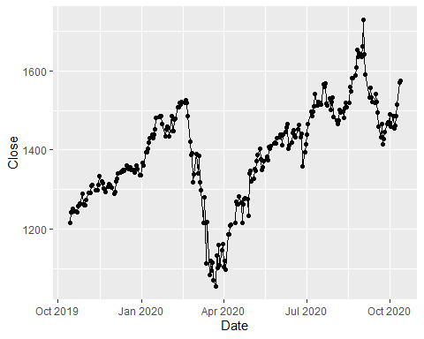

You have created many different plots of the same data but some are more helpful than others. Based on the plots you created, which one do you find most useful and why?  
**I find the line graph with the points included to be the most useful since the data is continuous and the graph helps illustrate the continuous trend of closing stock prices during the time frame. Additionally, I think the histogram is quite useful since histograms portray continuous data quite well**

#### Google Stock Daily Price Comparisons

For the next section, we will be comparing the open/close prices as well as the high/low prices within the GOOG dataset.

ggplot(GOOG) +  
 geom_line(aes(x=Date,y=High,color = 'High')) +  
 geom_line(aes(x=Date,y=Low,color = 'Low'))

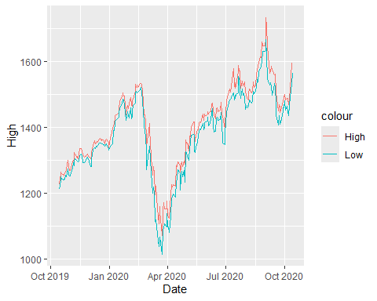

ggplot(GOOG) +  
 geom_line(aes(x=Date,y=Close,color = 'Close')) +  
 geom_line(aes(x=Date,y=Open,color = 'Open'))

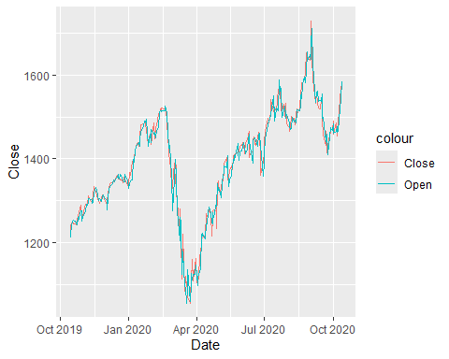

ggplot(GOOG,aes(x=Date,y=Close)) +  
 geom_area(color = 'black', fill = 'blue',alpha = .2)

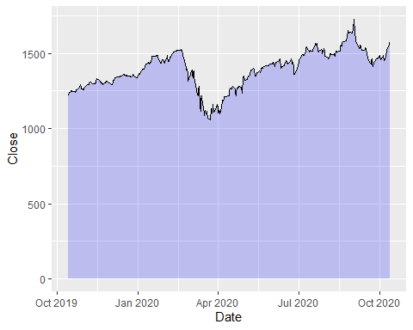

ggplot(GOOG,aes(x=Date,y=Open)) +  
 geom_area(color = 'blue', fill = 'green',alpha = .10)

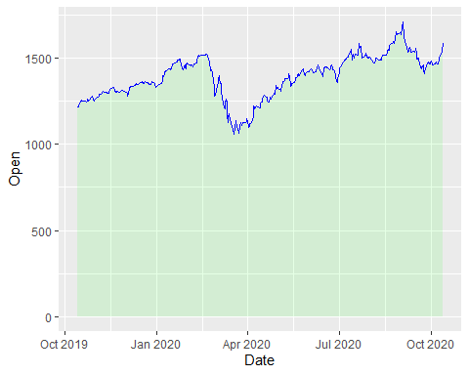

MayPrice = subset(GOOG,Date > '2020-04-30' & Date < '2020-06-01')  
  
ggplot(data= MayPrice, aes(x=Date, y= Close)) +  
 geom_point() +  
 geom_text(aes(label = round(Close)), size = 3, vjust = -1)

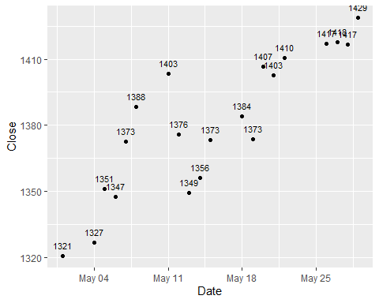

AprilPrice = subset(GOOG,Date > '2020-03-31' & Date < '2020-05-01')  
  
ggplot(data= AprilPrice, aes(x=Date, y= Open)) +  
 geom_point() +  
 geom_text(aes(label = round(Open)), size = 2, vjust = 1.5)

