BLACKWELL ENTERPRISES
Public Goods
AI Visibility Audit
An external audit of how six AI platforms see Public Goods today. And what we would do about it.

Prepared for Public Goods leadership
Date May 27, 2026
Contact armaan.priyadarshan.29@dartmouth.edu
Prepared by Armaan Priyadarshan, Samarjit Deshmukh, Ethan Zhou, Shamit D’Souza
Dartmouth Math & CS · Dartmouth CS · UC Berkeley MET (EECS & Business) · Stanford CS & Biology

Executive Summary
Three findings any Public Goods prospect can verify in five minutes using ChatGPT or Google. Each is currently shaping what AI engines tell prospects about the brand.

1 | AI engines tell prospects Public Goods is a scam.  ChatGPT with web search surfaces the BBB F rating, the nine unanswered complaints, and verbatim "fraudulent membership" language from Trustpilot and Reddit. Three independent platforms carry the same complaint with the same wording: unauthorized membership renewals years after a single purchase. The brand’s domain is cited directly alongside the BBB record.  "BBB shows PublicGoods.com with an F rating, citing failure to respond to 9 complaints. Multiple 2025-2026 complaints about customers claiming they did not knowingly sign up for an annual membership." ChatGPT, web search on.

2 | Public Goods is absent from synthesized AI category recommendations.  Prompted "best sustainable household brands," ChatGPT names Blueland, Grove, Seventh Generation, and Dropps. Public Goods is not mentioned at any depth. The brand appears in 8 of 40 human-written third-party listicles we audited, at parity with Grove and Thrive. It disappears when AI engines synthesize their own rankings. No Wikipedia entity, no Wikidata, merchant-only Knowledge Panel, name collision with the economics concept.  The Knowledge Panel for Public Goods carries delivery thresholds and payment options but zero entity facts (no founder, no founding date, no HQ). AI engines pulling "what is Public Goods" from the Knowledge Graph get a merchant card and nothing else.

3 | The membership’s actual value is invisible to AI in every machine-readable surface.  The member discount, the entire reason to buy the membership, lives in no machine-readable field. JSON-LD has no priceSpecification. The product JSON endpoint has no member or tier pricing key. The static HTML carries 12 empty member-price spans filled by JavaScript at render time. ChatGPT consequently frames Public Goods as the priciest membership ($65) against Grove ($29.99) and Thrive ($59.95). The 20% discount that would change the math cannot be quantified.  Public Goods loses every head-to-head price comparison ChatGPT can synthesize, on grounds that are technically wrong. The number that would correct the comparison is not absent from the site, only from the machine-readable surface AI engines read.

Composite AI Visibility: D (52/100), lowest in the competitive set, 27 points behind the average. Three further findings (shipping contradiction, bait-and-switch from a deprecated offer, thin product schema) detailed after the scorecard.

AI Visibility Scorecard
We graded Public Goods on five dimensions of how AI engines treat the brand. Each dimension scored 0 to 100 against observed AI behavior across ChatGPT, Reddit, Trustpilot, BBB, and the brand’s own indexed pages. Composite is the simple average.
D  52 / 100  PUBLIC GOODS |  | Public Goods is the lowest-scoring brand in its competitive set, trailing the average by 27 points. The competitive average across Grove (B+), Thrive (B-), and Blueland (B+) is 79. Public Goods is at 52, the only sub-B grade in the category.  The transactional infrastructure is genuinely strong. Three of the five dimensions that drive AI behavior toward customers (quotability, recommendability, reputation) are failing. The brand pays the cost on every AI shopping query in the category.

Dimension | Public Goods | Grove | Thrive | Blueland | What it measures
Discoverability | 75 | 85 | 90 | 75 | Entity presence, agent discovery files, crawler access
Quotability | 40 | 75 | 90 | 80 | Schema depth, structured policies, accuracy in machine-readable form
Recommendability | 30 | 85 | 90 | 90 | Inclusion in AI category recommendations, credentials, listicle presence
Transactability | 80 | 80 | 30 | 75 | UCP, MCP, payment handlers, agent-readable pricing
Reputation | 35 | 80 | 65 | 80 | Sentiment in AI training corpus, BBB, review aggregator presence
Composite | 52 (D) | 81 (B+) | 73 (B-) | 80 (B+)

Grading scale: A 90+, B 75-89, C 60-74, D 50-59, F below 50.

The short version
Public Goods built sophisticated infrastructure for AI agents to transact with the store. AI engines never get that far. They do not recommend the brand in category queries. When asked about it directly, they surface a fraud-adjacent reputation, a deprecated offer the brand discontinued last year, and a shipping policy that contradicts itself across four pages.
Six findings, ordered worst first.
- BBB F rating with nine unanswered complaints surfaces in ChatGPT responses, alongside corroborating "scam" and "fraud" language from Reddit and Trustpilot. Three independent platforms carry the same complaint with the same wording: unauthorized membership renewals years after a single purchase. ChatGPT cites PublicGoods.com by domain when surfacing the BBB record.
- Public Goods is absent from every AI-synthesized "best sustainable brands" ranking we ran. ChatGPT with web search names Blueland, Grove, Seventh Generation, and Dropps as category leaders. Public Goods is not mentioned. Blueland is a smaller company than Public Goods.
- Member pricing is structurally invisible across every machine-readable surface. The membership’s actual value proposition cannot be quoted by any AI agent that does not render JavaScript. Public Goods loses every head-to-head comparison this way. ChatGPT frames the brand as the pricier option versus Grove and Thrive because the discount cannot be quantified.
- The free shipping policy yields six different correct answers across three customer cohorts and two contradicting source pages. ChatGPT noticed and flagged the internal contradiction unprompted in one test.
- A deprecated 40% membership offer is actively indexed and surfaces in ChatGPT responses to prospective new members. The page calls 40% the "best available discount." That offer was discontinued in April 2025. AI engines are bait-and-switching prospects with the brand’s own indexed content.
- PDP schema is materially thinner than Grove and Blueland. No SKU. No per-variant offers. No FAQPage schema on the 31 accordion FAQs already on the page.

ChatGPT, Perplexity, and Google AI Mode all moved to live web retrieval as default behavior in 2026. Every additional query that hits live retrieval rather than training data widens the gap between Public Goods and the competitive set. The damage compounds weekly.

FINDING 1 OF 6 · CRITICAL
AI engines tell prospects Public Goods is a scam
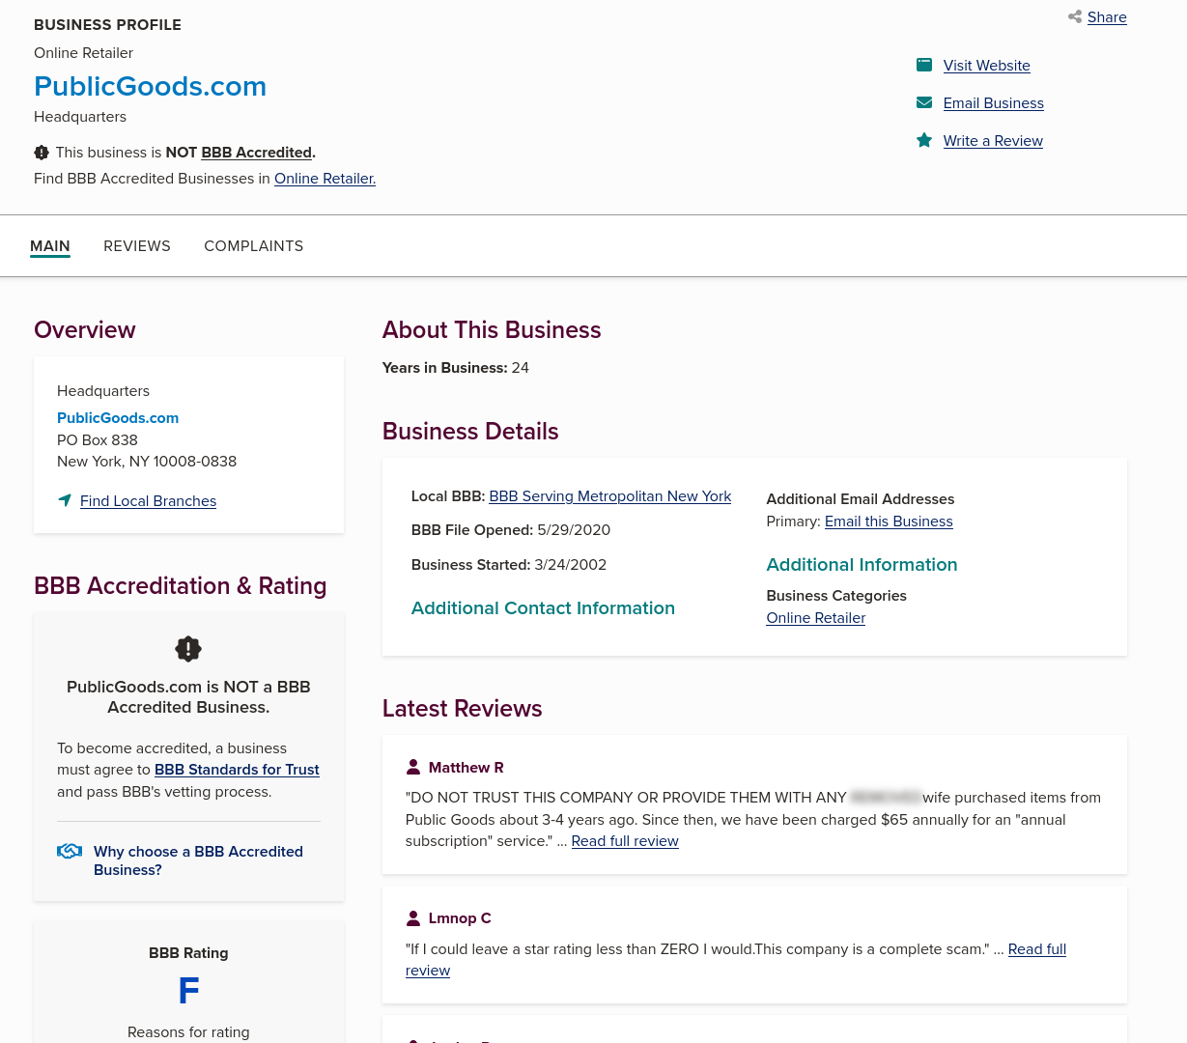 |  | 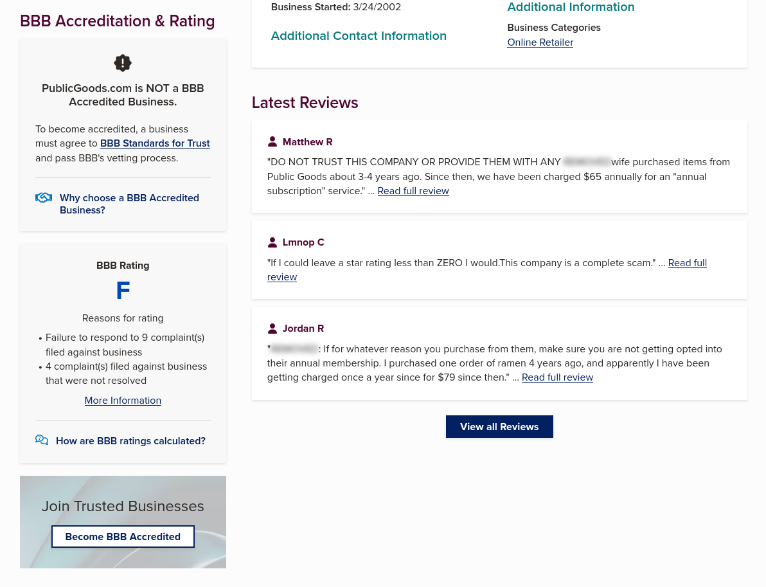
F rating. NOT BBB Accredited. 9 unanswered complaints. 4 unresolved. File opened 5/29/2020. Reviewer language: "DO NOT TRUST", "complete scam", "fraudulent annual subscription."
Three independent platforms, same complaint, same language
“Wife purchased items 3-4 years ago. We have been charged $65 annually for an ‘annual subscription’ service. (BBB)”
“Fraudulent membership fees charged years after one purchase. In 2025 I was charged $79 for a membership I never authorized. (Trustpilot, 1-star)”
“my bank caught it and flagged it as fraud. (Reddit r/ZeroWaste, in a thread titled "PSA: Public Goods is a scam")”
Additional Trustpilot 1-star titles, verbatim: "Fraudulent Cancellation Process" (canceled in January, charged March 18). "YOU CAN NEVER CANCEL!! Surreptitiously opted me into a membership." "Absolutely HORRENDOUS customer service… they gaslight you… I believe the 5 star reviews are not real." The word "Fraudulent" appears in two separate review titles. Reddit r/Scams also carries a 2024 thread: "Public Goods charged my card 4 years after purchase."
What ChatGPT tells a prospect today
Prompt with web search: "Public Goods customer complaints." Sources cited: bbb.org, trustpilot.com, reddit.com, publicgoods.com.
“BBB shows PublicGoods.com with an F rating, citing failure to respond to 9 complaints. Multiple 2025-2026 complaints about customers claiming they did not knowingly sign up for an annual membership.”

FINDING 2 OF 6 · CRITICAL
Public Goods does not exist in AI category awareness
Prompt: "Best sustainable household brands." ChatGPT with web search.
ChatGPT named four brands as category leaders, each with citable credentials:
- Blueland (best overall, citing B-Corp certification)
- Grove Collaborative (best one-stop, citing range and certifications)
- Seventh Generation
- Dropps
Public Goods was not in the main list. Not in honorable mentions. Not in a "consider also" section. The brand does not appear at any depth of the response.
Why this is the most expensive finding in the deck
Public Goods appears in 8 of 40 human-written third-party listicles we audited. The brand is in human consideration sets. It is not in AI consideration sets. As AI shopping recommendations replace human listicles in buyer journeys, this gap closes the funnel before it ever opens.
The brands ChatGPT named all have something to cite. Blueland and Grove have B-Corp certification. Public Goods has no surfaced credential. Grove (Q111170467) and Thrive (Q27150214) have Wikidata entities. Public Goods has none. The brand name also collides with the economics concept "public good," which dominates the SERP: four of the top eight organic Google results for "Public Goods" are the econ concept (Wikipedia "Public good", econlib, Investopedia, Khan Academy).
Three further signals AI engines weight
Merchant-only Knowledge Panel. Google’s Knowledge Panel for Public Goods exists, but it’s a commerce/merchant card (free delivery threshold, returns policy, payment options). Zero entity facts: no founder (Morgan Hirsh, founded 2016), no HQ, no founding date, no CEO. AI engines pulling "what is Public Goods" from the Knowledge Graph get nothing about the brand.
Negative Reddit ranks page 1 of Google for the brand’s own name. Search "publicgoods.com": position 7 is the r/ZeroWaste "PSA: Public Goods is a scam" thread. Search "Public Goods brand": position 3 is the r/BuyItForLife "Is Public Goods BIFL?" thread (upvote ratio 0.27). AI engines that crawl SERP for citations pick these up.
Absent from head-to-head comparison content. The top-ranking "best sustainable brand vs" article on Google is titled "Grove vs Blueland vs CleanCult vs Thrive vs Honest." Five brands compared in the category, none of them Public Goods. This is what ChatGPT pulls from when synthesizing comparison answers. Closing the gap is editorial and entity work, not Shopify theme work.

FINDING 3 OF 6 · HIGH SEVERITY
The membership’s actual value is invisible to AI
The entire reason to buy the membership is the lower price. That number exists in no machine-readable field anywhere on the site.
Three surfaces, all empty
JSON-LD on the natural shampoo PDP. One flat Offer at $19.95. No priceSpecification. No member tier. No eligibility logic. No SKU. No GTIN.
The /products/natural-shampoo.json endpoint. Rich data: real SKUs, real GTINs, inventory counts, full variant arrays, marketing copy. Zero member or tier pricing fields. The endpoint exposes a "Member Discount" tag as a string but no numeric discount.
Static HTML on the PDP. Twelve member-price spans. All empty. The actual member price is computed and injected by JavaScript at render time.
The competitive consequence we measured
Prompt: "Public Goods vs Grove Collaborative." ChatGPT with web search.
ChatGPT frames Public Goods as the more expensive membership: $65/year against Grove’s $29.99/year. The 20% discount that would offset this cannot be quantified because the member price is invisible. Public Goods loses every head-to-head this way. Same dynamic with Thrive ($59.95/year).
THIS IS NOT A GENERIC SHOPIFY THEME ISSUE
Member pricing as eligible-buyer schema requires custom UnitPriceSpecification with eligibleCustomerType, integrated with the Shopify customer-tag system, populated in both JSON-LD and the product JSON, and rendered server-side rather than client-side. No Shopify app does this out of the box for membership stores. The pattern requires specific schema knowledge and bespoke implementation work.

FINDING 4 OF 6 · HIGH SEVERITY
The shipping policy contradicts itself across four pages
Three customer cohorts. Two policy dimensions. Two source pages that disagree. Six possible correct answers, all crawlable, none mappable to the prospect.
Customer cohort | Free shipping rule | Source page
Members enrolled after 4/1/2025 | Free on all orders, no minimum | Membership info
Members enrolled before 4/1/2025 | Free on orders of $45+ | Legacy membership
Non-members | $45 minimum | FAQ page
Non-members | $65 minimum | Support page
ChatGPT flags the contradiction unprompted
Prompt with web search: "Does Public Goods offer free shipping?"
“Their current membership page also says members get free U.S. shipping on every order with no minimum required. The shipping FAQ on a different page lists the $45 threshold as universal for non-members, but the support page lists $65. The current threshold depends on which page is treated as authoritative.”
The policy is internally inconsistent enough that an AI engine flags it as a contradiction to the user. The user does not have to notice. ChatGPT volunteers the contradiction as part of the response.
Remediation requires more than picking one page and editing it. The policy must be unified across the FAQ, support, policy page, cart drawer, schema OfferShippingDetails, and the contradicting pages must be 301-redirected because AI engines have already cached the old versions.

FINDING 5 OF 6 · HIGH SEVERITY
AI is bait-and-switching the brand’s own prospects
The page at /pages/legacy-membership contains this sentence in its static, server-rendered HTML:
“automatically enrolled in our exclusive VIP Member program. This gives you the best available discount of 40% off most categories (30% off food items, regular pricing on frozen fish and plants), a special benefit…”
"Best available discount" implies the 40% rate is currently the best on offer. It is not. The April 2025 restructure moved new members to a flat 20%. Legacy members were grandfathered into the 40%. Nobody can sign up for that rate today.
Three things compound the problem:
- The page has no noindex meta directive or X-Robots-Tag header.
- The canonical URL is self-referencing. Public Goods is declaring the page the canonical version to index.
- It is present in sitemap_pages_1.xml. The site actively submits it to Google.
What ChatGPT does with it
Prompt with web search: "What discount do Public Goods members get?"
“20% off for new members. One caveat: Public Goods says legacy VIP members may keep a higher discount of 40% off most categories, 30% off food, and regular pricing on frozen fish and plants.”
Source cited: publicgoods.com
ChatGPT presents the deprecated offer as a live "caveat" to a new prospect. The prospect signs up, gets the 20%, and learns the 40% rate was never available to them. The brand’s own indexed content is producing the disappointment.
WHY THIS GETS WORSE OVER TIME
Every additional AI engine that adds live web retrieval is another engine pulling this page. The page is more useful to AI engines than to humans. Traffic to it is increasingly bots, which means its downstream impact is increasingly on AI responses, not on real customers seeing it directly.

FINDING 6 OF 6 · MEDIUM SEVERITY
Product detail schema is materially thinner than Grove and Blueland
Each Public Goods PDP carries 8 JSON-LD blocks (Product, Organization x2, BreadcrumbList, ProductGroup x2, WebPage, AggregateRating). The Product node has aggregateRating, brand, description, image, mpn, name, offers. What it does not have, by competitor benchmark:
- No SKU. sku field is null. Grove emits real SKUs (example: MM-37-030). Blueland too. Public Goods is the only one of the three with no SKU.
- No per-variant offers. One flat Offer at $19.95 collapses real Travel/Full/Refill/Set variants ranging $9.95 to $49.95. Grove emits five per-variant offers, each with its own price, GTIN-12, availability, and ?variant= deep link URL. ChatGPT cannot tell the agent which variant to buy.
- mpn holds the Shopify product ID, not a GTIN. Real barcodes (example: 810049440107) exist in /products/{handle}.json but never make it into JSON-LD. No usable identifier reaches AI catalog graphs.
- No FAQPage schema. The PDP carries 31 accordion FAQ mentions in HTML. Blueland exposes FAQPage. Public Goods does not. Schema.org Question and Answer nodes are how AI engines source PDP-level Q&A.
Blueland additionally exposes hasCertification and additionalProperty for kit composition. Public Goods exposes neither. The smallest brand in the competitive set carries the deepest product schema.

The trajectory: AI behavior is shifting against the brand
We ran every prompt twice: once with web browsing disabled (Pass 1, training-data-only), once with web browsing enabled (Pass 2, live retrieval). The gap between the two passes is the gap that AI engines close every week as live retrieval becomes default behavior across ChatGPT, Perplexity, and Google AI Mode.
Prompt category | Pass 1: no browsing | Pass 2: web search on
Discount question | Says 20%, the correct current rate. | Adds 40% as a current "caveat" by pulling the deprecated page.
Reputation question | "Legitimate, not a scam, but watch the membership terms." | Surfaces BBB F rating, 9 unanswered complaints, "fraudulent" verbatim.
Shipping question | Flat $45 minimum. | All three cohorts surfaced plus the FAQ-vs-Support contradiction flagged.
Category recommendation | Public Goods sometimes named alongside Grove and Thrive. | Public Goods absent. Blueland, Grove, Seventh Generation, Dropps named.

In 2024 a model’s training data was Public Goods’s primary AI exposure. In 2026 it is live retrieval, and the live retrieval surface is materially worse than the training data was. The deck before this page details why.

Competitive position
Same competitive set as the scorecard. This matrix details where Public Goods sits on the specific signals AI engines weight when deciding what to recommend and how to characterize a brand.
Signal | Public Goods | Grove | Thrive | Blueland
Wikipedia / Wikidata entity | No | Yes | Yes | No
B-Corp or comparable credential surfaced | No | Yes | Implicit | Yes
JSON-LD SKU on products | No | Yes | N/A | Yes
Per-variant offers in JSON-LD | No | Yes | N/A | Yes
FAQPage schema | No | No | No | Yes
llms.txt strategy | Protocol template | Protocol template | Massive content map | Content map
UCP / MCP discovery | Live | Live | Not present | Live
Trustpilot score | 4.3 / 687 | 4.9 / 1K+ | 4.3 | 4.5
BBB status | F, not accredited | Not flagged | Not flagged | Not flagged
Composite AI Visibility | 52 (D) | 81 (B+) | 73 (B-) | 80 (B+)

Three quick reads from the matrix. First, Public Goods’s transactional layer is at parity with Grove and Blueland and ahead of Thrive. The infrastructure investment was real. Second, every signal that drives AI recommendation behavior (entity, credentials, schema depth, llms.txt content) is where the gap lives. Third, the BBB F rating is a category outlier. Grove (4.9), Blueland (4.5), and Thrive (4.3) all maintain trust signals Public Goods does not.

Proposed engagement
Two phases. Phase 1 is a 30-day stabilization sprint that closes the bleeding. Phase 2 is ongoing AI visibility operations that take the composite score from D to B+ over four to six months. After Phase 1 we measure against benchmarks set together and decide whether Phase 2 makes sense.
PHASE 1 · 30-DAY STABILIZATION SPRINT
Eight specific remediations. Each closes a finding identified in this audit.
- noindex the deprecated 40% legacy-membership page, remove from sitemap. 1 line of code and a sitemap re-submit. Closes Finding 5.
- Unify the shipping policy across the FAQ, support page, membership info, and policy page. Add OfferShippingDetails schema. 301-redirect the contradicting versions. Closes Finding 4.
- Implement custom UnitPriceSpecification with eligibleCustomerType for member pricing. Populate in JSON-LD and product JSON. Render server-side. Closes Finding 3.
- Add per-variant Offer nodes with real SKUs and GTINs to PDP JSON-LD. Match the per-variant pattern Grove uses. Closes the SKU and per-variant gap in Finding 6.
- Add FAQPage schema to PDPs that have accordion FAQs (31 pages identified). Closes the FAQPage gap in Finding 6.
- Add Review schema (not just AggregateRating) to PDPs. Pulls in individual customer reviews as Schema.org Review nodes.
- Custom llms.txt content map with brand context, materials, category structure. Replace the Shopify protocol template with a content-first map matching Blueland’s pattern.
- Sitemap hygiene: remove deprecated pages, add agentic discovery cross-references. Light final pass.

Benchmarks set at kickoff
Joint benchmarks measured before and after the sprint. Schema validator pass at 100% is required for sign-off.
- Composite AI Visibility Score (target: 52 to 65+, D to C).
- Schema validator pass rate across PDPs (target: 100%).
- Surfacing rate of the deprecated 40% offer in ChatGPT (target: 0% from any new-prospect query).
- Shipping policy contradiction surfacing rate (target: 0% across 10 phrasings of the shipping prompt).
- Coverage rate in ChatGPT, Perplexity, Gemini "best sustainable household" responses (target: appearance in at least 2 of 6 prompts where 0 appear today).

PHASE 1 FEE
$1,000 USD all-in for the 30-day engagement. Audit, implementation, benchmark setup, verification. Payable on delivery of the verification report at day 30.

Phase 2 and beyond
Phase 1 closes the open wounds. Phase 2 takes Public Goods from D to B+. The work below is not what an in-house Shopify engineer does on a Tuesday.
Continuous AI behavior monitoring
Weekly 70-prompt benchmark across ChatGPT, Claude, Perplexity, Gemini, Copilot, Google AI Mode. Trend line per dimension, drift alerts, emerging-issue surfacing before retail metrics move. Internal teams do not have the prompt set, scoring discipline, or cross-platform access to build this.
Entity establishment campaign
Wikipedia article (drafted to notability standards), Wikidata entry with disambiguation against the econ concept Q1673101, Knowledge Panel facts (founder, founding date, HQ, CEO, B-Corp if pursued). 8 to 12 week effort. Without this, every AI recommendation gap persists structurally.
AI training corpus management
Reddit, YouTube, and community work calibrated to AI training data signals. Not generic PR. Identifying which threads AI engines surface, which language gets pulled verbatim, where counter-narrative work has impact. BBB and Trustpilot response strategy connects here, written with awareness of how AI engines will read replies downstream.
Competitive intelligence on agent-readable surfaces
Weekly tracking of what Grove, Thrive, and Blueland ship on their llms.txt, agents.md, JSON-LD, and protocol surfaces. Counter-moves where they matter. This is reconnaissance on the surface AI shopping platforms actually consume.
AI shopping platform partnership development
ChatGPT Shopping (announced expansion), Perplexity Shop, Google AI Mode shopping integrations. These platforms onboard partners through specific schema and policy requirements that go beyond what is currently public. Closed-room work.
Schema and protocol engineering for emerging standards
JSON-LD UnitPriceSpecification with eligibility is not a standard Shopify pattern. UCP capability extensions for member-pricing-aware checkout are not in the Shopify docs. AP2 mandate integration is not a self-serve feature. These specific patterns are what take AI visibility from D to A.

What only we do
The Phase 1 work could be approached by an internal team that knew it needed doing. The audit you are reading is what told the team it needed doing, and the methodology behind it is specifically what makes the difference.
We built the audit you are reading
Every finding came from running specific tools and queries in a specific order, with specific knowledge of what to look for. The audit took roughly forty hours across four people. None of it required admin access. All of it required knowing the right questions. Public Goods’s in-house team is excellent at Shopify. We are excellent at AI visibility. The skill sets do not overlap as much as they look.
The 70-prompt benchmark infrastructure
Our evaluation set covers discovery, reputation, membership, shipping, category recommendation, comparative, attribute-specific, direct shopping intent, and hallucination probes. Scoring covers coverage, sentiment, citation source distribution, hallucination rate, and competitive share of voice. The benchmark is how we measure whether technical fixes are actually moving AI behavior. Internal teams typically need a year of trial and error to build something equivalent.
Cross-platform AI literacy
What works on ChatGPT does not work on Perplexity. What surfaces on Gemini is invisible on Claude. The category-recommendation behavior on Google AI Mode is different from the head-to-head comparison behavior in ChatGPT Shopping. We track these differences week to week.
Reddit and community signal calibration
Not all negative Reddit threads matter. Some are upvoted and indexed by AI engines as authoritative; others die in their subreddit. We identify which threads AI engines actually surface, which language they pull verbatim, and where counter-narrative work has impact. This is research, not PR.
Schema engineering for emerging standards
JSON-LD UnitPriceSpecification with eligibility is not a standard Shopify pattern. UCP capability extensions for member-pricing-aware checkout are not in the Shopify docs. AP2 mandate integration is not a self-serve feature. These specific patterns are what take AI visibility from D to A.
The team
Armaan Priyadarshan (Dartmouth, Math and CS), Samarjit Deshmukh (Dartmouth, CS), Ethan Zhou (UC Berkeley, MET EECS and Business), Shamit D’Souza (Stanford, CS and Biology). Background spans AI agent research and infrastructure across 2025 to 2026, including custom MCP server work, agent evaluation frameworks, and AI visibility audits across consumer DTC categories.

EVIDENCE CATALOG
Reputation surface, in detail
Every signal in the deck is publicly verifiable. This page indexes the source material AI engines and human researchers can both retrieve. Each item includes platform, identifier, and verbatim text where relevant.
Trustpilot, in full
4.3/5 average from 687 reviews. 74% five-star, per ChatGPT’s own surfacing. Public Goods has the fewest Trustpilot reviews of the four brands compared. The Trustpilot profile carries a flag: "Hasn’t replied to negative reviews."
1-star review titles, verbatim:
- "Fraudulent ‘membership’ fees charged years after one purchase." Body: single one-time purchase in 2020, charged $79 in 2025, another $79 in 2026.
- "Fraudulent Cancellation Process." Body: canceled in January, received email confirmation, charged again March 18.
- "YOU CAN NEVER CANCEL!! Surreptitiously opted me into a membership."
- "Absolutely HORRENDOUS customer service… they gaslight you… I believe the 5 star reviews are not real."
The word "Fraudulent" appears in two separate review titles. AI engines retrieving Trustpilot for citation pick up this exact language.
Reddit, by thread
Subreddit and thread | Upvotes | Date | Signal
r/Frugal · "Public Goods has been a Huge Letdown" | 317 | 2019-03 | Flagship critical thread; 58 comments
r/ZeroWaste · "PSA: Public Goods is a scam" | 14 | 2024-08 | Cited by ChatGPT alongside BBB
r/Scams · "Public Goods charged my card 4 years after purchase" | 6 | 2024-08 | Subreddit name itself is a signal AI engines weight
r/ZeroWaste · "Bad experience" | 13 | 2021-04 | Membership friction pattern
r/BuyItForLife · "Is Public Goods BIFL?" | 0 | 2024-07 | Ratio 0.27 (downvoted); ranks page 1 of Google for brand name
r/Frugal · "Has anyone tried" | 6 | 2019-08 | Mixed-to-negative replies
r/ZeroWaste · "Has anyone tried" | 6 | 2020-05 | Mixed-to-negative replies
r/Frugal · "2025 updates?" | 1 | 2025-01 | Sentiment continuing into 2025

Reddit top comments, verbatim
- 100up: "the premise of ‘at cost’ is kind of illegitimate because every product is sold at an inflated rate." Directly attacks the brand’s core value proposition.
- 27up / 14up: "they require a membership. eff that." Pattern: free trial, order, cancel.
- 14up: "It was a cash grab scam. I apologize for posting it." An OP retracting a recommendation.
- 3up: "they really do suppress negative reviews, which was a deal breaker… I found Grove to be a little better."
- Multiple threads: "plastics galore" (greenwashing accusation, undermines sustainability positioning).
Listicle inclusion vs comparison exclusion
Public Goods appears in 8 of 40 third-party listicles we audited. Grove 8/40. Thrive 9/40. Blueland 4/40. Listicle presence is at parity. Where the brand disappears is head-to-head comparison content: the top "best sustainable brand vs" article on Google compares Grove, Blueland, CleanCult, Thrive, and Honest. Five brands, no Public Goods. ChatGPT pulls from comparison content disproportionately when synthesizing recommendations. Tier-1 press presence (CNN, USA Today, NPR, Forbes) is unconfirmed; those sites blocked our crawler.
Competitors named inside Public Goods Reddit threads
Thrive Market, Grove Collaborative, Blueland, The Good Store, SustainLA, Vitacost, Amazon. AI engines that follow citation chains end up at these brands when starting from a Public Goods search.

EVIDENCE CATALOG
Technical surface and AI behavior, in detail
Product detail page JSON-LD inventory
Each Public Goods PDP carries 8 JSON-LD blocks: Product, Organization, BreadcrumbList, ProductGroup, WebPage, Organization (duplicate), ProductGroup (duplicate), AggregateRating. The Product node has sku=null and mpn populated with the Shopify product ID (8655369011338), not a GTIN. Sample PDPs: Natural Shampoo $19.95 / 4.6 / 937 reviews. Laundry Sheets $19.95 / 4.9 / 24. Tree-Free Toilet Paper $49.95 / 4.4 / 473. Ceramic Bowls $19.95 / 4.8 / 50. Medium Roast Coffee $15.95 / 4.5 / 300.
Schema gap, by competitor
- Grove Collaborative. Per-product SKU populated (example: MM-37-030). Five per-variant offers per product, each with GTIN-12 (example: 808124144484), availability, price, and ?variant= deep link.
- Blueland. Kit-level SKU populated (example: KP-BC-KIT-2P-EM). FAQPage schema, hasCertification, additionalProperty. The smallest brand in the set carries the deepest schema.
- Public Goods. No SKU on any product, JSON-LD has no usable identifier. Real SKUs (010-101-014-011) and barcodes (810049440107) exist but live only in /products/{handle}.json, which AI engines do not consume as catalog truth. No FAQPage schema despite 31 HTML accordion mentions across the site. No Review schema. No priceSpecification.
Hidden product data and inadvertent exposure
The /products/{handle}.json endpoints expose information the JSON-LD layer should but does not carry: free-from claims (parabens, phosphates, chlorine bleach, added dyes, 1,4-dioxane) in body_html, "Made in Canada" origin, ply and sheet counts. The same endpoints also leak data the brand likely does not intend to expose: live inventory quantities (167, 91, etc.) and internal taxonomy tags (__label: Best Seller, CLP2026-…, refills). The valuable claims live where AI cannot read them; the operational data leaks where it should not.
Member pricing invisibility, three surfaces
Static HTML carries 12 member-price spans, all empty JavaScript placeholders. /products/{handle}.json has no member or discount or tier keys; only a tag value "Member Discount" as a flag, with no numeric value. JSON-LD has no priceSpecification across any of the 8 blocks. The member discount is computed client-side and exposed in no machine-readable field. The brand’s core value proposition is the one number AI cannot retrieve.
llms.txt and discovery layer, by competitor
Brand | llms.txt | llms-full.txt | Strategy | Sitemap loc
Public Goods | 4.4KB, 86 lines | Near-identical to llms.txt | Shopify protocol template (how to transact, no catalog) | 263
Grove | 4.3KB | Near-identical to llms.txt | Same protocol template as Public Goods | 7 (sitemap index)
Blueland | 12.9KB | 404 | Content map (pages, collections, hacks with descriptions) | 7 (sitemap index)
Thrive | 395KB, 2,815 lines | 2.7MB full catalog | Massive content map plus full product corpus | 15,598

Thrive’s robots.txt whitelists 13 named AI bots with Crawl-delay: 5. Public Goods and Grove have no AI-specific directives in robots.txt. Blueland allows OAI-SearchBot.
UCP and MCP, what we found
UCP discovery is live at /.well-known/ucp at version 2026-04-08, all 8 dev.ucp.shopping capabilities exposed, both Google Pay (merchant ID 8387991) and Shopify Card payment handlers configured. The 13 canonical UCP Shopping methods are implemented. The MCP endpoint at POST /api/ucp/mcp is gated: agent profile must be supplied in params.arguments.meta["ucp-agent"].profile as a fetchable HTTPS URL with valid cache-control. Anonymous probes return 422 across the validation pipeline (missing profile URI, missing version, invalid cache control). The transactional infrastructure is correctly implemented and protocol-compliant.
The investment is invisible to ChatGPT. ChatGPT scrapes the page rather than transacting through MCP. From a live capture (P63, web search on): "I can’t directly add it to your cart, no access to your logged-in shopping session." ChatGPT linked out, read the live page, surfaced the "Sold Out, Notify Me" state, and suggested an $11.95 Organic Shampoo Bar as alternative. The UCP/MCP layer is well built and presently un-used by the dominant AI shopping channel.
ChatGPT behavior, captured
Accurate cart math (P62, web search). Computed Shampoo $19.95 + Dish Soap $9.95 = $29.90, flagged $15.10 short of free shipping at $45. Hallucinations against current ground truth. P13 surfaced membership "often around $79" (the current price is $65; $79 carried from older BBB complaint text). P17 surfaced stray "$59/$49" pricing (current is $65). Self-flagged contradiction (P02). ChatGPT named all three shipping cohorts and flagged the contradiction unprompted: "their current membership page ALSO says… no minimum required."

Methodology. Crawler probes used curl with explicit AI bot user-agents (GPTBot, ClaudeBot, PerplexityBot, OAI-SearchBot) and Cloudflare returned HTTP 200 across all probes. Headless browser was bot-blocked on Google, DuckDuckGo, Trustpilot, and Reddit; headed Chromium with stealth cleared Google and Trustpilot. ChatGPT Plus accessed by importing valid session cookies into headed Chromium. Pass 1 (no browsing) and Pass 2 (forced web search) prompts captured across 40 prompts spanning discount, shipping, reputation, shopping, competitive, and category awareness queries. Raw evidence, screenshots, per-prompt response files, and TSV are available on request.

What is working, and next steps
What is working
Worth stating before closing. The transactional infrastructure Public Goods has built is sophisticated and worth preserving. UCP discovery is live at /.well-known/ucp at version 2026-04-08 with all eight dev.ucp.shopping capabilities exposed. Both Google Pay and Shopify Card payment handlers are configured. The llms.txt and agents.md files are customized rather than Shopify default. The robots.txt is sophisticated and routes agents correctly with an explicit human-approval invariant for checkout. Bot accessibility is clean across all 32 probes we ran.
The work in this audit is not "rebuild Public Goods." It is "use the infrastructure you have already paid for, and add the content layer that makes it pay off." The brand is one or two quarters of focused work away from a B+.
Engagement form
Consulting. Not a license. Not a subscription. Not a platform sale. We deliver Phase 1 against benchmarks set together. After the sprint we measure against those benchmarks, look at the numbers together, and decide whether to continue into Phase 2.
Decision needed
Greenlight on Phase 1 ($1,000) and a kickoff date. Benchmarks set in the first working session. Sprint begins within 5 business days of kickoff.
Contact
armaan.priyadarshan.29@dartmouth.edu

NOTE ON REPRODUCIBILITY
Every finding in this deck is externally reproducible using public tools (curl, Schema.org validator, ChatGPT Plus, Trustpilot, BBB, Reddit search, Shopify Commerce Readiness Scanner). We did not log into anything we did not have customer-tier access to. Methodology and raw data are available on request.

