REQUIREMENTS BASELINE
Ollama-Based Customer-Service Chatbot
A private-by-design, web-first assistant for e-commerce support - grounded in approved content, connected to deterministic commerce APIs, and designed for safe human escalation.

EXECUTIVE INTENT Resolve routine product, policy, and authenticated order-status questions while preserving customer privacy and agent control. The model never writes directly to commerce data; every business operation passes through an authorized, schema-validated tool. | DOCUMENT CONTROL  Status Planning baseline  Audience Product, Architecture, Engineering, Security  Decision Approve scope and Phase 0 discovery

1. SCOPE AND MEASURABLE OUTCOMES | MVP boundary
SELF-SERVICE | TRUST | PRIVACY | OPERABILITY
Product, policy, FAQ and authenticated order-status support. | Citations, abstention, policy controls and agent handoff. | Local inference, least-privilege tools and configurable retention. | Health, traces, quality evaluation, versioning and rollback.
IN SCOPE Responsive web chat; English; RAG over approved policies/catalog content; authenticated read-only order tools; feedback; handoff; role-based knowledge publishing. DEFERRED Payments, refunds, order mutation, voice/social channels, multilingual support, autonomous outbound actions and model fine-tuning.
2. FUNCTIONAL REQUIREMENTS | Must-have unless marked
ID | CAPABILITY | TESTABLE REQUIREMENT | PRIORITY
FR-01 | Customer experience | Embed a responsive Angular chat; stream responses; show sources, feedback and handoff; meet keyboard and screen-reader expectations. | MUST
FR-02 | Session + identity | Support guest and authenticated sessions, expiry and correlation IDs; bind customer identity only after verified authentication. | MUST
FR-03 | Routing + state | Route each turn to FAQ/RAG, commerce tool or human handoff using configurable policy and confidence thresholds; preserve bounded context. | MUST
FR-04 | Grounded answers | Ingest approved knowledge with metadata and versions; retrieve, rank and cite evidence; abstain when supporting evidence is insufficient. | MUST
FR-05 | Commerce tools | Call allowlisted catalog and order-status APIs through typed schemas with authorization, timeout, retry, idempotency and PII masking controls. | MUST
FR-06 | Safety + privacy | Screen prompt injection, enforce allow/deny policy, redact secrets/PII from logs, apply retention rules and audit privileged changes. | MUST
FR-07 | Human handoff | Create or enrich a support ticket with user-visible transcript, sources, identity context and reason for escalation - never hidden reasoning. | MUST
FR-08 | Administration + ops | Provide role-based publish/rollback, model/prompt configuration, health checks, metrics, traces, alerts and an evaluation dashboard. | MUST

3. NON-FUNCTIONAL ACCEPTANCE TARGETS | Validate on target hardware
SERVICE 99.5% application availability target during the pilot service window.  SECURITY TLS 1.2+, RBAC, managed secrets and audit coverage for privileged changes. | LATENCY p95 first token <= 4 s and complete answer <= 15 s at agreed pilot concurrency.  PRIVACY No unnecessary raw PII in prompts/logs; 30-day transcript retention default, configurable. | QUALITY >= 90% citation coverage for knowledge answers; unauthorized tool actions = 0.  RECOVERY Configuration/index RPO <= 24 h and RTO <= 4 h; model and prompt rollback tested.

SOLUTION DESIGN
Reference Architecture and Major Components
Modular services in containers: Docker Compose for the pilot; Kubernetes/OpenShift when scaling or isolation requirements justify it.

4. LOGICAL ARCHITECTURE | Trust controls apply end to end
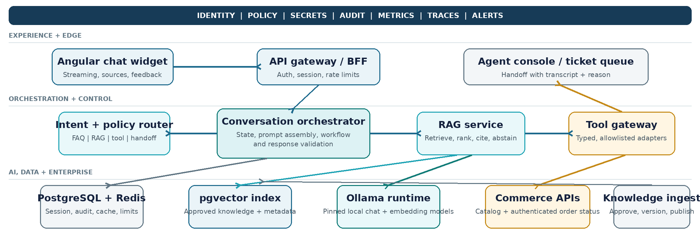
01  Authenticate + normalize | 02  Classify + select route | 03  Retrieve or call tool | 04  Assemble prompt + infer | 05  Validate, cite or abstain | 06  Respond, observe or hand off

5. COMPONENT RESPONSIBILITIES AND DESIGN DECISIONS | FR traceability
COMPONENT | RESPONSIBILITY | KEY DESIGN DECISION | MAP
Web widget + BFF | Angular UI; REST/SSE boundary; session token; input limits and rate limiting. | Keep channel logic out of orchestration; no customer credentials in browser storage. | FR-01/02
Conversation orchestrator | State machine, intent/policy route, prompt assembly, tool loop and final response validation. | Deterministic workflow owns control; model proposes but cannot self-authorize. | FR-02/03/06
RAG + ingestion | Parse, chunk, embed, index, retrieve, rerank and cite approved content; publish/rollback versions. | Filter by tenant, locale, product and effective date; abstain below evidence threshold. | FR-04/08
Tool gateway | Typed adapters for catalog, order status and ticketing with timeouts, retries and circuit breakers. | Allowlist only; validate input/output schemas; recheck authorization per call; idempotency keys. | FR-05/07
Ollama runtime | Local streaming chat and embedding inference with health, resource limits and pinned model artifacts. | Separate chat/embedding models; benchmark quantization; controlled upgrade and rollback. | FR-03/04/08
Data, trust + operations | PostgreSQL/Redis/pgvector state; guardrails, handoff, OpenTelemetry traces, dashboards, alerts, evaluations and runbooks. | Encrypt and expire sensitive state; trace all calls; never log hidden reasoning; degrade safely to agent/FAQ. | FR-02/04/06/07/08
SECURITY BOUNDARY Retrieved text and model output are untrusted. Only authenticated application services may invoke allowlisted tools; the model has no direct database, shell or network access.
DELIVERY PLAN
Implementation Phases, Acceptance and Assumptions
Indicative MVP duration: 9-10 weeks with a small cross-functional team, subject to API readiness, content quality and target-hardware benchmarks.

6. PHASED IMPLEMENTATION PLAN | Each phase ends at a usable gate
PHASE | FOCUS | TIME | PRIMARY OUTPUT | EXIT GATE
0 | Align + baseline | 1 wk | Architecture decisions, data classification, source inventory, API contracts, test set and delivery backlog. | Scope, SLOs, owners and risks approved.
1 | Vertical slice | 2 wk | Angular widget, BFF, session flow, orchestrator, Ollama streaming, health checks and basic FAQ route. | End-to-end answer and session flow in test.
2 | Knowledge grounding | 2 wk | Ingestion, pgvector, metadata filters, citations, abstention, content publishing and evaluation harness. | Grounding targets pass on agreed test set.
3 | Commerce + handoff | 2-3 wk | Catalog/order-status adapters, identity binding, typed tools, PII controls and support-ticket transfer. | Read-only authorized flows and negative tests pass.
4 | Hardening + pilot | 2 wk | Security, load, resilience, observability, backup/restore, runbooks, user acceptance and rollout controls. | Go-live checklist, dashboard and rollback drill approved.
5 | Production evolution | Ongoing | Feedback tuning, content expansion, GPU/horizontal scale, new channels and separately approved actions. | Each change has its own safety and acceptance gate.

7. VERIFICATION AND RELEASE ACCEPTANCE | Evidence required
FUNCTIONAL  FR-01 through FR-08 traced to automated UI/API tests and signed product acceptance. | GROUNDING  Agreed curated questions meet citation and correctness targets; unsupported questions abstain safely. | SECURITY  Prompt-injection, broken authorization, data leakage, abuse and dependency scans pass with no critical issue.
PERFORMANCE  Latency, capacity, error rate and resource use pass under agreed pilot load on target hardware. | RESILIENCE  API/model timeout, circuit-breaker, handoff, backup/restore and model/prompt rollback are demonstrated. | OPERATIONS  Dashboards, alerts, audit trail, content ownership, incident runbook and support handover are approved.

8. KEY ASSUMPTIONS  A1 A Dell PowerEdge R630-class host with about 64 GB RAM is the CPU-first pilot baseline; capacity must be benchmarked before the SLO is committed.  A2 Approved policy/product content has named owners; catalog, order-status and ticket APIs are documented and reachable.  A3 MVP order access is authenticated and read-only; guest users cannot retrieve customer-specific information.  A4 English and responsive web are first; WCAG 2.1 AA is the accessibility target; transcript retention defaults to 30 days, subject to policy.  A5 Model, prompt and index versions are pinned; no fine-tuning or autonomous commerce action is included in the first release. | 9. PRIMARY RISKS AND CONTROLS  Latency / capacity Use a right-sized quantized model, streaming, caching, bounded queues and load-based scale decisions.  Hallucination / stale content Require evidence, cite sources, abstain below threshold, assign owners and evaluate each published version.  Prompt injection / tool abuse Treat retrieved text as untrusted; enforce typed allowlisted tools, per-call authorization and output scanning.  Integration outage Apply timeout, retry, circuit breaker and graceful degradation to FAQ or agent handoff.  Unclear operating ownership Name product, content, model, security and on-call owners before the pilot gate.
NEXT DECISION Approve the MVP boundary and authorize Phase 0 to validate model licensing, source ownership, API readiness and measured Ollama capacity.

