To run and view the code follow instructions on:

Codebase contains commented descriptions of employed methods.
This document presents the graphs that can be found in the “graphs” folder.

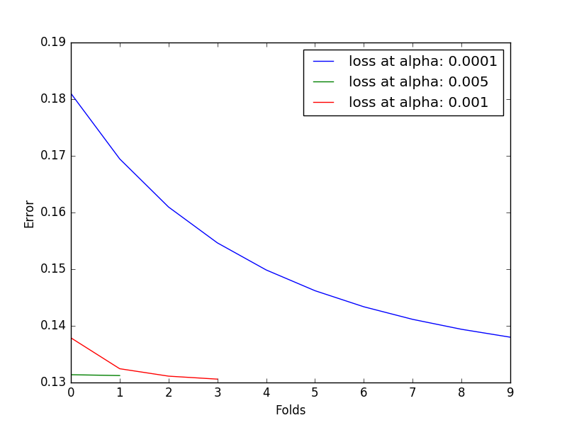Illustration 1: Stochastic Gradient Descent with linear regression trainer
SGD terminates after maximal amount of epochs or if it detects the fall in loss is minimal. Only alpha of 0.0001 converged across 10 fold.

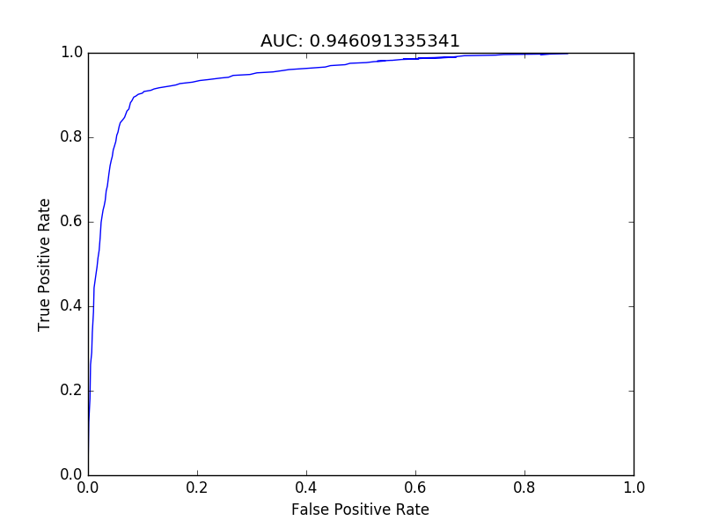Illustration 2: ROC graph with AUC in the title for SGD, linear regression
This is quite excellent performance, considering no feature engeneering was required. Spam recognition systems need to however be almost perfect not to annoy users.

Training with batch_size=1 was very slow due to the need to record loss on the whole dataset after each iteration. Batch gradient descent with sample as small as 20 was much faster. A Batch size of 920 was chosen to test the batch implementation since the full dataset of 4600 observations can be divided into 5 parts of 920 observations.

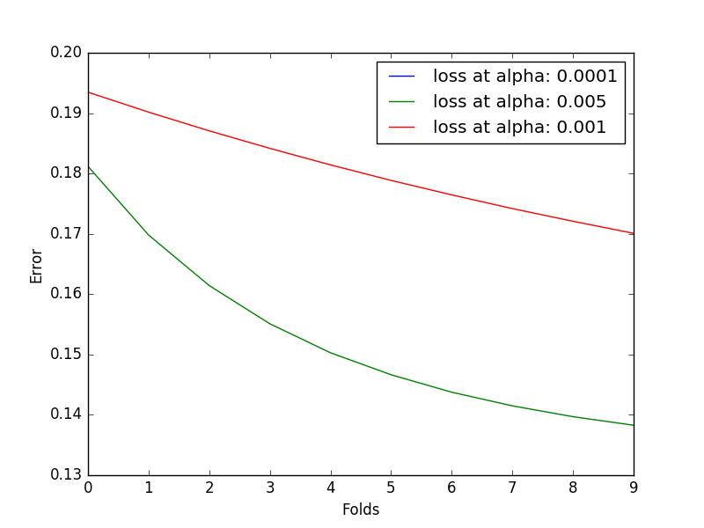Illustration 3: Batch gradient descent with linear regression trainer
Alpha of 0.0001 seems to be too small with no recorded observations passing to graph drawing function. It seems batch sgd prefers higher alphas.

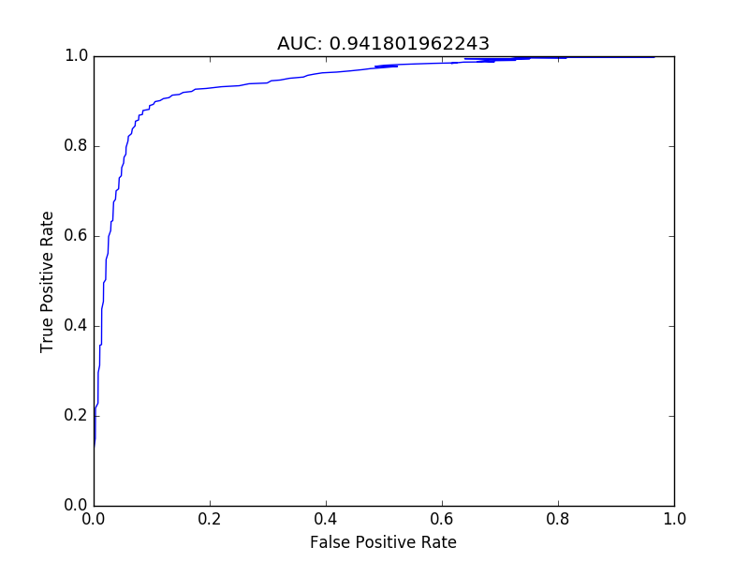Illustration 4: ROC and AUC of batch sgd linear regression trainer
Performance was not hindered in run of batch descent, with best alpha of 0.005 producing the same performance as alpha of 0.0001 in the fully stochastic gradient descent.

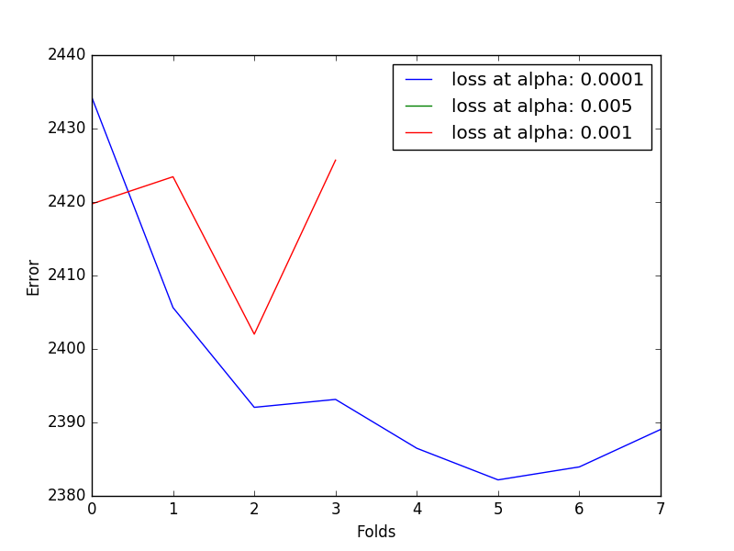Illustration 5: Stochastic logistic regression MSE over folds
Logistic loss trainer seems to be more volatile than linear regression. It seems to also favour small alphas.

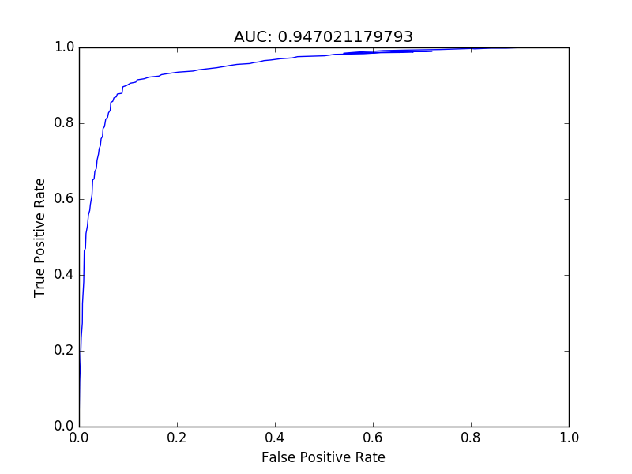Illustration 6: ROC and AUC of stochastic logistic regression
Performance was again not hindered, what mean the trainer converged to the objective loss minimum.

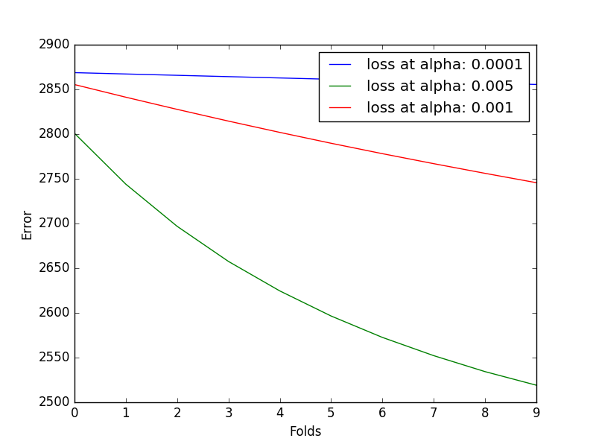Illustration 7: Batch gradient descent for logistic regression trainer
Large alphas seem to be prefered for this trainer. Convergence rate is very small for very small alpha.

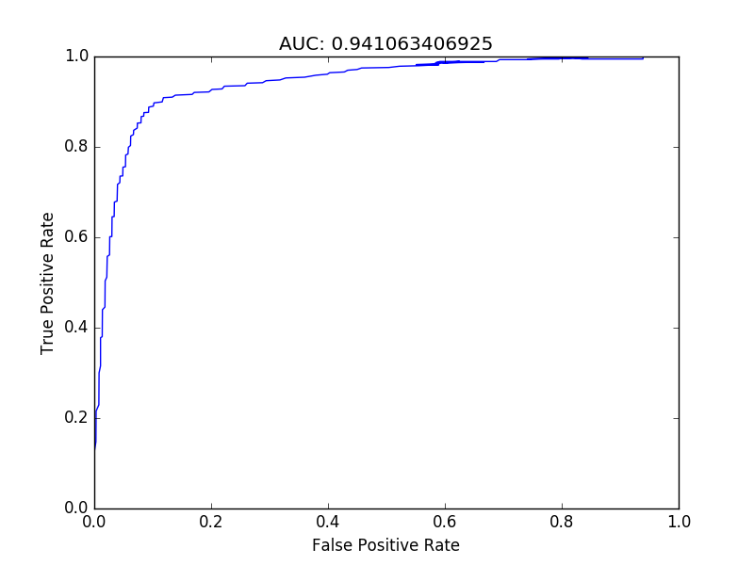
Performance was again not hindered what suggests global optimum was reached.

