A Deep Learning Approach for Improving Waste Classification Accuracy with ResNet50 Feature Extraction

Herdianti Darwis
Faculty of Computer Science
Universitas Muslim Indonesia
Makassar, Indonesia
herdianti.darwis@umi.ac.id
Wistiani Astuti
Faculty of Computer Science
Universitas Muslim Indonesia
Makassar, Indonesia
wistiani.astuti@umi.ac.id
Rahma Puspitasari
Faculty of Computer Science
Universitas Muslim Indonesia
Makassar, Indonesia
rahmapuspitasari.iclabs@umi.ac.id
Dedy Atmajaya
Faculty of Computer Science
Universitas Muslim Indonesia
Makassar, Indonesia
dedy.atmajaya@umi.ac.id
Purnawansyah
Faculty of Computer Science
Universitas Muslim Indonesia
Makassar, Indonesia
purnawansyah@umi.ac.id
Mardiyyah Hasnawi
Faculty of Computer Science
Universitas Muslim Indonesia
Makassar, Indonesia
mardiyyah.hasnawi@umi.ac.id

Abstract—This research investigates the use of deep learning for automatic waste classification, specifically using ResNet50 for feature extraction and combining it with various classification algorithms. The dataset comprises 1889 images categorized into four classes: plastic, metal, cardboard, and paper. Two approaches were evaluated: direct classification and feature extraction with ResNet50. The direct classification models, including SVM, KNN, and Random Forest, resulted in low performance, with an average accuracy of 60%. However, using ResNet50 for feature extraction significantly improved the classification accuracy across all models, with the combination of ResNet50 and SVM achieving an accuracy of 91%, and precision, recall, and F1-Score exceeding 92%. This demonstrates the effectiveness of ResNet50's feature extraction capability in enhancing the classification of images. The findings suggest that combining feature extraction and classification models provides a more accurate and efficient solution for automatic waste management systems, supporting the recycling process and waste management efficiency.
Keywords — deep learning, feature extraction, garbage classification, model performance, ResNet50

Introduction
Currently, every year, 2.01 billion tons of municipal trash are produced worldwide, with 33% of it being mismanaged and damaging the environment. Global waste production is anticipated to rise by 70% by 2050, reach 3.40 billion tons per year, driven by urbanization, population growth, and economic development [1]. Some countries, like China, generate Only 16 million of the 60 million tons of plastic garbage that are generated get recycled[2]. The waste problem in Indonesia is also very large and difficult to solve. According to data from the National Waste Management Information System or Sistem Informasi Pengelolaan Sampah Nasional (SIPSN) of the Ministry of Environment and Forestry or Kementerian Lingkungan Hidup dan Kehutanan (KLHK) in 2022, according to information provided by 202 regencies and cities around Indonesia, 21.1 million tons of garbage were produced nationwide. 34.29% (7.2 million tons) of this total are not yet adequately handled, whereas 65.71% (13.9 million tons) are. It is difficult to distinguish and sort waste types, which requires time and effort. Currently, waste separation is still done manually by workers to create a large-scale filtering system [3]. In some locations, waste is even burned. This harms the environment and releases harmful substances that threaten public health. This method is ineffective in dealing with and eliminating waste [4].
Machine learning techniques have shown great potential to address these issues, especially in automated waste classification processes. When waste is classified correctly, recycling and waste management become more efficient, which reduces environmental damage and health risks. Deep learning models such as convolutional neural networks (CNN) are particularly suitable for identifying waste types due to their capabilities in image classification. Despite progress, much remains to be done to integrate AI into waste management systems. This is mainly related to determining where and how AI can be used in real situations, such as waste treatment facilities, municipal waste sorting stations, or recycling plants [5].
The purpose of this study is to evaluate the effectiveness of image classification models for waste management by comparing two approaches: direct classification with deep learning models and feature extraction with ResNet50 coupled with machine learning models. The dataset used consists of four image classes, namely plastic, metal, cardboard, and paper [6]. While several studies, such as the use of HOG+KNN achieving 93.35% accuracy [7] or PublicGarbageNet with 96.35% accuracy [8], the research [9] also classifies the type of waste consisting of 5 classes, namely glass, fabric, paper, plastic and metal and produces an accuracy of 82.8% by using two combinations of deep learning models, namely transfer learning + DenseNet169.
This research aims to evaluate the effectiveness of a direct classification method without feature extraction process compared to a feature extraction-based approach in waste classification. The main focus of this research is the exploration of machine learning-based classification, where feature extraction is performed using a deep learning approach. This approach offers a more in-depth and adaptive representation of data than conventional methods, which are often used in conjunction with machine learning techniques.

Methods
As presents in Fig. 1, this research was conducted in four stages. Further explanation can be found in the following subsections.
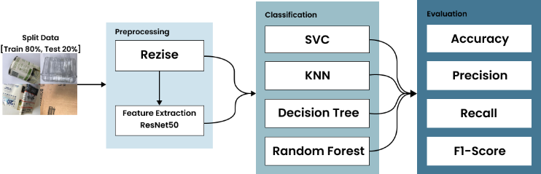
- Research design

Dataset
The dataset used was sourced from the Kaggle website, consisting of 1889 images categorized divided into four groups according to the kind of waste material. The first class is plastic, which includes 482 image samples, followed by the metal class with 410 samples. The cardboard class has 403 samples, and paper is the largest class with 594 samples. The data was then split into 80% for train and 20% for test. Each image was resized to 224$×$224 pixels, and its characteristics were taken out utilizing the ResNet50 model. The characteristics that were extracted were stored as numerical vectors in a CSV file. The dataset was processed in batches to facilitate storage and memory management during the feature extraction process. Several dataset examples are included in Table I.
- Dataset Information
Class Label | Garbage Class | Number of sample | Sample
0 | Plastic | 482 | 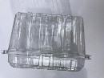
1 | Metal | 410 | 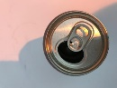
2 | Cardboard | 403 | 
3 | Paper | 594 | 
Total Images |  | 1889

Preprocessing
- Resize
Image preprocessing was performed to ensure consistent input for the model in this study. Resizing the image to 224 x 224 pixels, so that its size matches the input requirements of the model. [10].
- Feature Extraction
After the images underwent preprocessing, visual features were extracted using the pre-trained ResNet50 model, resulting in fixed-size feature vectors [11],[12]. One image was entered into ResNet50 separately, and its visual attributes were represented by the resulting features. The vector labels were matched to the material class and resulted in 2049 features. These features are stored in a CSV file for analysis and training of the classification model. Fig. 2 shows the architecture of ResNet50.
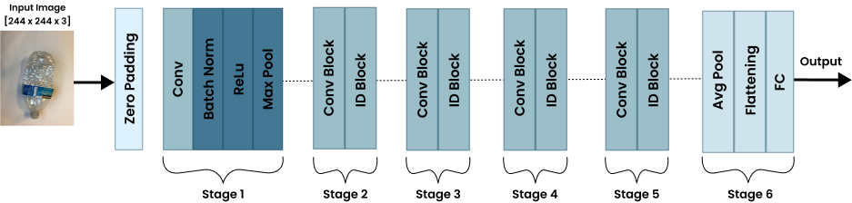
- Basic ResNet50 architecture

Clasification

ResNet50+SVC
This study used a combination of the ResNet50 model for feature extraction and Support Vector Classifier (SVC) as the final classification model. SVC was chosen for its effectiveness in separating high-dimensional data by maximizing the margin between classes[13],[14],[15]. A linear kernel SVC model was used to simplify the classification process. SVC works by maximizing the margin between two classes, formulated as in (1).
$$w^{T}x+b=0$$ | (1)
In this case, $w$ stands for weight,$x$ for feature, and $b$ for bias. w and b maximize the margin between classes by minimizing the loss function as in (2).
$$\frac{1}{2}{\left|\left|w\right|\right|}^{2}$$ | (2)
With the constraint that each sample xi satisfies, as in (3).
$$y_{i}\left(w^{T}x_{i}+b\right)≥1$$ | (3)
Where $y_{i}$ is the class label (1 or -1). SVC with a linear kernel projects data into a linear space to find the hyperplane that divides the classes by the greatest amount [16],[17]. Fig. 3 illustrates the concept of margin and hyperplane.
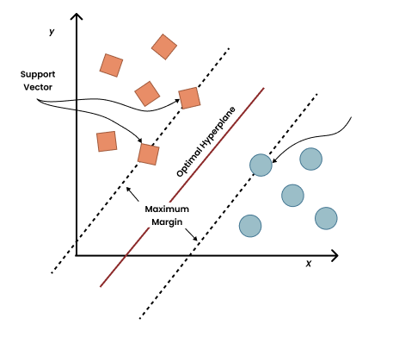
- SVC algorithm

ResNet50+KNN
In this study, a combination of ResNet50 and KNN was used for image classification. After the features were extracted, KNN leveraged ResNet50's visual extraction capabilities and the reliability of KNN in distance-based classification [18],[19],[20]. The formula for the Euclidean distance is (4).
$$d\left(x_{i},y_{i}\right)=\sqrt{\sum_{i=1}^{n}{{\left(x_{i}-y_{i}\right)}^{2}}}$$ | (4)

$n$ is the number of features, and $x_{i}$is the feature vector of the $i^{th}$image. A representation of the KNN method may be found in Figure 4.

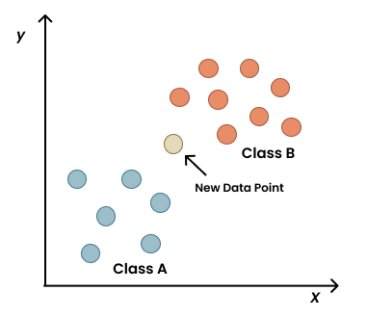
- KNN algorithm

ResNet50+DT
In this study, a combination of ResNet50 and decision tree was used for image classification. ResNet50 extracts features, which are then used as input for the decision tree [21],[22],[23]. The decision tree separates the data based on features using rules that maximize information gain as in (5).

$$IG\left(T,X\right)=H\left(T\right)-H\left(T | X\right)$$ | (5)
Based on feature$X$, the entropy before the split is denoted by $H(T)$, and the entropy after the split is denoted by $H(T|X)$. Alternatively, Gini impurity is calculated using the formula as in (6).
$$Gini=1-\sum_{i=1}^{n}{p_{i}^{2}}$$ | (6)
where the likelihood of a sample falling into a certain class is denoted by $p_{i}$ . After that, the model chooses the split that maximizes information gain or minimizes Gini impurity. Fig. 5 is a visualization of the decision tree algorithm.

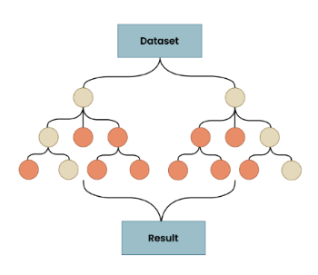
- Decision tree algorithm
- ResNet50+RF
In this study, a combination of the ResNet50 model for feature extraction and random forest as the final classification model was used. This combination provides more accurate and stable results by leveraging ResNet50 feature extraction capabilities and the reliability of random forest for efficient classification [24],[25],[26]. The formula for random forest prediction is as in (7).

$$\hat{y}=\text{model}\left(h_{1}\left(x\right),h_{2}\left(x\right),…,h_{B}\left(x\right)\right)$$ | (7)
Where $\hat{y}$ is the last prediction of the random forest, $h_{i}(x)$ is the prediction from the $i^{th}$ decision tree in the random forest, where $x$ is the input feature vector. The mode represents taking the prediction that appears most frequently among all predictions from B decision trees [27],[28]. Fig. 6 is a visualization of the random forest algorithm.

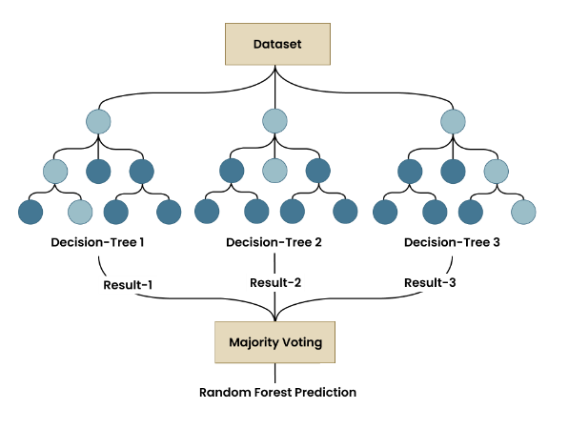
- Random forest algorithm

Evaluation
Various performance metrics are used to gain a better understanding of the model's capabilities. These include accuracy, which measures how often predictions are correct; precision, which measures how accurately the model predicts a particular class; and F1-Score, which combines precision and recall into a single value that balances the two.

To clarify how these metrics are calculated in the model evaluation, equation (8) – (11) are the formulas utilized to compute F1-score, recall, accuracy, and precision.

$$\text{Accuracy}=\frac{TP+TN}{TP+TN+FP+FN}$$ | (8)
$$\text{Precision}=\frac{TP}{TP+FP}$$ | (9)
$$\text{Recall}=\frac{TP}{TP+FN}$$ | (10)
$$\text{F1-Score}=2× \frac{Precision× Recall }{Precision + Recall}$$ | (11)
True Positive (TP) is the number of correct positive predictions, while True Negative (TN) is the number of correct negative predictions. False Positive (FP) refers to the number of incorrect positive predictions, and False Negative (FN) is the number of incorrect negative predictions.

Result and Discussion
The model was initially trained without feature extraction by employing a straight classification technique. The model directly received input images and classified them into four classes. The results of the direct classification showed low accuracy. Table II present comprising precision (P), accuracy (A), recall (R) and F1-Score for each trained model.
- Evaluation Results Using Direct Classification without ResNet50
Algorithm | A | P | R | F1-Score
SVC | 0.60 | 0.60 | 0.61 | 0.61
KNN | 0.55 | 0.60 | 0.56 | 0.55
DT | 0.58 | 0.58 | 0.57 | 0.58
RF | 0.72 | 0.74 | 0.72 | 0.73

After training the ResNet50 model for feature extraction and using several algorithms as classification models, the evaluation results were tested on the test dataset, yielding better accuracy. The trained models' accuracy, precision, recall, and F1 Score are shown in Table III.
- Evaluation Results Using Direct Classification with ResNet50
Algorithm | A | P | R | F1-Score
ResNet50+ SVC | 0.91 | 0.92 | 0.92 | 0.92
ResNet50+ KNN | 0.91 | 0.92 | 0.91 | 0.91
ResNet50+ DT | 0.72 | 0.72 | 0.72 | 0.72
ResNet50+ RF | 0.89 | 0.91 | 0.89 | 0.90

Fig. 7 is a graph showing the comparison of the values of these three metrics for each class.

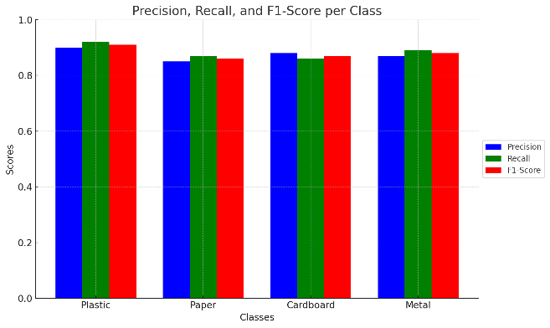
- Classification performance for each class
Testing the model on the test dataset shows that the SVC algorithm with linear kernel and ResNet50 for feature extraction improves the performance and accuracy significantly. As shown in Fig. 8, the training accuracy increases consistently with hyperparameter optimization, and the validation accuracy is stable at around 90%. This shows that the model is capable of good generalization without overfitting. The loss curves also support this finding: the training and validation losses decrease consistently before eventually leveling off, indicating the stability of the model at ideal parameter settings.
The complementary strength of the two methods can be attributed to the strong performance of the ResNet50-SVC combination, which produces high-dimensional and discriminative features that can be linearly separated in the transformed feature space. As it simplifies the classification task while maintaining computational efficiency, the linear kernel becomes an appropriate and efficient choice for SVC. The present invention demonstrates how effective the combination of deep feature extraction with linear SVC kernels can be for waste classification tasks.
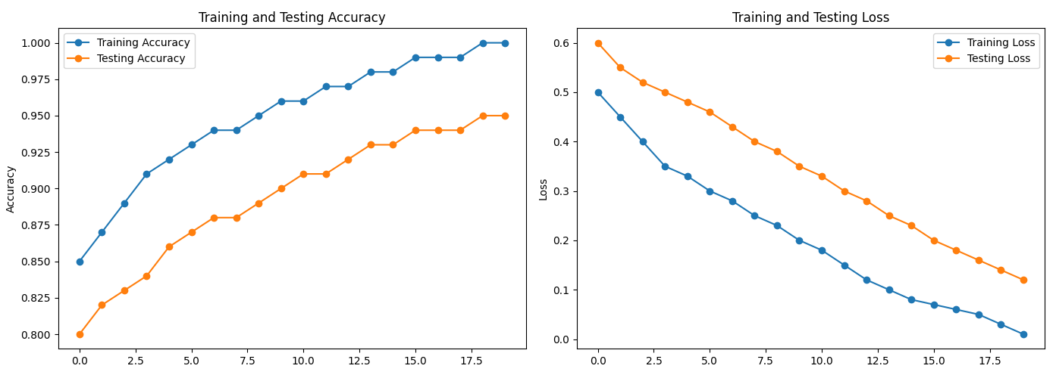
(a)

(b)
- Evaluation results based on the ResNet50+SVC model, (a). Accuracy, (b). Loss.
Fig. 9 displays the SVC model's confusion matrix for the test dataset. The model did well with over 70 correct predictions for each class, with 108 correct predictions for the paper class. However, there were some errors, such as considering cardboard as paper and plastic as metal.
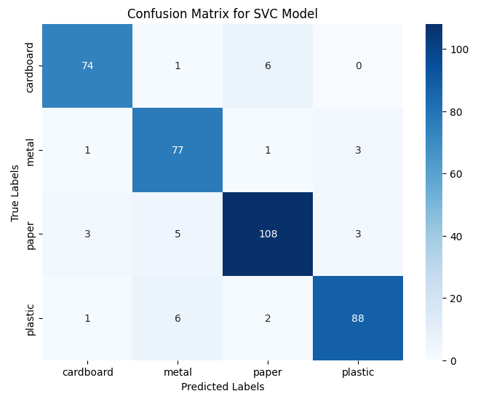
- Confusion matrix of ResNet50+SVC model.
Testing the model on the experimental dataset shows that the combination of ResNet50 for feature extraction and the KNN algorithm with $K$ = 5 improves performance and accuracy. The ability of the model to perform good generalization without significant overfitting is demonstrated by the fact that the training accuracy slightly decreases as the $K$ value increases, while the validation accuracy tends to stabilize at around 90%. The loss curves show that the validation loss is greater at lower K values, but then stabilizes as $K$ increases. The choice of $K$ = 5 ensures reliable classification performance while avoiding overfitting to noisy data as it provides the best balance between model complexity and accuracy.
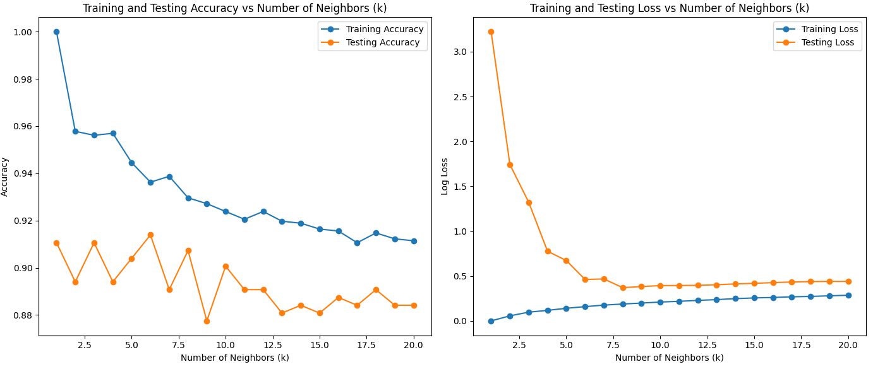



- Evaluation results based on the ResNet50+KNN model, (a). Accuracy, (b). Loss.

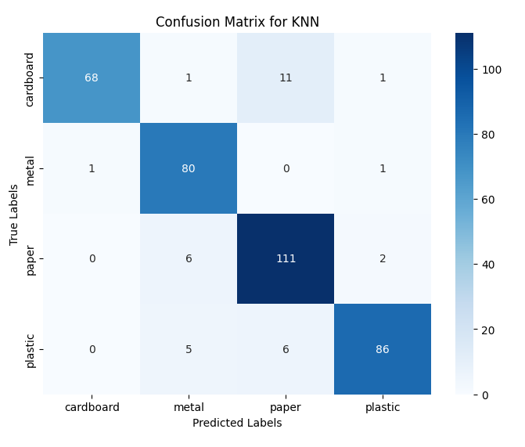
- Confusion matrix of ResNet50+KNN model.
After performing the accuracy and loss assessment for various $K$ values, an additional evaluation was performed using the confusion matrix to evaluate the classification performance of the model. The confusion matrix for the model's predictions on the test data is displayed in Fig. 11. The number of right and wrong predictions for each class is indicated by each cell. The model performs well in most classes the majority of the predictions are on the diagonal of the matrix, indicating correct classification. However, there were some errors in classification, especially between the cardboard and paper classes, where cardboard was sometimes classified as paper and vice versa. This suggests that some feature similarities between these two classes have affected the performance of the model.
Fig. 12 points the performance of the Decision Tree model with varying maximum depth (Max Depth). In the accuracy graph, as demonstrated, training accuracy continues to increase until it reaches 100%, but validation accuracy peaks at around a depth of 5 and then remains stable at around 75%, indicating overfitting at deeper levels. The loss graph also shows a decrease in training loss, but validation loss starts to rise sharply after a certain depth, indicating that the model becomes too complex and loses its ability to generalize effectively.
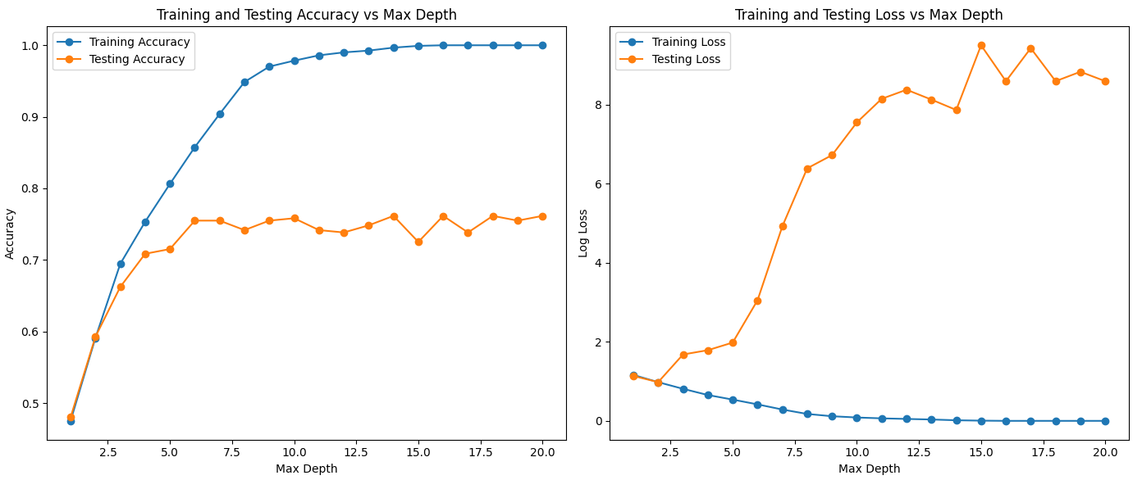
(a)

(b)
- Evaluation results based on the ResNet50+DT model, (a). Accuracy, (b). Loss.
The Decision Tree model's confusion matrix for the test dataset is presents in Fig. 13. The number of accurate and inaccurate forecasts for each class are in this display matrix. Most predictions are on the diagonal, indicating correct classifications, but there are some misclassifications, particularly in the paper class, which is sometimes misclassified as cardboard or metal. Despite these misclassifications, the model performed fairly well, with high correct predictions in the paper class 84 and plastic class 68.
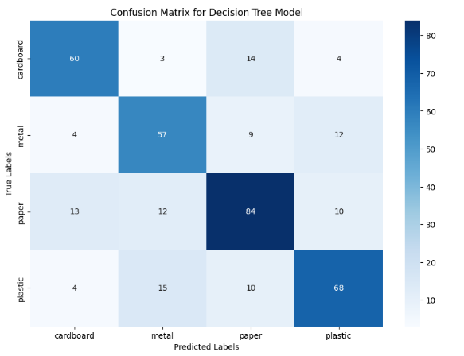
- Confusion matrix of ResNet50+DT model.
Fig. 14 indicates the accuracy and loss graphs for the random forest model with varying max depth. Training accuracy increased to nearly 100%, while validation accuracy remained stable around 85% after a depth of 5, indicating overfitting at greater depths. Training loss continued to decrease, but validation loss flattened after a depth of 5, indicating that model complexity increased without improving validation performance.
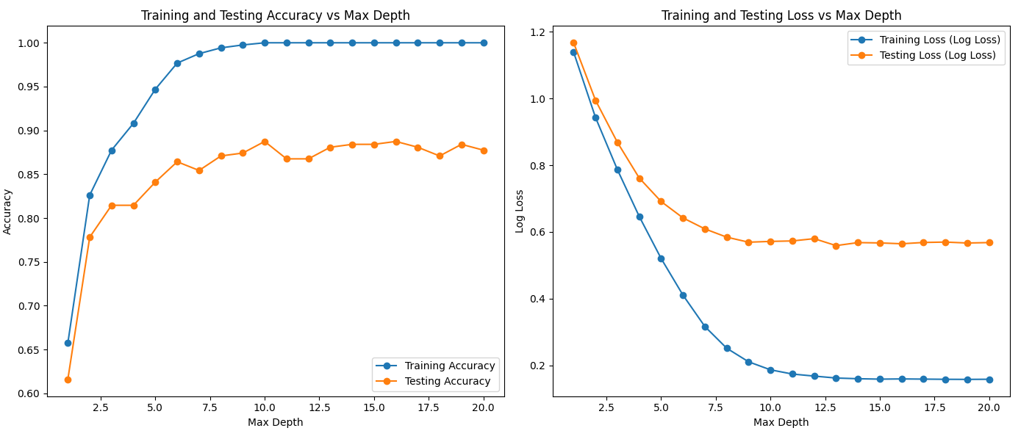
(a)

(b)
- Evaluation results based on the ResNet50+RF model, (a). Accuracy, (b). Loss.
To evaluate the trade-off between the performance of the model and its complexity, this study used a Random Forest model with a tree count of 100 and tested various values of max depth. The choice of this parameter aims to balance accuracy and computational efficiency. For example, setting max depth = 5 resulted in an optimal balance, with high accuracy while reducing the risk of overfitting. The ensemble nature of Random Forest also improves the reliability of the model by reducing the noise of individual decision trees, thus enabling the classification of complex features extracted by ResNet50. The model demonstrated reliable performance with 85% accuracy on the validation dataset, making it highly suitable for waste classification tasks
The random forest model's confusion matrix for the test dataset is shown in Fig. 15. For each class, the matrix displays the proportion of accurate and inaccurate forecasts. Most predictions are on the diagonal, indicating correct classifications. The model performed well on the paper class with 110 correct predictions and the plastic class with 85 correct predictions. However, there were some errors, such as cardboard being occasionally predicted as paper and plastic as metal, though overall, the model performed quite well across all classes.
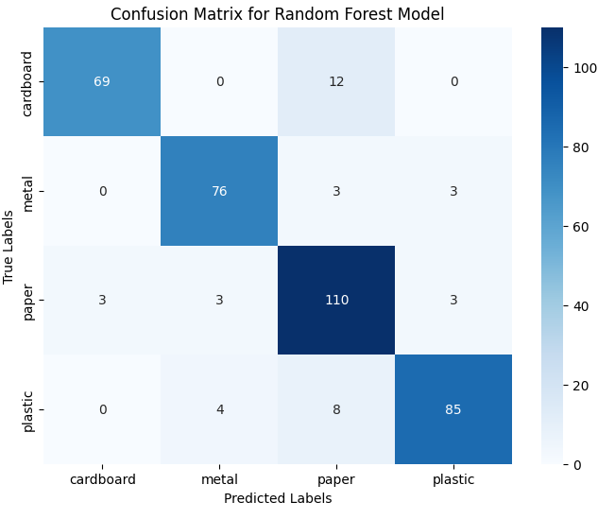
- Confusion matrix of ResNet50+RF model.
The results show that using direct classification without feature extraction results in low performance, such as SVC with 60% accuracy, as well as other classification models. After performing feature extraction using ResNet50, the performance of the model improved. The combination of ResNet50 with SVC achieved 91% accuracy, with precision, recall and F1-Score above 92%, as did the other models combined with ResNet50.
Despite the high overall accuracy, misclassification problems remain, such as labeling cardboard as paper or plastic as metal. These inaccuracies stem from the similarity of visual characteristics between certain classes, for example, cardboard and paper often have comparable textures and colors, while plastic and metal exhibit reflective properties. In addition, external factors such as noise or variability in the dataset, including different lighting conditions or inconsistent angles, further challenge the potential of the model to accurately distinguish classes.
Using feature extraction with ResNet50 improves the performance of the model compared to direct classification. ResNet50 excels because its architecture contains 50 layers, enabling complex feature extraction. Residual connections help overcome the missing gradient problem, allowing the model to be trained more effectively. This shows that using ResNet50 for image feature extraction can improve classification accuracy, especially when combined with more complex models such as SVC and some other models. It shows that each algorithm has unique advantages according to the characteristics of the data. SVM with a linear kernel excels in accuracy thanks to its ability to separate high-dimensional data, while Random Forest and KNN offer reliable alternatives with the flexibility to handle more complex data structures. Choosing the right algorithm in the context of ResNet50's extracted features is a key factor in successful classification.
However, despite the ability of ResNet50 to extract complex features, there are limitations in the features learned by the model. The model may not always be able to capture the differences between classes with similar visual traits, especially if the learned features are not specific enough. For example, the model may struggle to distinguish between cardboard and paper due to their similarity in texture and shape. Additionally, variations in the training data, such as noise or inconsistent image quality, may also limit the model's ability to distinguish between more complex classes.
The accuracy of the algorithms from earlier studies and the suggested approach is contrasted in Table IV.
- Comparison of Garbage Dataset Algorithm Accuracy
Research | Algorithm | Accuracy
K. Demir [7] | HOG+KNN | 93.35%
M. Zeng [8] | PublicGarbageNet | 96.35%
Q. Zhang [9] | Transfer Learning + DenseNet169 | 82.8%
The Proposed Methods | ResNet50+SVC | 91.00%
 | ResNet50+KNN | 91.00%

Although the accuracy of the proposed algorithm is lower compared to the research [7] and [8] as listed in table IV, this model still provides quite competitive results when compared to research that combines two deep learning models such as in research that uses the transfer learning + DenseNet169 model on garbage classification which results in an accuracy of 82.8%. This model still shows significant performance. This confirms its ability to handle complex classification challenges, while opening up opportunities for further improvement through optimisation. One of the main differentiating factors is the use of datasets and data preprocessing. This research used a smaller-sized dataset with a clean background, which although simple, helped the model to recognise patterns more easily. In contrast, studies such as PublicGarbageNet [8] use larger and more complex datasets with grey backgrounds, which adds challenges to the generalisation ability of the model. In addition, differences in training specifications, such as model architecture and optimisation strategies, also affect accuracy results.

Conclusion
This study shows that the direct classification approach results in low performance across all tested models, with an average accuracy of 60%. After feature extraction using ResNet50, the model's performance improved. The combination of ResNet50 with SVC and KNN achieved 91% accuracy, with improvements in precision, recall, and F1-Score. This proves that using feature extraction methods from deep learning, such as ResNet50, is highly effective in improving image classification accuracy, especially when combined with more complex classification models. These results indicate that an approach combining feature extraction and classification provides a more accurate solution for automatic waste classification systems.
This research focuses on exploring feature extraction using ResNet50. Future studies will focus on exploring other feature extraction models, such as VGG, Inception, and other deep learning architectures, to identify the most optimal approach for improving system performance.

Acknowledgment
The authors would like to express their sincere gratitude to Integrated Computer Laboratories (ICLabs), Faculty of Computer Science, University of Muslim Indonesia, for providing invaluable support and resources throughout this research. The guidance, facilities, and academic environment provided by the faculty were all critical to the success of this study.

References
[1] Z. Kang, J. Yang, G. Li, and Z. Zhang, “An Automatic Garbage Classification System Based on Deep Learning,” IEEE Access, vol. 8, pp. 140019–140029, 2020, doi: 10.1109/ACCESS.2020.3010496.
[2] S. Chen et al., “Carbon emissions under different domestic waste treatment modes induced by garbage classification: Case study in pilot communities in Shanghai, China,” Science of the Total Environment, vol. 717, p. 137193, 2020, doi: 10.1016/j.scitotenv.2020.137193.
[3] Rismiyati, S. N. Endah, Khadijah, and I. N. Shiddiq, “Xception Architecture Transfer Learning for Garbage Classification,” ICICoS 2020 - Proceeding: 4th International Conference on Informatics and Computational Sciences, no. May-2021, p. 4, 2020, doi: 10.1109/ICICoS51170.2020.9299017.
[4] Q. Chen and Q. Xiong, “Garbage Classification Detection Based on Improved YOLOV4,” Journal of Computer and Communications, vol. 08, no. 12, pp. 285–294, 2020, doi: 10.4236/jcc.2020.812023.
[5] S. Meng, N. Zhang, and Y. Ren, “X-DenseNet: Deep Learning for Garbage Classification Based on Visual Images,” J Phys Conf Ser, vol. 1575, no. 1, 2020, doi: 10.1088/1742-6596/1575/1/012139.
[6] K. Lin, Y. Zhao, L. Wang, W. Shi, F. Cui, and T. Zhou, “MSWNet: A visual deep machine learning method adopting transfer learning based upon ResNet 50 for municipal solid waste sorting,” Front Environ Sci Eng, vol. 17, no. 6, pp. 1–12, 2023, doi: 10.1007/s11783-023-1677-1.
[7] K. Demir and O. Yaman, “A HOG Feature Extractor and KNN-Based Method for Underwater Image Classification,” Firat University Journal of Experimental and Computational Engineering, vol. 3, no. 1, pp. 1–10, 2024, doi: 10.62520/fujece.1443818.
[8] M. Zeng, X. Lu, W. Xu, T. Zhou, and Y. Liu, “PublicGarbageNet : A Deep Learning Framework for Public Garbage Classification,” Chinese Control Conference, CCC, vol. 2020-July, pp. 7200–7205, 2020, doi: 10.23919/CCC50068.2020.9189561.
[9] Q. Zhang, Q. Yang, X. Zhang, Q. Bao, J. Su, and X. Liu, “Waste image classification based on transfer learning and convolutional neural network,” Waste Management, vol. 135, no. May, pp. 150–157, 2021, doi: 10.1016/j.wasman.2021.08.038.
[10] V. Kaya, “Classification of waste materials with a smart garbage system for sustainable development: a novel model,” Front Environ Sci, vol. 11, no. August, pp. 1–9, 2023, doi: 10.3389/fenvs.2023.1228732.
[11] X. Ma, Z. Li, and L. Zhang, “An Improved ResNet-50 for Garbage Image Classification,” Tehnicki Vjesnik, vol. 29, no. 5, pp. 1552–1559, 2022, doi: 10.17559/TV-20220420124810.
[12] W. Li et al., “Classification of High-Spatial-Resolution Remote Sensing Scenes Method Using Transfer Learning and Deep Convolutional Neural Network,” IEEE J Sel Top Appl Earth Obs Remote Sens, vol. 13, no. X, pp. 1986–1995, 2020, doi: 10.1109/JSTARS.2020.2988477.
[13] M. Sheykhmousa, M. Mahdianpari, H. Ghanbari, F. Mohammadimanesh, P. Ghamisi, and S. Homayouni, “Support Vector Machine Versus Random Forest for Remote Sensing Image Classification: A Meta-Analysis and Systematic Review,” IEEE J Sel Top Appl Earth Obs Remote Sens, vol. 13, pp. 6308–6325, 2020, doi: 10.1109/JSTARS.2020.3026724.
[14] Y. Pan, L. Zhang, X. Wu, and M. J. Skibniewski, “Multi-classifier information fusion in risk analysis,” Information Fusion, vol. 60, no. June 2019, pp. 121–136, 2020, doi: 10.1016/j.inffus.2020.02.003.
[15] H. Darwis, Z. Ali, Y. Salim, and P. L. L. Belluano, “Max Feature Map CNN with Support Vector Guided SoftMax for Face Recognition,” International Journal on Informatics Visualization, vol. 7, no. 3, pp. 959–966, 2023, doi: 10.30630/joiv.7.3.1751.
[16] I. N. Yulita, F. Ardiansyah, M. R. Ramdhani, M. A. Wicaksono, A. Trisanto, and A. Sholahuddin, “Combining inception-V3 and support vector machine for garbage classification,” Jurnal Infotel, vol. 15, no. 4, pp. 352–358, 2023, doi: 10.20895/infotel.v15i4.1027.
[17] P. Purnawansyah et al., “Comparative Study of Herbal Leaves Classification using Hybrid of GLCM-SVM and GLCM-CNN,” ILKOM Jurnal Ilmiah, vol. 15, no. 2, pp. 382–389, 2023, doi: 10.33096/ilkom.v15i2.1759.382-389.
[18] S. M. Kasongo and Y. Sun, “A deep learning method with wrapper based feature extraction for wireless intrusion detection system,” Comput Secur, vol. 92, p. 15, 2020, doi: 10.1016/j.cose.2020.101752.
[19] R. K. Dinata, N. Hasdyna, S. Retno, and M. Nurfahmi, “K-means algorithm for clustering system of plant seeds specialization areas in east Aceh,” ILKOM Jurnal Ilmiah, vol. 13, no. 3, pp. 235–243, 2021, doi: 10.33096/ilkom.v13i3.863.235-243.
[20] A. R. Manga, M. A. F. Latief, A. W. M. Gaffar, H. Azis, R. Satra, and Y. Salim, “Hyperparameter Tuning of Identity Block Uses an Imbalance Dataset with Hyperband Method,” in 2024 18th International Conference on Ubiquitous Information Management and Communication (IMCOM), 2024, pp. 1–7. doi: 10.1109/IMCOM60618.2024.10418427.
[21] W. Liu et al., “Image Recognition for Garbage Classification Based on Transfer Learning and Model Fusion,” Math Probl Eng, vol. 2022, p. 12, 2022, doi: 10.1155/2022/4793555.
[22] H. Lu and X. Ma, “Hybrid decision tree-based machine learning models for short-term water quality prediction,” Chemosphere, vol. 249, p. 126169, 2020, doi: 10.1016/j.chemosphere.2020.126169.
[23] H. Azis, L. Syafie, F. Fattah, and ..., “Unveiling Algorithm Classification Excellence: Exploring Calendula and Coreopsis Flower Datasets with Varied Segmentation Techniques,” 2024 18th International …, 2024, doi: 10.1109/IMCOM60618.2024.10418246.
[24] A. Namoun, B. R. Hussein, A. Tufail, A. Alrehaili, T. A. Syed, and O. Benrhouma, “An Ensemble Learning Based Classification Approach for the Prediction of Household Solid Waste Generation,” Sensors, vol. 22, no. 9, p. 23, 2022, doi: 10.3390/s22093506.
[25] P. S. Ezekiel, O. E. Taylor, and M. O. Musa, “A Framework for Predicting the Porosity and Permeability of Petro Physical Rock Types using Random Forest Classifier,” Ijarcce, vol. 11, no. 1, 2022, doi: 10.17148/ijarcce.2022.11117.
[26] R. J. Suhatril, R. D. Syah, M. Hermita, B. Gunawan, and W. Silfianti, “Evaluation of Machine Learning Models for Predicting Cardiovascular Disease Based on Framingham Heart Study Data,” ILKOM Jurnal Ilmiah, vol. 16, no. 1, pp. 68–75, 2024, doi: 10.33096/ilkom.v16i1.1952.68-75.
[27] M. Schonlau and R. Y. Zou, “The random forest algorithm for statistical learning,” Stata Journal, vol. 20, no. 1, pp. 3–29, 2020, doi: 10.1177/1536867X20909688.
[28] S. Suswadi and Moh. Erkamim, “Sentiment Analysis of Shopee App Reviews Using Random Forest and Support Vector Machine,” ILKOM Jurnal Ilmiah, vol. 15, no. 3, pp. 427–435, 2023, doi: 10.33096/ilkom.v15i3.1610.427-435.

