A TEMPLATE FOR THE arxiv STYLE
A preprint
David S. Hippocampus  Department of Computer Science Cranberry-Lemon University Pittsburgh, PA 15213 hippo@cs.cranberry-lemon.edu | Elias D. Striatum  Department of Electrical Engineering Mount-Sheikh University Santa Narimana, Levand stariate@ee.mount-sheikh.edu
June 29, 2023

Abstract
Lorem ipsum dolor sit amet, consectetuer adipiscing elit. Ut purus elit, vestibulum ut, placerat ac, adipiscing vitae, felis. Curabitur dictum gravida mauris. Nam arcu libero, nonummy eget, consectetuer id, vulputate a, magna. Donec vehicula augue eu neque. Pellentesque habitant morbi tristique senectus et netus et malesuada fames ac turpis egestas. Mauris ut leo. Cras viverra metus rhoncus sem. Nulla et lectus vestibulum urna fringilla ultrices. Phasellus eu tellus sit amet tortor gravida placerat. Integer sapien est, iaculis in, pretium quis, viverra ac, nunc. Praesent eget sem vel leo ultrices bibendum. Aenean faucibus. Morbi dolor nulla, malesuada eu, pulvinar at, mollis ac, nulla. Curabitur auctor semper nulla. Donec varius orci eget risus. Duis nibh mi, congue eu, accumsan eleifend, sagittis quis, diam. Duis eget orci sit amet orci dignissim rutrum.

Keywords First keyword · Second keyword · More

Introduction
Nam dui ligula, fringilla a, euismod sodales, sollicitudin vel, wisi. Morbi auctor lorem non justo. Nam lacus libero, pretium at, lobortis vitae, ultricies et, tellus. Donec aliquet, tortor sed accumsan bibendum, erat ligula aliquet magna, vitae ornare odio metus a mi. Morbi ac orci et nisl hendrerit mollis. Suspendisse ut massa. Cras nec ante. Pellentesque a nulla. Cum sociis natoque penatibus et magnis dis parturient montes, nascetur ridiculus mus. Aliquam tincidunt urna. Nulla ullamcorper vestibulum turpis. Pellentesque cursus luctus mauris. Nulla malesuada porttitor diam. Donec felis erat, congue non, volutpat at, tincidunt tristique, libero. Vivamus viverra fermentum felis. Donec nonummy pellentesque ante. Phasellus adipiscing semper elit. Proin fermentum massa ac quam. Sed diam turpis, molestie vitae, placerat a, molestie nec, leo. Maecenas lacinia. Nam ipsum ligula, eleifend at, accumsan nec, suscipit a, ipsum. Morbi blandit ligula feugiat magna. Nunc eleifend consequat lorem. Sed lacinia nulla vitae enim. Pellentesque tincidunt purus vel magna. Integer non enim. Praesent euismod nunc eu purus. Donec bibendum quam in tellus. Nullam cursus pulvinar lectus. Donec et mi. Nam vulputate metus eu enim. Vestibulum pellentesque felis eu massa.

Headings: first level
Quisque ullamcorper placerat ipsum. Cras nibh. Morbi vel justo vitae lacus tincidunt ultrices. Lorem ipsum dolor sit amet, consectetuer adipiscing elit. In hac habitasse platea dictumst. Integer tempus convallis augue. Etiam facilisis. Nunc elementum fermentum wisi. Aenean placerat. Ut imperdiet, enim sed gravida sollicitudin, felis odio placerat quam, ac pulvinar elit purus eget enim. Nunc vitae tortor. Proin tempus nibh sit amet nisl. Vivamus quis tortor vitae risus porta vehicula. See Section 2.

Headings: second level
Fusce mauris. Vestibulum luctus nibh at lectus. Sed bibendum, nulla a faucibus semper, leo velit ultricies tellus, ac venenatis arcu wisi vel nisl. Vestibulum diam. Aliquam pellentesque, augue quis sagittis posuere, turpis lacus congue quam, in hendrerit risus eros eget felis. Maecenas eget erat in sapien mattis porttitor. Vestibulum porttitor. Nulla facilisi. Sed a turpis eu lacus commodo facilisis. Morbi fringilla, wisi in dignissim interdum, justo lectus sagittis dui, et vehicula libero dui cursus dui. Mauris tempor ligula sed lacus. Duis cursus enim ut augue. Cras ac magna. Cras nulla. Nulla egestas. Curabitur a leo. Quisque egestas wisi eget nunc. Nam feugiat lacus vel est. Curabitur consectetuer.
$$L_{dice}=\frac{{2A}_{nl}}{A_{n}+A_{;}}$$

Headings: third level
Suspendisse vel felis. Ut lorem lorem, interdum eu, tincidunt sit amet, laoreet vitae, arcu. Aenean faucibus pede eu ante. Praesent enim elit, rutrum at, molestie non, nonummy vel, nisl. Ut lectus eros, malesuada sit amet, fermentum eu, sodales cursus, magna. Donec eu purus. Quisque vehicula, urna sed ultricies auctor, pede lorem egestas dui, et convallis elit erat sed nulla. Donec luctus. Curabitur et nunc. Aliquam dolor odio, commodo pretium, ultricies non, pharetra in, velit. Integer arcu est, nonummy in, fermentum faucibus, egestas vel, odio.

Paragraph Sed commodo posuere pede. Mauris ut est. Ut quis purus. Sed ac odio. Sed vehicula hendrerit sem. Duis non odio. Morbi ut dui. Sed accumsan risus eget odio. In hac habitasse platea dictumst. Pellentesque non elit. Fusce sed justo eu urna porta tincidunt. Mauris felis odio, sollicitudin sed, volutpat a, ornare ac, erat. Morbi quis dolor. Donec pellentesque, erat ac sagittis semper, nunc dui lobortis purus, quis congue purus metus ultricies tellus. Proin et quam. Class aptent taciti sociosqu ad litora torquent per conubia nostra, per inceptos hymenaeos. Praesent sapien turpis, fermentum vel, eleifend faucibus, vehicula eu, lacus.

Examples of citations, figures, tables, references

Citations
Citations use References -> Cross-reference to Numbered Item - Paragraph number (full context). It is shown on figure 1. result will look like this [1]. This works both on WPS office and MS word. But bibliography works muuuch better in MS word.
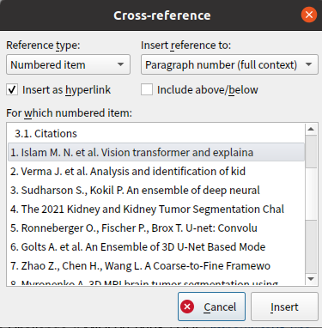
Figure 1: Creating link to paper with cross-reference tool

Figures
Insert figure from clipboard or from hard drive. To create label to figure right click on in and select Caption menu (Figure 2). Select “Figure” label and type text to it (Figure 3). To create cross-reference inside paragraph use same method as described in Citations section.

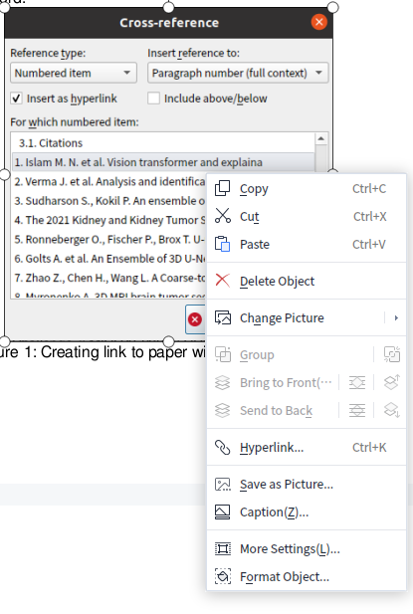
Figure 2: Context menu with caption menu
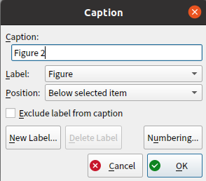
Figure 3: Caption dialog menu

Tables
Insert table and fill with data. To create caption to Table use similar algorithm as described in Figures section. Right-click on table and select caption menu. Only difference is that caption of table must be above table.

Table 1: Sample table
Method | Column header 1 | Column header 2
lowres | 0,70 | 0,29
fullres | 0,72 | 0,50
cascade | 0,69 | 0,35

References
- Islam M. N. et al. Vision transformer and explainable transfer learning models for auto detection of kidney cyst, stone and tumor from CT-radiography //Scientific Reports. – 2022. – Т. 12. – №. 1. – С. 1-14.
- Verma J. et al. Analysis and identification of kidney stone using Kth nearest neighbour (KNN) and support vector machine (SVM) classification techniques //Pattern Recognition and Image Analysis. – 2017. – Т. 27. – №. 3. – С. 574-580.
- Sudharson S., Kokil P. An ensemble of deep neural networks for kidney ultrasound image classification //Computer Methods and Programs in Biomedicine. – 2020. – Т. 197. – С. 105709.
- The 2021 Kidney and Kidney Tumor Segmentation Challenge // MICCAI 2021 / URL: https://kits21.kits-challenge.org/
- Ronneberger O., Fischer P., Brox T. U-net: Convolutional networks for biomedical image segmentation //International Conference on Medical image computing and computer-assisted intervention. – Springer, Cham, 2015. – С. 234-241.
- Golts A. et al. An Ensemble of 3D U-Net Based Models for Segmentation of Kidney and Masses in CT Scans //International Challenge on Kidney and Kidney Tumor Segmentation. – Springer, Cham, 2022. – С. 103-115.
- Zhao Z., Chen H., Wang L. A Coarse-to-Fine Framework for the 2021 Kidney and Kidney Tumor Segmentation Challenge //International Challenge on Kidney and Kidney Tumor Segmentation. – Springer, Cham, 2022. – С. 53-58.
- Myronenko A. 3D MRI brain tumor segmentation using autoencoder regularization //International MICCAI Brainlesion Workshop. – Springer, Cham, 2018. – С. 311-320.
- Ginsburg B. et al. Stochastic gradient methods with layer-wise adaptive moments for training of deep networks //arXiv preprint arXiv:1905.11286. – 2019.
- Hatamizadeh A. et al. Unetr: Transformers for 3d medical image segmentation //Proceedings of the IEEE/CVF Winter Conference on Applications of Computer Vision. – 2022. – С. 574-584.
- Cao H. et al. Swin-unet: Unet-like pure transformer for medical image segmentation //arXiv preprint arXiv:2105.05537. – 2021.
- Isensee F. et al. nnU-Net: a self-configuring method for deep learning-based biomedical image segmentation //Nature methods. – 2021. – Т. 18. – №. 2. – С. 203-211.
- Liu S. et al. 3d anisotropic hybrid network: Transferring convolutional features from 2d images to 3d anisotropic volumes //Medical Image Computing and Computer Assisted Intervention–MICCAI 2018: 21st International Conference, Granada, Spain, September 16-20, 2018, Proceedings, Part II 11. – Springer International Publishing, 2018. – С. 851-858.
- Baid U. et al. The rsna-asnr-miccai brats 2021 benchmark on brain tumor segmentation and radiogenomic classification //arXiv preprint arXiv:2107.02314. – 2021.
- Antonelli M. et al. The medical segmentation decathlon //Nature communications. – 2022. – Т. 13. – №. 1. – С. 1-13.

Use footnote for providing further information about author (webpage, alternative address)—not for acknowledging funding agencies

