**Abstract**

The transport system of the Recife [Metropolitan Area](https://www.sciencedirect.com/topics/social-sciences/metropolitan-area) is under change. As a subsidy to its change an efficiency analysis is done with the purpose of highlighting characteristics of the efficient systems. Twelve transport system from several countries in Europe and seven from [Brazil](https://www.sciencedirect.com/topics/engineering/brazil) are analyzed: nine from Europe and only one from Brazil were found efficient. These system are characterized by very different [power structure](https://www.sciencedirect.com/topics/social-sciences/power-structure) and tariff structure. Efficient ones adopted a more democratic power partition among communalities and established a more broad system of tariffs. Among other lessons it is suggested that RMR adopts a structure that allows a more equal partition of the several municipalities comprising the Metro Area including representatives of users groups like workers associations and syndicates. Also it should adopt a more flexible tariff systems giving advantages to usual users at the same time that decreases costs and improves the operational efficiency.

## Itroduction

Metropolitan areas have experienced in the last decades an increasing expansion bringing, as a consequence, several socio-economic problems such as an unequal spatial urban development, a high pressure on disposable infrastructure, land and housing shortages, and, with emphasis, lack of urban services. These problems, in addition to low income and unemployment, expel poorer people to urban peripheries where housing costs are lower. But these peripheries are diploid of public services and increase the cost of providing urban infrastructure. Public transport, in particular, planned to operate in more density populated areas, offer a lower frequency and quality service, due in part to larger distances and a precarious road system. Unorganized urban expansion leads to an unorganized and irrational transport system in which superimposition of routes is one of its characteristics. In addition, municipal system if not centrally coordinated results in superimposition and low coordination of routes and irrationality of the whole system.

Urban expansion, a conurbation phenomenon in which city limits loose expression bring planning difficulties. Notwithstanding the difficulties, people require in each area an adequate public transport that allows easy moves to work, shopping, educational, health, and cultural centers. Thus, a metropolitan public transport system needs to assure mobility and accessibility through a fast, secure, regular, and trustable transport at a reasonable cost. Unfortunately it is not easy to assure all these characteristics due to complex institutional arrangements between state and several municipalities. Thus, a first step consists of working an agreement among all political institutions involved. In particular, questions such as power division among them, administrative coordination, financing, and selection and operation of all concession to operate the several services involved (bus, metro, vans, and so).

The main objective of this paper consists of directive propositions to a new institutional arrangement to the Recife Metropolitan Area – RMA based on efficiency analysis of several transport systems. A data envelopment analysis – DEA is adopted to select efficiency systems and their characteristics are analyzed to highlight key propositions that may help the improvement of RMA transport system.

In the next section, questions related to quality and efficiency in public transport systems are revised. In the third section, efficiency analysis and the DEA method are presented. In the fourth section, prior efficiency studies of transport systems are briefly revised. In the fifth section, the systems analyzed, data basis and selected variables are presented. In the sixth section, the Recife Metropolitan Area Transport Agency and the Metropolitan Transport Consortium are described. The following two sections bring the results

**Section snippets**

**Quality and efficiency in public transport**

Quality and efficiency of public transport systems may be analyzed based on several factors relating to the quality of the service that is offered – service performance – and to the performance of the agencies and companies in charge of it. As an example, Santos (2000) points several characteristics required for a good performance:

* (a)

System accessibility, determined by the distance between users origin and the initial station and between the last station and the final destination. The shorter this

**Measuring efficiency in public transport – a DEA analysis**

The efficiency of transport systems is determined by a data envelopment analysis – DEA. Urban transport systems are considered decision making units – DMUs that relatively measured in relation to those that determine the efficiency frontier. There are two major approaches – a parametric and a non-parametric one. Parametric frontiers are characterized by a production function of constant parameters. This method was originally developed by Aigner and Chu (1968). A functional form is defined and

**Background**

Several studies have been carried out to analyze the efficiency of urban transport services, using non-parametric techniques. A brief review of some of these studies are presented.

Karlaftis (2004) presented a review of papers analyzing the performance of transport systems. Tomazinis (1977) specified a number of parameters to measure public transport systems and defined some basic concepts for the evaluation, such as efficiency, productivity and service quality. Fielding et al., 1978, Fielding

**Selected transport services, variables, and data**

Nineteen public metropolitan transport systems were analyzed (Table 1): seven Brazilian, five Spanish, two English, one French, one German, one Dutch, one Greek, and one Lithuanian. The selection of different countries services is justified, even if public transport policies are different, because of proposals similarity, that is, all present the goal of decreasing inputs and increasing outputs, assuring the highest quality as possible. Data analyses were applied showing consistency

## RMA Agency and Metropolitan Transport Consortium

The administrative agency for the Recife Metropolitan Area, known as EMTU/Recife, is composed of 29 members representing the state government, 14 municipalities that compose the metropolitan area, state congress, municipal council of all 14 municipalities, public and private operators representatives, and representatives of employees, of users, and of producers and service providers. But EMTU/Recife was not empowered to administer and control all municipal transport systems. Thus,

## Results

The efficiency scores obtained from the DEA model are presented in Table 3. The following systems were considered efficient: Seville, Madrid, Barcelona, Bilbao, Valencia, Manchester, Amsterdam, Athens, Vilnius, and Sao Paulo. The others are inefficient in different degree: London, Lyon, Frankfurt, Recife, Belo Horozonte, Fortaleza, Joao Pessoa, Salvador, and Teresina.

Of all Brazilian systems, only one was efficient. This represents 14% of the analyzed systems. European systems scored much

## Analysis

The efficiency scores were analyzed according to the following criteria: power partition among the components of the administrative agency of the transport system and tariff structure.

## Proposals for the institutional re-organization of RMA

Efficiency analysis comparing Brazilian and European transport systems may be very important to highlight aspects for service improvement. The DEA variable returns model used showed that only 14.3% of the analyzed Brazilian systems are efficient or 5.3% of the total analyzed systems. In contrast, only 25% of European systems were inefficient. A comparison of efficient and inefficient systems determines differential characteristics. Two characteristics are emphasized in this paper: the number of

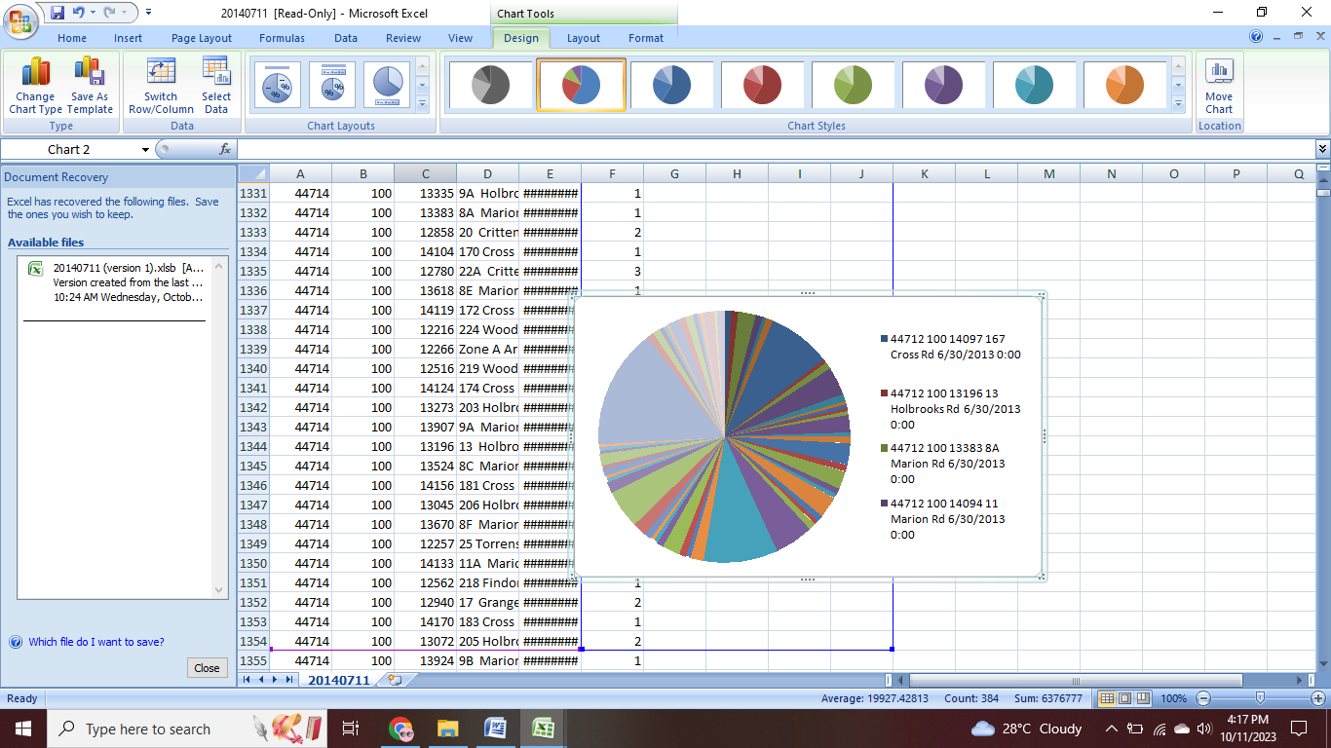

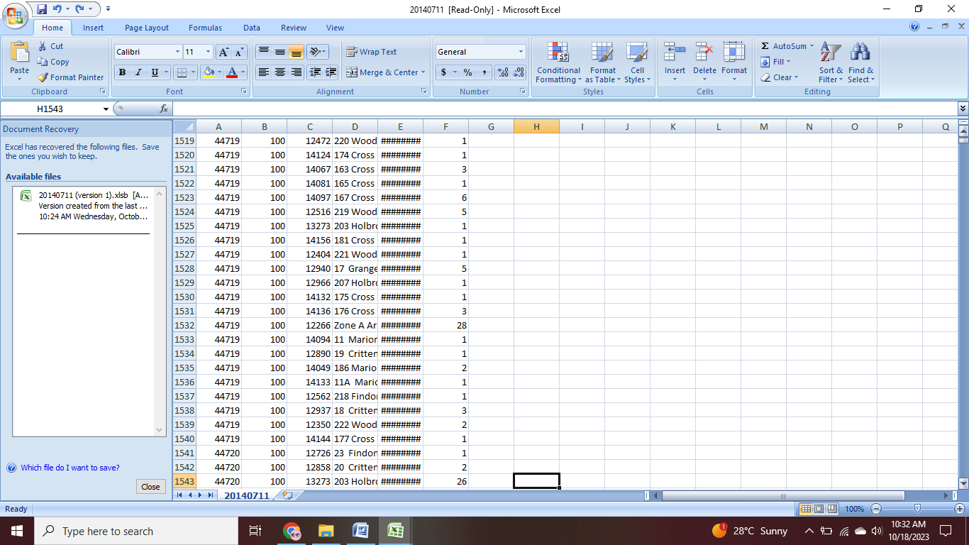

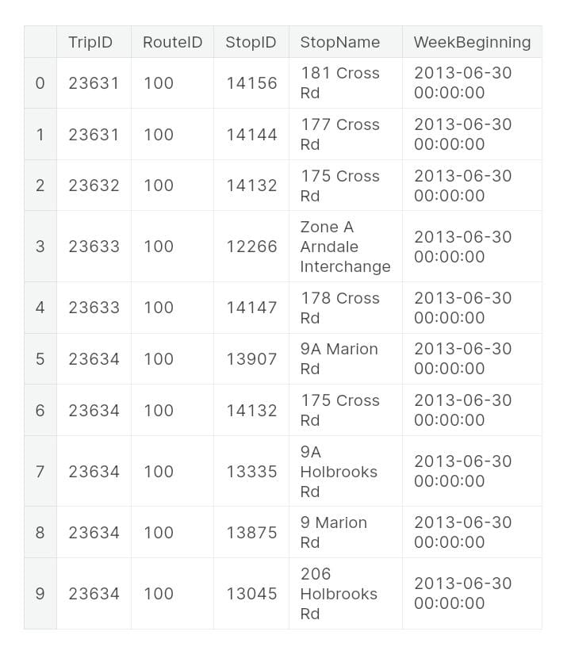



**CONCLUSION:**

Planning boundaries for roads and assessing associated environmental effects are often based on socioeconomic considerations, resulting in a mismatch between planning scales and spatial scales at which ecological systems operate. In part, this mismatch results because there are few legal incentives or disincentives to consider environmental effects beyond political jurisdictions, and thus decision making remains primarily local. The ecological effects of roads are typically much larger than the road itself, and they often extend beyond regional planning domains.Scientific literature on ecological effects of roads generally addresses local-to-intermediate scales, and many of those effects are wellSuggested Citation:"8 Conclusions and Recommendations." Transportation Research Board and National Research Council. 2005. Assessing and Managing the Ecological Impacts of Paved Roads. Washington, DC: The National Academies Press. doi: 10.17226/11535.×SaveCanceldocumented. However, there are few integrative or large-scale studies. Sometimes the appropriate spatial scale for ecological research is not known in advance, and in that case, some ecological effects of roads may go undetected if an inappropriate scale is chosen. Few studies have addressed the complex nature of the ecological effects of roads, and the studies that have done so were often based on small sampling periods and insufficient sampling of the range of variability in ecological systems.National Academies of Sciences, Engineering, and Medicine. 2005. Assessing and Managing the Ecological Impacts of Paved Roads. Washington, DC: The National Academies Press. https://doi.org/10.17226/11535.