Activity 6

1. Analysis of Agile Methodology for Final Year Project Management System

- Adaptability: Your project requirements may evolve as you gather feedback from stakeholders or identify new needs.
- Incremental Delivery: Allows you to develop a functional system in manageable parts, making it easier to test and improve.
- Stakeholder Engagement: Regular demos and reviews ensure your project aligns with expectations.
- Time Management: Short development cycles (sprints) facilitate steady progress within academic deadlines.
- Risk Reduction: Continuous testing and feedback help identify issues early.

2. Traditional vs. Modern (Agile) Approaches

ASPECT | TRADITIONAL | MODERN (AGILE)
Requirements | Fully specified upfront | Evolving, refined through iterations
Development process | Sequential | Iterative and incremental
Flexibility | Low, changes are difficult and costly | High, changes integrated easily
Stakeholder involvement | Limited, mainly at start and end | Continous, regular feedback sessions
Testing | After implementation | Continous, integrated into development
Delivery | Single final product | Multiple usable releases(increments)

3. Chosen Methodology: Agile

- Agile allows iterative development, which is perfect for academic projects where requirements might change or be clarified over time.
- Regular feedback loops with supervisors or peers ensure the project stays aligned with expectations.
- It encourages continuous improvement and early detection of issues, increasing the likelihood of project success.

- Diagram Mapping Project Tasks to SDLC Phases using Agile

A visual flowchart showing:

- Your project backlog (list of features)
- Sprint cycles with planning, development, testing, review, and retrospectives
- The progressive build-up of system modules over multiple sprints

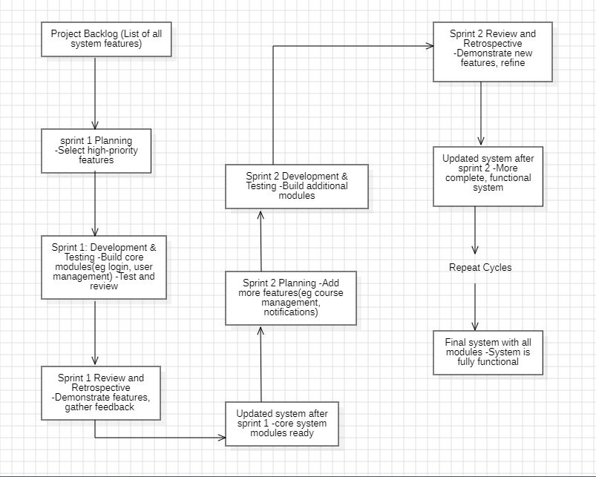

5. Deliverables

A report Detailing the Chosen Agile Methodology

Introduction:
Overview of Agile principles and values.
Agile is a project management approach that emphasizes flexibility, collaboration, and rapid delivery. It is an iterative and incremental approach that focuses on delivering working software in short cycles, called sprints or iterations. Agile aims to foster a culture of continuous improvement, transparency, and customer satisfaction.

Key Principles of Agile

The Agile manifesto, written by Kent Beck, Mike Beedle, and others in 2001, outlines the four core values and 12 principles of Agile:

Core Values

1. Individuals and interactions over processes and tools
2. Working software, over comprehensive documentation
3. Customer collaboration, over contract negotiation
4. Responding to change, over following a plan

Principles

1. Our highest priority is to satisfy the customer through early and continuous delivery of valuable software.
2. Welcome changing requirements, even late in development.
3. Deliver working software frequently, from a couple of weeks to a couple of months, with a preference to the shorter timescale.
4. Business people and developers must work together daily throughout the project.
5. Build projects around motivated individuals. Give them the environment and support their need, and trust them to get the job done.
6. The most efficient and effective method of conveying information to and within a development team is face-to-face conversation.
7. Working software is the primary measure of progress.
8. Agile processes promote sustainable development. The sponsors, developers, and users should be able to maintain a constant pace indefinitely.
9. Continuous attention to technical excellence and good design enhances agility.
10. Simplicity--the art of maximizing the amount of work not done is essential.
11. The best architectures, requirements, and designs emerge from self-organizing teams.
12. At regular intervals, the team reflects on how to become more agile and adjusts its behavior accordingly**.

How Agile Will Be Applied to Our Project

To apply Agile to our project, we will follow the Scrum framework, which is a widely used Agile methodology. Our project will consist of the following:

1. Sprints: We will have two-week sprints, with a clear definition of what needs to be accomplished during each sprint.
2. Daily Stand-ups: Team members will attend daily meetings to discuss progress, plans, and any obstacles.
3. Sprint Planning: Before each sprint, the team will plan and prioritize the work to be done.
4. Sprint Review: At the end of each sprint, the team will review the completed work and provide feedback.
5. Retrospective: After each sprint, the team will reflect on what went well and what didn't, and make adjustments to improve the process.
6. Backlog: We will maintain a product backlog, which is a prioritized list of features and user stories to be developed.

Justification:

- Flexibility in Requirements: As a final year project, requirements may evolve based on ongoing feedback from supervisors and stakeholders. Agile’s responsiveness allows us to incorporate changes seamlessly.

- Customer Collaboration: Regular interactions with stakeholders ensure that the project aligns with their expectations and needs.

- Early and Continuous Delivery: Agile promotes delivering functional parts of the system early, enabling early testing and feedback, which helps in identifying issues promptly.

- Risk Management: Iterative development reduces the risk of project failures by allowing regular assessment and course correction.

- Enhanced Team Collaboration: Daily stand-ups and collaborative planning foster effective communication within the team.

Implementation Plan

1. Project Backlog Creation: Develop a prioritized list of features, user stories, and tasks necessary for the system.

2. Sprint Planning: At the start of each sprint, select items from the backlog to work on, defining clear goals.

3. Sprint Execution: Team members work collaboratively on assigned tasks, holding daily stand-up meetings to track progress and address obstacles.

4. Sprint Review: At the end of each sprint, demonstrate the completed features to stakeholders to gather feedback.

5. Sprint Retrospective: Reflect on the sprint process to identify what went well and areas for improvement.

6. Continuous Refinement: Adjust the backlog based on feedback and project insights, ensuring ongoing relevance and priority alignment.

Benefits:
1. Increased flexibility: Agile allows us to respond quickly to changes in requirements or priorities.
2. Improved collaboration: Agile promotes close collaboration between team members, stakeholders, and customers.
3. Faster time-to-market: Agile enables us to deliver working software in short cycles, reducing the overall project duration.
4. Higher quality: Agile's focus on continuous improvement and testing ensures that our software is of high quality.

Challenges & Solutions

Challenges | Potential impact | Proposed solution
Scope creep | Uncontrolled expansion of features may delay delivery | Maintain a well-prioritized backlog and enforce strict sprint scope boundaries
Team coordination | Miscommunication may lead to misunderstandings and delays | Conduct daily stand ups and use collaborative tools like Trello for task tracking
Stakeholder engagement | Lack of regular feedback could mis align the project | Schedule consistent review sessions and encourage active stakeholder participation
Time constraints | Limited time for multiple sprints may impact quality | Focus on high priority features and deliver working software incrementally
Changing Requirements | Frequent changes may cause confusion | Implement flexible planning and adapt the backlog based on feedback

