*********************************************************
Report: hw8
Author: F74044127 林慶瑞 <bladeath860620@gmail.com>
Class: 甲班
Description:
How do you finish this homework?
I looked up informations about link list on the textbook and discussed with my friends.
What did you learned from this homework?
Using link list to create information structures and to sort informations.
*********************************************************
Code:
#include <stdio.h>
#include <stdlib.h>
#include <math.h>
#include <string.h>
//0.0.0.0(address)/length
/*unsigned long long int begin,end, result= 0;
begin=rdtsc();
// executing code you want to measure
end=rdtsc();
result = end-begin;*/
inline unsigned long long int rdtsc()
{
unsigned long long int x;
asm volatile ("rdtsc" : "=A" (x));
return x;
}

struct IP
{
unsigned int address;
unsigned int length;
struct IP *next;
};
typedef struct IP ip;

unsigned int bin(unsigned int adr[])
{
unsigned int bin_adr = 0;
bin_adr |= (adr[0] << 24);
bin_adr |= (adr[1] << 16);
bin_adr |= (adr[2] << 8);
bin_adr |= adr[3];
return bin_adr;
}

ip *newnode(ip *head, unsigned int adr, unsigned int len)//put ip under link lists while doing sort at the same time()
{
ip *temp = head;
ip *node = malloc(sizeof(ip));
node -> address = adr;
node -> length = len;
node -> next = NULL;
if(head == NULL)
{
return node;
}
if(head -> length <= len)
{
node -> next = head;
return node;
}//
while(temp -> next != NULL)
{
if((temp -> next) -> length <= len)
{
node -> next = temp -> next;
temp -> next = node;
return head;
}
else
{
temp = temp -> next;
}
}
temp -> next = node;//
return head;
}

unsigned int bin_to_int(unsigned int adr[], unsigned int length, unsigned int int_adr)
{
if(length >= 8 && length <= 15)
{
return bin(adr) >> (32-8);
}
if(length >= 16 && length <= 32)
{
return bin(adr) >> (32-12);
}
}

unsigned int bin_to_int1(unsigned int adr[])//rewrote two kinds of bin_to_int because no length is given while searching
{
return bin(adr) >> (32-8);
}
unsigned int bin_to_int23(unsigned int adr[])
{
return bin(adr) >> (32-12);
}

/*unsigned int compare_length(unsigned int len_mem[])
{
unsigned int longest, compare;
int i;
longest = len_mem[0];
compare = len_mem[1];
if(compare > longest)
{
longest = len_mem[1];
return longest;
}
else
{
return longest;
}
}*/

ip *searching(ip *head, unsigned int goal/*, unsigned int len_mem[]*/)
{
unsigned int origin_adr;
unsigned int target;
int i = 0;
int count = 0;
ip *save;
ip *temp = head;
while(temp != NULL)
{
origin_adr = (temp -> address) >> (32 - (temp -> length));
target = goal >> (32 - (temp -> length));
if(origin_adr == target)
{
/*save = temp;
len_mem[i] = temp -> length;
if(len_mem[1] > len_mem[0])
{
len_mem[0] = len_mem[1];
}
i = 1;
count++;
printf("%d\n", count);*/
return temp;
}
else
{
temp = temp -> next;
}
}
/*if(len_mem[0] == 0)
{
return NULL;
}
else
{
save -> length = len_mem[0];
return save;
}*/
return NULL;
}

void memory_to_ip(ip *memory, FILE *result)//turn memory to binary mode
{
unsigned int adr[4];
unsigned int length = memory -> length;
unsigned int binary = memory -> address;
adr[0] = binary >> 24;
binary &= 0x00FFFFFF;
adr[1] = binary >> 16;
binary &= 0x0000FFFF;
adr[2] = binary >> 8;
binary &= 0x000000FF;
adr[3] = binary;
fprintf(result, "%u.%u.%u.%u/%u\n", adr[0], adr[1], adr[2], adr[3], length);
return;
}

void link_list(ip *head, FILE *test)
{
ip *temp = head;
while(temp != NULL)
{
memory_to_ip(temp, test);
temp = temp -> next;
}
return;
}

ip* del(ip *head, unsigned int adr, unsigned int len)
{
ip *temp = head;
ip *dele;
if(head == NULL)
{
return head;
}
if((head -> length) == len && (head -> address) == adr)
{
dele = head;
free(dele);
head = head -> next;
return head;
}
while(temp -> next != NULL)
{
if(((temp -> next) -> length) == len && ((temp -> next) -> address) == adr)
{
dele = temp -> next;
free(dele);
temp -> next = (temp -> next) -> next;
return head;
}
else
{
temp = temp -> next;
}
}
return head;
}

int main()
{
int i;
int locate_tab = 0;
char string[30];
unsigned int adr[4], length;
unsigned int int_adr = 0;
//unsigned int len_mem[20] = {0};
ip *tab1[(int)pow(2,8)];
ip *tab2[(int)pow(2,12)];
ip *tab3[(int)pow(2,12)];
FILE *k400, *result, *search, *insert, *delete, *test ,*search_csv, *insert_csv, *delete_csv;
k400 = fopen("IPv4_400k.txt", "r");
result = fopen("result.txt", "w");
search = fopen("IPv4_search.txt", "r");
insert = fopen("IPv4_insert.txt", "r");
delete = fopen("IPv4_delete.txt", "r");
test = fopen("test.txt", "w");
search_csv = fopen("search.csv", "w");
insert_csv = fopen("insert.csv", "w");
delete_csv = fopen("delete.csv", "w");
unsigned long long int begin,end;
for(i = 0; i < pow(2,8); i++)
{
tab1[i] = NULL;
}
for(i = 0; i < pow(2,12); i++)
{
tab2[i] = NULL;
tab3[i] = NULL;
}
//put all element in tab arrays to prevent *head from segmentation fault
while(fgets(string, 30, k400) != NULL)
{
sscanf(string, "%u.%u.%u.%u/%u", &adr[0], &adr[1], &adr[2], &adr[3], &length);
if(length >= 8 && length <= 15)
{
int_adr = bin_to_int(adr, length, int_adr);
tab1[int_adr] = newnode(tab1[int_adr], bin(adr), length);
}
if(length >= 16 && length <= 24)
{
int_adr = bin_to_int(adr, length, int_adr);
tab2[int_adr] = newnode(tab2[int_adr], bin(adr), length);
}
if(length >=25 && length <= 32)
{
int_adr = bin_to_int(adr, length, int_adr);
tab3[int_adr] = newnode(tab3[int_adr], bin(adr), length);
}
}
/*^^^^^^^^^^^^^^^^^^^^^^^^^^^^^^create^^^^^^^^^^^^^^^^^^^^^^^^^^^^^^*/
for(i = 0; i < 1 << 8; i++)
{
link_list(tab1[i], test);
fprintf(test, "%s", "=========================\n");
}
for(i = 0; i < 1 << 12; i++)
{
link_list(tab2[i], test);
fprintf(test, "%s", "=========================\n");
}
for(i = 0; i < 1 << 12; i++)
{
link_list(tab3[i], test);
fprintf(test, "%s", "=========================\n");
}
/*^^^^^^^^^^^^^^^^^^^^^^^^^^^^^^^test^^^^^^^^^^^^^^^^^^^^^^^^^^^^^^^*/
ip *memory;
while(fgets(string, 30, search) != NULL)
{
begin=rdtsc();
sscanf(string, "%u.%u.%u.%u", &adr[0], &adr[1], &adr[2], &adr[3]);
int_adr = bin_to_int23(adr);
memory = searching(tab3[int_adr], bin(adr)/*, len_mem*/);
if(memory != NULL)
{
memory_to_ip(memory, result);
locate_tab = 3;
}

int_adr = bin_to_int23(adr);
memory = searching(tab2[int_adr], bin(adr)/*, len_mem*/);
if(memory != NULL && locate_tab == 0)
{
memory_to_ip(memory, result);
locate_tab = 2;
}

int_adr = bin_to_int1(adr);
memory = searching(tab1[int_adr], bin(adr)/*, len_mem*/);
if(memory != NULL && locate_tab == 0)
{
memory_to_ip(memory, result);
locate_tab = 1;
}
if(locate_tab == 0)
{
fprintf(result, "%s", "0.0.0.0/0\n");
}
locate_tab = 0;
end=rdtsc();
fprintf(search_csv, "%llu\n", end-begin);
}
/*^^^^^^^^^^^^^^^^^^^^^^^^^^^^^^search^^^^^^^^^^^^^^^^^^^^^^^^^^^^^^*/
while(fgets(string, 30, insert) != NULL)
{
begin=rdtsc();
sscanf(string, "%u.%u.%u.%u/%u", &adr[0], &adr[1], &adr[2], &adr[3], &length);
if(length >= 8 && length <= 15)
{
int_adr = bin_to_int(adr, length, int_adr);
tab1[int_adr] = newnode(tab1[int_adr], bin(adr), length);
}
if(length >= 16 && length <= 24)
{
int_adr = bin_to_int(adr, length, int_adr);
tab2[int_adr] = newnode(tab2[int_adr], bin(adr), length);
}
if(length >=25 && length <= 32)
{
int_adr = bin_to_int(adr, length, int_adr);
tab3[int_adr] = newnode(tab3[int_adr], bin(adr), length);
}
end=rdtsc();
fprintf(insert_csv, "%llu\n", end-begin);
}
/*^^^^^^^^^^^^^^^^^^^^^^^^^^^^^^insert^^^^^^^^^^^^^^^^^^^^^^^^^^^^^^*/
while(fgets(string, 30, delete) != NULL)
{
begin=rdtsc();
sscanf(string, "%u.%u.%u.%u/%u", &adr[0], &adr[1], &adr[2], &adr[3], &length);
if(length >= 8 && length <= 15)
{
int_adr = bin_to_int(adr, length, int_adr);
tab1[int_adr] = del(tab1[int_adr], bin(adr), length);
}
if(length >= 16 && length <= 24)
{
int_adr = bin_to_int(adr, length, int_adr);
tab2[int_adr] = del(tab2[int_adr], bin(adr), length);
}
if(length >=25 && length <= 32)
{
int_adr = bin_to_int(adr, length, int_adr);
tab3[int_adr] = del(tab3[int_adr], bin(adr), length);
}
end=rdtsc();
fprintf(delete_csv, "%llu\n", end-begin);
}
/*^^^^^^^^^^^^^^^^^^^^^^^^^^^^^^delete^^^^^^^^^^^^^^^^^^^^^^^^^^^^^^*/
fclose(k400);
fclose(result);
fclose(search);
fclose(insert);
fclose(delete);
fclose(test);
fclose(search_csv);
fclose(insert_csv);
fclose(delete_csv);
}

Compilation:
gcc -o hw8 hw8.c

Execution:
./hw8

Output:
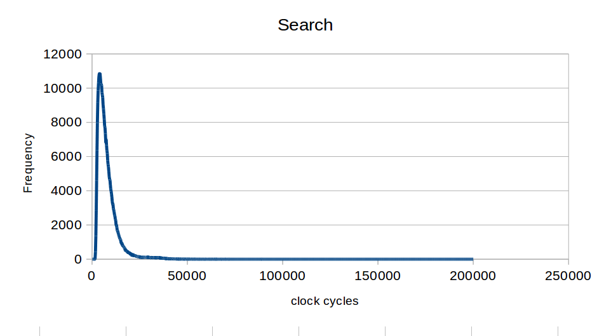
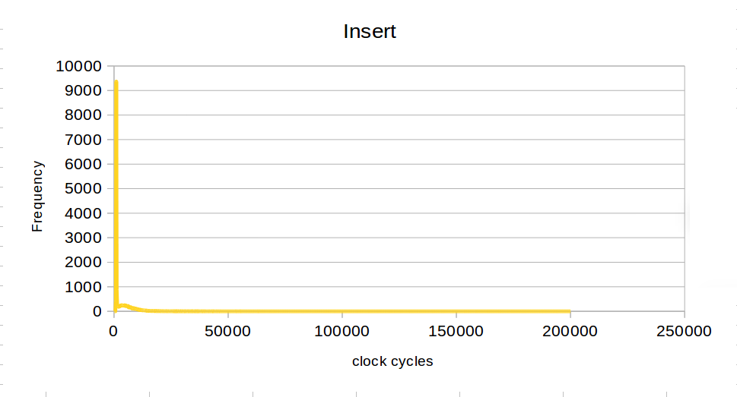
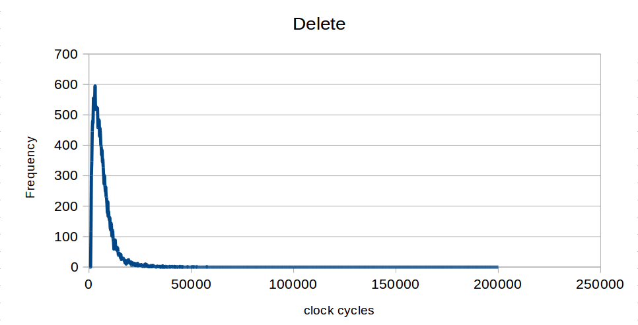
Error while compiling:
Not much, most of them were segmentation faults. Error were mostly about the information in the link lists are wrong.(used the “diff” command in linux to compare “result.txt” with my friends)

Further informations can be found on ”https://github.com/bladeath860620/hw8”
I've uploaded different version and histories of my code

