Toy Robot Simulation - Read Me File

How to Run

Project was tested and created with a Live Server, using a webpage over a CLI app.

To Run Commands.

1. Open index.html Webpage with Live Server
2. Select Choose File (skip if you wish to input manually)
3. 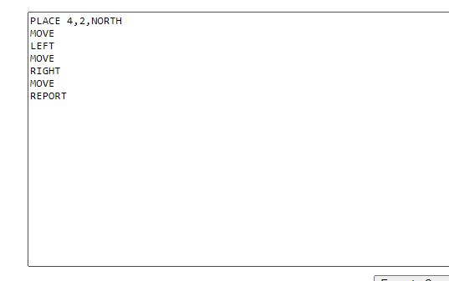Text from the file will fill the TextArea.
4. Add additional Commands if you wish
5. 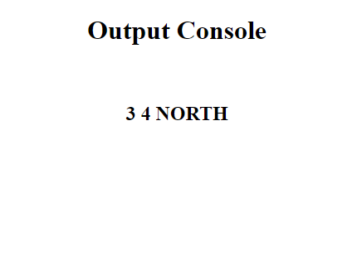Click Execute Command Button
6. Any Report Commands will output into the output console.

Note

* Output Console is case sensitive and requires all caps.
* Make sure PLACE Command is structure as “PLACE x,y,f” (e.g 1,2,NORTH)
* Make sure there is no spaces before or after the commands as it will prevent the line from being executed properly.

Choices

* With this project I aimed to prioritise legibility and readability over raw efficiency, I have always prioritised code that is easier to read and edit over an unreadable mess that is two lines more efficient.
* While reviewing the brief I was not sure on the complexity to which you wanted to the project to go. I originally created modules with other project src files, but it quickly became over complicated, I instead dialled most of my code to a simpler form, which would be easier to read and change if need be.
* Toy Orientation was saved as a number instead of a string, this made it easier long term to adjust the direction and made the code slightly more efficient long term.