Test Report

Project Name: GATE.SHOP

Document Date: <2022.11.14.>

**Junior SOFTWARE TESTER:**

**BLAGA MADALINA**

Table of Contents

Testing Scope 4

1.1. Test Environment 4

1.2. Testing Team 4

Test Results 5

1.3. Executed Test Cases 5

1.4. Exploratory testing 5

Defects 6

1.5. New defects 6

1.6. Validated bugs 6

1.7. Old bugs still open 6

Conclusions 7

# Testing Scope

| Product/Feature | Testing Period | Tested Builds | Deployment Date |
| --- | --- | --- | --- |
| **Create new account** | 30/09 – 05/10 | Version 1.0 | 19/11/2022 |
| **Login** | 05/10 – 16/10 | Version 1.0 | 19/11/2022 |
| **Forgot password** | 20/10 – 28/10 | Version 1.0 | 19/11/2022 |
| **Add to cart** | 28/10 – 03/11 | Version 1.0 | 19/11/2022 |
| **Continue shopping** | 03/11 – 05/11 | Version 1.0 | 19/11/2022 |
| **Update cart** | 06/11 – 06/11 | Version 1.0 | 19/11/2022 |
| **Add to favourite** | 08/11 – 08/11 | Version 1.0 | 19/11/2022 |
| **Remove from cart** | 08/11 – 08/11 | Version 1.0 | 19/11/2022 |
| **Checkout** | 08/11 – 08/11 | Version 1.0 | 19/11/2022 |
| **Search** | 08/11 – 08/11 | Version 1.0 | 19/11/2022 |
| **Log -out** | 08/11 – 08/11 | Version 1.0 | 19/11/2022 |
| **My account** | 09/11 – 09/11 | Version 1.0 | 19/11/2022 |
| **Payment and delivery** | 10/11 – 10/11 | Version 1.0 | 19/11/2022 |
| **Sort and filter** | 10/11 – 10/11 | Version 1.0 | 19/11/2022 |
| **Responsive testing** | 11/11 – 11/11 | Version 1.0 | 19/11/2022 |
| **Web accessibility testing** | 11/11 – 11/11 | Version 1.0 | 19/11/2022 |
| **Connectivity** | 11/11 – 11/11 | Version 1.0 | 19/11/2022 |
| **Security testing** | 12/11 – 20/11 | Version 1.0 | 19/11/2022 |

## Test Environment

| Test Environment | Software Details | Comments |
| --- | --- | --- |
| PRODUCTION | Windows 10, Os build 21H2/ 19044.1645,  Microsoft Edge (Version 107.0.1418.26 (Official build) (64-bit)) | Laptop Dell |
|  | Windows 10, Os build 21H2/ 19044.1645;  Chrome (Version 107.0.5304.88 (Official Build) (64-bit)) | Laptop Dell |
|  | MANTIS bug management tool |  |
| WEB Tools/services | https://www.browserstack.com/responsive |  |
| https://web.dev/measure/ |  |
| https://sitecheck.sucuri.net/ |  |

## Testing Team

| Role | Name | Comments (e.g. test effort h) |
| --- | --- | --- |
| Junior Tester | Madalina Blaga | 40 hours |
| Mentor | [Catalin Mihacea](https://platforma.scoalainformala.ro/user/view.php?id=10018&course=1) |  |
| Mentor | [Mihai Streza](https://platforma.scoalainformala.ro/user/view.php?id=12042&course=1) |  |

# Test Results

## Executed Test Cases

|  |  |  |  |  |  |  |  |  |
| --- | --- | --- | --- | --- | --- | --- | --- | --- |
| **Test overview** | **STATUS** | | | | | | | |
| **Pass**  **%** | **No of tests** | **Passed** | **Failed** | **Blocked** | **Not tested** | Improvement ID | Bugs ID |
| **Create new account** | 83,3% | 48 | 40 | 8 | 0 | 0 | - | ID 0044996; ID 0044961; ID 0044970; ID 0044971;ID 0044972; ID 0044997; ID 0044998; ID 0044999 |
| **Login** | 87,5% | 8 | 7 | 1 | 0 | 0 | - | ID 0045133 |
| **Forgot password** | 100,0% | 3 | 3 | 0 | 0 | 0 | - | - |
| **Add to cart** | 100,0% | 3 | 3 | 0 | 0 | 0 | - | - |
| **Continue shopping** | 100,0% | 1 | 1 | 0 | 0 | 0 | - | - |
| **Update cart** | 80,0% | 5 | 4 | 1 | 0 | 0 | ID 0045134 | ID 0045135 |
| **Favorite list** | 100,0% | 3 | 3 | 0 | 0 | 0 | ID 0045136 | - |
| **Remove from cart** | 100,0% | 3 | 3 | 0 | 0 | 0 | ID 0045137 |  |
| **Checkout** | 100,0% | 2 | 2 | 0 | 0 | 0 | - | - |
| **Search** | 100,0% | 7 | 7 | 0 | 0 | 0 | - | - |
| **Logout** | 100,0% | 2 | 2 | 0 | 0 | 0 | - | - |
| **My account** | 91,7% | 12 | 7 | 0 | 0 | 0 | - | ID 0045138 |
| **Payment and delivery** | 100,0% | 7 | 7 | 0 | 0 | 0 | - | - |
| **Sort and filter** | 15,6% | 6 | 5 | 1 | 0 | 0 | - | ID 0045139 |
| **Responsive testing** | 100,0% | 6 | 6 | 0 | 0 | 0 | - | - |
| **Web accessibility testing** | 25,00% | 4 | 4 | 0 | 0 | 0 | - | - |
| **Connectivity** | 0,00% | 4 | 0 | 4 | 0 | 0 | - | ID 0045167 |
| **Security testing** | 88,89% | 9 | 8 | 1 | 0 | 0 | - | ID 0045166 |

## Exploratory testing

| Functionality | Defects |
| --- | --- |
| Create new account | ID 0044996; ID 0044961; ID 0044970; ID 0044971;ID 0044972; ID 0044997; ID 0044998; ID 0044999 |
| Login | ID 0045133 |
| Forgot password | - |
| Add to cart | - |
| Continue shopping | - |
| Update cart | ID 0045135 |
| Add to favorite | - |
| Remove from cart | - |
| Checkout - | | - |
| Search | - |
| Log -out | - |
| My account | ID 0045138 |
| Payment and delivery | - |
| Sort and filter | ID 0045139 |
| Responsive testing | - |
| Web accessibility testing | - |
| Connectivity | ID 0045167 |
| Security testing | ID 0045166 |

# Defects

## New defects

| Defect ID | Defect summary | Severity |
| --- | --- | --- |
| [0045166](https://bugs.scoalainformala.ro/view.php?id=45166) | No firewall detected during security scan of the website | major |
| [0045139](https://bugs.scoalainformala.ro/view.php?id=45139) | Price filter resets to default if the value is typed in the price box | minor |
| [0045138](https://bugs.scoalainformala.ro/view.php?id=45138) | New card cannot be added without placing an order | normal |
| [0045137](https://bugs.scoalainformala.ro/view.php?id=45137) | No option to delete all items from the bag at once only remove on by one | minor |
| [0045136](https://bugs.scoalainformala.ro/view.php?id=45136) | Form Cart only move product to favourite list is available | minor |
| [0045135](https://bugs.scoalainformala.ro/view.php?id=45135) | More than quantity than on stock for a product can be added in the cart. | normal |
| [0045134](https://bugs.scoalainformala.ro/view.php?id=45134) | Missing feature to type in the quantity for any product | minor |
| [0045133](https://bugs.scoalainformala.ro/view.php?id=45133) | When login with incorrect e-mail address the correct error message is not displayed | normal |
| [0044998](https://bugs.scoalainformala.ro/view.php?id=44998) | Registration form - Cod postal field - not showing the correct error message when 11 characters are typed in | normal |
| [0044999](https://bugs.scoalainformala.ro/view.php?id=44999) | In registration form the text field "Localitate" is a mandatory field but is not labelled with " * " | normal |
| [0044997](https://bugs.scoalainformala.ro/view.php?id=44997) | In registration form the text field "Cod postal" is a mandatory field but is not labelled with "*" | normal |
| [0044996](https://bugs.scoalainformala.ro/view.php?id=44996) | Registration form - "Strada" field - accepts symbols as valid input - no error message is displayed | normal |
| [0044972](https://bugs.scoalainformala.ro/view.php?id=44972) | Street number field of the registration form accepts decimal numbers | normal |
| [0044971](https://bugs.scoalainformala.ro/view.php?id=44971) | Street number field of the registration form accepts alphabetical characters | normal |
| [0044970](https://bugs.scoalainformala.ro/view.php?id=44970) | Street text field of the registration form accepts decimal numbers | normal |
| [0044961](https://bugs.scoalainformala.ro/view.php?id=44961) | Street text field of the registration form accepts integer numbers | normal |

## Validated bugs

| Defect ID | Defect summary | Status |
| --- | --- | --- |
| [0045166](https://bugs.scoalainformala.ro/view.php?id=45166) | No firewall detected during security scan of the website | Open |
| [0045139](https://bugs.scoalainformala.ro/view.php?id=45139) | Price filter resets to default if the value is typed in the price box | Open |
| [0045138](https://bugs.scoalainformala.ro/view.php?id=45138) | New card cannot be added without placing an order | Open |
| [0045137](https://bugs.scoalainformala.ro/view.php?id=45137) | No option to delete all items from the bag at once only remove on by one | Open |
| [0045136](https://bugs.scoalainformala.ro/view.php?id=45136) | Form Cart only move product to favourite list is available | Open |
| [0045135](https://bugs.scoalainformala.ro/view.php?id=45135) | More than quantity than on stock for a product can be added in the cart. | Open |
| [0045134](https://bugs.scoalainformala.ro/view.php?id=45134) | Missing feature to type in the quantity for any product | Open |
| [0045133](https://bugs.scoalainformala.ro/view.php?id=45133) | When login with incorrect e-mail address the correct error message is not displayed | Open |
| [0044998](https://bugs.scoalainformala.ro/view.php?id=44998) | Registration form - Cod postal field - not showing the correct error message when 11 characters are typed in | Open |
| [0044999](https://bugs.scoalainformala.ro/view.php?id=44999) | In registration form the text field "Localitate" is a mandatory field but is not labelled with " * " | Open |
| [0044997](https://bugs.scoalainformala.ro/view.php?id=44997) | In registration form the text field "Cod postal" is a mandatory field but is not labelled with "*" | Open |
| [0044996](https://bugs.scoalainformala.ro/view.php?id=44996) | Registration form - "Strada" field - accepts symbols as valid input - no error message is displayed | Open |
| [0044972](https://bugs.scoalainformala.ro/view.php?id=44972) | Street number field of the registration form accepts decimal numbers | Open |
| [0044971](https://bugs.scoalainformala.ro/view.php?id=44971) | Street number field of the registration form accepts alphabetical characters | Open |
| [0044970](https://bugs.scoalainformala.ro/view.php?id=44970) | Street text field of the registration form accepts decimal numbers | Open |
| [0044961](https://bugs.scoalainformala.ro/view.php?id=44961) | Street text field of the registration form accepts integer numbers | Open |

## Old bugs still open

| Defect ID | Defect summary | Severity |
| --- | --- | --- |
| [0045166](https://bugs.scoalainformala.ro/view.php?id=45166) | No firewall detected during security scan of the website | major |
| [0045139](https://bugs.scoalainformala.ro/view.php?id=45139) | Price filter resets to default if the value is typed in the price box | minor |
| [0045138](https://bugs.scoalainformala.ro/view.php?id=45138) | New card cannot be added without placing an order | normal |
| [0045137](https://bugs.scoalainformala.ro/view.php?id=45137) | No option to delete all items from the bag at once only remove on by one | minor |
| [0045136](https://bugs.scoalainformala.ro/view.php?id=45136) | Form Cart only move product to favourite list is available | minor |
| [0045135](https://bugs.scoalainformala.ro/view.php?id=45135) | More than quantity than on stock for a product can be added in the cart. | normal |
| [0045134](https://bugs.scoalainformala.ro/view.php?id=45134) | Missing feature to type in the quantity for any product | minor |
| [0045133](https://bugs.scoalainformala.ro/view.php?id=45133) | When login with incorrect e-mail address the correct error message is not displayed | normal |
| [0044998](https://bugs.scoalainformala.ro/view.php?id=44998) | Registration form - Cod postal field - not showing the correct error message when 11 characters are typed in | normal |
| [0044999](https://bugs.scoalainformala.ro/view.php?id=44999) | In registration form the text field "Localitate" is a mandatory field but is not labelled with " * " | normal |
| [0044997](https://bugs.scoalainformala.ro/view.php?id=44997) | In registration form the text field "Cod postal" is a mandatory field but is not labelled with "*" | normal |
| [0044996](https://bugs.scoalainformala.ro/view.php?id=44996) | Registration form - "Strada" field - accepts symbols as valid input - no error message is displayed | normal |
| [0044972](https://bugs.scoalainformala.ro/view.php?id=44972) | Street number field of the registration form accepts decimal numbers | normal |
| [0044971](https://bugs.scoalainformala.ro/view.php?id=44971) | Street number field of the registration form accepts alphabetical characters | normal |
| [0044970](https://bugs.scoalainformala.ro/view.php?id=44970) | Street text field of the registration form accepts decimal numbers | normal |
| [0044961](https://bugs.scoalainformala.ro/view.php?id=44961) | Street text field of the registration form accepts integer numbers | normal |

Conclusions

**The website GATE.SHOP.ro is an e-commerce site with the scope to:**

* **Sell products to eastern Europe clients, while ensuring:**
* **a satisfying shopping experience for the clients**
* **easy to access and to use web site**
* **good customer service**
* **secure data and payments**

**All the main functionalities are implemented and functional. Test coverage is good, as all end user major functionalities were tested.**

**No critical or blocker bugs were found.**

**Website is functional on desktop and mobile devices.**

**From a total of 133 tests:**

* **112 representing 86%, have a passed status;**
* **16 tests representing 12%, have failed status, and**
* **2% improvements identified that may increase end user experience while using the web site.**

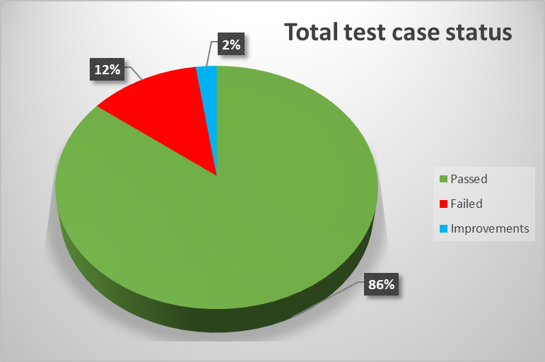

**Out of the total 16 bugs found, 1 ( 6%) bug has major severity due to missing firewall protection and potential increased risk for security breaches; 11 bugs ( 69%) with normal severity mainly concentrated in the “Create new account feature” and 4 bugs ( 25%) with minor severity concentrated in the shopping cart feature.**

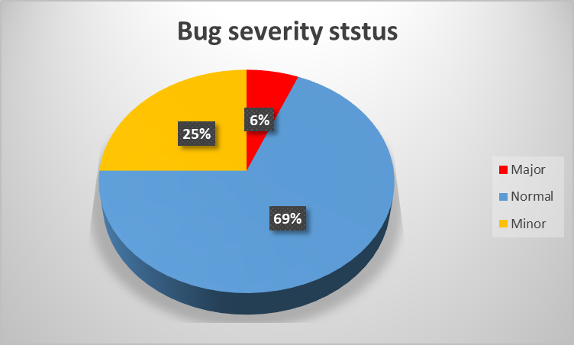

**2% of total bugs found are proposed improvements that will contribute to increasing the end user’s experience while navigating on the website.**

**All the bugs have been validated.**

**All the bugs have been allocated and have an open status in the Mantis bug management tool.**

**All the testing was done on the production environment on Microsoft Windows 10 version 20H2 and using web browser: Microsoft Edge (Version 107.0.1418.26 (Official build) (64-bit)) and Chrome (Version 107.0.5304.88 (Official Build) (64-bit))**

**Security testing audit was performed using a web service tool SUCURI Site check.**

**Web accessibility testing was performed using a web service tool Web.Dev. resulting in validating the functionality of the website on desktop and mobile devices.**

**Browserstack.com web service was used to perform responsive audit.**

**The Gate.Shop is functioning as client required, improvements can be made to enhance user experience (see open improvement) and as recommendation a firewall to increase web site security is necessary to be implemented.**