

**“AZƏRBAYCAN HAVA YOLLARI” CJSC NATIONAL AVIATION ACADEMY**

**Individual Work № 1:**

**Topic: CPU manufacturers and brands**

**Subject: System software and Operating systems-2**

**Teacher: Mehemmed Shahmaliyev**

**Group: 1459i Student: Maryam Hummatova**

**Date: Signature:H.F**

**Baku 2022**

What Is A CPU?

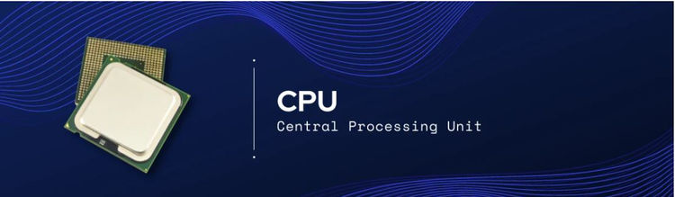

A Central Processing Unit (CPU) is the core processor that exists in all of your smart devices. CPU is a general-purpose processor designed with a few powerful cores and large cache memory that enables it to run a few software threads at once. A CPU

is like a conductor in an orchestra; it controls all of the other components from memory to graphics card to perform many processing functions for the system.

A CPU has at least a single processing core but has evolved over time to include more and more cores. Having several cores enables the CPU the ability to perform multithreading, a technology that allows the CPU to perform two lines of execution (threads) at once on a single core. Moreover, modern CPUs now have two to six cores, and some even have eight to 64 cores for enterprise-level CPUs usually reserved for the datacenter.

CPU Features Summary:

* Has Several Cores
* Low Latency
* Specialized in Serial Processing
* Capable of executing a handful of operations at once
* Have the highest FLOPS utilization for RNNs (recurrent neural network)
* Support the largest model thanks to its large memory capacity
* Much more flexible and programmable for irregular computations (e.g., small batches non MatMul computations)

# What are Different Types of Processors : Applications and Characteristics

Processors are invented by Marcian Hoff (28th October 1937 in New York). Some of the processor manufacturer companies are [Intel](https://www.elprocus.com/know-about-architecture-of-the-intel-8080-microprocessor/), AMD, Qualcomm, Motorola, Samsung, IBM, etc. The processors are small size chips made by silicon that are placed inside the devices to perform the task or operation within seconds and its speed is measured in terms of megahertz. The fetching, decoding, executing and write back the instructions are the four main primary functions of the processor. In mobile phones, laptops, computers, washing machines, etc processors are used. In this article, the different types of processors are discussed.

## What is a Processor?

**Definition:** The processor is a chip or a logical circuit that responds and processes the basic instructions to drive a particular computer. The main functions of the processor are fetching, decoding, executing, and write back the operations of an instruction. The processor is also called the brain of any system which incorporates computers, laptops, smartphones, embedded systems, etc. The ALU (Arithmetic Logic Unit) and CU (Control Unit) are the two parts of the processors. The Arithmetic Logic Unit performs all mathematical operations such as additions, multiplications, subtractions, divisions, etc and the control unit works like traffic police, it manages the command or the operation of the instructions. The processor communicates with the other components also they are input/output devices and memory/storage devices.

### Types of Processors

There are different types of processors in the embedded system which include the following.

### General Purpose Processor

There are five types of general-purpose processors they are, Microcontroller, Microprocessor, Embedded Processor, DSP and Media Processor.

#### Microprocessor

The general-purpose processors are represented by the microprocessor in embedded systems. There are different varieties of microprocessors available in the market from different companies. The microprocessor is also a general-purpose processor that consists of a control unit, ALU, a bunch of registers also called scratchpad registers, control registers and status registers.

There may be an on-chip memory and some interfaces for communicating with the external world like interrupt lines, other lines for the memory and ports for communicating with the external world. The ports often called the programmable ports that means, we can program these ports either to be acting as an input or as an output. The general-purpose processors are shown in the below table.

|  |  |  |  |  |  |  |
| --- | --- | --- | --- | --- | --- | --- |
| **S.NO** | **Processor** | **Clock Speed** | **Bus Width** | **MIPS** | **Power** | **Price** |
| **1** | Intel Pentium 111 | The clock speed of Intel Pentium 111 processor is 1GHz | The bus width of Intel Pentium 111 processor is 32 | A million instructions per second of Intel Pentium 111 processor is ~900 | The power of this processor is 97 W | $900 |
| **2** | IBM PowerPC 750X | The clock speed of the IBM PowerPC 750X processor is 550 MHz | The bus width of the IBM PowerPC 750X processor is 32/64 | A million instructions per second of IBM PowerPC 750X processor is ~1300 | The power of this processor is 5 W | #900 |
| **3** | MIPS R5000 | The clock speed of the MIPS R5000 processor is 250 MHz | The bus width of the MIPS R5000 processor is 32/64 | NA | NA | NA |
| **4** | StrongARM  SA-110 | The clock speed of StrongARM  SA-110 processor is 233 MHz | The bus width of StrongARM  SA-110processor is 32 | The million instructions per second of StrongARM  SA-110processor is 268 | The power of this processor is 1 W | NA |

#### Microcontroller

The microcontroller is basically a computer that comes in various packages and sizes. The reading input and responding to output is the basic function of the microcontroller. Generally, it is known as General Purpose Input Output (GPIO). Some of the microcontrollers are Microchip Atmega328-AU, Microchip P1C16F877A-I/P, Microchip P1C16F1503-I/P, Microchip P1C16F671-I/SN, Microchip P1C18F45K22-I/P, etc.

#### Embedded Processor

An embedded processor is one type of processor which is designed to control mechanical functions and electrical functions. It consists of several blocks they are the processor, timer, an interrupt controller, program memory and data memory, power supply, reset and clock oscillator circuits, system application-specific circuits, ports and interfacing circuits.

### Digital Signal Processor

The digital signal processor is one type of processor used for measuring, filtering and/or compress digital or analog signals. The signal processing means analysis and manipulation of signal. This processing can be done via computer or [Application Specific Integrated Circuits (ASIC)](https://www.elprocus.com/application-specific-integrated-circuits/), Field Programmable Gate Array (FPGA) or Digital Signal Processor (DSP) to obtain the clear signal. The DSP processors are used in an oscilloscope, barcode scanners, mobile phones, printers, etc. These processors are fast and use for real-time applications. The typical DSP system is shown in the below  figure.

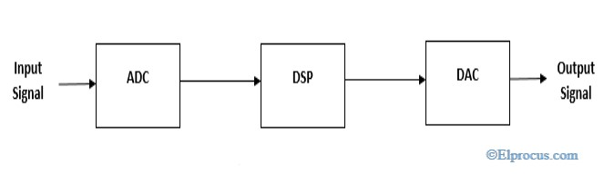*typical-system-for-digital-signal-processors*

The digital signal processors are shown in the below table

|  |  |  |  |  |  |
| --- | --- | --- | --- | --- | --- |
| **S.NO** | **Processor** | **Clock Speed** | **Bus Width** | **MIPS** | **Price** |
| **1** | T1 C5416  Processor | The clock speed of the T1 C5416 processor is 160 MHz | The bus width of T1 C5416  Processor is 32 | The million instructions per second for T1 C5416  The processor is ~600 | The price of the T1 C5416  The processor is $34 |
| **2** | DSP 32C  Processor | The clock speed of the DSP 32C Processor  is 80 MHz | The bus width of DSP 32C  Processor is 32 | The million instructions per second for DSP 32C  Processor is 40 | The price of the DSP 32C  Processor $75 |

#### Applications of DSP

The applications of the [digital signal processor](https://www.elprocus.com/digital-to-analog-converter-dac-applications/) are

* Speech processing
* Image processing
* Medical processing
* Biometric Processing
* Seismology
* Radar

### Media Processor

The image/video processor is the media processor that is designed or created to deal with the data in real-time. The voice user interface and professional audio are the applications of the audio processor. Some of the media processors are TN2302AP IP, IN2602 AP IP, DM3730, DM3725, DM37385, DM388, TMS320DM6467, TMS320DM6431, etc

### Application-Specific System Processors (ASSPs)

The application-specific system processor is a semiconductor [integrated circuit](https://www.elprocus.com/how-integrated-circuits-work-physically/) product used to implements a specific function. The performance, characteristics and die size of the application-specific system processor is the same as the ASIC. The ASSP’s are used in various types of industries to perform video encoding or decoding and audio encoding or decoding. In place of embedded software, the application-specific system processor is used to run the application and it provides the solution faster. Example: IIM7100, W3100A

### Application-Specific Instruction Set Processors (ASIPs)

The application-specific instruction-set processors are designed for specific applications. These processors have low power consumption, high computational speed, and good flexibility. Due to programmability, the data path utilization is high in ASIPs, and the performance of this instruction set processor is good.

### ASIC Processors

The application-specific integrated circuits are built for specific applications. These chips are small in size and consume low power. The design cost of ASIC is high and this is the main disadvantage. The application-specific integrated circuit chips are used in satellites, modems, computers, etc. Some of the top ASICs manufacturer companies are Ams AG. Listed Company, Bitfury. Private Company, XMOS [Semiconductor](https://www.elprocus.com/semiconductor-devices-types-and-applications/) Private Company, Analogix Semiconductor Private Company, EDAptive Computing Private Company, Lumen Radio Private Company, Integrated Device Technology, Hookit. Private Company, etc.

### MultiProcessor

The multiprocessor is a computer with more than one CPU, each shares main memory, a computer bus, and peripherals to simultaneously process the programs and these systems are also known as tightly coupled systems. The advantages of multiprocessors are increased throughput, increased reliability and economy of scale. These processors are used when very high speed is required to process a large volume of data. The symmetric multiprocessor is shown in the below figure.

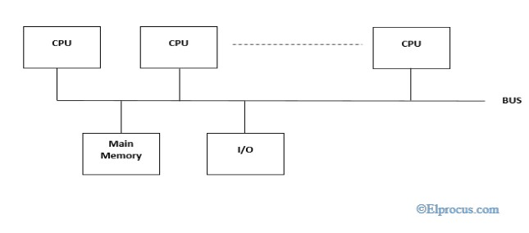*symmetric-multiprocessors*

### Characteristics of Multiprocessors

The Characteristics of Multiprocessor are

* The multiprocessors consist of more than two processors or two processors which are similar
* Memory and input/output facilities shared by the processors
* The access time of the memory is the same for each processor because the processors are connected by bus
* Access to the input/output devices are shared by the processors
* The same function performed by all the processors