上机实验报告（10）

姓名：邱文静

班级：17应用统计（1）班

学号：117060400119 指导老师：林卫中

# 实验名称：文件和数据格式化

# 实验目的：

* 掌握文件的读写方法以及打开、关闭和保存等基本操作
* 理解数据组织的维度及其特点
* 掌握一二维数据的存储格式和读写方法
* 运用PIL库进行基本的图像处理

# 实验过程及结果：

1. 程序练习题7.1：Python源文件改写。

**源代码：**

import Keyword

Kws = Keyword.kwlist

file = input("读取的文件：")

fr = open(file,'r',encoding = 'utf-8')

wline = ''

for line in fr:

wline += '\n'

if 'import' in line:

wline += line

else:

j = 0

while line[j] == ' ':

j += 1

sline = line.split()

for w in sline:

if ':' in w:

w = w[0:-1]

if w in Kws:

wline += w

else:

wline += w.upper()

wline += ' '

fr.close()

fw = open(file,'w',encoding = 'utf-8')

fw.write(wline)

fw.close()

1. 程序练习题7.2：图像文件压缩。

**源代码(1)：**

from PIL import Image

im = Image.open("957.jpg")

im.thumbnail((360,360))

im.save("9571.jpg")

#or

im.resize((360,360))

im.save("9572.jpg")

**执行结果：**

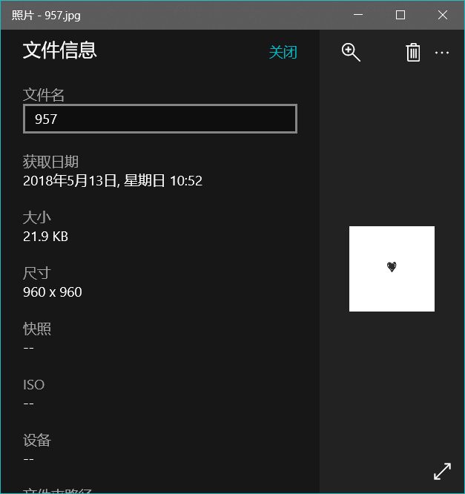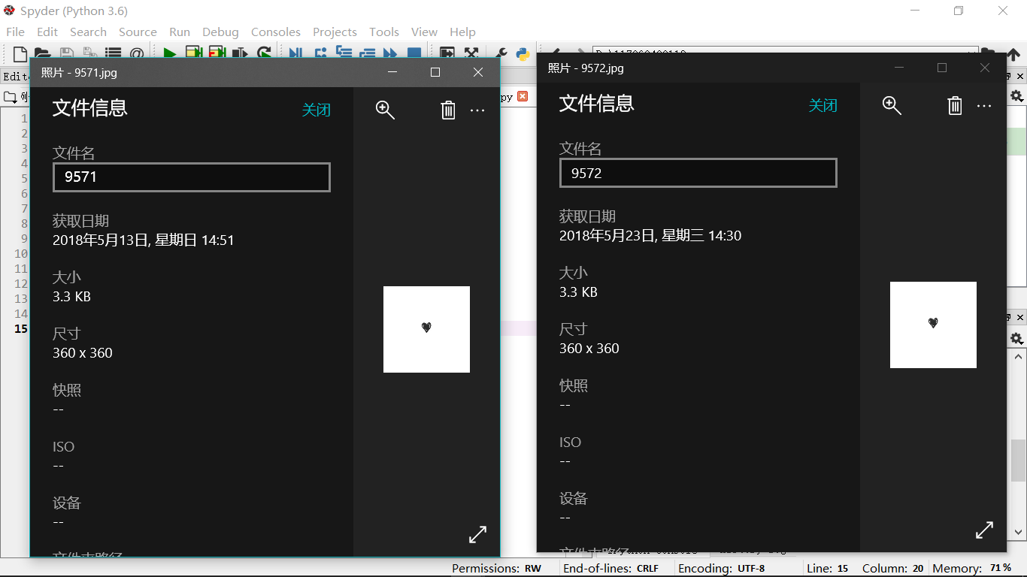

**源代码(2):**

from PIL import Image

im = Image.open("957.jpg")

w,h = im.size

c = 5

im.thumbnail((w//c,h//c))

im.save("9571.jpg")

#or

im2 = Image.open("957.jpg")

im2.resize((w//c,h//c)).save("9572.jpg")

**执行结果：**

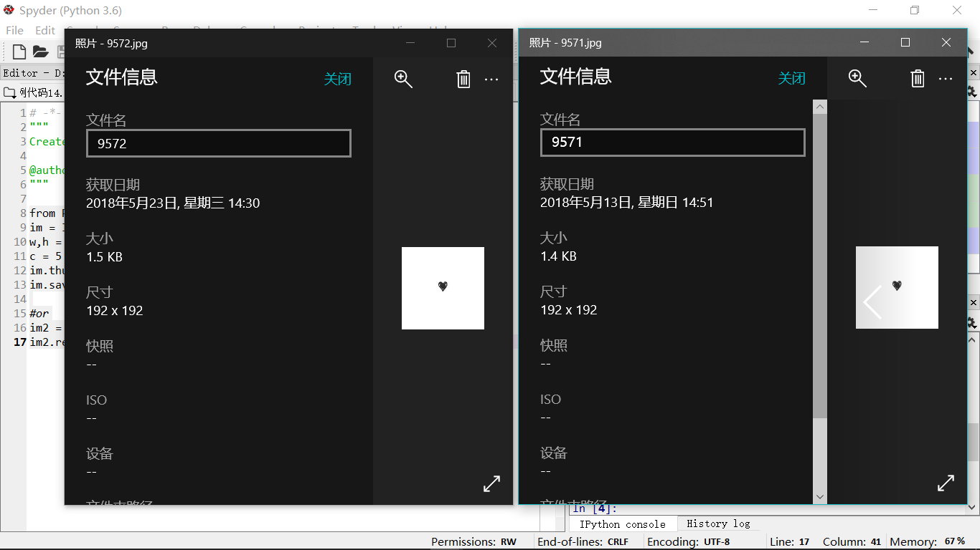

1. 程序练习题7.5：制作英文学习词典

**源代码：**

import os

def userOperateInterface():

print("\n请选择词典功能")

print("i: 添加单词")

print("s: 查询单词")

print("Q: 退出词典")

print("请选择功能：")

return input()

def addWord(wordDict:dict, fileName):

str = input("您输入要加入的单词：")

if str in wordDict.keys():

print("该单词已添加到字典库\n")

else:

t = input("请输入此单词的中文释义：")

wordDict[str] = t

with open(fileName,'a') as fw:

fw.write(str + " " + t +'\n')

def selectWord(wordDict:dict):

str = input("请输入您要查询的单词:")

if str not in wordDict.keys():

print("字典库中未找到这个单词\n")

else:

print(wordDict[str])

def main():

wordDict = {}

if os.path.exists("dict.txt"):

with open("dict.txt", 'r') as fr:

for ln in fr:

s = ln.split(" ")

wordDict[s[0]] = s[1]

else:

fw = open("dict.txt",'w')

fw.close()

print("******欢迎使用简明英汉词典*******")

while True:

op = userOperateInterface()

if op == "i":

addWord(wordDict,'dict.txt')

elif op == "s":

selectWord(wordDict)

elif op == "Q":

break

else:

print("输入有误\n")

main()

**执行结果：**

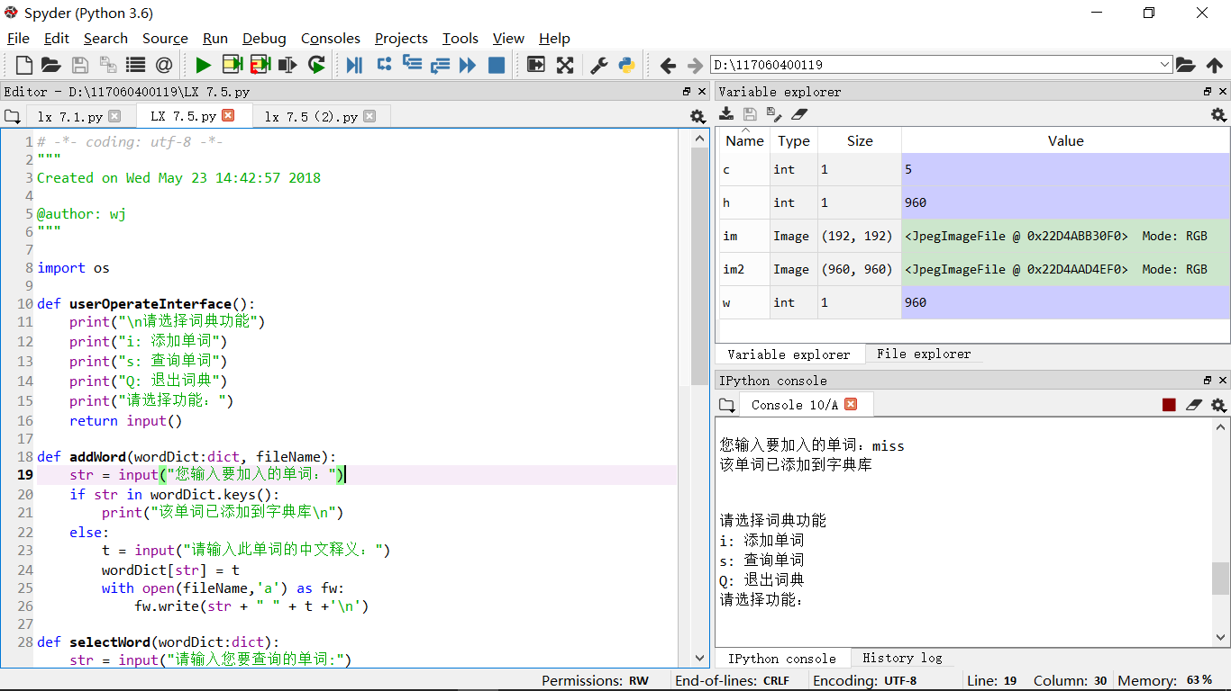

1. 程序练习题7.5改写：加入测试小程序

**源代码：**

import os

import random

def userOperateInterface():

print("\n请选择词典功能")

print("i: 添加单词")

print("s: 查询单词")

print("Q: 退出词典")

print("t:测试")

print("请选择功能：")

return input()

def addWord(wordDict:dict, fileName):

str = input("您输入要加入的单词：")

if str in wordDict.keys():

print("该单词已添加到字典库\n")

else:

t = input("请输入此单词的中文释义：")

wordDict[str] = t

with open(fileName, 'a') as fw:

fw.write(str + " " + t + '\n')

def selectWord(wordDict:dict):

str = input("请输入您要查询的单词：")

if str not in wordDict.keys():

print("字典库中未找到这个单词\n")

else:

print(wordDict[str])

mean = input("请输入该词的其他释义:")

if mean not in wordDict[str]:

wordDict[str] += mean

def testWord(wordDict:dict):

wordlist = wordDict.keys()

t1 = random.sample(wordlist,5)

c = 0

for w in t1:

print("请输入单词{}的中文释义".format(w))

e = input()

if e in wordDict[w]:

c += 1

print("right")

else:

print("error")

print("您共答对{}题".format(c))

def main():

wordDict = {}

if os.path.exists("dict.txt"):

with open("dict.txt", 'r') as fr:

for ln in fr:

s = ln.split(" ")

wordDict[s[0]] = s[1]

else:

fw = open("dict.txt",'w')

fw.close()

print("******欢迎使用简明英汉词典******")

while True:

op = userOperateInterface()

if op == 'i':

addWord(wordDict, 'dict.txt')

elif op == 's':

selectWord(wordDict)

elif op == 't':

testWord(wordDict)

elif op == 'Q':

break

else:

print("输入有误\n")

main()

**执行结果：**

