上机实验报告（11）

|  |  |
| --- | --- |
| 姓名：邱文静 | 学号：117060400119 |
| 班级：17应用统计(1)班 | 指导老师：林卫中老师 |

# 实验名称：科学计算和可视化

# 实验目的：

* 了解科学计算的基本概念
* 了解数据可视化的概念
* 运用科学计算库进行矩阵分析和数值运算
* 了解图像的矩阵表示和处理
* 运用数据绘图库进行坐标系绘制
* 运用数据绘图库进行雷达图绘制

# 实验过程及结果

1. 解方程Ax = b

**源代码1：**

import numpy as np

from numpy.linalg import inv

A = np.array([[1,0.5,5],[2.3,2,3],[4,1,1.7]])

b = np.array([[1],[2],[3]])

x = np.matmul(inv(A),b)

print(x)

**源代码2：**

import numpy as np

from numpy.linalg import inv

b = np.array([[1,2,3]])

x = np.matmul(inv(A),np.transpose(b))

print(x)

**实验结果：**

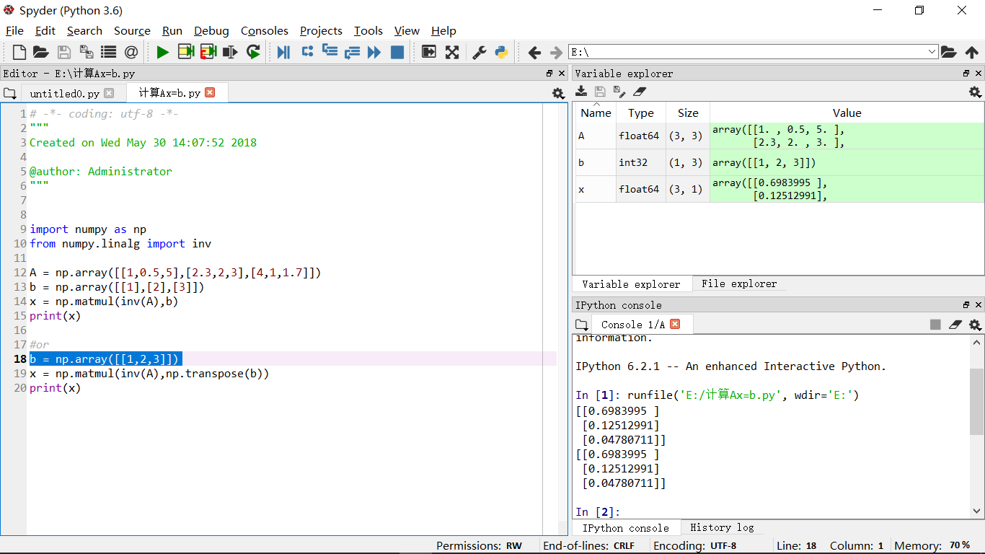

1. 绘制一副自己的人物肖像的手绘效果图

**源代码：**

from PIL import Image

import numpy as np

vec_el = np.pi/2.2

vec_az = np.pi/4.

depth = 10.

im = Image.open('957.jpg').convert('L')

a = np.array(im).astype('float')

grad = np.gradient(a)

grad_x,grad_y = grad

grad_x = grad_x*depth/100

grad_y = grad_y*depth/100

dx = np.cos(vec_el)*np.cos(vec_az)

dy = np.cos(vec_el)*np.sin(vec_az)

dz = np.sin(vec_el)

A = np.sqrt(grad_x**2 + grad_y**2 + 1.)

uni_x = grad_x/A

uni_y = grad_y/A

uni_z = 1./A

a2 = 255*(dx*uni_x + dy*uni_y + dz*uni_z)

a2 = a2.clip(0,255)

im2 = Image.fromarray(a2.astype('uint8'))

im2.save('9571.jpg')

im2.show()

**运行结果：**

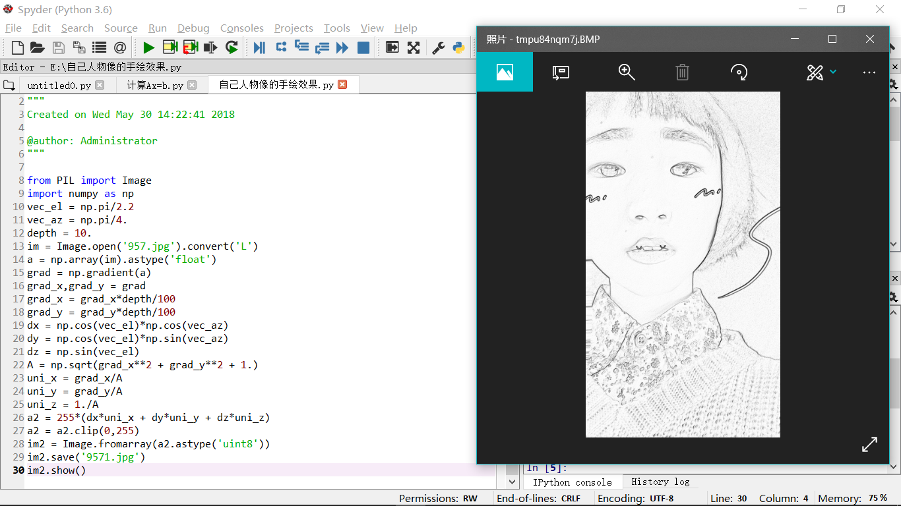

1. P259 程序练习题9.1

**源代码：**

import numpy as np

import matplotlib.pyplot as plt

import matplotlib

t = np.linspace(0,2*np.pi,100)

N = 20

k = 1

y = 4*np.sin(t)/(np.pi)

while k <= 20:

y = y + (4*np.sin((2*k-1)*t))/((2*k-1)*np.pi)

k = k + 1

plt.plot(t,y,'r')

pit.show()

**执行结果：**

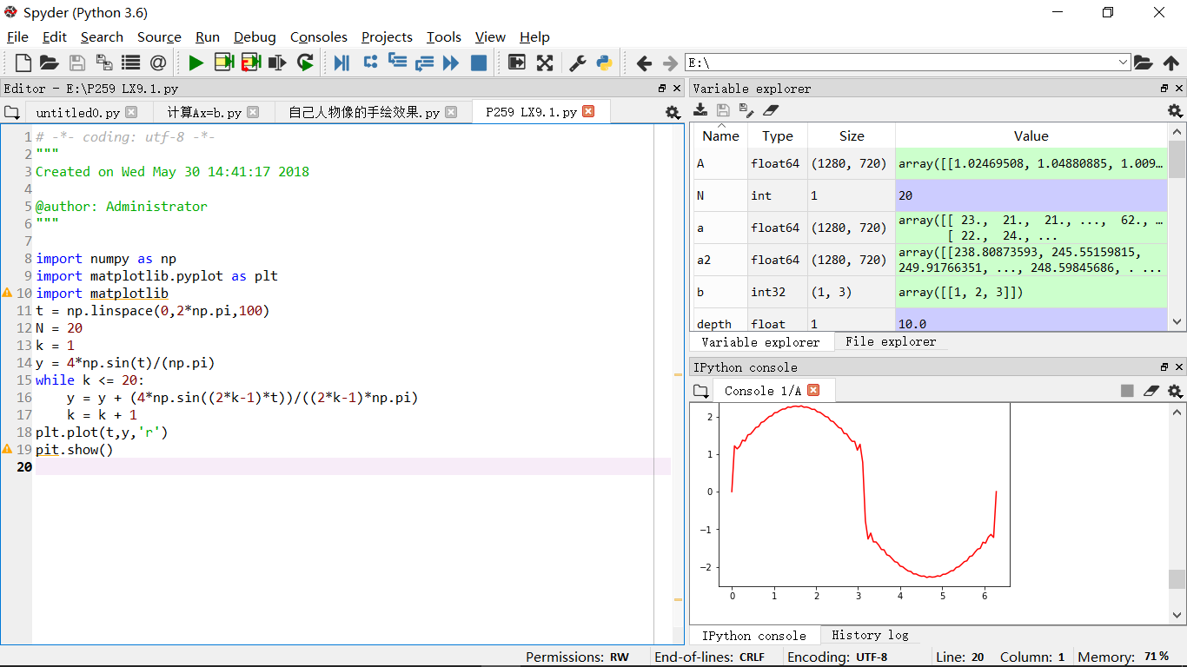

1. 画圆

**源代码1：**

import matplotlib.pyplot as plt

import numpy as np

x = np.arange(0.0, 2, 0.01)

y1 = np.sin(2*np.pi*x)

y2 = 1.2*np.sin(4*np.pi*x)

fig, ax = plt.subplots()

ax.plot(x, y1, x, y2, color='black')

ax.fill_between(x, y1, y2, where=y2>y1, facecolor='green')

ax.fill_between(x, y1, y2, where=y2<=y1, facecolor='red')

ax.set_title('fill between where')

plt.show()

**执行结果：**

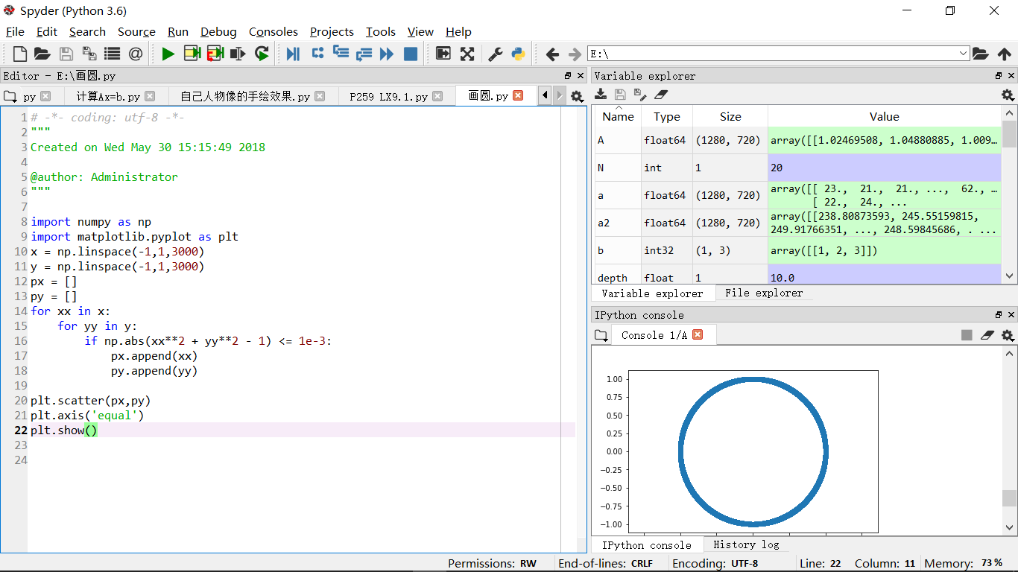

**源代码2：**

import matplotlib.pyplot as plt

import numpy as np

t = np.linspace(0,2*np.pi,100)

x = np.sin(t)

y = np.cos(t)

plt.plot(x,y)

plt.axis('equal')

plt.show()

**执行结果：**

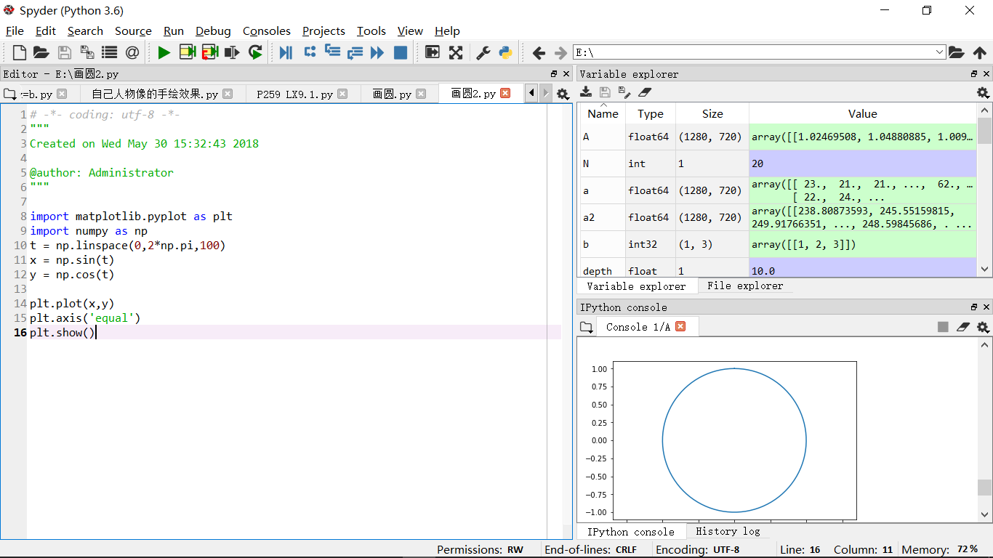

**源代码3：**

import numpy as np

import matplotlib.pyplot as plt

x = np.linspace(-1,1,100)

y = np.sqrt(1-x**2)

z = -y

plt.plot(x,y,'r')

plt.plot(x,z,'g')

plt.axis('equal')

plt.show()

**执行结果：**

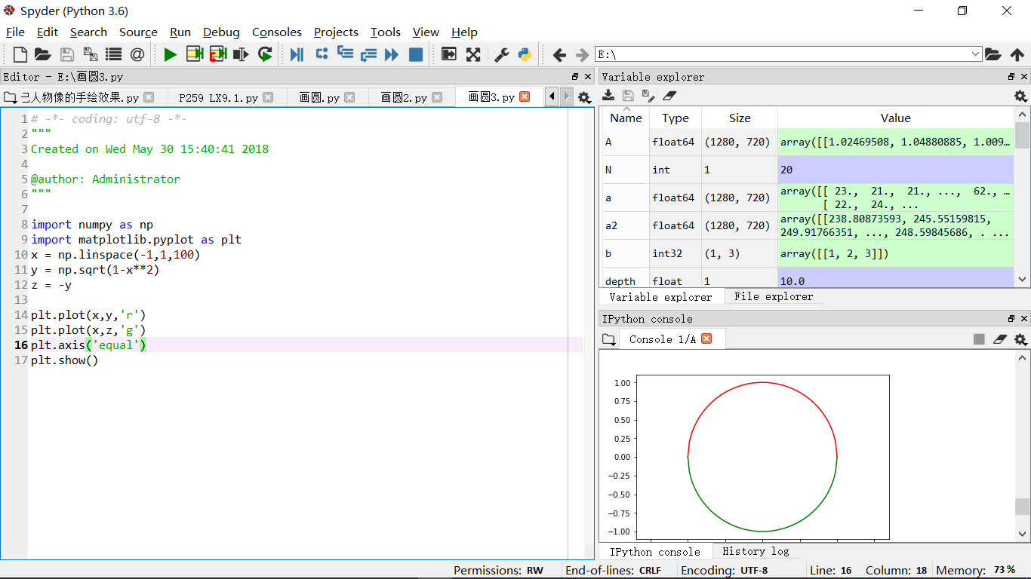

1. Matplotlib官网资料的学习

**源代码：**

import matplotlib.pyplot as plt

import numpy as np

x = np.arange(0.0, 2, 0.01)

y1 = np.sin(2*np.pi*x)

y2 = 1.2*np.sin(4*np.pi*x)

fig, ax = plt.subplots()

ax.plot(x, y1, x, y2, color='black')

ax.fill_between(x, y1, y2, where=y2>y1, facecolor='green')

ax.fill_between(x, y1, y2, where=y2<=y1, facecolor='red')

ax.set_title('fill between where')

plt.show()

**执行结果：**

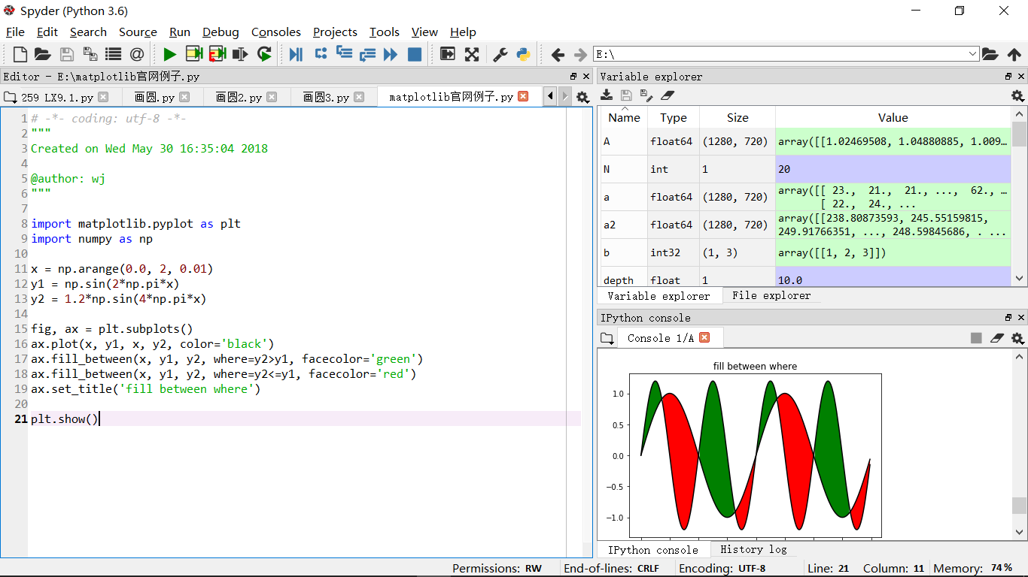

# 实验结论：

是时候展现python对于应用统计专业的实用性了，功能很强大。不过，仅靠课堂老师讲解是远远不够的，需要我自己课外去翻阅查找资料才能学习透灵活运用python，将其功能表现最大化，我会加油的！