上机实验报告（13）

|  |  |
| --- | --- |
| 姓名：邱文静 | 学号：117060400119 |
| 班级：17应统(1)班 | 指导老师：林卫中老师 |

# 实验名称：程序设计方法论

# 实验目的：

* 了解计算思维的概念
* 掌握自顶向下的设计方法
* 掌握自底向上的执行过程
* 了解计算生态和模块编程思想
* 掌握Python第三方库的安装方法
* 掌握Python源文件的打包方法

# 实验过程及结果

1. 程序练习题8.1 借鉴实例15的思路，采用乒乓球规则模拟比赛，分析体育竞技规律

**源代码：**

from random import random

def printIntro():

print("这个程序模拟两个选手A和B的某种竞技比赛")

print("程序运行需要A和B的能力值（以0到1之间的小数表示）")

def getInputs():

a = eval(input("请输入选手A的能力值(0-1): "))

b = eval(input("请输入选手B的能力值(0-1): "))

n = eval(input("模拟比赛的场次: "))

return a, b, n

def simNGames(n, probA, probB):

winsA, winsB = 0, 0

for i in range(n):

scoreA, scoreB = simOneGame(probA, probB)

if scoreA > scoreB:

winsA += 1

else:

winsB += 1

return winsA, winsB

def gameOver(a,b):

return a==11 or b==11

def simOneGame(probA, probB):

scoreA, scoreB = 0, 0

serving = 0

i = 0

while not gameOver(scoreA, scoreB):

if serving == 0:

if random() < probA:

scoreA += 1

else:

scoreB += 1

else:

if random() < probB:

scoreB += 1

else:

scoreA += 1

i += 1

if i%2 == 0:

serving = (serving+1)%2

return scoreA, scoreB

def printSummary(winsA, winsB):

n = winsA + winsB

print("竞技分析开始，共模拟{}场比赛".format(n))

print("选手A获胜{}场比赛，占比{:0.1%}".format(winsA, winsA/n))

print("选手B获胜{}场比赛，占比{:0.1%}".format(winsB, winsB/n))

def main():

printIntro()

probA, probB, n = getInputs()

winsA, winsB = simNGames(n, probA, probB)

printSummary(winsA, winsB)

main()

**执行结果：**

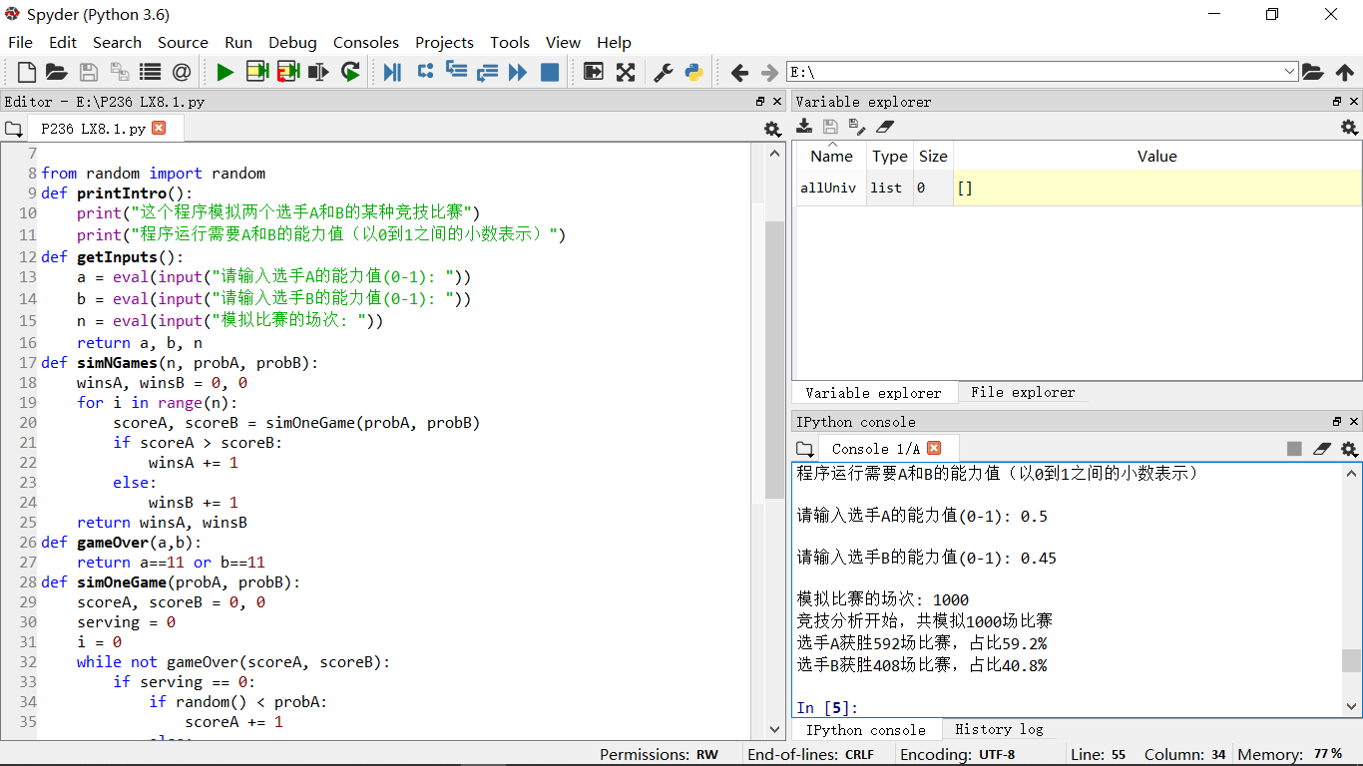

1. 程序练习题8.1扩展：在一局比赛中，先得11分的一方为胜方，10平后，先得两分的一方为胜方

**源代码1：**

from random import random

def printIntro():

print("这个程序模拟两个选手A和B的某种竞技比赛")

print("程序运行需要A和B的能力值（以0到1之间的小数表示）")

def getInputs():

a = eval(input("请输入选手A的能力值(0-1): "))

b = eval(input("请输入选手B的能力值(0-1): "))

n = eval(input("模拟比赛的场次: "))

return a, b, n

def simNGames(n, probA, probB):

winsA, winsB = 0, 0

for i in range(n):

scoreA, scoreB = simOneGame(probA, probB)

if scoreA > scoreB:

winsA += 1

else:

winsB += 1

return winsA, winsB

def gameOver(a,b):

if (a==11 and b<10) or (b==11 and a<10):

return True

if(a >= 10 and b-a == 2) or (b >= 10 and a-b == 2):

return True

return False

def simOneGame(probA, probB):

scoreA, scoreB = 0, 0

serving = 0

i = 0

while not gameOver(scoreA, scoreB):

if serving == 0:

if random() < probA:

scoreA += 1

else:

scoreB += 1

else:

if random() < probB:

scoreB += 1

else:

scoreA += 1

i += 1

if i%2 == 0:

serving = (serving+1)%2

return scoreA, scoreB

def printSummary(winsA, winsB):

n = winsA + winsB

print("竞技分析开始，共模拟{}场比赛".format(n))

print("选手A获胜{}场比赛，占比{:0.1%}".format(winsA, winsA/n))

print("选手B获胜{}场比赛，占比{:0.1%}".format(winsB, winsB/n))

def main():

printIntro()

probA, probB, n = getInputs()

winsA, winsB = simNGames(n, probA, probB)

printSummary(winsA, winsB)

main()

**源代码2：**

from random import random

def printIntro():

print("这个程序模拟两个选手A和B的某种竞技比赛")

print("程序运行需要A和B的能力值（以0到1之间的小数表示）")

def getInputs():

a = eval(input("请输入选手A的能力值(0-1): "))

b = eval(input("请输入选手B的能力值(0-1): "))

n = eval(input("模拟比赛的场次: "))

return a, b, n

def simNGames(n, probA, probB):

winsA, winsB = 0, 0

for i in range(n):

scoreA, scoreB = simOneGame(probA, probB)

if scoreA > scoreB:

winsA += 1

else:

winsB += 1

return winsA, winsB

def gameOver(a,b):

if a < b:

a,b = b,a

if a == 11 and b < 10:

return True

if b >= 10 and a - b == 2:

return True

return False

def simOneGame(probA, probB):

scoreA, scoreB = 0, 0

serving = 0

i = 0

while not gameOver(scoreA, scoreB):

if serving == 0:

if random() < probA:

scoreA += 1

else:

scoreB += 1

else:

if random() < probB:

scoreB += 1

else:

scoreA += 1

i += 1

if i%2 == 0:

serving = (serving+1)%2

return scoreA, scoreB

def printSummary(winsA, winsB):

n = winsA + winsB

print("竞技分析开始，共模拟{}场比赛".format(n))

print("选手A获胜{}场比赛，占比{:0.1%}".format(winsA, winsA/n))

print("选手B获胜{}场比赛，占比{:0.1%}".format(winsB, winsB/n))

def main():

printIntro()

probA, probB, n = getInputs()

winsA, winsB = simNGames(n, probA, probB)

printSummary(winsA, winsB)

main()

**执行结果：**

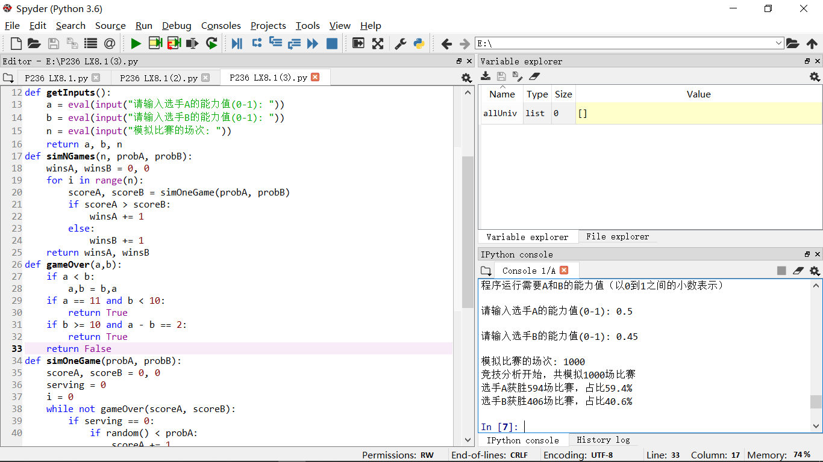

1. 程序练习题8.2：借鉴实例15的思路，采用篮球规则模拟比赛，分析体育竞技规律。比较结果与程序练习题8.1的不同

**源代码：**

from random import random

from random import randint

def printIntro():

print("这个程序模拟两个选手A和B的某种竞技比赛")

print("程序运行需要A和B的能力值（以0到1之间的小数表示）")

def getInputs():

g1 = eval(input("请输入球队A的投篮能力值(0-1): "))

b1 = eval(input("请输入球队A的篮板能力值(0-1): "))

g2 = eval(input("请输入球队B的投篮能力值(0-1): "))

b2 = eval(input("请输入球队B的篮板能力值(0-1): "))

n = eval(input("模拟比赛的场次: "))

return g1, b1, g2, b2, n

def simNGames(n, goleA, boardA, goleB, boardB):

winsA, winsB = 0, 0

for i in range(n):

scoreA, scoreB = simOneGame(goleA, boardA, goleB, boardB)

if scoreA > scoreB:

winsA += 1

else:

winsB += 1

return winsA, winsB

def gameOver(t):

return t >= 12*60

def simOneGame(goleA, boardA, goleB, boardB):

scoreA, scoreB = 0, 0

serving = 0 #0: 代表A队发球，1：代表B队发球

totalTime = 0

while not gameOver(totalTime):

t = randint(1, 24)

totalTime += t

if t == 24:

serving = (serving + 1)%2

else:

if serving == 0:

if random() < goleA:

scoreA += 1

serving = 1

else:

if random() < boardA:

serving=0

else:

serving = 1

else:

if random() < goleB:

scoreB += 1

serving = 0

else:

if random() < boardB:

serving = 1

else:

serving=0

return scoreA, scoreB

def printSummary(winsA, winsB):

n = winsA + winsB

print("竞技分析开始，共模拟{}场比赛".format(n))

print("选手A获胜{}场比赛，占比{:0.1%}".format(winsA, winsA/n))

print("选手B获胜{}场比赛，占比{:0.1%}".format(winsB, winsB/n))

def main():

printIntro()

goleA, boardA, goleB, boardB, n = getInputs()

winsA, winsB = simNGames(n, goleA, boardA, goleB, boardB)

printSummary(winsA, winsB)

main()

**执行结果：**

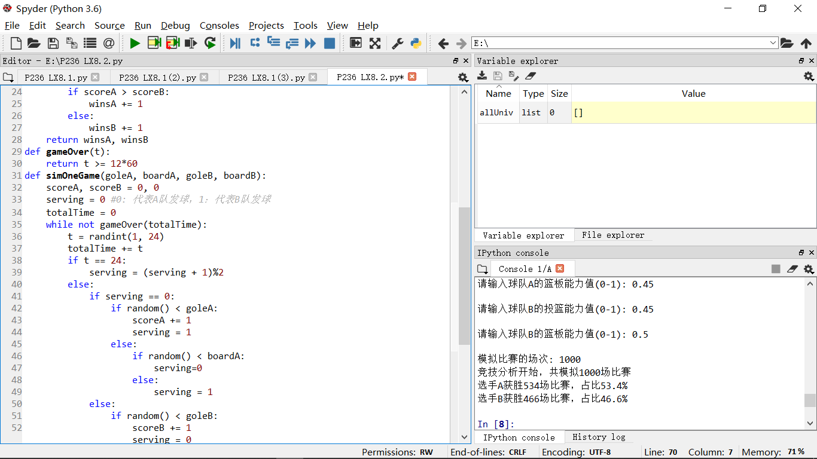

# 实验心得·

越发感觉力不从心，上机坐最后一排老忘记眼镜，弄得要借助手机相机来清晰从而老师比他人晚一步跟不上老师的脚步，希望老司机能尽量广播那样好看些，先谢谢老师了，我自己也会努力抓紧学会，不再掉队！期末考个好成绩，明年二级能顺利考过，加油！