上机实验报告（七）

姓名：邱文静

班级：17应用统计（1）班

学号：117060400119

指导老师：林卫中老师

# 实验名称：边学边玩

# 实验目的：

* 树立想法比语法重要理念
* 边学边玩，慢慢改进简化代码，玩出新高度
* 学会怎么用函数封装简化代码
* 明确递归函数要有个边界出口

# 实验过程及结果：

1. **微实例5.3的新玩法1：从后往前反转字符串**

**源代码：**

def reverse(s):

n = len(s)

if n == 1:

return s

else:

return reverse(s[-1] )+ reverse(s[0:-1])

str = input('请输入一个字符串：')

print(reverse(str))

**执行结果：**

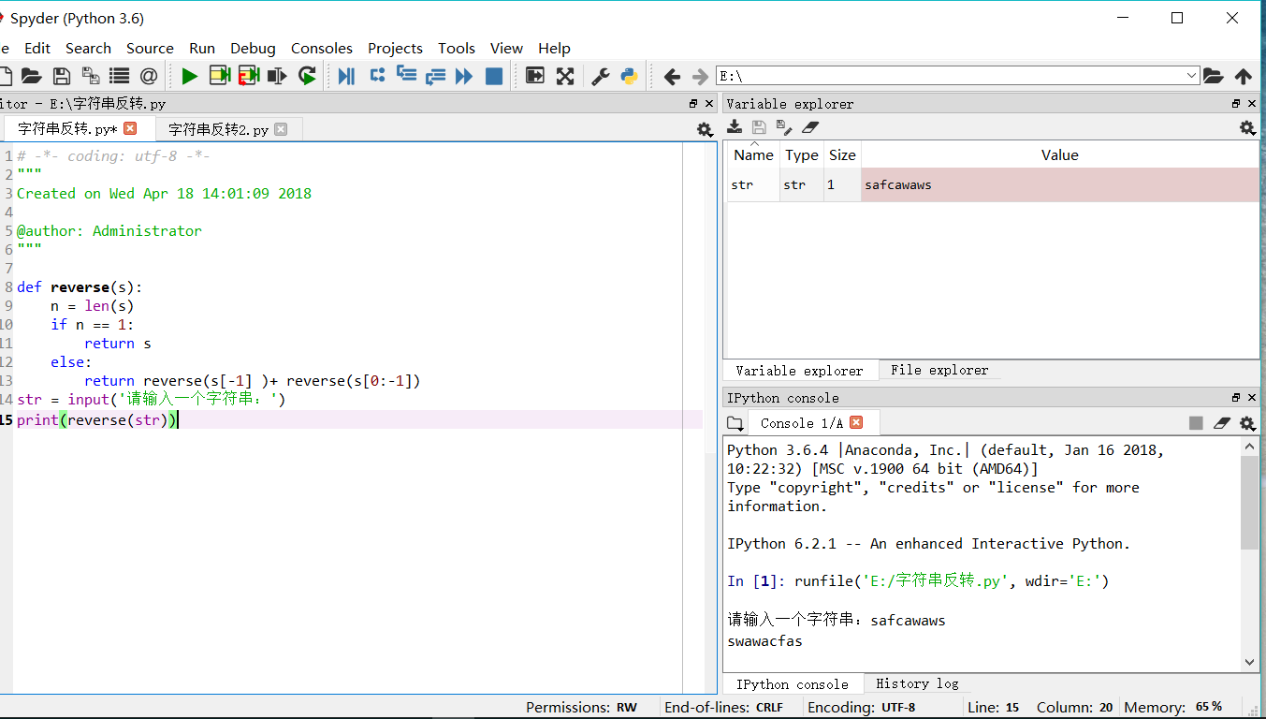

1. **微实例5.3简化：**

**源代码：**

def reverse(s):

return s[::-1]

str = input('请输入一个字符串:')

print(reverse(str))

**执行结果：**

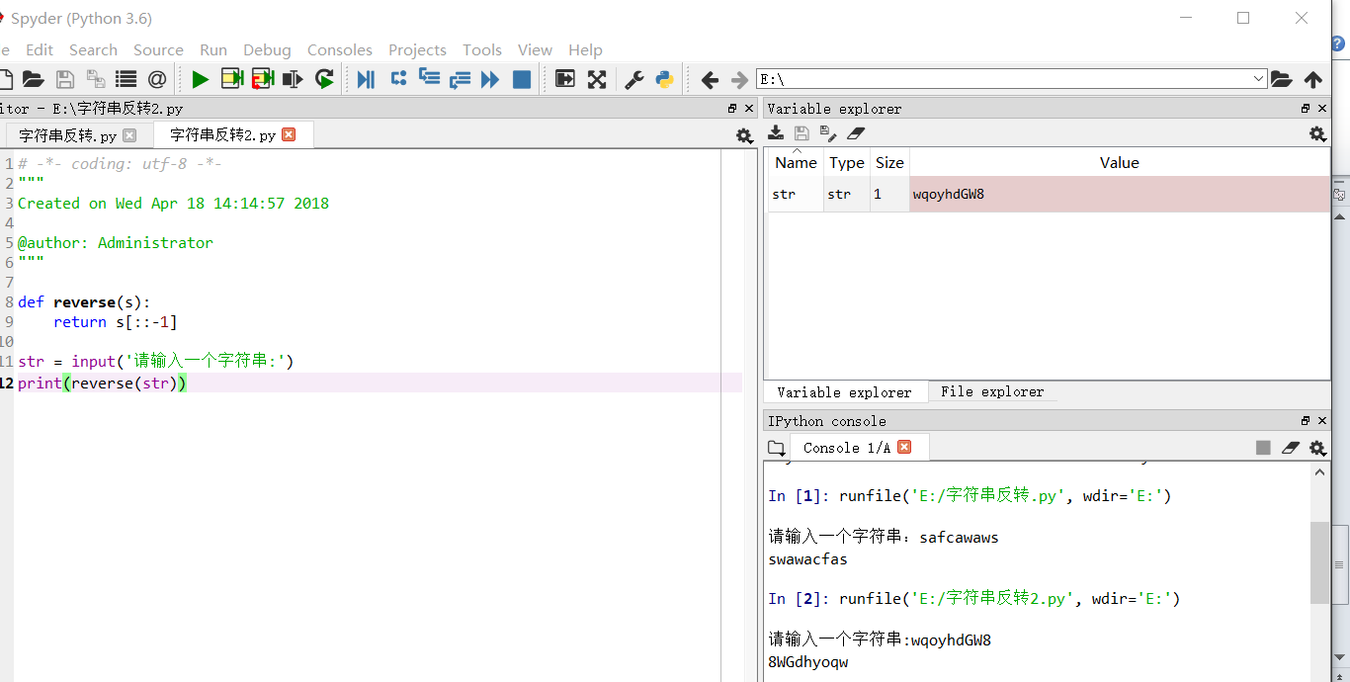

1. **Python123在线编码**

**源代码：**

def fib(n):

if n < 0:

print('Error')

elif n == 0:

return 0

elif n == 1:

return 1

else:

return fib(n-1) + fib(n-2)

n = int(input("请输入一个整数："))

for i in range(1,n+1):

print(fib(i),end = ',')

**执行结果：**

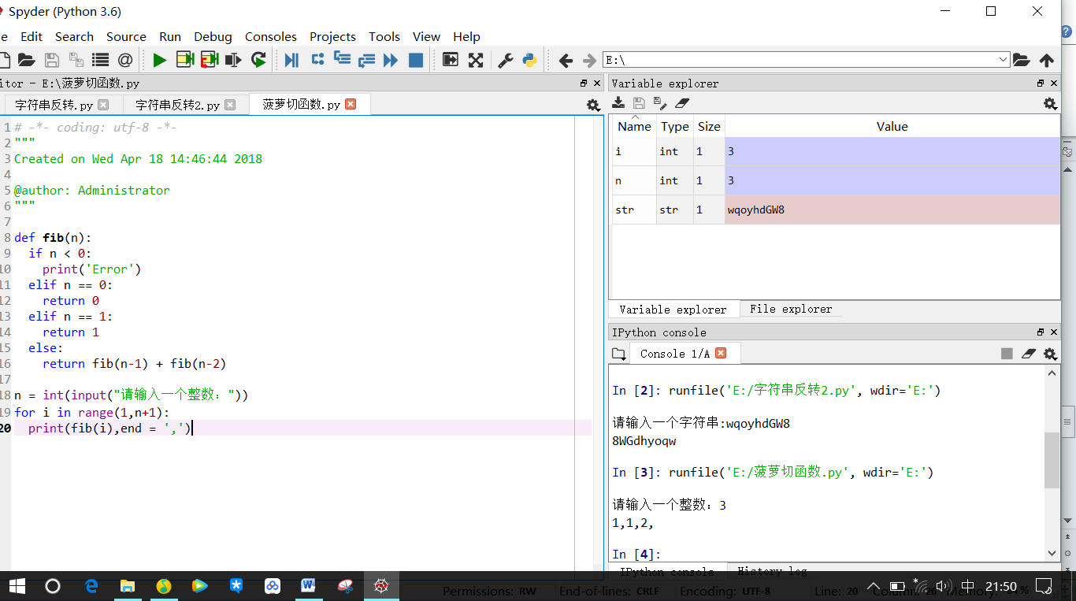

1. **数码管新玩法1：每个数字颜色不一样**

**源代码：**

**# 7段数码管,每个数字颜色不一样**

import turtle, datetime

strcol = ['red','blue','yellow','gold','violet','purple','green','darkgreen','grey','orange']

def drawGap(): #绘制数码管间隔

turtle.penup()

turtle.fd(5)

def drawLine(draw): #绘制单段数码管

drawGap()

turtle.pendown() if draw else turtle.penup()

turtle.fd(40)

drawGap()

turtle.right(90)

def drawDigit(digit): #根据数字绘制七段数码管

turtle.pencolor(strcol[digit])

drawLine(True) if digit in [2,3,4,5,6,8,9] else drawLine(False)

drawLine(True) if digit in [0,1,3,4,5,6,7,8,9] else drawLine(False)

drawLine(True) if digit in [0,2,3,5,6,8,9] else drawLine(False)

drawLine(True) if digit in [0,2,6,8] else drawLine(False)

turtle.left(90)

drawLine(True) if digit in [0,4,5,6,8,9] else drawLine(False)

drawLine(True) if digit in [0,2,3,5,6,7,8,9] else drawLine(False)

drawLine(True) if digit in [0,1,2,3,4,7,8,9] else drawLine(False)

turtle.left(180)

turtle.penup()

turtle.fd(20)

def drawDate(date): #获得要输出的数字

for i in date:

if i == '-':

turtle.pencolor("black")

turtle.write('年',font=("Arial", 18, "normal"))

turtle.fd(40)

elif i == '=':

turtle.pencolor("black")

turtle.write('月',font=("Arial", 18, "normal"))

turtle.fd(40)

elif i == '+':

turtle.pencolor("black")

turtle.write('日',font=("Arial", 18, "normal"))

else:

drawDigit(eval(i))

def main():

turtle.setup(800, 350, 200, 200)

turtle.penup()

turtle.fd(-300)

turtle.pensize(5)

drawDate(datetime.datetime.now().strftime('%Y-%m=%d+'))

turtle.hideturtle()

turtle.done()

main()

**执行结果：**

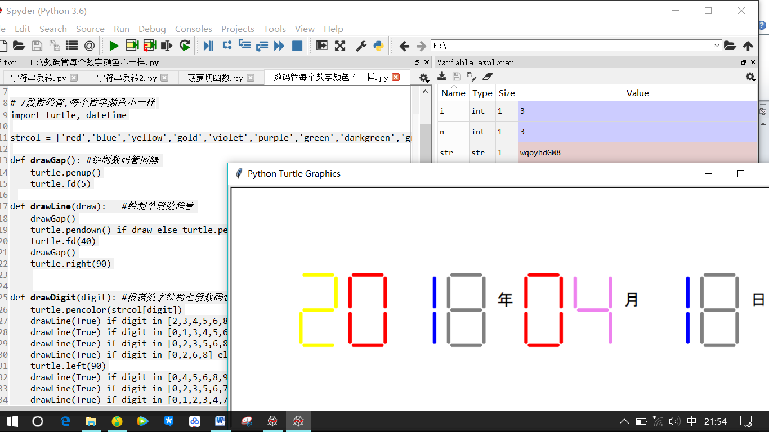

1. **数码管新玩法2：每段数码管颜色不一样**

**源代码：**

import turtle, datetime

strcol = ['red','blue','yellow','gold','violet','purple','green']

def drawGap(): #绘制数码管间隔

turtle.penup()

turtle.fd(5)

def drawLine(draw): #绘制单段数码管

drawGap()

turtle.pendown() if draw else turtle.penup()

turtle.fd(40)

drawGap()

turtle.right(90)

def drawDigit(digit): #根据数字绘制七段数码管

# turtle.pencolor(strcol[digit])

turtle.pencolor(strcol[0])

drawLine(True) if digit in [2,3,4,5,6,8,9] else drawLine(False)

turtle.pencolor(strcol[1])

drawLine(True) if digit in [0,1,3,4,5,6,7,8,9] else drawLine(False)

turtle.pencolor(strcol[2])

drawLine(True) if digit in [0,2,3,5,6,8,9] else drawLine(False)

turtle.pencolor(strcol[3])

drawLine(True) if digit in [0,2,6,8] else drawLine(False)

turtle.left(90)

turtle.pencolor(strcol[4])

drawLine(True) if digit in [0,4,5,6,8,9] else drawLine(False)

turtle.pencolor(strcol[5])

drawLine(True) if digit in [0,2,3,5,6,7,8,9] else drawLine(False)

turtle.pencolor(strcol[6])

drawLine(True) if digit in [0,1,2,3,4,7,8,9] else drawLine(False)

turtle.left(180)

turtle.penup()

turtle.fd(20)

def drawDate(date): #获得要输出的数字

for i in date:

if i == '-':

turtle.pencolor("black")

turtle.write('年',font=("Arial", 18, "normal"))

turtle.fd(40)

elif i == '=':

turtle.pencolor("black")

turtle.write('月',font=("Arial", 18, "normal"))

turtle.fd(40)

elif i == '+':

turtle.pencolor("black")

turtle.write('日',font=("Arial", 18, "normal"))

else:

drawDigit(eval(i))

def main():

turtle.setup(800, 350, 200, 200)

turtle.penup()

turtle.fd(-300)

turtle.pensize(5)

drawDate(datetime.datetime.now().strftime('%Y-%m=%d+'))

turtle.hideturtle()

turtle.done()

main()

**执行结果：**

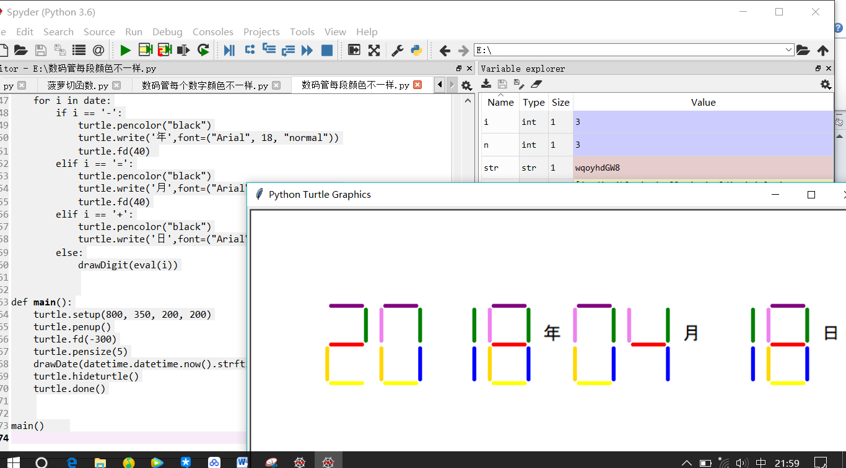

1. **数码管新玩法3：简化绘制数码管代码**

**源代码：**

import turtle, datetime

strcol = ['red','blue','yellow','gold','violet','purple','green']

def drawGap(): #绘制数码管间隔

turtle.penup()

turtle.fd(5)

def drawLine(draw,n): #绘制单段数码管

drawGap()

turtle.pendown() if draw else turtle.penup()

turtle.fd(40)

drawGap()

turtle.right(90)

def drawDigit(digit): #根据数字绘制七段数码管

#turtle.pencolor(strcol[digit])

drawLine(True,0) if digit in [2,3,4,5,6,8,9] else drawLine(False,0)

drawLine(True,1) if digit in [0,1,3,4,5,6,7,8,9] else drawLine(False,1)

drawLine(True,2) if digit in [0,2,3,5,6,8,9] else drawLine(False,2)

drawLine(True,3) if digit in [0,2,6,8] else drawLine(False,3)

turtle.left(90)

drawLine(True,4) if digit in [0,4,5,6,8,9] else drawLine(False,4)

drawLine(True,5) if digit in [0,2,3,5,6,7,8,9] else drawLine(False,5)

drawLine(True,6) if digit in [0,1,2,3,4,7,8,9] else drawLine(False,6)

turtle.left(180)

turtle.penup()

turtle.fd(20)

def drawDate(date): #获得要输出的数字

for i in date:

if i == '-':

turtle.pencolor("black")

turtle.write('年',font=("Arial", 18, "normal"))

turtle.fd(40)

elif i == '=':

turtle.pencolor("black")

turtle.write('月',font=("Arial", 18, "normal"))

turtle.fd(40)

elif i == '+':

turtle.pencolor("black")

turtle.write('日',font=("Arial", 18, "normal"))

else:

drawDigit(eval(i))

def main():

turtle.setup(800, 350, 200, 200)

turtle.penup()

turtle.fd(-300)

turtle.pensize(5)

drawDate(datetime.datetime.now().strftime('%Y-%m=%d+'))

turtle.hideturtle()

turtle.done()

main()

**执行结果：**

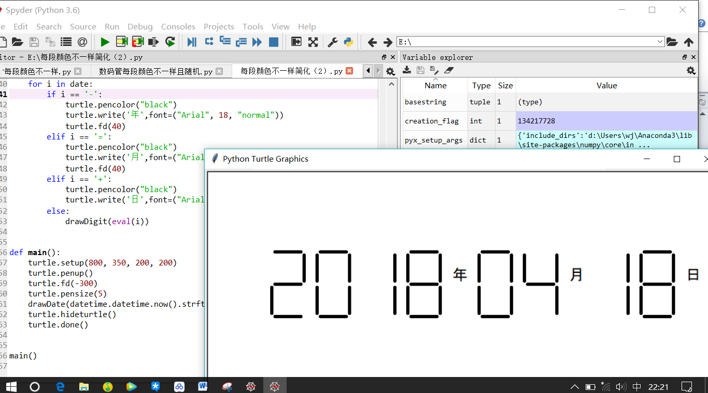

1. **程序练习题5.7：编写一个汉诺塔的移动函数**

**源代码：**

def hanoi(a,b,c,n): #n个盘子由a柱借助b柱移动到c柱

if n == 1:

print(a + '-->' +b)

else:

hanoi(a,c,b,n-1)

hanoi(a,b,c,1)

hanoi(b,a,c,n-1)

hanoi('a','b','c',3)

**执行结果：**

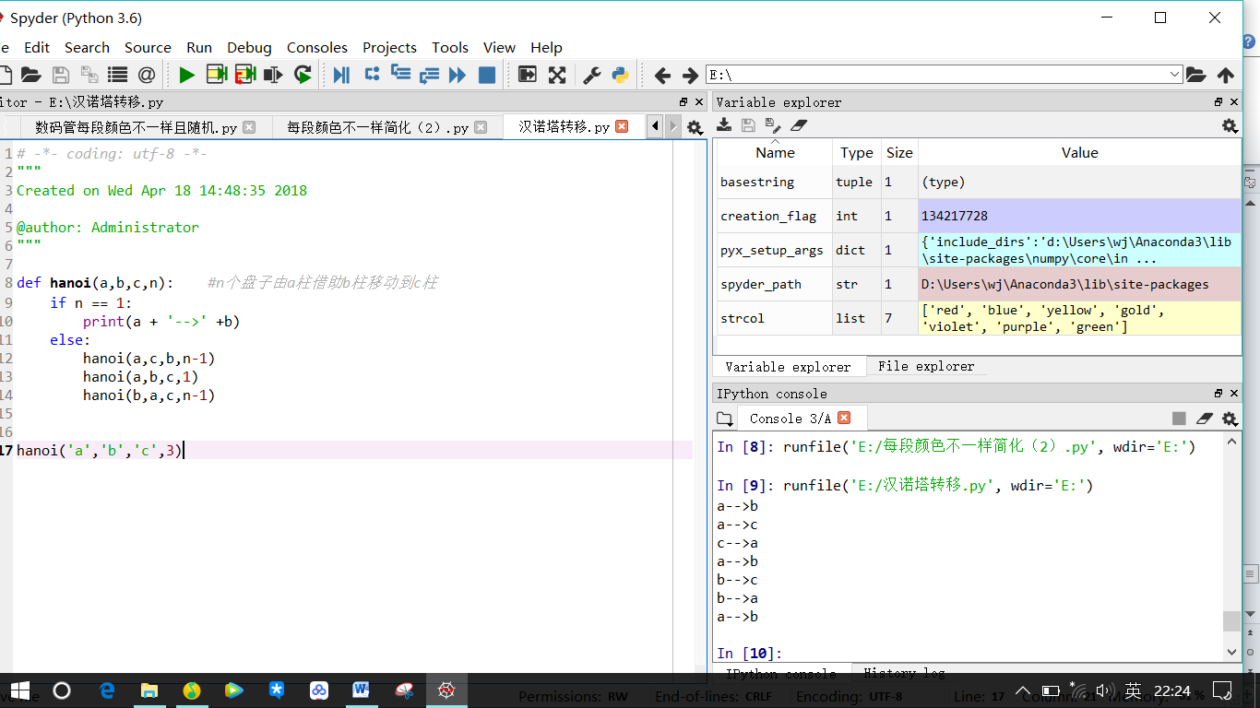

# 实验心得：

首先要熟悉编程基本语法，然后激发想法，不过想法比语法重要，要会玩，把编代码当作一种乐趣来玩，在玩的过程中提升改进编程能力。坚持天天码代码，加油！