第七章相关作业

姓名：邱文静 班级：17应用统计(1)班

学号：117060400119 指导老师：林卫中老师

# 题目清单

* 程序练习题7.1（教材211页）
* 程序练习题7.2（教材211页）
* 思考与练习7.8（教材194页）
* 自己轮廓获取。参考教材192页微实例7.6，选取一副自己的照片，获取自己人像的轮廓
* 选取一张图片，自行设计对图片进行一些类似PS的操作，保留图片前后的文件进行对照

# 作业展示

1. 程序练习题7.1

**源代码：**

excludes = {"False","None","True","and","as","assert","break","class","continue",

"def","del","elif","else","except","finally","for","from","global",

"if","import","in","is","lambda","nonlocal","not","or","pass","raise",

"return","try","while","with","yield"}

def getText():

txt = open("0阶科赫曲线.py","r").read()

txt = txt.lower()

for ch in '!"#$%&()*+,-./:;<=>?@[\\]^_`{|}~':

txt = txt.replace(ch," ")

return txt

txt = getText()

for p in txt:

if ord("a") <= ord("p") <= ord("z"):

print(chr(ord("A") <= ord("p") <= ord("Z")))

else:

print(p)

1. 程序练习题7.2

**源代码：**

from PIL import Image

im = Image.open("957.jpg")

im.thumbnail((360,360))

im.save("9571.jpg")

**执行结果前后：**





1. 思考与练习7.8

**源代码：**

from PIL import Image

im = Image.open("hongse.jpg")

r,g,b = im.split()

om = Image.merge("RGB",(b,g,r))

om.save('hongse1.jpg')

**执行结果前后：**





1. 自己轮廓获取

**源代码：**

from PIL import Image

from PIL import ImageFilter

im = Image.open('jingzi.jpg')

om = im.filter(ImageFilter.CONTOUR)

om.save('jingzi1.jpg')

**执行结果前后：**



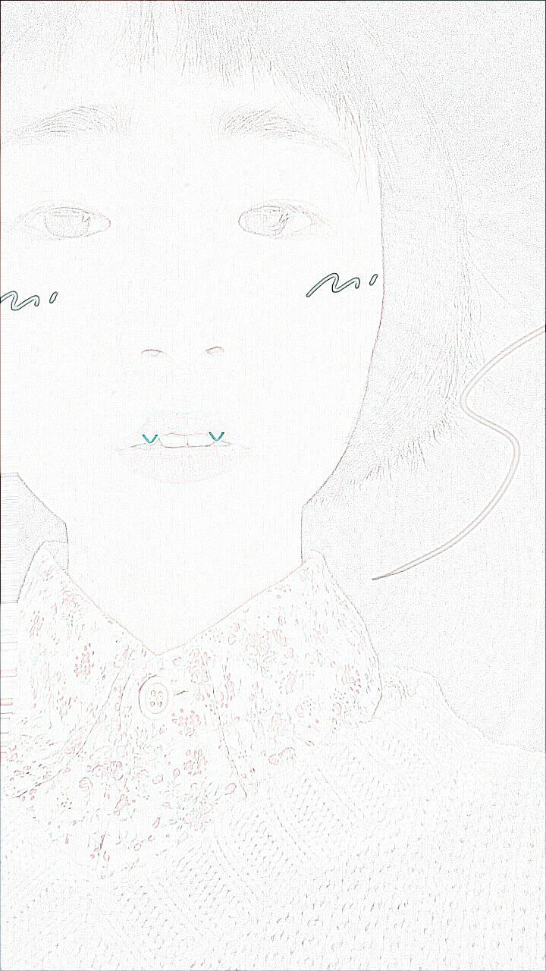

1. 自行设计进行类似PS操作

**源代码：**

from PIL import Image

from PIL import ImageFilter

from PIL import ImageEnhance

im = Image.open('PS.jpg')

im.thumbnail((1000,2000))

r,g,b = im.split()

om = Image.merge("RGB",(g,b,r))

om = im.filter(ImageFilter.BLUR)

om = ImageEnhance.Contrast(im)

om.enhance(20).save('PS1.jpg')

**设计前后对比：**

前：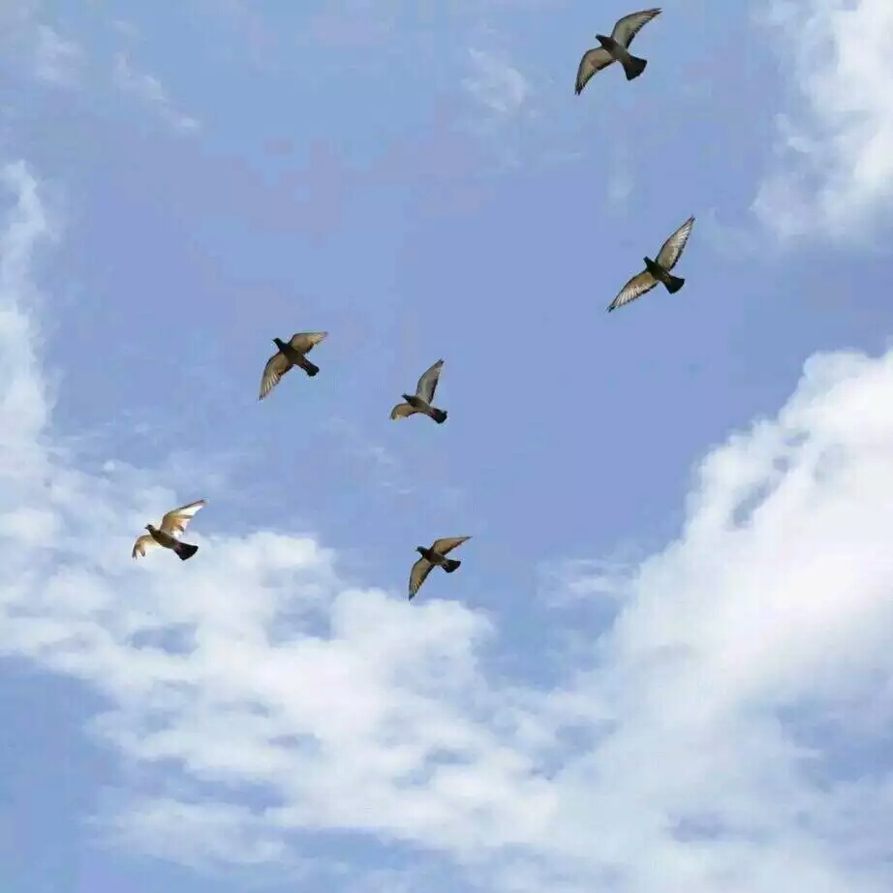

后：

