Name Matthew Fry Mark ____________/50

## Brief introduction __/3

The feature I am implementing is puck movement. This includes general puck physics such as sliding, bouncing off walls, and responding to collisions, as well as passing mechanics between players. Players can pass the puck to teammates, with the puck following a calculated trajectory based on direction, speed, and potential interceptions. This feature ensures smooth, realistic puck behavior in a 2D top-down view, integrating with player controls and AI for opponents.

## Use case diagram with scenario __14

### Use Case Diagrams

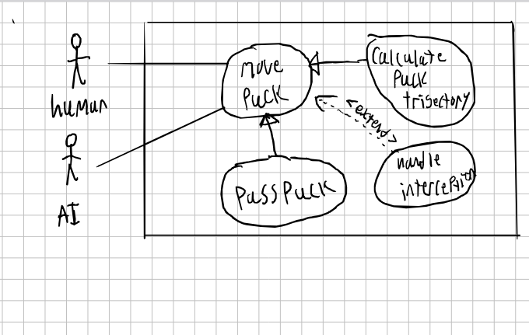

### Scenarios

**Name:** Pass the Puck

**Summary: Puck is passed to teamate**

**Actors:** human player and AI player

**Preconditions:** is in possesion of puck

**Basic sequence:**

**Step 1:** Human player is in range and has selected a player to pass too

**Step 2:** system calculates puck movement

**Step 3:** puck moves toward target

**Step 4:** Teameate recives puck if no interception

**Exceptions:**

**Step 1:** oppenent intercepts puck

**Post conditions:** oppenent has puck

**Name:** Move the puck

**Summary: Puck is moved across the ice after hit**

**Actors:** human player and AI player

**Preconditions:** puck is in motion

**Basic sequence:**

**Step 1:** update puck position

**Step 2:** check for collision

**Step 3:** apply physics

**Step 4:** puck comes to rest

**Exceptions:**

**Step 1:** collision detected

**Post conditions:** puck bounces at reflected angle

**Name: handel interception**

**Summary: an opponent steal the puck**

**Preconditions: puck in the middle of a pass**

**Basic sequence:**

**Step 1:** check if player is near the puck in motion

**Step 2:** if yes, %chance of intercepting puck

**Name:** Move the puck

**Summary: Puck is moved across the ice after hit**

## Data Flow diagram(s) from Level 0 to process description for your feature _______14

[Get the Level 0 from your team. Highlight the path to your feature]

Example:

### Data Flow Diagrams

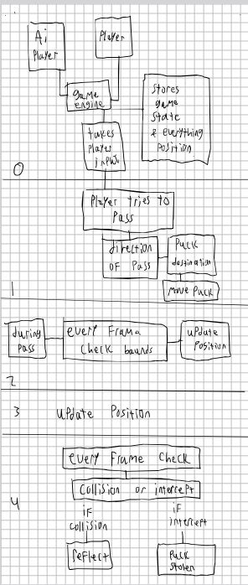

### Process Descriptions

Process 0: Ai player, player, and puck, and game engine. Everyhting is connected to the game engine which stores all the relevent information, like state and position.

Process 1. if player tries to pass, collect direction, then calculate puck movement

process 2. for each frame check for bounds and check for intercept (while passing)

process 3. update the pucks postion

process 4 if theres a collision or intercept do

4.1 reflect off collision

4.2 oppenent has the puck

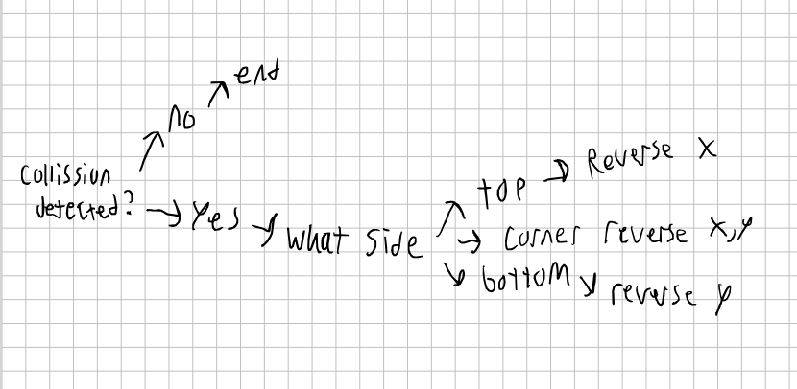

## Acceptance Tests ________9

* Basic pass, a player and his teammate within a certain distance of eachother, just standing still
* pass while in move ment
* collecting the puck after collision with a wall
* interception

## Timeline _________/10

### Work items

|  |  |  |
| --- | --- | --- |
| Task | Duration (PWks) | Predecessor Task(s) |
| 1. Requirements Collection | 5 | - |
| 2. Research physics for puck integration | 2 | 1 |
| 3. implement basic puck movement | 3 | 2 |
| 4. implement passing and trajectory | 6 | 3 |
| 5. implement collision handling | 2 | 4 |
| 6. testing | 10 | 5 |
| 7. documentation | 1 | 6 |
| 8. final integration | 1 | 7 |

### Pert diagram

### Gantt timeline

