Name: Bigyan Karki Mark _____________________/50

Brief introduction __/3

The Background & Audio System enhances the Retro Hockey experience by combining the static hockey rink background with immersive sounds.
- The background provides the rink environment, keeping visuals simple but clear, with fallback options if assets are missing.
- The audio provides looping background music and situational sound effects (player actions like catch, pass, shoot; fouls; and activity/event sounds such as goals, whistles, and crowd cheers).

Use case diagram with scenario __14

Name: Load Background & Manage Game Audio
Actors: Player, Game System, Background & Audio System
Preconditions: The game must have been launched successfully, all assets must be available, and all subsystems must be properly initialized.

Basic Sequence of Events:

The player starts the game: The player initiates the game by launching it, which triggers the game system's start-up process.

The game system initializes the background and audio system: Once the game is launched, the game system proceeds to initialize the subsystems responsible for managing the game’s background visuals and audio components.

The background component loads and displays the static rink: The game system loads the background assets (such as the rink or arena image) and displays it on the screen. The background may include an optional zoom effect, depending on the game’s design and settings.

The audio component loads background music and sound effects: Simultaneously, the audio system loads the necessary background music and sound effects, preparing them to be played during gameplay. This includes music tracks and various sound effects that will be triggered during different events in the game.

Background music begins looping: Once the background music is successfully loaded, the game system begins playing the music on a loop, providing an immersive audio environment for the player.

Action sounds play during gameplay: As the player engages in various actions (such as catching, passing, or shooting), the appropriate sound effects are triggered. These action sounds help enhance the player’s experience by providing immediate feedback to their actions.

Foul sounds trigger during penalties: Whenever a penalty or foul occurs during the game, the relevant sound effect (such as a whistle or penalty sound) is played to indicate that a rule violation has taken place.

Event/activity sounds trigger during key events: Key events within the game, such as a goal being scored, a whistle blowing, or the crowd cheering, trigger specific event-based sounds. These sounds provide important auditory cues to the player, signaling significant moments in the game.

Exceptions:

If the background asset is missing: If the background image or asset is missing or cannot be loaded, the game system will display a fallback solid color instead of the expected background. This ensures that the game continues to run smoothly without crashing.

If the music or sound effects are missing: If one or more sound assets (such as background music or sound effects) are unavailable, the system will gracefully skip the missing sound. The game will continue running without crashing or causing any major disruptions, though the missing sound will not be played.

If there is a subsystem error: In the case of an error occurring within the background or audio subsystem (such as a failure to load or play sounds), the system will mute all sounds as a precaution and display a warning message to the player. This ensures that the game can continue without audio distractions, and the player is notified of the issue.

Postconditions:

The static rink (or arena) is successfully displayed on the screen, providing the visual background for the gameplay.

The background music plays in a loop, if available, to create an immersive atmosphere for the player.

Gameplay sounds, such as action sounds (catch, pass, shoot), foul sounds, and event-based sounds (goal, whistle, crowd cheer), trigger appropriately at the correct times during the game.

Priority: 1 (This process is a high priority, as it affects both the visual and auditory experience of the game, directly impacting the player’s immersion and enjoyment.)
ID: BA01e Case: Manage Background & Audio

Use Case Diagrams
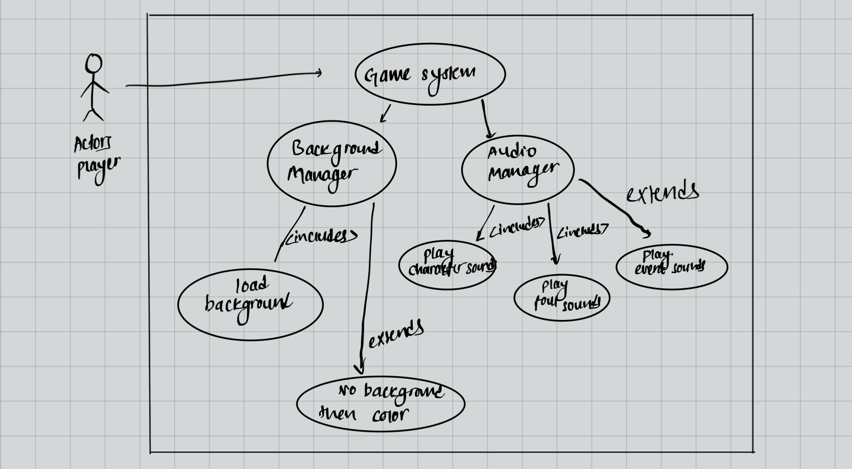

Data Flow diagram(s) from Level 0 to process description for your feature _______14

Data Flow Diagrams
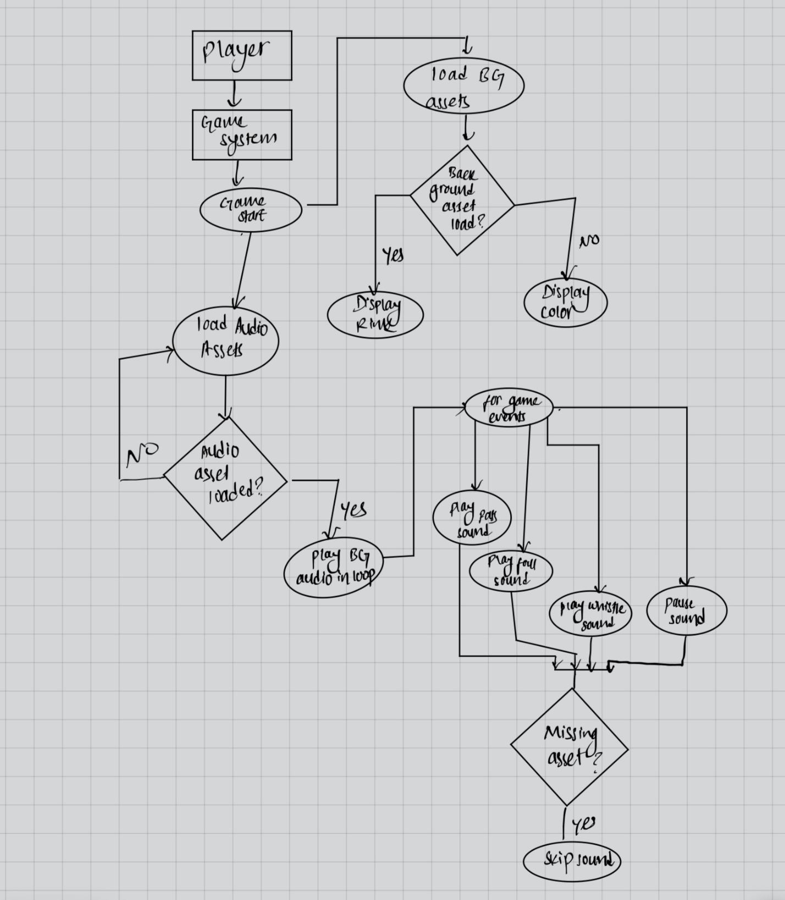

Process Descriptions
ON game start:
LOAD background asset
IF found THEN
DISPLAY rink (apply zoom if needed)
ELSE
DISPLAY fallback color
LOAD audio assets
PLAY background music in loop
FOR each event in game
IF event = catch/pass/shoot THEN
PLAY corresponding sound
ELSE IF event = foul THEN
PLAY foul sound
ELSE IF event = goal/whistle/crowd cheer THEN
PLAY event sound
ENDFOR
IF asset missing THEN
skip sound
IF subsystem fails THEN
mute all sounds

Acceptance Tests ________9

Background Tests
- Background Loading: Ensure the background asset loads correctly, displaying the rink as intended.
- Fallback Asset Handling: If the background asset is missing or cannot be loaded, verify that a solid fallback color is displayed in place of the missing asset.
- Resolution Scaling: Test that the background scales appropriately for larger screen resolutions without any distortion or loss of visual clarity.

Audio Tests
- Background Music Looping: Verify that the background music loops continuously without interruptions, maintaining smooth playback throughout the game.
- Action Sound Effects: Ensure that sound effects for actions like catch, pass, and shoot trigger correctly when the corresponding events occur in the game.
- Foul Sound: Check that the designated foul sound plays correctly when a penalty or foul event is triggered during the game.
- Event Sounds: Confirm that specific event sounds (such as goal, whistle, and crowd cheer) are triggered and played correctly at the appropriate moments.
- Missing Sound Asset Handling: If any sound asset is missing or fails to load, the system should skip playing the sound gracefully without causing any disruption to the gameplay.
- Subsystem Failure Handling: In the event of a subsystem failure (such as a failure in the audio system), verify that the game enters "mute mode" and no audio is played until the issue is resolved.

Timeline _________/10

Work items
Task | Duration (PWks) | Predecessor Task(s)
1. Requirements Collection | 2 | -
2. Asset Gathering (Background + Audio) | 3 | 1
3. Background Integration | 2 | 2
4. Audio Integration | 3 | 2
5. Programming (System Manager) | 3 | 3, 4
6. Testing | 2 | 5
7. Documentation | 2 | 6
8. Integration with Gameplay | 2 | 6

Pert diagram
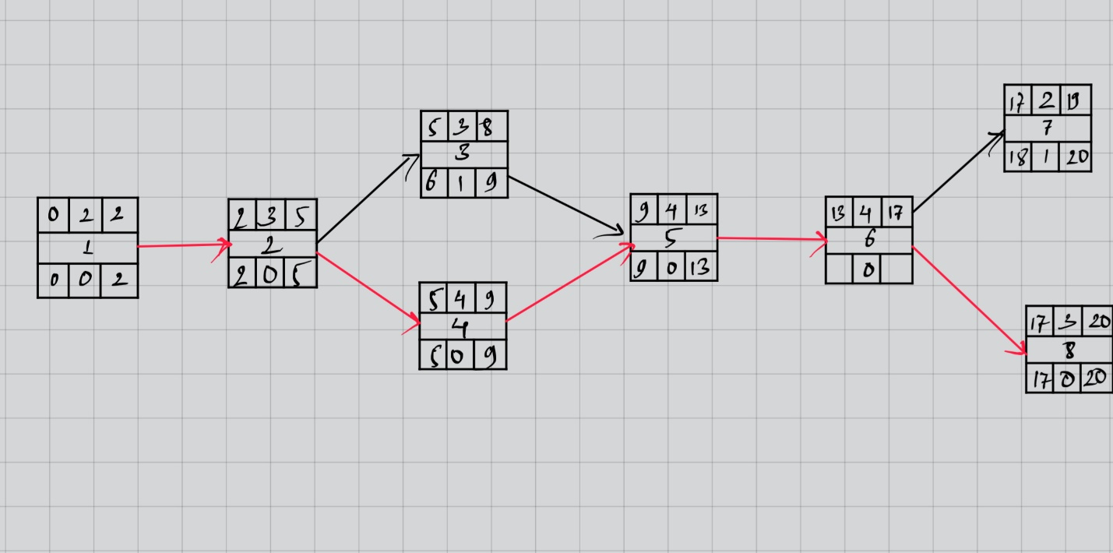

Gantt timeline

