Name Matthew Fry Mark ____________/50

Brief introduction __/3
The feature I am implementing is puck movement. This includes general puck physics such as sliding, bouncing off walls, and responding to collisions, as well as passing mechanics between players. Players can pass the puck to teammates, with the puck following a calculated trajectory based on direction, speed, and potential interceptions. This feature ensures smooth, realistic puck behavior in a 2D top-down view, integrating with player controls and AI for opponents.

Use case diagram with scenario __14

Use Case Diagrams
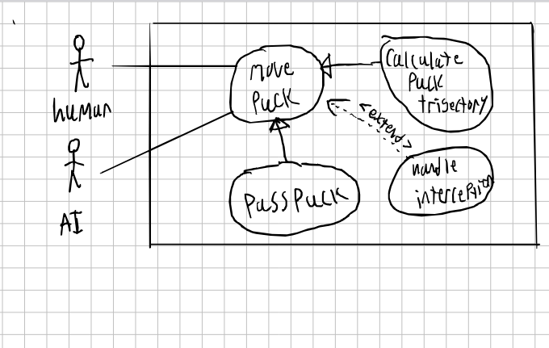

Scenarios
Name: Pass the Puck
Summary: Puck is passed to teamate
Actors: human player and AI player
Preconditions: is in possesion of puck
Basic sequence:
Step 1: Human player is in range and has selected a player to pass too
Step 2: system calculates puck movement
Step 3: puck moves toward target
Step 4: Teameate recives puck if no interception
Exceptions:
Step 1: oppenent intercepts puck
Post conditions: oppenent has puck

Name: Move the puck
Summary: Puck is moved across the ice after hit
Actors: human player and AI player
Preconditions: puck is in motion
Basic sequence:
Step 1: update puck position
Step 2: check for collision
Step 3: apply physics
Step 4: puck comes to rest
Exceptions:
Step 1: collision detected
Post conditions: puck bounces at reflected angle

Name: handel interception
Summary: an opponent steal the puck
Preconditions: puck in the middle of a pass
Basic sequence:
Step 1: check if player is near the puck in motion
Step 2: if yes, %chance of intercepting puck
Name: Move the puck
Summary: Puck is moved across the ice after hit

Data Flow diagram(s) from Level 0 to process description for your feature _______14
[Get the Level 0 from your team. Highlight the path to your feature]
Example:

Data Flow Diagrams
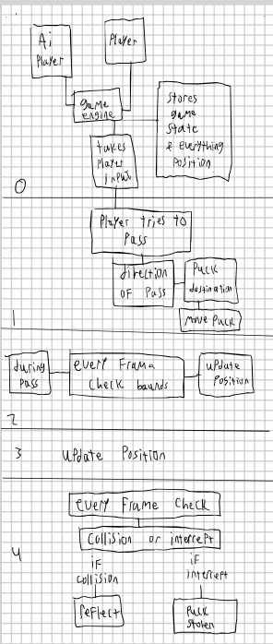

Process Descriptions
Process 0: Ai player, player, and puck, and game engine. Everyhting is connected to the game engine which stores all the relevent information, like state and position.
Process 1. if player tries to pass, collect direction, then calculate puck movement
process 2. for each frame check for bounds and check for intercept (while passing)
process 3. update the pucks postion
process 4 if theres a collision or intercept do
4.1 reflect off collision
4.2 oppenent has the puck

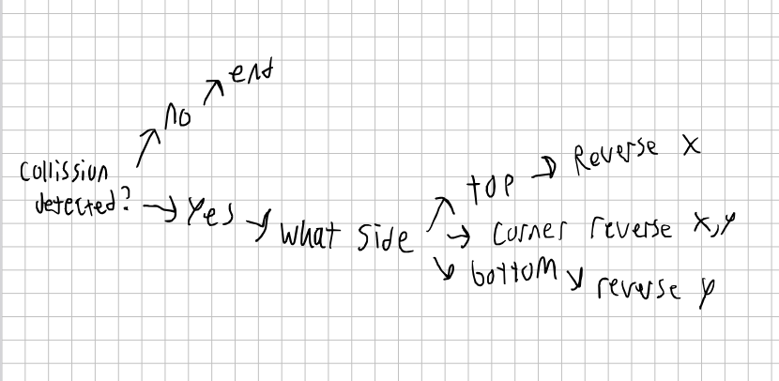

Acceptance Tests ________9
- Basic pass, a player and his teammate within a certain distance of eachother, just standing still
- pass while in move ment
- collecting the puck after collision with a wall
- interception

Timeline _________/10

Work items
Task | Duration (PWks) | Predecessor Task(s)
1. Requirements Collection | 5 | -
2. Research physics for puck integration | 2 | 1
3. implement basic puck movement | 3 | 2
4. implement passing and trajectory | 6 | 3
5. implement collision handling | 2 | 4
6. testing | 10 | 5
7. documentation | 1 | 6
8. final integration | 1 | 7

Pert diagram

Gantt timeline

