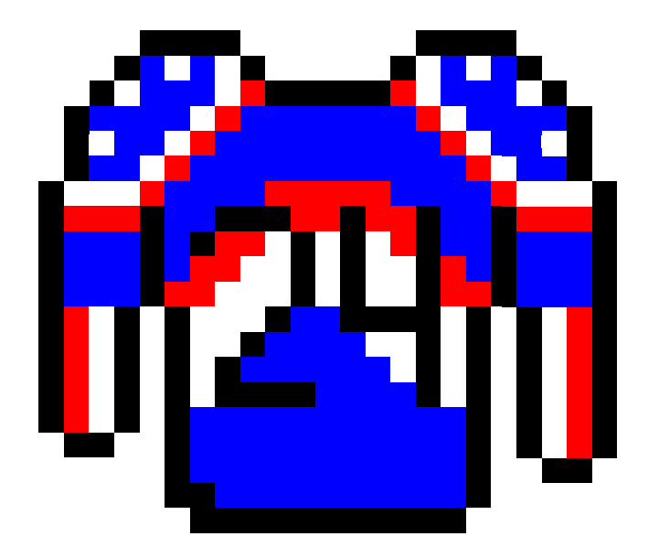

Project 24

RetroHockey
Request for Proposal
Version 2.0
Document History
Version | When | Who | What
1.0 | 2025 09-18 | Robbie Reinhardt  Ananda Shretha  Nathan Sawyer  BigYan Karki  Dylan Gomez | Initial Drafting
2.0 | 2025  09-18 | Matthew Fry | Final Draft
2.1 | 2025  09-18 | Bigyan | Fixed Section 9

Table of Contents
- Problem description
- Project Objectives
- Current System(s) – if any or similar
systems

- Intended users and their interaction with
the system

- Known interactions with other systems
inside/outside the client organization

- Known constraints to development
- Project Schedule
- How to Submit Proposals
- Dates
- Glossary of Terms
- Client Teams

- Problem description / opportunity / expression of need

The intended goal for this project is to develop Retro Hockey, a simple 16-bit style hockey game that offers both an engaging single-player experience and a highly replayable challenge mode. The game will feature a top-down 5v5 hockey match with easy-to-learn controls, allowing players to focus on strategy and skill. We believe there is a market for games that combine a nostalgic aesthetic with modern replayability, as evidenced by the success of other retro-inspired sports and arcade games.
Our planned game modes will set it apart from simple, repetitive titles. The single-player mode will allow players to practice and learn the mechanics, while the "Road to the Stanley Cup" playoff mode will serve as the primary challenge. This mode will feature a progressively increasing difficulty level, ensuring that each game is a new and more demanding test of the player's abilities. By offering a game that is easy to understand but provides a deep sense of progression and challenge, Retro Hockey is poised to appeal to a broad audience and maintain player engagement over the long term.

- Project Objectives
Player Controls
- Joystick Movement for player, player controls one skater, who ever has the puck
- Buttons for Pass, Shoot, BigHIt, steal, and intercept
- Only certain actions availble weather on defence or offence
Functional Offense
- Pass to teamates, when they get the puck you now control that player
- AI team mates play and function with success based on stats and position
- Pucks can be stolen depending on enemy stats
Function Defence
- When a player or teammate is near an oppenent with the puck they can attempt to steal it, chance depending on stats
- if a puck is shot near a player there is a chance for an interception
- you can body check (big hit) to dirupt an enemy player
- Enemy Ai plays and is able to do all the above as well
Team Stats
- all players have speed, hit strength, steal odds, shot success and intercept chance
- quick play will have randomized stats within a balanced range while in the cup mode the stats progressivly get harder
UI, Scoring, and other QOL enhancements
- Real time score display
- quick play is a fresh start every time you play
- in the cup mode you are allowed to save your place and come back later
- puase menu is availble, you can resume, restart match, quit to menu, and access volume settings.
- Backgroun music to keep the player engaged
- scoring sound effects (ie crowd cheering)
- other engaging sounds that make sense given the context
- Camera will follow who every has the puck, if no one is in control of the puck it will follow the puck

- Current system(s) – if any / similar systems
Retro Bowl - “Retro Bowl is an engaging game of 11-on-11 American football. Lace up your shoelaces and kick off the epic season in the pixelated world. Unique gameplay and experiences focused on skill and progression will immerse you. Enjoy top matches with your coaching talents, can you? Become an excellent head coach to take your virtual football team to the finals. Perform maneuvers, avoid obstacles, and score points like a true pro. This sports-themed game will not let you down, even with the smallest tasks. Prepare yourself mentally and come up with a basic initial strategy to participate in this game! Even if you only need simple preparation steps, like a passionate heart for football, you can try Retro Bowl!” - Description from retrobowl.io
Blades of Steal (NES) - “Blades of Steel, later released in Japan as Konamic Ice Hockey (Konamikku Aisu Hokkē), is an ice hockey video game released by Konami for North American arcades in 1987, and ported to the Family Computer Disk System and Nintendo Entertainment System in 1988. All teams are fictional but based out of real Canadian and American cities. The game is known for its fast-paced hockey action and especially for the fighting. It is a one or two player game. When playing against the computer, there are three difficulty levels to choose from: Junior, College, and Pro (with Pro being the most difficult and Junior being the easiest). Each team consists of three forwards, two defencemen, and a goaltender. “ Description from wikipedia

- Intended users and their basic interaction with the system

Sports enjoyers and the people who are looking for a fun game. People who want a fun and challenging game they can pick up and play at any time. There are two options for different kinds of players including the campaign “Road to the Stanley Cup” option allowing for players who enjoy the challenge and there is the simple grab and go option to allow for quick gaming sessions.
This game will be rated  (E for everyone)

Users will interact through controlling a player on the team. On offense, this player will be able to pass, shoot, and skate along the ice. On defense, the player is able to attempt to gain reposition of the puck through intercepting a pass, big hit, and stealing the puck.

- Known interactions with other systems within or outside of the client organization.
Available on
- Mobile App Stores
- Steam
Developed in
- Unity
- Git

- Known constraints to development

1. Complexity of Code / game logic
2. Shorter time span then usaully for this type of project
3. Limited funding
4. Unity is required

- Project Schedule

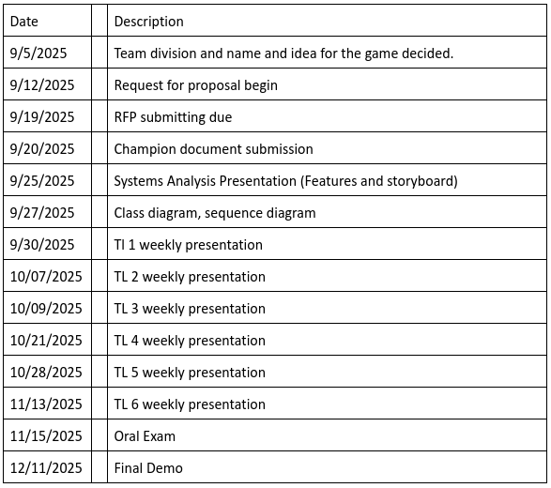
8.0 | How To Submit Proposals
Interested parties are invited to submit their proposals in electronic
PDF format. Submissions should be sent to
fakemail@retrohockey.com with the subject line: Retro Hockey
Proposal Submission.

Proposals must include:
- A detailed description of the proposed solution.
- Team qualifications and relevant experience.
- Estimated timeline and milestones.
- Cost estimates (if applicable).

Late submissions may not be considered unless prior approval has
been obtained. Each proposal should clearly identify the submitting
organization or team and the primary contact person.

9.0 | Dates
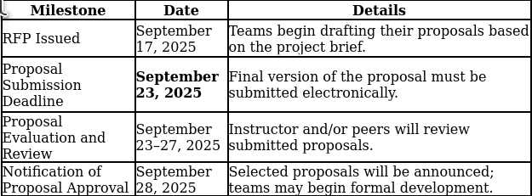

All proposals must be submitted by September 19, 2025, at 11:59 PM PDT. The Champion document is due on September 20, 2025. Proposals will be reviewed from September 21 through September 24, 2025, and applicants will be notified of the decision on September 24, 2025. Approved teams will then present their Systems Analysis and Storyboard on September 25, 2025, followed by submission of the Class Diagram and Sequence Diagram on September 27, 2025.

10.0 Glossary of terms

Terms that are meaningful to your client group but might not be understood by someone outside your group.

*Note: Remember that “system” means product, service, and/or system your group would like to see created, built, upgraded, and/or changed. It is a broad term.

11.0 Client Team
Robbie Reinhardt
Rein5800@vandals.uidaho.edu
Ananda Shretha

Nathan Sawyer
sawy4810@vandals.uidaho.edu
Bigyan Karki
Dylan Gomez
gome2670@vandals.uidaho.edu
Matthew Fry  fry2305@vandals.uidaho.edu | 3rd year CS Student at the University of Idaho  Profficient in developing computer applications

