Name_Nathan Sawyer Mark _____________________/50

Brief introduction __/3
I will be implementing the offense within Retro Hockey. I will be responsible for creating a functional offense system. This system will be able to pass the puck, skate in reasonable patterns, and shoot when the opportunity arises.

This system must have reasonable passing and skating such that the offense does not cause a quick turnover. The offense will also take into account where the defense is and adjust the movements accordingly. This system is crucial to the games functionality, and much of the “fun” the player has playing the game depends on the functionality of this system.

Use case diagram with scenario __14
[Use the lecture notes in class.
Ensure you have at least one exception case, and that the <<extend>> matches up with the Exceptions in your scenario, and the Exception step matches your Basic Sequence step.
Also include an <<include>> that is a suitable candidate for dynamic binding]
Example:

Use Case Diagrams
Player
Locate Team and
playcall
include
Decide where to skate

Locate Defenders
Collision
Turnover
exclude

Scenarios
[Decides where to skate]
Name: Skate_Direction
Summary: Calculate and decide the best play to make depending on the defense positions
Actors: Deffense, Offense, puck position, goalie position
Preconditions: Offense has possession of the puck
Basic sequence:
Step 1: Get current position and direction
Step 2: Get Defense position and Offense position
Step 3: Get Current “playcall”, evaluate if it still fits
Step 4: Decide where to skate next
Exceptions:
Step 1: Puck is traveling towards player: go towards puck
Step 2: Player collides with other player
Post conditions: Continues until turnover
Priority: 1*
ID: C01
*The priorities are 1 = must have, 2 = essential, 3 = nice to have.
Player
Pass puck
Interception
Keep puck
exclude
include
include

Puck is passed
Puck is not passed
turnover

[Pass the puck]
Name: Passes
Summary: Calculate and decide the best pass to make or to make a pass at all
Actors: Deffense, Offense, puck position, goalie position
Preconditions: Offense has possession of the puck
Basic sequence:
Step 1: Get current position and direction
Step 2: Get Defense position and Offense position
Step 3: Decide if user should pass or continue with puck
Step 4: Complete action
Exceptions:
Step 1: Passing lane blocked
Step 2: Puck intercepted
Post conditions: Continues until turnover
Priority: 2*
ID: C02
*The priorities are 1 = must have, 2 = essential, 3 = nice to have.
Player
Shoot Puck
Keep puck
Shoot and Miss / Deflection
exclude
turnover
Score
Next decision
Include

include

[Shoot the puck]
Name: Shoots
Summary: Calculate and decide the best shot to make or to make a shot at all
Actors: Deffense, Offense, puck position, goalie position
Preconditions: Offense has possession of the puck
Basic sequence:
Step 1: Get current position and direction
Step 2: Get Defense position and Offense position
Step 3: Decide if user should shoot or continue with puck
Step 4: Complete action
Exceptions:
Step 1: Shooting lane blocked
Step 2: Puck intercepted
Post conditions: Continues until turnover
Priority: 2*
ID: C03
*The priorities are 1 = must have, 2 = essential, 3 = nice to have.

Player
Defender Steals Puck Exclude Turnover
Defender blocks lane Exclude Big hit
Continue with puck Include New decision
[Skate the puck]
Name: Skate_with_puck
Summary: Calculate and decide to skate with the puck or not.
Actors: Deffense, Offense, puck position, goalie position
Preconditions: Offense has possession of the puck
Basic sequence:
Step 1: Get current position and direction
Step 2: Get Defense position and Offense position
Step 3: Decide if user should skate with puck
Step 4: Complete action
Exceptions:
Step 1: Defender blocks lane
Step 2: Defender steals puck
Post conditions: Continues until turnover
Priority: 1*
ID: C04
*The priorities are 1 = must have, 2 = essential, 3 = nice to have.

Data Flow diagram(s) from Level 0 to process description for your feature

Data Flow Diagrams
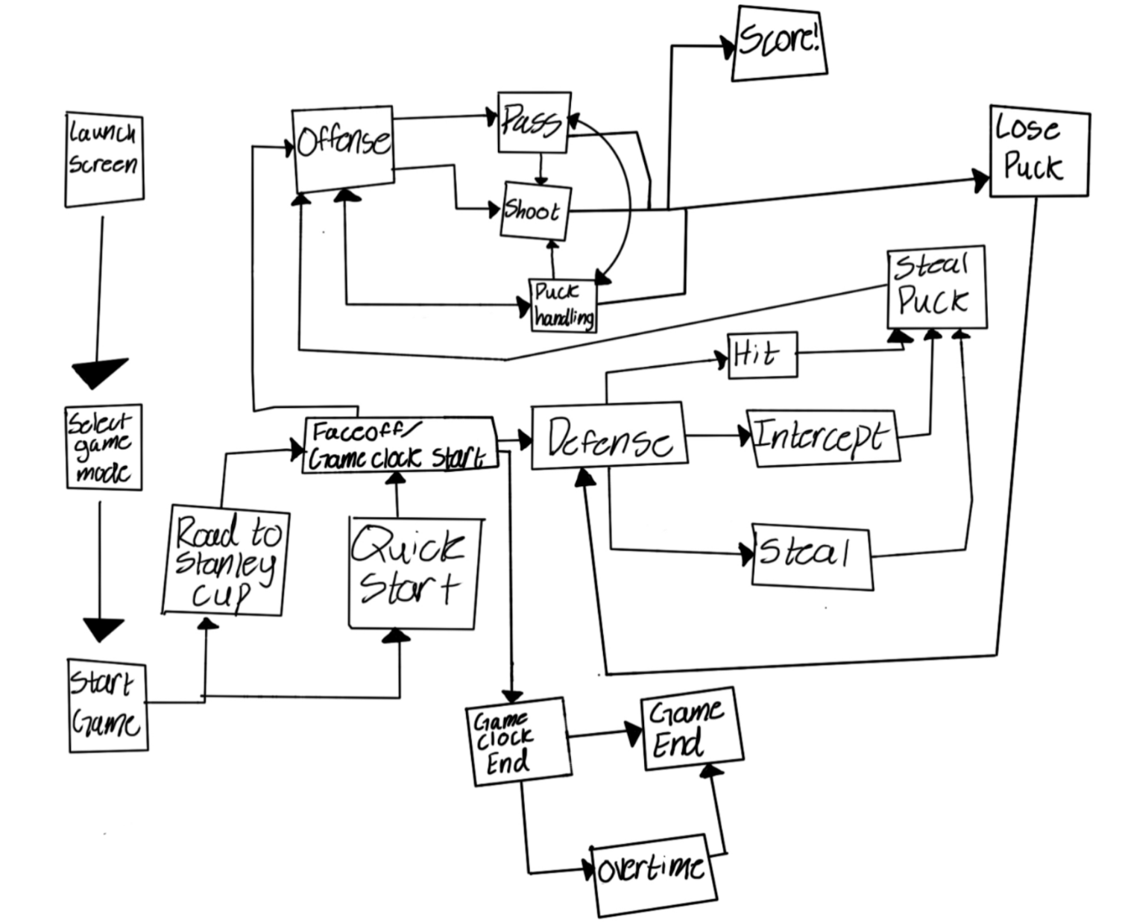
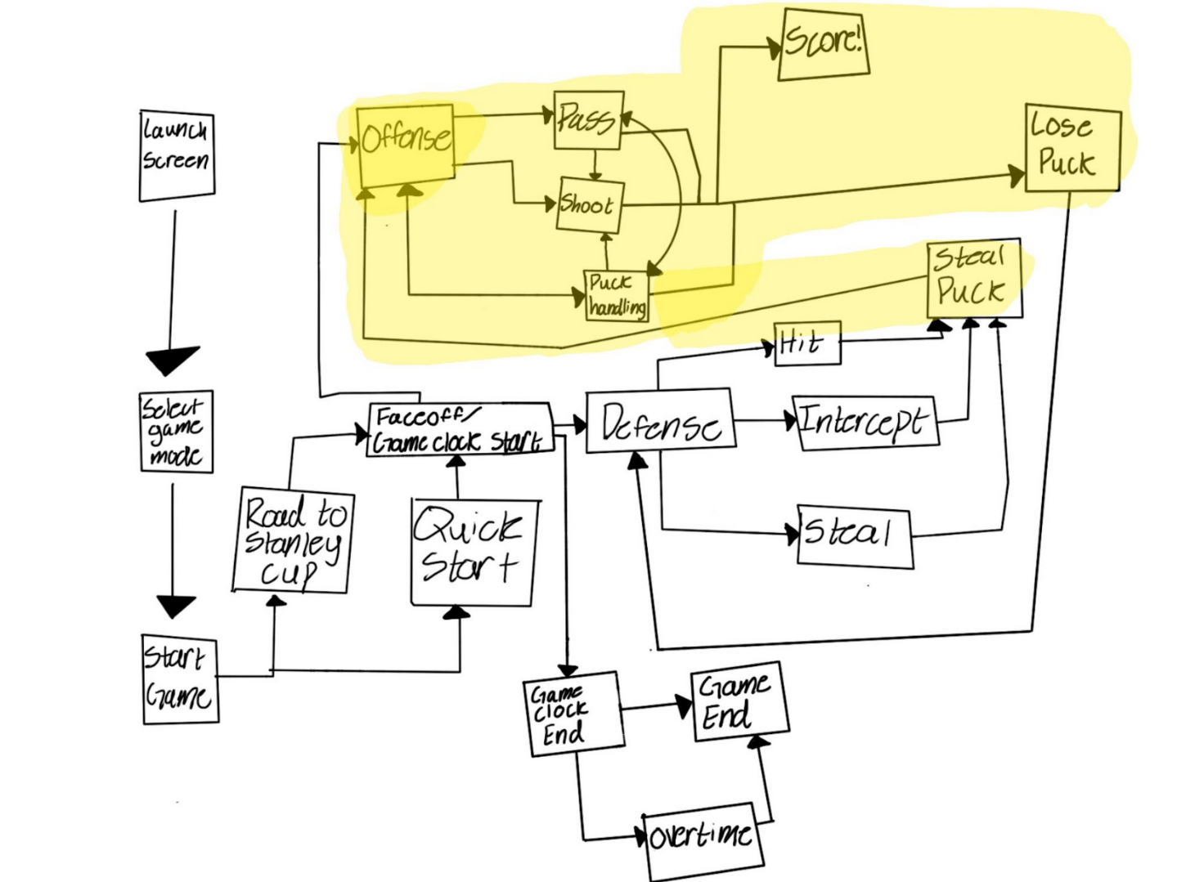

Process Descriptions
On-Puck:
Pass If: No open net shot is possible, or defender is blocking path to goal
Shoot if : Shoot if there is clear path to goal and player is close
Else: Skate with puck to differing position
Off-puck:
If playcall not decided:
If: player positioning is in man coverage, send offense in a crossing pattern to get free
If : defense is in a zone coverage, skate to “holes” in zone
While: defender is blocking path, skate around defender
If two or more players get blocked, switch playcall

If: puck is passed:
Closest player head towards the puck
If : puck is shot and deflected
All players “crash” on puck

Acceptance Tests ________9
Offense must be able to score at a bare minimum of 5% of the time without player interaction. If the offense is turning over the puck consistently, this would make the game extremely difficult and frustrating to play.
Offense must prioritize passing back to the user when the user is open. This must happen at a minimum of 50% of the time when the user is uncovered.

Offense must pass the puck with an average of 2 times per possession at a minimum. In a fast break, this clearly would not be the case, but those should not be too common.
Defenders must be avoided and cannot be skated straight into. No more than 20% of puck positions should end in big collisions
Inputs vs Outputs
Input | Output
Puck passed | Puck Received
Defender blocking route | Defender avoided
Defender blocking offender | Defender avoided
Offense receives puck | Offense scores > 5%
User is open | Puck is passed > 50%
Offense receives puck | Offense passes puck > 2 times (excluding fast breaks)

Timeline _________/10
[Figure out the tasks required to complete your feature]
Example:

Work items
Task | Duration (PWks) | Predecessor Task(s)
1. Define actions and workflow | 1 | -
2. Skating logic | 6 | 1
3. Passing Logic | 2 | 2
4. Shooting logic | 2 | 2, 3
5. Documentation | 1 | 4
6. Testing | 4 | 4
7. Bug Fixing | 6 | 6
8. Finishing Touches | 1 | 5, 7

Pert diagram
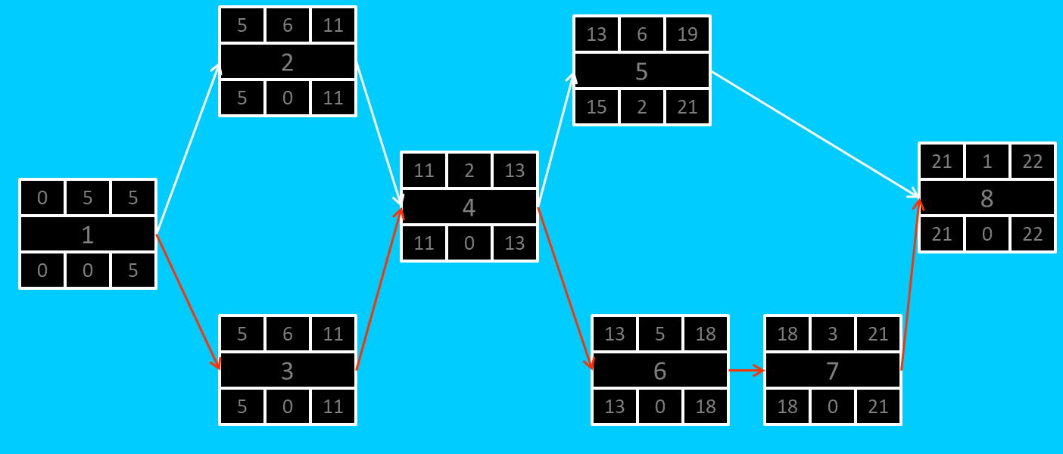
Gant timeline:
Key = 1 = hours spent working

1 | 1 | 1 | 1 | 1 | 1
2 |  |  |  |  |  | 1 | 1
3 |  |  |  |  |  | 1 | 1
4 |  |  |  |  |  |  |  | 1 | 1
5 |  |  |  |  |  |  |  |  |  | 1
6 |  |  |  |  |  |  |  |  |  |  | 1 | 1 | 1 | 1
7 |  |  |  |  |  |  |  |  |  |  |  |  |  |  | 1 | 1 | 1 | 1 | 1
8 |  |  |  |  |  |  |  |  |  |  |  |  |  |  |  |  |  |  | 1

