Streaming using BigQuery:
Data in BigQuery after the initial upload, the arrestdate is 12th April.
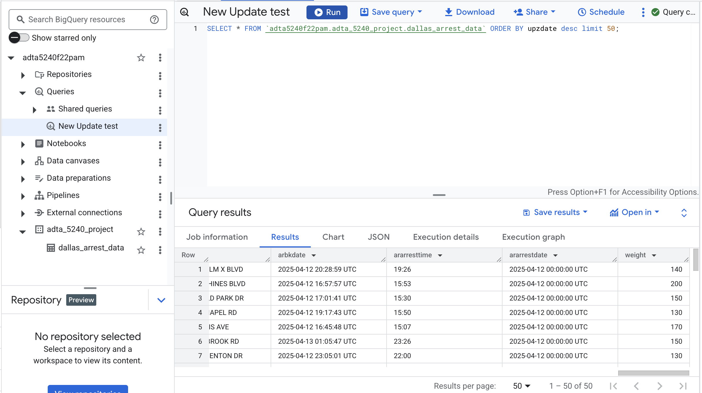
After running the python script which connects to the BigQuery table, the ararrestdate has been updated to 16th April i.e., the updates that happened after 12th April were inserted into the table.
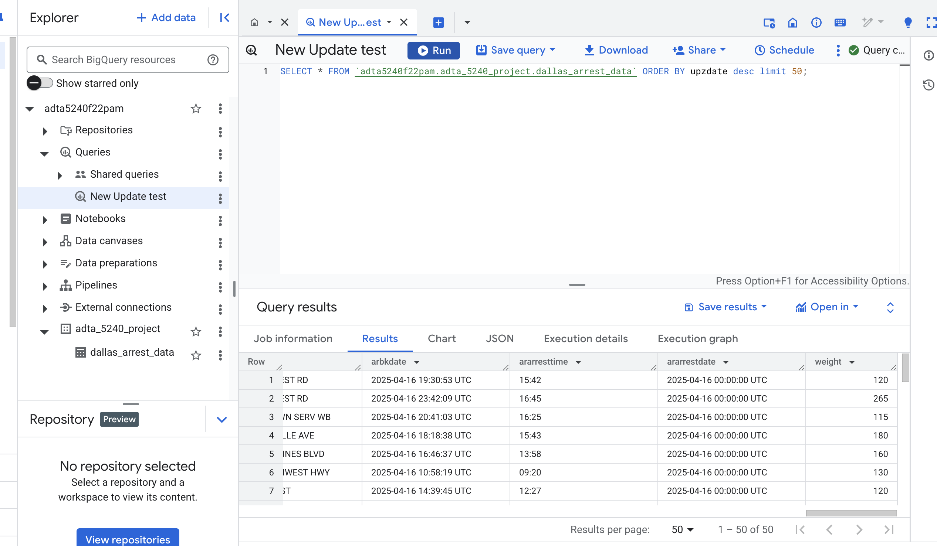
Streaming using HDFS ecosystem:
- Creating HDFS ecosystem, no tables:
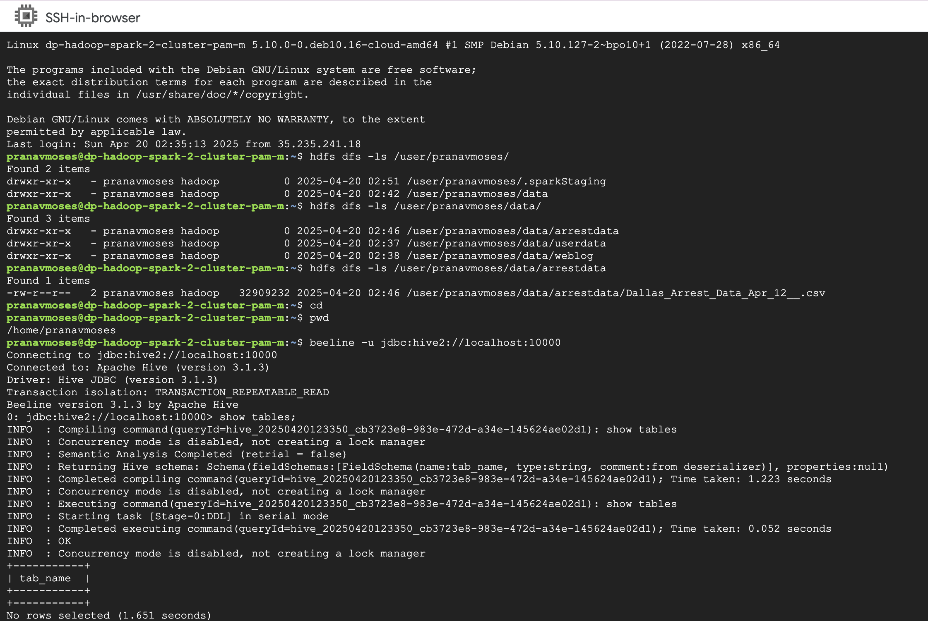
- After the data has been loaded to the HDFS folder, a table is created using the following query:
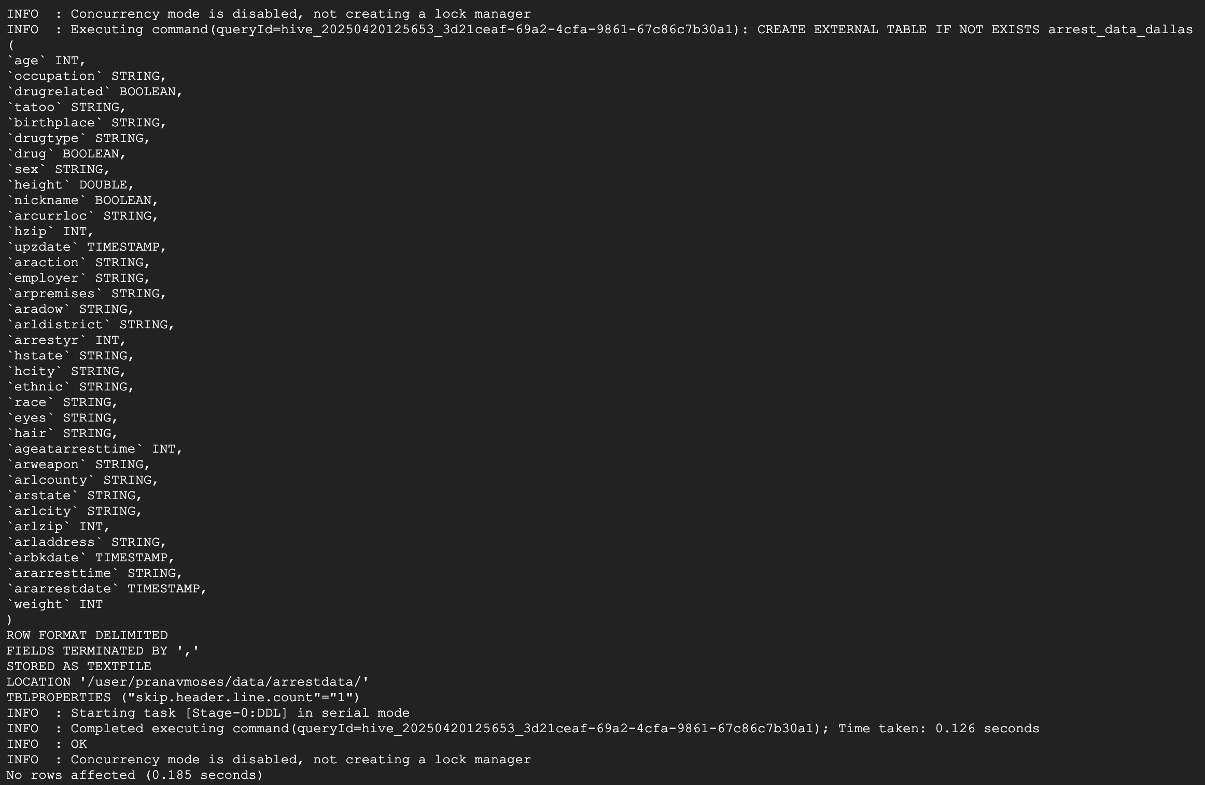

- A python script is uploaded to the dataproc clusters namenode VM:
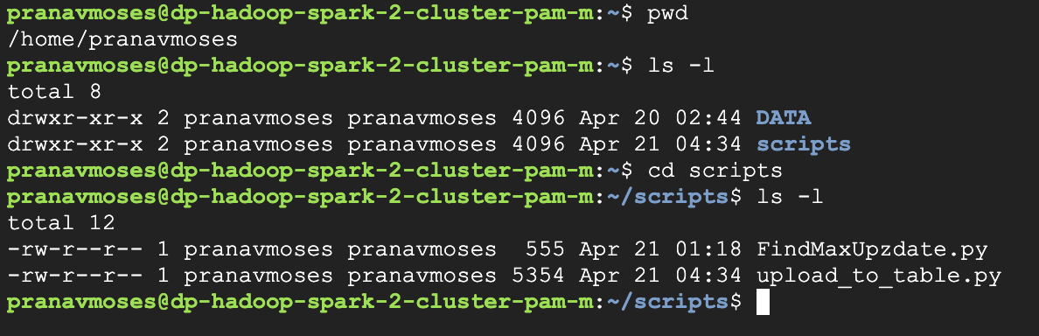
- Running the python script:
- Results from the python script, the new max date for upzdate is April 19th.
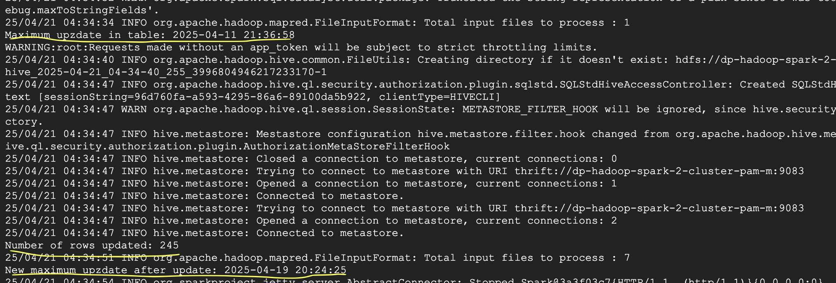

BigQuery script:
import os
import pandas as pd
from sodapy import Socrata
from datetime import datetime, timedelta
from google.cloud import bigquery
import urllib.parse

os.environ["GOOGLE_APPLICATION_CREDENTIALS"] = "adta5240f22pam-f3b757ff53fa.json"
bq_client = bigquery.Client()

table_id = "adta5240f22pam.adta_5240_project.dallas_arrest_data"

client = Socrata("www.dallasopendata.com", None)

yesterday = datetime.now() - timedelta(days=1)
date = yesterday.date()

# Get yesterday's date
yesterday = datetime.now() - timedelta(days=1)
date = str(yesterday.date())

# Define the SQL query with the date injected
query = f"""
SELECT age,
ageatarresttime,
araction,
aradow,
ararrestdate,
ararresttime,
arbkdate,
arcurrloc,
arladdress,
arlcity,
arlcounty,
arldistrict,
arlzip,
arpremises,
arrestyr,
arstate,
arweapon,
birthplace,
drug,
drugrelated,
drugtype,
employer,
ethnic,
eyes,
hair,
hcity,
height,
hstate,
hzip,
nickname,
occupation,
race,
sex,
tatoo,
upzdate,
weight
WHERE ararrestdate = '{date}'
"""

# Encode the query string
safe_string = urllib.parse.quote_plus(query)

# Construct the full URL
url = f'https://www.dallasopendata.com/resource/sdr7-6v3j.csv?$query={safe_string}'

df = pd.read_csv(url)

df['height'] = df['height'].str.replace('-', ".")
df['height'] = df['height'].astype(float)
df['age'] = df['age'].astype(int)
df['drugrelated'] = df['drugrelated'].astype(bool)
df['drug'] = df['drug'].astype(bool)
df['nickname'] = df['nickname'].astype(bool)
df['upzdate'] = pd.to_datetime(df['upzdate'])
df['arbkdate'] = pd.to_datetime(df['arbkdate'])
df['ararrestdate'] = pd.to_datetime(df['ararrestdate'])
df['arldistrict'] = df['arldistrict'].astype(str)
# df['ageatarresttime'] = df['ageatarresttime'].astype(int) ---- Need to be fixed.

job = bq_client.load_table_from_dataframe(df, table_id, job_config=bigquery.LoadJobConfig(
write_disposition="WRITE_APPEND" # Ensures new data is appended
))

print("Data loaded to BigQuery successfully. ", df.shape)

Spark script:
from pyspark.sql import SparkSession
from pyspark.sql.functions import col, max
import pandas as pd
from sodapy import Socrata
import urllib
from pyspark.sql.types import *
from datetime import datetime

# Create Spark session
spark = SparkSession.builder \
.appName("Update arrest_data_dallas") \
.enableHiveSupport() \
.getOrCreate()

try:
# Step 1: Get the max upzdate from existing table
df_existing = spark.table("arrest_data_dallas")
max_upzdate = df_existing.agg(max(col("upzdate"))).collect()[0][0]

# Convert max_upzdate to datetime if it's not already
if isinstance(max_upzdate, str):
max_upzdate = datetime.strptime(max_upzdate, '%Y-%m-%d %H:%M:%S')

# Format date for the query
date_for_query = max_upzdate.strftime('%Y-%m-%d %H:%M:%S')
print(f"Maximum upzdate in table: {date_for_query}")

# Step 2: Query new data from Dallas Open Data API
client = Socrata("www.dallasopendata.com", None)

# Define the SQL query with the date injected
query = f"""
SELECT age,
occupation,
drugrelated,
tatoo,
birthplace,
drugtype,
drug,
sex,
height,
nickname,
arcurrloc,
hzip,
upzdate,
araction,
employer,
arpremises,
aradow,
arldistrict,
arrestyr,
hstate,
hcity,
ethnic,
race,
eyes,
hair,
ageatarresttime,
arweapon,
arlcounty,
arstate,
arlcity,
arlzip,
arladdress,
arbkdate,
ararresttime,
ararrestdate,
weight
WHERE upzdate > '{date_for_query}'
"""

# Encode the query string
safe_string = urllib.parse.quote_plus(query)

# Construct the full URL
url = f'https://www.dallasopendata.com/resource/sdr7-6v3j.csv?$query={safe_string}'

# Read data using pandas
df_pandas = pd.read_csv(url)
df_pandas = df_pandas.where(pd.notnull(df_pandas), None)

if len(df_pandas) > 0:
# Step 3: Clean and transform the pandas dataframe
df_pandas['height'] = df_pandas['height'].str.replace('-', ".")
df_pandas['height'] = df_pandas['height'].astype(float)
df_pandas['age'] = df_pandas['age'].astype(int)
df_pandas['drugrelated'] = df_pandas['drugrelated'].astype(bool)
df_pandas['drug'] = df_pandas['drug'].astype(bool)
df_pandas['nickname'] = df_pandas['nickname'].astype(bool)
df_pandas['upzdate'] = pd.to_datetime(df_pandas['upzdate'])
df_pandas['arbkdate'] = pd.to_datetime(df_pandas['arbkdate'])
df_pandas['ararrestdate'] = pd.to_datetime(df_pandas['ararrestdate'])
df_pandas['arldistrict'] = df_pandas['arldistrict'].astype(str)
df_pandas['arpremises'] = df_pandas['arpremises'].astype(str)
df_pandas['birthplace'] = df_pandas['birthplace'].astype(str)
df_pandas['drugtype'] = df_pandas['drugtype'].astype(str)
df_pandas['occupation'] = df_pandas['occupation'].astype(str)
df_pandas['tatoo'] = df_pandas['tatoo'].astype(str)
df_pandas['sex'] = df_pandas['sex'].astype(str)
df_pandas['arcurrloc'] = df_pandas['arcurrloc'].astype(str)
df_pandas['araction'] = df_pandas['araction'].astype(str)
df_pandas['employer'] = df_pandas['employer'].astype(str)
df_pandas['aradow'] = df_pandas['aradow'].astype(str)
df_pandas['arldistrict'] = df_pandas['arldistrict'].astype(str)
df_pandas['hstate'] = df_pandas['hstate'].astype(str)
df_pandas['hcity'] = df_pandas['hcity'].astype(str)
df_pandas['ethnic'] = df_pandas['ethnic'].astype(str)
df_pandas['race'] = df_pandas['race'].astype(str)
df_pandas['eyes'] = df_pandas['eyes'].astype(str)
df_pandas['hair'] = df_pandas['hair'].astype(str)
df_pandas['arweapon'] = df_pandas['arweapon'].astype(str)
df_pandas['arlcounty'] = df_pandas['arlcounty'].astype(str)
df_pandas['arstate'] = df_pandas['arstate'].astype(str)
df_pandas['arlcity'] = df_pandas['arlcity'].astype(str)
df_pandas['arladdress'] = df_pandas['arladdress'].astype(str)
df_pandas['ararresttime'] = df_pandas['ararresttime'].astype(str)

# Convert pandas dataframe to Spark dataframe
spark_df = spark.createDataFrame(df_pandas)

# Step 4: Append new data to the existing table
# The insertInto method appends data to an existing table
spark_df.write.mode("append").insertInto("arrest_data_dallas")

rows_updated = spark_df.count()
print(f"Number of rows updated: {rows_updated}")

# Verify the update
new_max_upzdate = spark.table("arrest_data_dallas").agg(max(col("upzdate"))).collect()[0][0]
print(f"New maximum upzdate after update: {new_max_upzdate}")

else:
print("No new data found to update.")

except Exception as e:
print(f"Error: {str(e)}")
finally:
spark.stop()

