Computer programming

Final Project

Report

I.E.S. San Vicente
San Vicente del Raspeig (Alicante)
2017/2018

Teachers:
José Ignacio Cabanes / Ignacio Iborra

Student:
Javier Saorín Vidal

1. Introduction
Project name
BoxHead

Made by
Javier Saorín Vidal

Short description of the project
BoxHead is a top-down zombie shooter video game for one player. It is a graphical application that uses the SDL graphics library.

2. Functionality of the project
After entering the program, a welcome screen will we displayed, where the user can choose between:

• Start a new game.
• Continue the last saved game.
• See highscores.
• Options.
• Quit the game.

If the user chooses a new game he starts at a tutorial level to taught the basic gameplay of BoxHead.

After advancing the level, the score obtained will be shown, the time spent and will be advanced to the next level. (In this step the game will be saved automatically).

Before quitting the game, the scoreboard will be saved, and it will be retrieved in the next session.

The images for the walls and the background screen are read from file at the beginning of the game.

3. Screen prototype
The game screen will look like this (a bit less bloody):

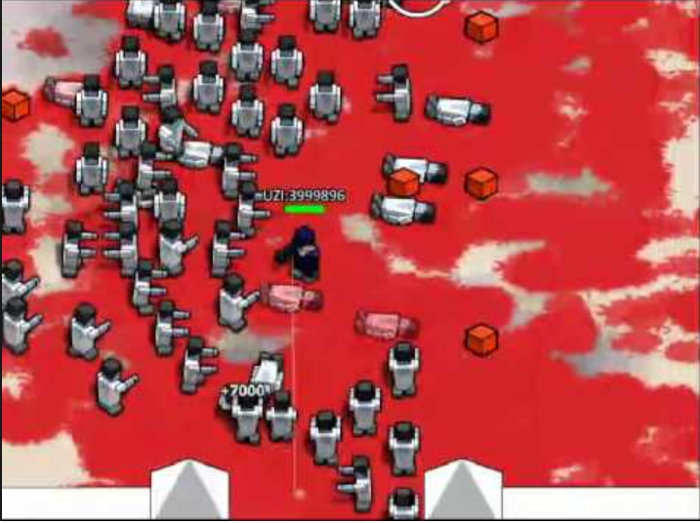

4.Analysis

4a. Requisites
Requisite | Date achieved
The player can move through the map, the player is centered on the screen and make scroll when moving. Collides with walls, barrels and other map elements.
The player can shoot using the mouse to any part of the screen, if the bullets hit any enemy they will take damage and die with enough damage.
The player can create their own maps with a map editor within the game.
The enemies will begin to appear by hordes, the amount of enemies and their difficulty will increase. (Damage, speed, amount of life). | X
There will be a HUD that displays the life of the player, the current horde, the remaining enemies and the amount of ammo and grenades.
During the game randomly appear healing packs, ammunition packs, grenades and traps.
There will be a menu that can be used with both the mouse and the keyboard, when an option is selected it will be highlighted. | X
There will be a Highscore screen that will show the best scores of each player.

4b. Basic pseudocode

4c. Classes diagram

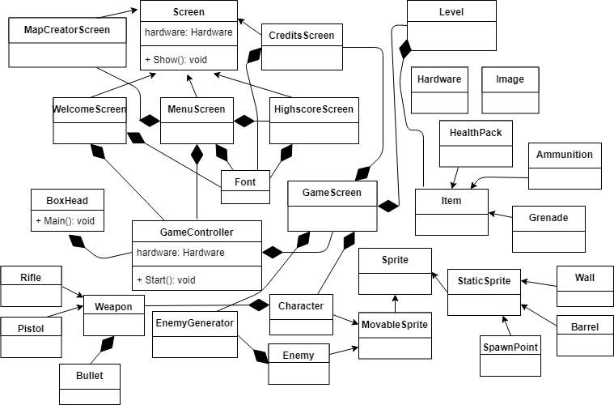

5. Initial planning and expected deliveries

5a. Expected deliveries
- Version 1: Gamecontroller class that controls the flow of the program, the game loop and the skeleton of the rest of the classes.

- Version 2: Define obstacles (walls, barrels, mines...) and a Level class which reads the map from a text file.

- Version 3: Player movement logic and scroll. The player remains always in the center of the screen, the scroll will occur every time the player moves, the scroll will stop once the player collides with the edge of the map.

- Version 4: Movement of enemies and attacks. The enemies walk to the player and attack him if he is on a certain range.

- Version 5: Collisions of the character and enemies with elements of the map (Walls, traps, barrels).

- Version 6: MenuScreen that allows the user to start a new game, continue a game, select a start horde, create a map, show help. Can be used with mouse. If the mouse is over a text this text will be displayed with other color/size.

- Version 7: EnemyGenerator class that makes hordes of enemies and increases the quantity of the enemies, their life, damage and speed each round.

- Version 8: Mouse detection for the shoot logic and player orientation.

- Version 9: HighscoreScreen class that display the name of the players with highest scores. Taking the score of each player from a text file.

- Version 10: MapCreatorScreen class which allows the user to create maps. Make the user interface which allows the user to put wall, traps, barrels and enemy spawns.

- Version 11: Continue with the MapCreatorScreen class. Make the logic to save to a file the map generated by the user.

- Version 12: Make the WelcomeScreen and CreditsScreen. The credits will be taken from a text file and displayed with an animation.

- Version 13: Make items like healing packs, ammunition, grenades, traps and a method to randomize their apparition.

- Version 14: Add an enemy boss who can go through walls, shoot the player, summon more enemies. His difficulty will increase as he has less life.

- Version 15: Add a hud to show the remaining life, the amount of ammunition, the time played, the current horde and the number of remaining enemies to pass the horde.

5b. Real deliveries
- Version 1 (May 14): Created the Gamecontroller class and the skeleton of all the classes.

- Version 2 (May 15): Defined obstacles (walls, barrels and mines) and the Level class now reads the map from a text file with a method named Load. Added a method to detect if the character collides with a healthpack.
- Version 3 (May 16): Implemented a DrawObstacle method in the Level class that draws all the obstacles in the screen. Implemented a moveCharacter method in the GameScreen class that checks the keyboard imput and move the character ( Don't work yet. )
- Version 4 (May 17): Fill the WelcomeScreen Class, change the hardware class to allow to draw messages with different fonts, program the show() method to show a static background image, and the title doing a small animation.

- Version 5 (May 18): Movement of enemies and attacks. The enemies walk to the player and attack him if he is on a certain range. Tested a enemy on the GameScreen class.

- Version 6 (May 21): Updated MenuScreen to start a new game, continue a game, select a start horde, go to the map editor screen and options screen. Can not be used with mouse (for the moment). The selected option is displayed with other color.

- Version 7 (May 22): EnemyGenerator class now generate enemies, more each round, with random stats, detect the spawn points and move each enemy to a different spwan point.

- Version 8 (May 23): Mouse detection for the and player orientation.

- Version 9 (May 24): HighscoreScreen class that display the name of the players with highest scores. Taking the score of each player from a text file. (Not finished yet!) Updated Gamescreen class and level class to make scroll properly. Updated character animation method to support 36 images.

- Version 10 (May 25):

- Version 11 (May 28):

- Version 12 (May 29):

- Version 13 (May 30):

- Version 14 (May 31):

- Version 15 (June 01):

6. File formats

6a. Plain files format
The Level class use text files to load the different obstacles.
The text files store the type of the obstacle with a letter and the obstacle x and y position.
The fields are separated with semicoloms.
Example:
w;700;200
s;210;321
b;800;234

6b. Entity-Relationship Diagram (If needed)
(…)

7. Problems found and solutions
(…)

8. Improvements or restrictions to the starting design
(…)

9. Screenshots of the final project
(…)

10. Source code of the final project
(…)

