**AI Services Portal User Guide**

**What is this Website?**

This website allows you to upload various file types for analysis via Google Artificial Intelligence, using different modules for different inputs and expected outputs. A module is a tool which can be used to extract relevant information from an expected input. There are several modules implemented in the website which can extract the required information from image, video, and audio file types.

**The Step-by-Step Process**

Before beginning, make sure you have received an API key from your systems administrator. This is a .json file which is what provides access to the website features. It would also be useful to know which module you should be working with. If you are unsure which one you are supposed to be using, ask your systems administrator, or someone else who would know.

The website homepage is the gateway to every implemented module. From here, you can select whichever one it is you need. The picture below shows the modules which were available at the time of this guide’s last update. There may be more or less than the number shown if the website has since been updated.

**The Homepage**

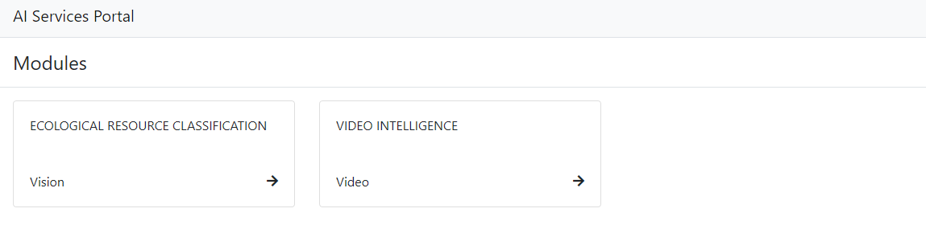

Select the module you would like to use by clicking the corresponding button. This guide will step you through using the Ecological Resource Classification module. The process will be near identical for each other module.

**Uploading**

Once you have chosen a module, you will be taken to a page that looks something like the image below. Here, you must upload both your inputs to be processed, and the API key .json file which will allow your files to be processed.

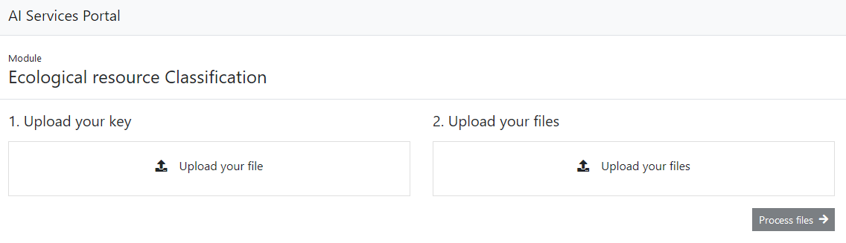

It does not matter the order in which you upload the files so long as they are both uploaded. To upload the API key, click the button below the “1. Upload your key” text, shown below.



You will be taken to a window where you may select the .json file to upload. Other file types will not be displayed. Once you have done this, the left button should read “1 file selected” below the default text. Now you can upload your input files by clicking the other button below the “2. Upload your files” text.

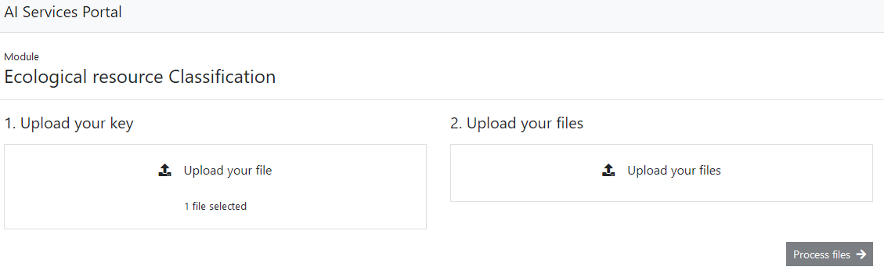

Each different module will only accept certain file types and will usually accept either one or multiple files. The Ecological Resource Classification module seen in this guide can accept multiple image files. Other modules can accept either video or audio files. The accepted file types for each are listed on the next page.

|  |  |  |
| --- | --- | --- |
| **Image** | **Video** | **Audio** |
| * .JPEG * .PNG8 / .PNG24 / .PNG * .GIF (first frame) * .BMP * .WEBP * .RAW * .ICO * .PDF * .TIFF | * .MOV * .MPEG4 * .MP4 * .AVI | * .MP3 * .FLAC * .OGG * .WAV |

For this example, multiple image files have been selected (three in this case). To select multiple files that are not necessarily grouped together on windows, hold down the ctrl key as you select the files. To select all files in a folder instantly, press ctrl + a.

Once you have chosen the files you would like to process, there should be text below the default button text reading “X files selected”, “X” being the number of files selected. Now you can have your selected files uploaded and processed by pressing the button to the bottom right of the screen.

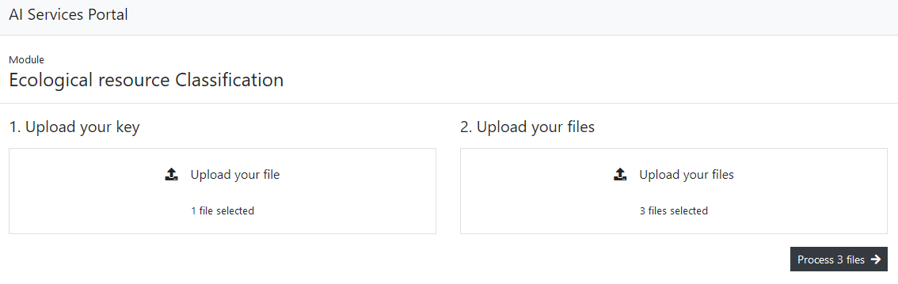

While the files are being uploaded, you will be able to track their progress at the bottom right corner. Here you can see how many of the of the total selected files have been uploaded so far.

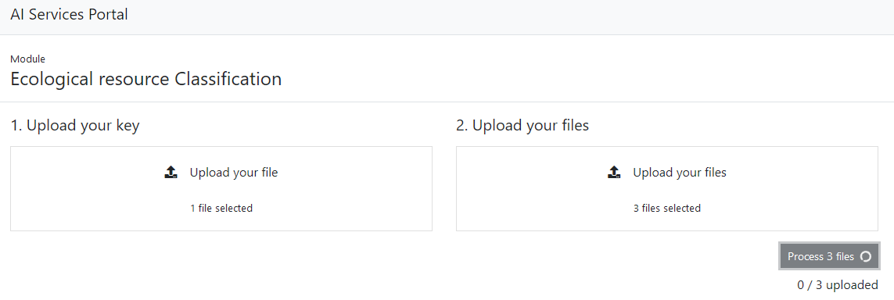

**Tracking Progress**

Once this is done, you will be taken to the following page which provides you with your task ID for later follow-up should it be necessary. There will also be a button to take you to the next page which displays the current progress of the processing.

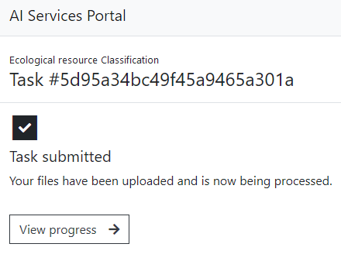

The progress page will display different information depending on the module selected. In the case of Ecological Resource Classification Module, the pending (to be processed) images and images determined to be either containing an animal or blank (processed) will be listed as seen below. Other modules will all likely contain a pending list, though the other sections may be different. Clicking the chevrons to the right of a lists title (highlighted in the below image) will hide that list. This will be useful when there are a lot of files to display.

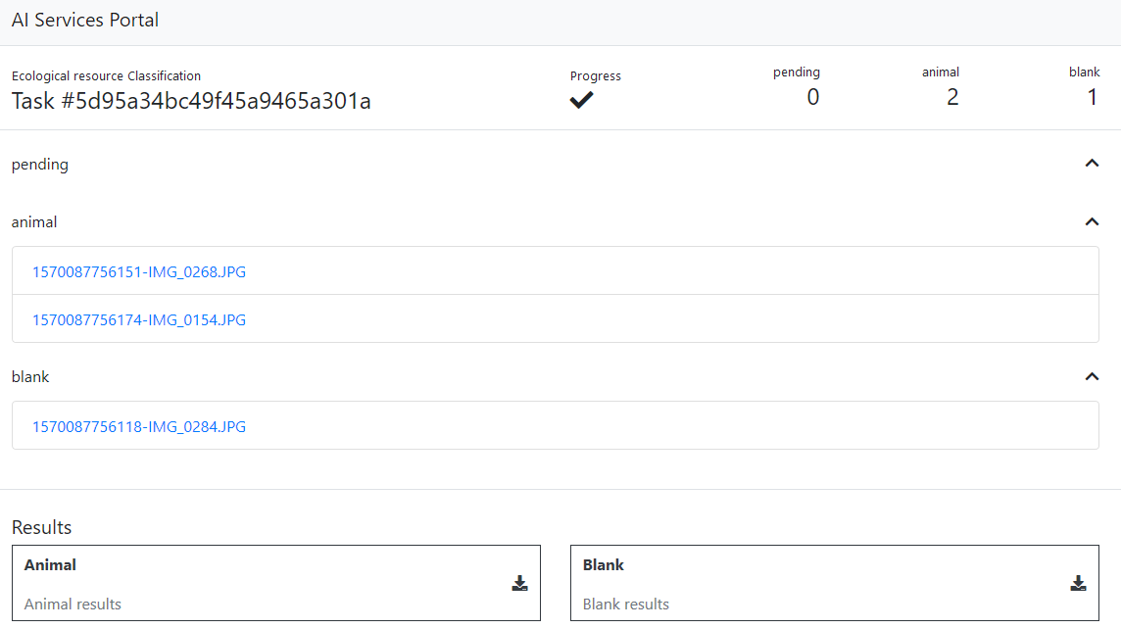

**Results**

This module allows users to download zipped files at the bottom of the page. One contains all the images determined to contain an animal, while the other contains all the images determined to be blank. In the below image the respective buttons are highlighted. Each module will again likely provide different data in the results section, though most will have a download of some sort.



Below is the downloaded animal file containing the zipped results.

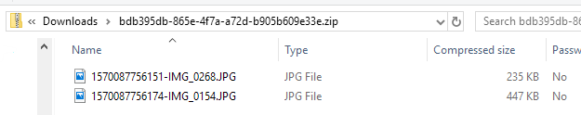

Again, depending on the module you use, different options for downloads may be available, if any.